Table of Contents
UNITED STATES
SECURITIES AND EXCHANGE COMMISSION
WASHINGTON, DC 20549
________________________________________________
FORM 10-Q
________________________________________________
(Mark One)
x |  |  | QUARTERLY REPORT PURSUANT TO SECTION 13 OR 15(d) OF THE SECURITIES EXCHANGE ACT OF 1934
For the quarterly period ended June 30, 2026
OR
o |  |  | TRANSITION REPORT PURSUANT TO SECTION 13 OR 15(d) OF THE SECURITIES EXCHANGE ACT OF 1934
For the transition period from ___________________ to ___________________
Commission File Number: 001-39567
________________________________________________
C4 Therapeutics, Inc.
(Exact Name of Registrant as Specified in its Charter)
________________________________________________
Delaware |  |  | 47-5617627
(State or other jurisdiction of  incorporation or organization) |  |  | (I.R.S. Employer  Identification No.)
490 Arsenal Way, Suite 120,  Watertown, MA |  |  | 02472
(Address of principal executive offices) |  |  | (Zip Code)
(617) 231-0700
(Registrant’s telephone number, including area code)
________________________________________________
Securities registered pursuant to Section 12(b) of the Act:
Title of each class |  |  |  |  |  | Trading  Symbol(s) |  |  |  |  |  | Name of each exchange on which registered
Common Stock, $0.0001 par value per share |  |  |  |  |  | CCCC |  |  |  |  |  | The Nasdaq Global Select Market
Indicate by check mark whether the registrant (1) has filed all reports required to be filed by Section 13 or 15(d) of the Securities Exchange Act of 1934 during the preceding 12 months (or for such shorter period that the registrant was required to file such reports), and (2) has been subject to such filing requirements for the past 90 days. Yes x No ☐
Indicate by check mark whether the registrant has submitted electronically every Interactive Data File required to be submitted pursuant to Rule 405 of Regulation S-T (§232.405 of this chapter) during the preceding 12 months (or for such shorter period that the registrant was required to submit such files). Yes x No ☐
Indicate by check mark whether the registrant is a large accelerated filer, an accelerated filer, a non-accelerated filer, smaller reporting company, or an emerging growth company. See the definitions of “large accelerated filer,” “accelerated filer,” “smaller reporting company,” and “emerging growth company” in Rule 12b-2 of the Exchange Act.
Large accelerated filer |  |  | o |  |  |  |  |  | Accelerated filer |  |  | o
Non-accelerated filer |  |  | x |  |  |  |  |  | Smaller reporting company |  |  | x
 |  |  |  |  |  |  |  |  | Emerging growth company |  |  | o
If an emerging growth company, indicate by check mark if the registrant has elected not to use the extended transition period for complying with any new or revised financial accounting standards provided pursuant to Section 13(a) of the Exchange Act. o
Indicate by check mark whether the registrant is a shell company (as defined in Rule 12b-2 of the Exchange Act). Yes ☐ No x
As of July 31, 2026, the registrant had 123,025,136 shares of common stock, $0.0001 par value per share, outstanding.

Table of Contents
SPECIAL NOTE REGARDING FORWARD-LOOKING STATEMENTS
This Quarterly Report on Form 10-Q, or Form 10-Q, including the section entitled “Management’s Discussion and Analysis of Financial Condition and Results of Operations,” contains express or implied forward-looking statements that are based on our management’s beliefs and assumptions and on information currently available to our management. Although we believe that the expectations reflected in these forward-looking statements are reasonable, these statements relate to future events or our future operational or financial performance, and involve known and unknown risks, uncertainties, and other factors that may cause our actual results, performance, or achievements to be materially different from any future results, performance, or achievements expressed or implied by these forward-looking statements. Forward-looking statements in this Form 10-Q may include, but are not limited to, statements about:
•the initiation, timing, progress, results, safety and efficacy, and cost of our research and development programs and our current and future preclinical studies and clinical trials, including statements regarding the timing of initiation and completion of studies or trials, the period during which the results of the trials will become available, and our research and development programs;
•our ability to obtain funding for our operations necessary to continue or complete further development, manufacturing and commercialization of our product candidates;
•our ability to obtain and maintain regulatory approval for any of our current or future product candidates;
•the period of time over which we anticipate our existing cash and cash equivalents, and marketable securities will be sufficient to fund our operating expenses and capital expenditure requirements;
•our ability to identify and develop product candidates for treatment of additional disease indications;
•the potential attributes and benefits of our product candidates;
•the rate and degree of market acceptance and clinical utility for any product candidates we may develop;
•the pricing and reimbursement of our product candidates, if approved, including the possibility for reduced pricing of any approved products if they are later subject to mandatory price negotiation with the Centers for Medicare & Medicaid Services under the Inflation Reduction Act of 2022 or other applicable laws;
•the effects of competition with respect to any of our current or future product candidates, as well as innovations by current and future competitors in our industry;
•the implementation of our strategic plans for our business, any product candidates we may develop, and our TORPEDO® platform;
•the ability and willingness of our third-party strategic collaborators to continue research, development, and manufacturing activities relating to our product candidates, including our ability to advance programs under our existing collaboration agreements with F. Hoffmann-La Roche Ltd and Hoffmann-La Roche Inc., or Roche, Betta Pharmaceuticals Co., Ltd., or Betta Pharma, and Merck KGaA, Darmstadt, Germany, or MKDG, or other new collaboration agreements;
•the scope of protection we are able to establish and maintain for intellectual property rights covering our product candidates;
•our financial performance, including but not limited to our estimates of our future expenses, revenues, capital requirements, and our needs for additional financing;
•future agreements with third parties in connection with the manufacturing and commercialization of our product candidates, if approved;
•the size and growth potential of the markets for our product candidates and our ability to serve those markets;
•regulatory developments in the United States and foreign countries;
•our ability to contract with third-party suppliers and manufacturers and their ability to perform adequately;
•our ability to attract and retain key scientific or management personnel;
•developments relating to our competitors and our industry;
•the effect of any geopolitical conflicts or new or increased international tariffs, including mitigation efforts and economic effects, on any of the foregoing or other aspects of our business operations, including but not limited to our preclinical studies, ongoing clinical trials and future clinical trials; and

Table of Contents
•other risks and uncertainties, including those discussed in Part II, Item 1A - Risk Factors in this Form 10-Q.
In some cases, forward-looking statements can be identified by terminology such as “will,” “may,” “should,” “could,” “expects,” “intends,” “plans,” “aims,” “anticipates,” “believes,” “estimates,” “predicts,” “potential,” “continue,” or the negative of these terms or other comparable terminology, although not all forward-looking statements contain these words. These statements are only predictions. You should not place undue reliance on forward-looking statements because they involve known and unknown risks, uncertainties, and other factors, which are, in some cases, beyond our control and which could materially affect results. Factors that may cause actual results to differ materially from current expectations include, among other things, those listed under the section titled “Risk Factors” and elsewhere in this Form 10-Q. If one or more of these risks or uncertainties occur, or if our underlying assumptions prove to be incorrect, actual events or results may vary significantly from those expressed or implied by the forward-looking statements. No forward-looking statement is a promise or a guarantee of future performance.
The forward-looking statements in this Form 10-Q represent our views as of the date of this Form 10-Q. We anticipate that subsequent events and developments will cause our views to change. However, while we may elect to update these forward-looking statements at some point in the future, we have no current intention of doing so except to the extent required by applicable law. You should therefore not rely on these forward-looking statements as representing our views as of any date subsequent to the date of this Form 10-Q.

Table of Contents
SUMMARY OF RISK FACTORS
Our ability to implement our business strategy is subject to numerous risks that you should be aware of before making an investment decision. These risks are described more fully in Part II, Item 1A - Risk Factors in this Form 10-Q. These risks include, among others:
•We are a clinical-stage biopharmaceutical company and have incurred significant losses since our inception. We expect to incur losses over at least the next several years and may never achieve or maintain profitability.
•We will need substantial additional funding to pursue our business objectives and continue our operations. If we are unable to raise capital when needed, we may be required to delay, limit, reduce or terminate our research or product development programs or future commercialization efforts.
•Our approach to the discovery and development of product candidates based on our TORPEDO platform is unproven, which makes it difficult to predict the time, cost and likelihood of successfully developing any products.
•While we are a clinical-stage company and have commenced clinical trials of several product candidates, we have never obtained regulatory approval to commercialize any of our product candidates. Our business could be harmed if we are unable to develop, manufacture, obtain regulatory approval for, commercialize, or gain market acceptance of our product candidates, or if we experience significant delays in doing any of these things.
•We cannot be certain of the timely completion or outcome of our preclinical testing and clinical trials. In addition, the results of preclinical studies may not be predictive of the results of clinical trials and the results of any early-stage clinical trials we commence may not be predictive of the results of later-stage clinical trials.
•Our preclinical studies and clinical trials may fail to demonstrate adequately the safety and efficacy of any of our product candidates, which would prevent, delay, or require additional research or analysis to proceed with development, regulatory approval, and commercialization of our current and future product candidates.
•We have ongoing collaborations with Roche, Betta Pharma, and MKDG. We may also seek to enter into additional collaborations in the future with third parties for the discovery, development and/or commercialization of certain of our product candidates. However, we may never realize the full potential benefits under these existing or potential collaboration arrangements.
•We face substantial competition, which may result in others discovering, developing or commercializing products for the same indication and/or patient population before or more successfully than we do.
•We rely, and expect to continue to rely, on third parties for the manufacture of our product candidates for preclinical and clinical testing, as well as for commercial manufacture if any of our product candidates receive marketing approval. This reliance on third parties may increase the risk that we will not have sufficient quantities of our product candidates in a timely manner, or at an acceptable cost or quality.
•Potential changes in government programs or policies and changes in government staffing or funding levels could affect various aspects of our business, and our degrader clinical candidates that require government review or approval may experience delays in obtaining requisite authorizations.
•International trade policies, including tariffs, sanctions, and trade barriers may adversely affect our business, financial condition and results of operations and prospects.
•If we are unable to obtain and maintain patent protection for our technology and any future products or if the scope of the patent protection obtained is not sufficiently broad or enforceable, our competitors could develop and commercialize technology, product candidates, or products similar or identical to ours, and our ability to successfully commercialize our technology, product candidates, and any future products may be impaired.

Table of Contents
NOTE REGARDING COMPANY REFERENCES
Unless the context otherwise requires, the terms “C4 Therapeutics,” “the Company,” “we,” “us,” and “our” in this Form 10-Q refer to C4 Therapeutics, Inc. and its consolidated subsidiary.

NOTE REGARDING TRADEMARKS
We own or have rights to various trademarks, service marks and trade names that are used in connection with the operation of our business, including our company name, C4 Therapeutics, our logo, the name of our TORPEDO technology platform and the names of our BIDAC and MONODAC protein degrader product candidates. This Form 10-Q may also contain trademarks, service marks, and trade names of third parties, including, without limitation, our collaboration partners Roche, Biogen, MKDG, and Pfizer Inc., or Pfizer, which are the property of their respective owners. Our use or display of third parties’ trademarks, service marks, trade names, or products in this Form 10-Q is not intended to and does not imply a relationship with, or endorsement or sponsorship by us. Solely for convenience, the trademarks, service marks, and trade names referred to in this Form 10-Q may appear without the ®, TM or SM symbols, but the omission of such references is not intended to indicate, in any way, that we will not assert, to the fullest extent under applicable law, our rights or the right of the applicable owner of these trademarks, service marks, and trade names.

Table of Contents
Table of Contents
 |  |  |  |  |  | Page
PART I. |  |  | FINANCIAL INFORMATION
Item 1. |  |  | Financial Statements (Unaudited) |  |  | 1
 |  |  | Condensed Consolidated Balance Sheets |  |  | 1
 |  |  | Condensed Consolidated Statements of Operations and Comprehensive Loss |  |  | 2
 |  |  | Condensed Consolidated Statements of Stockholders' Equity |  |  | 3
 |  |  | Condensed Consolidated Statements of Cash Flows |  |  | 5
 |  |  | Notes to Unaudited Condensed Consolidated Financial Statements |  |  | 6
Item 2. |  |  | Management’s Discussion and Analysis of Financial Condition and Results of Operations |  |  | 21
Item 3. |  |  | Quantitative and Qualitative Disclosures About Market Risk |  |  | 27
Item 4. |  |  | Controls and Procedures |  |  | 28
PART II. |  |  | OTHER INFORMATION
Item 1. |  |  | Legal Proceedings |  |  | 29
Item 1A. |  |  | Risk Factors |  |  | 29
Item 2. |  |  | Unregistered Sales of Equity Securities and Use of Proceeds |  |  | 71
Item 3. |  |  | Defaults Upon Senior Securities |  |  | 71
Item 4. |  |  | Mine Safety Disclosures |  |  | 71
Item 5. |  |  | Other Information |  |  | 71
Item 6. |  |  | Exhibits |  |  | 72
 |  |  | SIGNATURES |  |  | 74

i
Table of Contents
PART I—FINANCIAL INFORMATION

Item 1. Financial Statements.

C4 Therapeutics, Inc.
Condensed Consolidated Balance Sheets
(in thousands, except share and per share amounts)
(Unaudited)
 |  |  | June 30,  2026 |  |  |  |  |  | December 31,  2025
Assets
Current assets:
Cash and cash equivalents |  |  | $ | 78,610 |  |  |  |  | $ | 74,603
Marketable securities, current |  |  | 175,053 |  |  |  |  |  | 173,934
Accounts receivable |  |  | 1,334 |  |  |  |  |  | 2,401
Prepaid expenses and other current assets |  |  | 7,905 |  |  |  |  |  | 7,172
Total current assets |  |  | 262,902 |  |  |  |  |  | 258,110
Marketable securities, non-current |  |  | 46,786 |  |  |  |  |  | 48,563
Property and equipment, net |  |  | 4,149 |  |  |  |  |  | 4,744
Right-of-use asset |  |  | 37,637 |  |  |  |  |  | 40,532
Restricted cash |  |  | 3,443 |  |  |  |  |  | 3,443
Other assets |  |  | 4,487 |  |  |  |  |  | 3,683
Total assets |  |  | $ | 359,404 |  |  |  |  | $ | 359,075
Liabilities and Stockholders’ Equity
Current liabilities:
Accounts payable |  |  | $ | 1,121 |  |  |  |  | $ | 858
Accrued expenses and other current liabilities |  |  | 13,785 |  |  |  |  |  | 13,314
Deferred revenue, current |  |  | 26,661 |  |  |  |  |  | 12,493
Operating lease liability, current |  |  | 6,680 |  |  |  |  |  | 6,367
Total current liabilities |  |  | 48,247 |  |  |  |  |  | 33,032
Deferred revenue, net of current |  |  | 13,714 |  |  |  |  |  | 15,841
Operating lease liability, net of current |  |  | 50,178 |  |  |  |  |  | 53,615
Total liabilities |  |  | 112,139 |  |  |  |  |  | 102,488
Commitments and contingencies (see Note 12)
Stockholders’ equity:
Preferred stock, par value of $0.0001 per share; 10,000,000 shares authorized, and no shares issued or outstanding as of June 30, 2026 and December 31, 2025, respectively |  |  | — |  |  |  |  |  | —
Common stock, par value of $0.0001 per share; 300,000,000 shares authorized as of June 30, 2026, and December 31, 2025, respectively, and 122,905,756 and 96,914,418 shares issued and outstanding as of June 30, 2026 and December 31, 2025, respectively |  |  | 12 |  |  |  |  |  | 9
Additional paid-in capital |  |  | 1,035,154 |  |  |  |  |  | 995,221
Accumulated other comprehensive income |  |  | (444) |  |  |  |  |  | 50
Accumulated deficit |  |  | (787,457) |  |  |  |  |  | (738,693)
Total stockholders’ equity |  |  | 247,265 |  |  |  |  |  | 256,587
Total liabilities and stockholders’ equity |  |  | $ | 359,404 |  |  |  |  | $ | 359,075
See accompanying notes to unaudited condensed consolidated financial statements.

1
Table of Contents
C4 Therapeutics, Inc.
Condensed Consolidated Statements of Operations and Comprehensive Loss
(in thousands, except share and per share amounts)
(Unaudited)
 |  |  | Three Months Ended June 30, |  |  |  |  |  |  |  |  |  |  |  | Six Months Ended June 30,
 |  |  | 2026 |  |  |  |  |  | 2025 |  |  |  |  |  | 2026 |  |  |  |  |  | 2025
Revenue from collaboration agreements |  |  | $ | 6,641 |  |  |  |  | $ | 6,463 |  |  |  |  | $ | 12,793 |  |  |  |  | $ | 13,701
Operating expenses:
Research and development |  |  | 24,471 |  |  |  |  |  | 26,197 |  |  |  |  |  | 49,077 |  |  |  |  |  | 53,269
General and administrative |  |  | 8,593 |  |  |  |  |  | 8,767 |  |  |  |  |  | 17,924 |  |  |  |  |  | 18,097
Total operating expenses |  |  | 33,064 |  |  |  |  |  | 34,964 |  |  |  |  |  | 67,001 |  |  |  |  |  | 71,366
Loss from operations |  |  | (26,423) |  |  |  |  |  | (28,501) |  |  |  |  |  | (54,208) |  |  |  |  |  | (57,665)
Other income, net:
Interest and other income, net |  |  | 2,788 |  |  |  |  |  | 2,481 |  |  |  |  |  | 5,444 |  |  |  |  |  | 5,323
Total other income, net |  |  | 2,788 |  |  |  |  |  | 2,481 |  |  |  |  |  | 5,444 |  |  |  |  |  | 5,323
Net loss |  |  | $ | (23,635) |  |  |  |  | $ | (26,020) |  |  |  |  | $ | (48,764) |  |  |  |  | $ | (52,342)
Net loss per share − basic and diluted |  |  | $ | (0.18) |  |  |  |  | $ | (0.37) |  |  |  |  | $ | (0.38) |  |  |  |  | $ | (0.74)
Weighted-average shares outstanding − basic and diluted |  |  | 130,696,742 |  |  |  |  |  | 71,005,743 |  |  |  |  |  | 128,398,417 |  |  |  |  |  | 70,919,871
Other comprehensive loss:
Unrealized loss on marketable securities |  |  | (122) |  |  |  |  |  | (73) |  |  |  |  |  | (494) |  |  |  |  |  | (83)
Comprehensive loss |  |  | $ | (23,757) |  |  |  |  | $ | (26,093) |  |  |  |  | $ | (49,258) |  |  |  |  | $ | (52,425)
See accompanying notes to unaudited condensed consolidated financial statements.

2
Table of Contents
C4 Therapeutics, Inc.
Condensed Consolidated Statements of Stockholders’ Equity
(in thousands, except share amounts)
(Unaudited)
 |  |  | Common Stock |  |  |  |  |  |  |  |  |  |  |  | Additional  Paid-In  Capital |  |  |  |  |  | Accumulated  Other  Comprehensive  Income (Loss) |  |  |  |  |  | Accumulated  Deficit |  |  |  |  |  | Total  Stockholders'  Equity
 |  |  | Shares |  |  |  |  |  | Amount
Balance as of December 31, 2025 |  |  | 96,914,418 |  |  |  |  |  | $ | 9 |  |  |  |  | $ | 995,221 |  |  |  |  | $ | 50 |  |  |  |  | $ | (738,693) |  |  |  |  | $ | 256,587
Issuance of common stock upon exercise of warrants |  |  | 6,187,000 |  |  |  |  |  | 1 |  |  |  |  |  | — |  |  |  |  |  | — |  |  |  |  |  | — |  |  |  |  |  | 1
Issuance of common stock upon exercise of stock options |  |  | 271,175 |  |  |  |  |  | — |  |  |  |  |  | 605 |  |  |  |  |  | — |  |  |  |  |  | — |  |  |  |  |  | 605
Issuance of common stock upon vesting of restricted stock units, net of shares repurchased for tax withholding |  |  | 606,925 |  |  |  |  |  | — |  |  |  |  |  | (200) |  |  |  |  |  | — |  |  |  |  |  | — |  |  |  |  |  | (200)
Issuance of common stock under 2020 ESPP |  |  | 43,361 |  |  |  |  |  | — |  |  |  |  |  | 56 |  |  |  |  |  | — |  |  |  |  |  | — |  |  |  |  |  | 56
Stock-based compensation |  |  | — |  |  |  |  |  | — |  |  |  |  |  | 2,671 |  |  |  |  |  | — |  |  |  |  |  | — |  |  |  |  |  | 2,671
Change in unrealized loss, net on marketable securities |  |  | — |  |  |  |  |  | — |  |  |  |  |  | — |  |  |  |  |  | (372) |  |  |  |  |  | — |  |  |  |  |  | (372)
Net loss |  |  | — |  |  |  |  |  | — |  |  |  |  |  | — |  |  |  |  |  | — |  |  |  |  |  | (25,129) |  |  |  |  |  | (25,129)
Other |  |  | 13,471 |  |  |  |  |  | — |  |  |  |  |  | 28 |  |  |  |  |  | — |  |  |  |  |  | — |  |  |  |  |  | 28
Balance as of March 31, 2026 |  |  | 104,036,350 |  |  |  |  |  | $ | 10 |  |  |  |  | $ | 998,381 |  |  |  |  | $ | (322) |  |  |  |  | $ | (763,822) |  |  |  |  | $ | 234,247
Issuance of common stock upon exercise of warrants |  |  | 9,508,500 |  |  |  |  |  | 1 |  |  |  |  |  | — |  |  |  |  |  | — |  |  |  |  |  | — |  |  |  |  |  | 1
Issuance of common stock pursuant to the at-the-market equity program, net |  |  | 9,273,620 |  |  |  |  |  | 1 |  |  |  |  |  | 33,547 |  |  |  |  |  | — |  |  |  |  |  | — |  |  |  |  |  | 33,548
Issuance of common stock upon exercise of stock options |  |  | 77,657 |  |  |  |  |  | — |  |  |  |  |  | 176 |  |  |  |  |  | — |  |  |  |  |  | — |  |  |  |  |  | 176
Stock-based compensation |  |  | — |  |  |  |  |  | — |  |  |  |  |  | 3,036 |  |  |  |  |  | — |  |  |  |  |  | — |  |  |  |  |  | 3,036
Change in unrealized loss, net on marketable securities |  |  | — |  |  |  |  |  | — |  |  |  |  |  | — |  |  |  |  |  | (122) |  |  |  |  |  | — |  |  |  |  |  | (122)
Net loss |  |  | — |  |  |  |  |  | — |  |  |  |  |  | — |  |  |  |  |  | — |  |  |  |  |  | (23,635) |  |  |  |  |  | (23,635)
Other |  |  | 9,629 |  |  |  |  |  | — |  |  |  |  |  | 14 |  |  |  |  |  | — |  |  |  |  |  | — |  |  |  |  |  | 14
Balance as of June 30, 2026 |  |  | 122,905,756 |  |  |  |  |  | $ | 12 |  |  |  |  | $ | 1,035,154 |  |  |  |  | $ | (444) |  |  |  |  | $ | (787,457) |  |  |  |  | $ | 247,265
See accompanying notes to unaudited condensed consolidated financial statements.
3
Table of Contents
 |  |  | Common Stock |  |  |  |  |  |  |  |  |  |  |  | Additional  Paid-In  Capital |  |  |  |  |  | Accumulated  Other  Comprehensive  Income (Loss) |  |  |  |  |  | Accumulated  Deficit |  |  |  |  |  | Total  Stockholders'  Equity
 |  |  | Shares |  |  |  |  |  | Amount
Balance as of December 31, 2024 |  |  | 70,625,899 |  |  |  |  |  | $ | 7 |  |  |  |  | $ | 849,625 |  |  |  |  | $ | 53 |  |  |  |  | $ | (633,699) |  |  |  |  | $ | 215,986
Issuance of common stock upon vesting of restricted stock units, net of shares repurchased for tax withholding |  |  | 321,342 |  |  |  |  |  | — |  |  |  |  |  | (155) |  |  |  |  |  | — |  |  |  |  |  | — |  |  |  |  |  | (155)
Issuance of common stock under 2020 ESPP |  |  | 35,589 |  |  |  |  |  | — |  |  |  |  |  | 109 |  |  |  |  |  | — |  |  |  |  |  | — |  |  |  |  |  | 109
Stock-based compensation |  |  | — |  |  |  |  |  | — |  |  |  |  |  | 5,507 |  |  |  |  |  | — |  |  |  |  |  | — |  |  |  |  |  | 5,507
Change in unrealized loss, net on marketable securities |  |  | — |  |  |  |  |  | — |  |  |  |  |  | — |  |  |  |  |  | (10) |  |  |  |  |  | — |  |  |  |  |  | (10)
Net loss |  |  | — |  |  |  |  |  | — |  |  |  |  |  | — |  |  |  |  |  | — |  |  |  |  |  | (26,322) |  |  |  |  |  | (26,322)
Other |  |  | 6,831 |  |  |  |  |  | — |  |  |  |  |  | 25 |  |  |  |  |  | — |  |  |  |  |  | — |  |  |  |  |  | 25
Balance as of March 31, 2025 |  |  | 70,989,661 |  |  |  |  |  | $ | 7 |  |  |  |  | $ | 855,111 |  |  |  |  | $ | 43 |  |  |  |  | $ | (660,021) |  |  |  |  | $ | 195,140
Stock-based compensation |  |  | — |  |  |  |  |  | — |  |  |  |  |  | 4,992 |  |  |  |  |  | — |  |  |  |  |  | — |  |  |  |  |  | 4,992
Change in unrealized loss, net on marketable securities |  |  | — |  |  |  |  |  | — |  |  |  |  |  | — |  |  |  |  |  | (73) |  |  |  |  |  | — |  |  |  |  |  | (73)
Net loss |  |  | — |  |  |  |  |  | — |  |  |  |  |  | — |  |  |  |  |  | — |  |  |  |  |  | (26,020) |  |  |  |  |  | (26,020)
Other |  |  | 17,422 |  |  |  |  |  | — |  |  |  |  |  | 25 |  |  |  |  |  | — |  |  |  |  |  | — |  |  |  |  |  | 25
Balance as of June 30, 2025 |  |  | 71,007,083 |  |  |  |  |  | $ | 7 |  |  |  |  | $ | 860,128 |  |  |  |  | $ | (30) |  |  |  |  | $ | (686,041) |  |  |  |  | $ | 174,064
See accompanying notes to unaudited condensed consolidated financial statements.

4
Table of Contents
C4 Therapeutics, Inc.
Condensed Consolidated Statements of Cash Flows
(in thousands)
(Unaudited)
 |  |  | Six Months Ended June 30,
 |  |  | 2026 |  |  |  |  |  | 2025
Cash flows used in operating activities:
Net loss |  |  | $ | (48,764) |  |  |  |  | $ | (52,342)
Adjustments to reconcile net loss to cash used in operating activities:
Stock-based compensation expense |  |  | 5,707 |  |  |  |  |  | 10,499
Depreciation and amortization expense |  |  | 696 |  |  |  |  |  | 1,071
Reduction in carrying amount of right-of-use asset |  |  | 2,895 |  |  |  |  |  | 3,317
Net accretion of discounts on marketable securities |  |  | (1,275) |  |  |  |  |  | (1,364)
Other |  |  | 42 |  |  |  |  |  | 48
Changes in operating assets and liabilities:
Accounts receivable |  |  | 1,067 |  |  |  |  |  | 901
Prepaid expenses and other current and long-term assets |  |  | (1,537) |  |  |  |  |  | 3,974
Accounts payable |  |  | 263 |  |  |  |  |  | 889
Accrued expenses and other current liabilities |  |  | 471 |  |  |  |  |  | (6,103)
Operating lease liability |  |  | (3,124) |  |  |  |  |  | (2,833)
Deferred revenue |  |  | 12,041 |  |  |  |  |  | (3,399)
Net cash used in operating activities |  |  | (31,518) |  |  |  |  |  | (45,342)
Cash flows provided by (used in) investing activities:
Proceeds from maturities of marketable securities |  |  | 113,080 |  |  |  |  |  | 115,551
Purchases of marketable securities |  |  | (111,641) |  |  |  |  |  | (47,320)
Purchases of property and equipment, net |  |  | (101) |  |  |  |  |  | (185)
Net cash provided by investing activities |  |  | 1,338 |  |  |  |  |  | 68,046
Cash flows provided by (used in) financing activities:
Proceeds from exercise of stock options |  |  | 781 |  |  |  |  |  | —
Proceeds from issuance of common stock from at-the-market equity offering |  |  | 33,548 |  |  |  |  |  | —
Proceeds from exercise of warrants |  |  | 2 |  |  |  |  |  | —
Payments for repurchase of common stock for tax withholding |  |  | (200) |  |  |  |  |  | (155)
Other |  |  | 56 |  |  |  |  |  | 109
Net cash provided by (used in) financing activities |  |  | 34,187 |  |  |  |  |  | (46)
Net change in cash, cash equivalents and restricted cash |  |  | 4,007 |  |  |  |  |  | 22,658
Cash, cash equivalents and restricted cash at beginning of period |  |  | 78,046 |  |  |  |  |  | 58,942
Cash, cash equivalents and restricted cash at end of period |  |  | $ | 82,053 |  |  |  |  | $ | 81,600
Reconciliation of cash, cash equivalents and restricted cash:
Cash, cash equivalents and restricted cash at end of period |  |  | $ | 82,053 |  |  |  |  | $ | 81,600
Less: restricted cash |  |  | (3,443) |  |  |  |  |  | (3,443)
Cash and cash equivalents at end of the period |  |  | $ | 78,610 |  |  |  |  | $ | 78,157
Supplemental disclosures of cash flow information:
Cash paid for leases |  |  | $ | 4,666 |  |  |  |  | $ | 4,666
Supplemental disclosures of non-cash investing activities:
Capital expenditures in accounts payable and accrued expenses |  |  | $ | — |  |  |  |  | $ | 294
See accompanying notes to unaudited condensed consolidated financial statements.

5
Table of Contents
C4 THERAPEUTICS, INC.
Notes to Condensed Consolidated Financial Statements
(Unaudited)

Note 1. Nature of the business and basis of presentation
C4 Therapeutics, Inc., or, together with its subsidiary, the Company, is a clinical-stage biopharmaceutical company dedicated to delivering on the promise of targeted protein degradation, or TPD, science to create a new generation of small-molecule medicines that transform patients’ lives. Leveraging our proprietary TORPEDO platform, the Company efficiently designs and optimizes small-molecule protein degraders that are highly active against their desired targets by harnessing the body’s natural process for destroying unwanted proteins. Our strategy is to develop degraders that modulate clinically validated disease pathways with best-in-class or first-in-class potential to address significant unmet patient needs. To date, our degraders have demonstrated oral bioavailability and catalytic activity, and we have also leveraged our capability to design compounds that are brain penetrant.
Our clinical pipeline is comprised of two oncology programs while our discovery efforts are focused on inflammation, neuroinflammation, and neurodegeneration. Additionally, our partnership strategy allows us to further expand our reach in both oncology and non-oncology indications.
The Company was incorporated in Delaware on October 7, 2015 and has its principal office in Watertown, Massachusetts.
Liquidity and capital resources
Since its inception, the Company’s primary activities have been focused on research and development activities, building the Company’s intellectual property, recruiting and retaining personnel, and raising capital to support these activities. To date, the Company has funded its operations primarily with proceeds received from the sales of redeemable convertible preferred stock, public offerings of the Company’s common stock, private placements of the Company's common stock, debt financing, and through its collaboration agreements.
The Company has incurred recurring losses since its inception, including net losses of $48.8 million and $52.3 million for the six months ended June 30, 2026 and 2025, respectively. In addition, as of June 30, 2026, the Company had an accumulated deficit of $787.5 million. To date, the Company has not generated any revenue from product sales as none of its product candidates have been approved for commercialization. The Company expects to continue to generate operating losses for the foreseeable future.
The Company expects that its cash, cash equivalents, and marketable securities of $300.4 million as of June 30, 2026 will be sufficient to fund its operations for at least the next twelve months from the date of issuance of these condensed consolidated financial statements. Accordingly, the condensed consolidated financial statements have been prepared on a basis that assumes the Company will continue as a going concern and contemplates the realization of assets and satisfaction of liabilities and commitments in the ordinary course of business.
Risks and uncertainties
The Company is subject to risks common to other life science companies in the early development stage including, but not limited to, uncertainty of ability to raise additional financing, product development and commercialization, development by its competitors of new technological innovations, dependence on key personnel, market acceptance of products, lack of marketing and sales history, product liability, protection of proprietary technology and intellectual property, and compliance with regulations of the Food and Drug Administration, or the FDA, and other government agencies. If the Company does not successfully advance its programs into and through human clinical trials and commercialize any of its product candidates either directly or through collaborations with other companies, the Company may be unable to produce product revenue or achieve profitability. There can be no assurance that the Company’s research and development efforts will be successful, adequate protection for the Company’s intellectual property will be obtained, any products developed will obtain necessary government regulatory approval, or any approved products will be commercially viable. Even if the Company’s product development efforts are successful, it is uncertain when, if ever, the Company will generate significant revenue from product sales. The Company operates in an environment of rapid change in technology and substantial competition from pharmaceutical and biotechnology companies.

Note 2. Summary of significant accounting policies
Basis of presentation and consolidation
The accompanying condensed consolidated financial statements have been prepared in accordance with generally accepted accounting principles in the United States of America, or U.S. GAAP, and applicable rules and regulations of the Securities and Exchange Commission, or the SEC, regarding interim financial reporting, and the instructions to Form 10-Q and
6
Table of Contents
Article 10 of Regulation S-X. Accordingly, certain information and footnote disclosures normally included in financial statements prepared in accordance with U.S. GAAP have been condensed or omitted from this report, as is permitted by such rules and regulations. These condensed consolidated financial statements include the accounts of C4 Therapeutics, Inc. and its subsidiary, C4T Securities Corporation. All intercompany balances and transactions have been eliminated in consolidation.
Unaudited interim financial information
The accompanying condensed consolidated balance sheet as of June 30, 2026, the condensed consolidated statements of operations and comprehensive loss for the three and six months ended June 30, 2026 and 2025, the condensed consolidated statements of stockholders’ equity for the three and six months ended June 30, 2026 and 2025, and the condensed consolidated statements of cash flows for the six months ended June 30, 2026 and 2025, and the related interim disclosures are unaudited. These unaudited condensed consolidated financial statements include all adjustments necessary, consisting of only normal recurring adjustments, to fairly state the financial position and the results of the Company’s operations and cash flows for interim periods in accordance with U.S. GAAP. Interim period results are not necessarily indicative of results of operations or cash flows for a full year or any subsequent interim period. The accompanying condensed consolidated financial statements should be read in conjunction with the Company’s audited consolidated financial statements as of and for the year ended December 31, 2025, and notes thereto, which are included in the Company’s 2025 Annual Report on Form 10-K that was filed with the SEC on February 26, 2026, or the 2025 Annual Report.
Use of estimates
The preparation of condensed consolidated financial statements in conformity with U.S. GAAP requires management to make estimates and assumptions that affect the reported amounts of assets and liabilities and disclosure of contingent assets and liabilities as of the date of the condensed consolidated financial statements and the reported amounts of revenues and expenses during the reporting period. Significant estimates and assumptions reflected in these condensed consolidated financial statements include, but are not limited to, amounts and timing of revenues recognized under the Company’s research and development collaboration arrangements, prepaid and accrued research and development expense, incremental borrowing rate used in the measurement of lease liabilities, and estimated volatility used in fair valuation of stock options. The Company bases its estimates and assumptions on historical experience and known trends when available and on various factors that it believes to be reasonable under the circumstances. This process may result in actual results differing materially from those estimated amounts used in the preparation of the condensed consolidated financial statements. The Company assesses estimates on an ongoing basis.
Significant accounting policies
The Company’s significant accounting policies are disclosed in Note 2, Summary of significant accounting policies, to the audited consolidated financial statements for the year ended December 31, 2025, which are included in the Company’s 2025 Annual Report. Since the date of those consolidated financial statements, there have been no material changes to the Company’s significant accounting policies.
Recently issued accounting standards
In November 2024, the FASB issued ASU 2024-03, Income Statement—Reporting Comprehensive Income—Expense Disaggregation Disclosures (Subtopic 220-40): Disaggregation of Income Statement Expenses, or ASU 2024-03. ASU 2024-03 requires enhanced disclosures of disaggregated income statement expenses. Disclosure within the notes of the financial statements for each annual and interim period should include: employee compensation, depreciation, and intangible asset amortization, included in each relevant expense caption; certain amounts that are already required to be disclosed under current GAAP in the same disclosure as the other disaggregation requirement; a qualitative description of the amounts remaining in relevant expense captions that are not separately disaggregated quantitatively; and the total amount of selling expenses and, in annual reporting periods, an entity’s definition of selling expenses. ASU 2024-03 is effective for fiscal years beginning after December 15, 2026, and interim periods within fiscal years beginning December 15, 2027. Early adoption is permitted. The Company is currently evaluating the effect that adoption of ASU 2024-03 will have on its consolidated financial statements.

Note 3. Fair value measurements
The following table presents information about the Company’s financial assets measured at fair value on a recurring basis and indicates the level of the fair value hierarchy utilized to determine such fair values as of June 30, 2026 (in thousands):
7
Table of Contents
 |  |  | Fair Value |  |  |  |  |  | Level 1 |  |  |  |  |  | Level 2 |  |  |  |  |  | Level 3
Cash equivalents:
Money market funds |  |  | $ | 78,341 |  |  |  |  | $ | 78,341 |  |  |  |  | $ | — |  |  |  |  | $ | —
Marketable securities:
Corporate debt securities |  |  | 183,747 |  |  |  |  |  | — |  |  |  |  |  | 183,747 |  |  |  |  |  | —
U.S. government debt securities |  |  | 22,589 |  |  |  |  |  | — |  |  |  |  |  | 22,589 |  |  |  |  |  | —
U.S. Treasury securities |  |  | 15,503 |  |  |  |  |  | — |  |  |  |  |  | 15,503 |  |  |  |  |  | —
Total cash equivalents and marketable securities |  |  | $ | 300,180 |  |  |  |  | $ | 78,341 |  |  |  |  | $ | 221,839 |  |  |  |  | $ | —
There have been no transfers between fair value levels during the six months ended June 30, 2026.
The following table sets forth the fair value of the Company’s financial assets by level within the fair value hierarchy at December 31, 2025 (in thousands):
 |  |  | Fair Value |  |  |  |  |  | Level 1 |  |  |  |  |  | Level 2 |  |  |  |  |  | Level 3
Cash equivalents:
Money market funds |  |  | $ | 59,857 |  |  |  |  | $ | 59,857 |  |  |  |  | $ | — |  |  |  |  | $ | —
Corporate debt securities |  |  | 11,476 |  |  |  |  |  | — |  |  |  |  |  | 11,476 |  |  |  |  |  | —
U.S. government debt securities |  |  | 3,000 |  |  |  |  |  | — |  |  |  |  |  | 3,000 |  |  |  |  |  | —
Marketable securities:
Corporate debt securities |  |  | 176,614 |  |  |  |  |  | — |  |  |  |  |  | 176,614 |  |  |  |  |  | —
U.S. Treasury securities |  |  | 29,130 |  |  |  |  |  | — |  |  |  |  |  | 29,130 |  |  |  |  |  | —
U.S. government debt securities |  |  | 16,753 |  |  |  |  |  | — |  |  |  |  |  | 16,753 |  |  |  |  |  | —
Total cash equivalents and marketable securities |  |  | $ | 296,830 |  |  |  |  | $ | 59,857 |  |  |  |  | $ | 236,973 |  |  |  |  | $ | —
The Company classifies its money market funds, which are valued based on quoted market prices in active markets, with no valuation adjustment, as Level 1 assets within the fair value hierarchy.
Marketable securities consist of U.S. Treasury securities, U.S. government debt securities, and corporate debt securities, all of which are classified as available-for-sale pursuant to ASC 320, Investments – Debt and Equity Securities. Marketable securities are classified within Level 2 of the fair value hierarchy because pricing inputs are other than quoted prices in active markets, which are either directly or indirectly observable as of the reporting date, and fair value is determined using models or other valuation methodologies on a recurring basis.

Note 4. Marketable securities
Marketable securities as of June 30, 2026 consisted of the following (in thousands):
 |  |  | Amortized  Cost |  |  |  |  |  | Gross  Unrealized  Gains |  |  |  |  |  | Gross  Unrealized  Losses |  |  |  |  |  | Fair  Value
Marketable securities, current:
Corporate debt securities |  |  | $ | 148,852 |  |  |  |  | $ | 4 |  |  |  |  | $ | (292) |  |  |  |  | $ | 148,564
U.S. government debt securities |  |  | 15,025 |  |  |  |  |  | — |  |  |  |  |  | (35) |  |  |  |  |  | 14,990
U.S. Treasury securities |  |  | 11,502 |  |  |  |  |  | 1 |  |  |  |  |  | (4) |  |  |  |  |  | 11,499
Marketable securities, non-current:
Corporate debt securities |  |  | 35,264 |  |  |  |  |  | — |  |  |  |  |  | (81) |  |  |  |  |  | 35,183
U.S. Treasury securities |  |  | 4,013 |  |  |  |  |  | — |  |  |  |  |  | (9) |  |  |  |  |  | 4,004
U.S. government debt securities |  |  | 7,627 |  |  |  |  |  | — |  |  |  |  |  | (28) |  |  |  |  |  | 7,599
Total marketable securities, current and non-current |  |  | $ | 222,283 |  |  |  |  | $ | 5 |  |  |  |  | $ | (449) |  |  |  |  | $ | 221,839
8
Table of Contents
Marketable securities as of December 31, 2025 consisted of the following (in thousands):
 |  |  | Amortized  Cost |  |  |  |  |  | Gross  Unrealized  Gains |  |  |  |  |  | Gross  Unrealized  Losses |  |  |  |  |  | Fair  Value
Marketable securities, current:
Corporate debt securities |  |  | $ | 131,038 |  |  |  |  | $ | 50 |  |  |  |  | $ | (37) |  |  |  |  | $ | 131,051
U.S. Treasury securities |  |  | 28,107 |  |  |  |  |  | 26 |  |  |  |  |  | (2) |  |  |  |  |  | 28,131
U.S. government debt securities |  |  | 14,756 |  |  |  |  |  | — |  |  |  |  |  | (4) |  |  |  |  |  | 14,752
Marketable securities, non-current:
Corporate debt securities |  |  | 45,544 |  |  |  |  |  | 33 |  |  |  |  |  | (14) |  |  |  |  |  | 45,563
U.S. government debt securities |  |  | 2,002 |  |  |  |  |  | — |  |  |  |  |  | (1) |  |  |  |  |  | 2,001
U.S. Treasury securities |  |  | 1,000 |  |  |  |  |  | — |  |  |  |  |  | (1) |  |  |  |  |  | 999
Total marketable securities, current and non-current |  |  | $ | 222,447 |  |  |  |  | $ | 109 |  |  |  |  | $ | (59) |  |  |  |  | $ | 222,497
Marketable securities classified as current have maturities of less than one year and are classified as available-for-sale. Marketable securities classified as non-current are those that: (i) have a maturity of greater than one year, and (ii) are not intended to be liquidated within the next twelve months, although these funds are available for use and, therefore, are classified as available-for-sale. No available-for-sale debt securities held as of June 30, 2026 or December 31, 2025 had remaining maturities greater than five years.
Based on factors such as historical experience, market data, issuer-specific factors, and current economic conditions, the Company did not record an allowance for credit losses at June 30, 2026 and December 31, 2025, related to these securities.

Note 5. Property and equipment
Property and equipment consisted of the following (in thousands):
 |  |  | June 30,  2026 |  |  |  |  |  | December 31,  2025
Property and equipment:
Laboratory equipment |  |  | $ | 8,861 |  |  |  |  | $ | 8,819
Leasehold improvements |  |  | 4,548 |  |  |  |  |  | 4,548
Furniture and fixtures |  |  | 1,435 |  |  |  |  |  | 1,435
Office equipment |  |  | 621 |  |  |  |  |  | 621
Computer equipment |  |  | 157 |  |  |  |  |  | 98
Total property and equipment |  |  | 15,622 |  |  |  |  |  | 15,521
Less: accumulated depreciation |  |  | (11,473) |  |  |  |  |  | (10,777)
Total property and equipment, net |  |  | $ | 4,149 |  |  |  |  | $ | 4,744
Depreciation expense related to property and equipment is as follows (in thousands):
 |  |  | Three Months Ended June 30, |  |  |  |  |  |  |  |  |  |  |  | Six Months Ended June 30,
 |  |  | 2026 |  |  |  |  |  | 2025 |  |  |  |  |  | 2026 |  |  |  |  |  | 2025
Depreciation expense |  |  | $ | 336 |  |  |  |  | $ | 416 |  |  |  |  | $ | 696 |  |  |  |  | $ | 780

Note 6. Leases
The Company leases office and laboratory space under a non-cancelable operating lease. In addition, the Company subleases a portion of its office and laboratory space. In September 2025, the Company entered into a sublease agreement with a third party, or the 2025 Sublease, for a portion of the office and laboratory space in Suite 200 at 490 Arsenal Way, Watertown, Massachusetts. The term of the 2025 Sublease ends in January 2029, with an option to extend for an additional two year term. The Company began recognizing sublease income upon the commencement of the 2025 Sublease in February 2026.
There have been no material changes to the terms of the Company’s lease during the six months ended June 30, 2026. For additional information, please read Note 6, Leases, to the audited consolidated financial statements included in the Annual Report.

9
Table of Contents
Note 7. Accrued expenses and other current liabilities
Accrued expenses and other current liabilities consisted of the following (in thousands):
 |  |  | June 30,  2026 |  |  |  |  |  | December 31,  2025
Accrued expenses and other current liabilities:
Accrued compensation and benefits |  |  | $ | 5,056 |  |  |  |  | $ | 8,656
Accrued research and development |  |  | 7,734 |  |  |  |  |  | 3,259
Other |  |  | 995 |  |  |  |  |  | 1,399
Total accrued expenses and other current liabilities |  |  | $ | 13,785 |  |  |  |  | $ | 13,314

Note 8. Collaboration and license agreements
Roche Degrader-Antibody Conjugate Collaboration and License Agreement
On April 8, 2026, the Company entered into a new collaboration and license agreement with Roche, or the Roche DAC Agreement, to develop degrader-antibody conjugates, or DACs, an emerging modality designed to selectively target and neutralize disease-causing proteins in cancer cells.
Under the terms of the Roche DAC Agreement, the Company granted Roche a worldwide, exclusive license under certain of the Company's intellectual property rights to develop, manufacture, and commercialize DACs directed to two initial undisclosed oncology targets exclusive to the collaboration. The Company will use its proprietary TORPEDO platform to design degrader payload candidates. Roche will select and design the antibody as well as conjugate the antibody to the degrader payload. The Company received an upfront cash payment of $20.0 million in the second quarter of 2026 and is eligible to receive discovery, regulatory, and commercial milestone payments totaling over $1.0 billion in the aggregate. Roche is responsible for all development, regulatory approval, manufacturing, and commercialization activities and associated costs. The Company is entitled to tiered royalties on future net sales, subject to reductions under customary circumstances as described in the Roche DAC Agreement. In addition, under the Roche DAC Agreement, Roche retains an option to add one additional target exercisable within a specified period following the effective date of the agreement. If Roche exercises this option, the additional program would also provide additional potential milestones and royalties.
The collaboration is managed by a joint research committee, or the Roche DAC JRC, which is comprised of representatives from both Roche and the Company. Roche may terminate the Roche DAC Agreement for convenience on a target-by-target basis or in its entirety upon prior written notice, with such termination taking effect ninety (90) days upon the Company's receipt of such notice. Each party also has various termination rights under certain circumstances, including but not limited to insolvency or a material breach by the other party, subject to certain conditions.
Roche DAC Agreement Accounting
The Company identified two performance obligations at the outset of the Roche DAC Agreement, represented by the two potential research and development targets. While the Company is obligated under the Roche DAC Agreement to provide the exclusive license and perform certain research activities, the Company determined that the license, the research activities, and participation on the Roche DAC JRC are considered promised services. Participation on the Roche DAC JRC to oversee the research activities contemplated under the Roche DAC Agreement was determined to be quantitatively and qualitatively immaterial and, therefore, was excluded from the performance obligations. The total transaction price of the Roche DAC Agreement is allocated to the performance obligations based on their relative standalone selling price. The Company recognizes the transaction price allocated to the performance obligations as the research and development services are provided, using an input method, in proportion to costs incurred to date for each research and development target as compared to total costs incurred and expected to be incurred in the future to satisfy the underlying obligation. The transaction price was not allocated to the option right, which is not discounted and therefore not considered a material right.
As of June 30, 2026, the total transaction price of $20.0 million is allocated to the two performance obligations and $17.3 million remains unsatisfied.
Amounts due to the Company that have not yet been received are recorded as accounts receivable and amounts received that have not yet been recognized as revenue are recorded as deferred revenue on the Company’s condensed consolidated balance sheet.
Pfizer Collaboration and Supply Agreement
On September 30, 2025, the Company entered into a Clinical Trial Collaboration and Supply Agreement with Pfizer, or the Pfizer Agreement. Pursuant to the Pfizer Agreement, Pfizer will supply the Company with elranatamab (ELREXFIO®), a
10
Table of Contents
B-cell maturation antigen CD3 targeted bispecific antibody, for the Company's ongoing Phase 1b trial evaluating the safety and tolerability of cemsidomide, an IKZF1/3 degrader, and dexamethasone in combination with elranatamab as a second-line or later therapy for patients with multiple myeloma. Under the terms of the Pfizer Agreement, Pfizer will supply elranatamab for use in the trial at no cost to the Company, while the Company will sponsor, conduct and pay the costs of the trial. The Pfizer Agreement provides that the Company and Pfizer will jointly own clinical data generated from the trial. The collaboration is managed by a joint development committee responsible for coordinating all regulatory and other activities under the Pfizer Agreement. Under the terms of the Pfizer Agreement, each party has various termination rights under certain circumstances, including material breach, insolvency, and other customary provisions, subject to certain conditions.
MKDG Collaboration and License Agreement
On March 1, 2024, the Company entered into a license and collaboration agreement with MKDG, or the MKDG Agreement, to discover two targeted protein degraders against critical oncogenic proteins.
Under the terms of the MKDG Agreement, the Company granted MKDG a worldwide, exclusive license under certain of the Company's intellectual property rights to develop, manufacture, and commercialize two targeted protein degraders against critical oncogenic proteins within the KRAS family. MKDG is responsible for all development, regulatory approval, manufacturing and commercialization costs. Under the terms of the MKDG Agreement, MKDG agreed to make an upfront cash payment of $16.0 million and to fund the Company's discovery research efforts. The Company is eligible to receive approximately $740 million in the aggregate in discovery, regulatory, and commercial milestone payments across the collaboration, plus tiered royalties on net sales. Royalties payable from MKDG to the Company range from mid-single digit to low-double digit percentages, subject to reductions under certain circumstances as described in the MKDG Agreement. In April 2025, the Company earned a $1.0 million milestone for the achievement of a discovery milestone for one of the active collaboration targets, which resulted in the addition of $1.0 million to the transaction price for the collaboration. As the research activities with MKDG have progressed and evolved over time, there is only one target on which the parties continue to collaborate.
The collaboration is managed by a joint research committee, or MKDG JRC, and a joint steering committee, or MKDG JSC, each of which is comprised of representatives of MKDG and the Company. Under the MKDG Agreement, MKDG has final decision-making authority over the MKDG JSC, which has the authority to decide matters that cannot be resolved by the MKDG JRC. MKDG may terminate the MKDG Agreement on a project-by-project basis or in its entirety upon 60 days’ prior written notice. Each party also has various termination rights under certain circumstances, including but not limited to patent challenges, insolvency, or a material breach by the other party, subject to certain conditions.
MKDG Agreement Accounting
The Company originally identified two performance obligations at the outset of the MKDG Agreement, represented by the two potential research and development targets. While the Company is obligated under the MKDG Agreement to provide the exclusive license and perform certain research activities, the Company determined that the license, the research activities, and participation on the MKDG JRC and MKDG JSC are considered promised services. Participation on the MKDG JRC and MKDG JSC to oversee the research activities contemplated under the MKDG Agreement was determined to be quantitatively and qualitatively immaterial and, therefore, was excluded from the performance obligations. The total transaction price of the MKDG Agreement is allocated to the performance obligations based on their relative standalone selling price. The Company recognizes the transaction price allocated to the performance obligations as the research and development services are provided, using an input method, in proportion to costs incurred to date for each research and development target as compared to total costs incurred and expected to be incurred in the future to satisfy the underlying obligation. Incremental fees for research and development services are paid at agreed upon FTE rates and recognized as revenue in the period incurred.
As of June 30, 2026, the total transaction price of $17.0 million is allocated to the one remaining performance obligation and $2.2 million remains unsatisfied.
Amounts due to the Company that have not yet been received are recorded as accounts receivable and amounts received that have not yet been recognized as revenue are recorded as deferred revenue on the Company’s condensed consolidated balance sheet.
Betta Pharma License and Collaboration Agreement
On May 29, 2023, the Company entered into a license and collaboration agreement, or the Betta Pharma License Agreement, with Betta Pharma to collaborate on the development, manufacturing, and commercialization of CFT8919 in Greater China, comprised of mainland China, Hong Kong SAR, Macau SAR and Taiwan, with the Company retaining rights to CFT8919 in the rest of the world other than Greater China, or the C4T Territory.
11
Table of Contents
Under the terms of the Betta Pharma License Agreement, the Company grants Betta Pharma an exclusive license under certain of the Company's intellectual property rights to develop, manufacture and commercialize CFT8919 for all uses in humans in Greater China. Betta Pharma is responsible for all development, regulatory approval, manufacturing and commercialization costs in Greater China except where Betta Pharma acts as the Company's agent in Greater China in connection with a global trial sponsored by the Company. As part of the collaboration, Betta Pharma made an upfront cash payment of $10.0 million to the Company and has agreed to make up to $357.0 million in aggregate milestone payments, plus tiered royalties on net sales of CFT8919 in Greater China. These payments are subject to a withholding tax by the State Taxing Authority of the People's Republic of China. Royalties payable from Betta Pharma to the Company range from low to mid double-digit percent, subject to certain reductions under certain circumstances as described in the Betta Pharma License Agreement. In addition, as part of the collaboration, the Company has agreed to make milestone payments to Betta Pharma of up to $40.0 million following the Company's receipt of approval of a New Drug Application for CFT8919 from the FDA, with the milestone amount based on the percentage of patients in contemplated clinical trials that were enrolled by Betta Pharma and the line of therapy of the approval. In addition, the Company has agreed to pay Betta Pharma tiered royalties on net sales of CFT8919 in the C4T Territory in the low single digit percent range, subject to reductions under certain circumstances as described in the Betta Pharma License Agreement.
In connection with the execution of the Betta Pharma License Agreement, the Company, Betta Pharma, and an affiliate of Betta Pharma, (Betta Investment (Hong Kong) Limited, or Betta Investment), entered into a stock purchase agreement dated May 29, 2023, or the Betta Stock Purchase Agreement, and together with the Betta Pharma License Agreement, the Betta Agreements, pursuant to which Betta Investment agreed to purchase 5,567,928 shares of the Company's common stock for an aggregate purchase price of approximately $25.0 million, or $4.49 per share, which represented a 25% premium over the 60-trading-day volume weighted average closing price as of two trading days prior to the effective date of the Betta Stock Purchase Agreement. The Betta Stock Purchase Agreement has certain restrictions customary to agreements of this nature. The closing under the Betta Stock Purchase Agreement occurred on January 4, 2024. The $25.0 million of proceeds that the Company received were recorded as $20.0 million for the issuance of shares, with the remaining $5.0 million of premium paid on the share price recorded as consideration for revenue under the Betta Pharma License and Collaboration Agreement.
The collaboration is managed by a joint steering committee, which is composed of representatives from both Betta Pharma and the Company. Following the completion of the dose escalation phase of the Phase 1 trial of CFT8919, Betta Pharma may terminate the Betta Pharma License Agreement for convenience upon at least 90 days’ prior written notice. Each party also has various termination rights under certain circumstances, including but not limited to regulatory safety stoppages, patent challenges, insolvency, or a material breach by the other party, subject to certain conditions.
Betta Agreements accounting
The Company expects to recognize revenue under the Betta Agreements from one type of arrangement, the licensing agreement. The Betta Agreements will consist of the following activities: (1) license of intellectual property, (2) clinical supply agreement, (3) manufacturing technology transfer, and (4) commercial manufacturing supply agreement. The clinical supply agreement, or the Betta Pharma Supply Agreement, was signed on August 31, 2024. The Company recognizes the transaction price allocated to the performance obligation as the costs related to manufactured clinical supply are incurred, using an input method, in proportion to costs incurred to date as compared to total costs incurred and expected to be incurred in the future to satisfy the underlying obligation. The clinical manufacturing costs are paid at agreed upon rates and included in the estimated transaction price. The estimated transaction price as of June 30, 2026, is $125.0 million, consisting of the $10.0 million upfront cash consideration, $5.0 million from the closing of the Betta Stock Purchase Agreement, a $2.0 million milestone achieved in December 2023 under the Betta Pharma License Agreement, and the estimated consideration expected to be received from the manufactured clinical supply of $108.0 million. This estimate includes a number of assumptions, including but not limited to the duration and total volume of clinical supply to be provided by the Company pursuant to the Betta Pharma Supply Agreement. In the event there are fluctuations in the Company's assumptions, the estimates of consideration expected to be received pursuant to the Betta Pharma Supply Agreement will also change. Due to scientific and technical uncertainties of the clinical trials, the Company cannot be certain that this amount will be recognized as revenue in future periods.
Amounts due to the Company that have not yet been received are recorded as accounts receivable and amounts received that have not yet been recognized as revenue are recorded as deferred revenue on the Company’s consolidated balance sheet.
Roche Collaboration and License Agreement
In March 2016, the Company entered into a license agreement with F. Hoffmann-La Roche Ltd and Hoffmann-La Roche Inc., or Roche, which was amended in June 2016 and again in March 2017. The Company and Roche amended and restated that agreement (as so amended) in December 2018. This amended and restated agreement is referred to as the 2018 Roche
12
Table of Contents
Agreement. Under the 2018 Roche Agreement, the Company and Roche agreed to collaborate in the research, development, manufacture and commercialization of target-binding degrader medicines using the Company’s proprietary TORPEDO platform for the treatment of cancers and other indications. Under the 2018 Roche Agreement, the Company may elect to opt into certain co-development rights, in which case the Company will receive an increased royalty rate on future product sales from products directed to that target. In addition, if the Company opts into certain co-detailing rights, it is also entitled to reimbursement of certain commercialization costs. Upon entry into the 2018 Roche Agreement, the Company received additional upfront consideration of $40.0 million.
In November 2020, the Company signed a further amendment, the effect of which was to provide that the parties would develop up to five potential targets, with Roche maintaining its option rights to license and commercialize products directed to those targets. The November 2020 amendment also provides a mechanism through which the Company and Roche can mutually agree to terminate the 2018 Roche Agreement on a target-by-target basis by the entry into a Mutual Target Termination Agreement. Upon the entry into a Mutual Target Termination Agreement, the 2018 Roche Agreement provides that all rights and responsibilities for know-how and other intellectual property in support of products that use inhibition as their mode of action revert to Roche and all rights and responsibilities for know-how and other intellectual property in support of products that use degradation as their mode of action revert to the Company. In support of this allocation of rights, Roche provides the Company, and the Company provides Roche, with a perpetual irrevocable, fully paid up, exclusive (even as to the party granting the license), sublicensable (including in multiple tiers) license to the patents and know-how that are allocated to a party under a Mutual Target Termination Agreement. As the research activities with Roche have progressed and evolved over time, there are now two targets on which the parties continue to collaborate, with Roche maintaining its option rights to license and commercialize products directed to those two targets. In December 2023, the Company signed a second amendment to the 2018 Roche Agreement, the effect of which was to update the terms of the agreement as it pertains to the two targets on which the parties continue to collaborate. Under the second amendment to the 2018 Roche Agreement, Roche retains its option rights to license and commercialize products directed to those targets but the timing of its option rights is adjusted to begin upon Roche's receipt of the dose range finding data package. There was no material impact to the accounting in 2023 as a result of the second amendment to the 2018 Roche Agreement.
Under the 2018 Roche Agreement, as amended, the Company receives annual research plan payments of $1.0 million for each active research plan. For the two targets that remain under collaboration among the parties, Roche is required to pay the Company fees of $2.0 million upon the progression of targets to the lead series identification achievement phase. In March 2025, the Company achieved this $2.0 million milestone for each of the active collaboration targets, which resulted in the addition of $4.0 million to the transaction price for the collaboration. In the event Roche exercises its option rights as to one of these targets, Roche is required to pay the Company an option exercise fee of $8.0 million.
Under the 2018 Roche Agreement, as amended, for each target option exercised by Roche, the Company is eligible to receive milestone payments up to $273.0 million upon the achievement of certain development milestones with respect to corresponding products, subject to certain reductions and exclusions based on intellectual property coverage. Roche is also required to pay the Company up to $150.0 million per target in one-time sales-based milestone payments upon the achievement of specified levels of net sales of a product directed to such target. Finally, Roche is required to pay the Company tiered royalties ranging from the mid-single digits to mid-teen percentages on net sales of products sold by Roche pursuant to its exercise of its option rights, subject to certain reductions. For sales of products for which the Company exercises its co-development right, the applicable royalty rates will be increased by a low-single digit percentage.
The collaboration is managed by a joint research committee, or the Roche JRC. The Company has control over the Roche JRC prior to Roche’s exercise of its option rights as to a particular target, with Roche assuming control of the Roche JRC thereafter. Roche may terminate the 2018 Roche Agreement on a target-by-target or product-by-product basis under several scenarios, upon at least 90 days’ prior written notice. Each party also has various termination rights under certain circumstances, including but not limited to insolvency or a material breach by the other party, subject to certain conditions.
Roche Agreement accounting
At commencement, the Company identified twelve performance obligations within the 2018 Roche Agreement, represented by the six potential research and development targets then included in the collaboration and the option rights held by Roche for each of those six targets. A non-exclusive royalty-free license to use the Company’s intellectual property to conduct research and development activities and participation on the Roche JRC were identified as promised services. However, the Company determined that the research and development license and research and development services were not distinct from one another, and participation on the Roche JRC was determined to be quantitatively and qualitatively immaterial.
13
Table of Contents
The total transaction price of the 2018 Roche Agreement is allocated to the performance obligations based on their relative standalone selling price. The allocated transaction price is recognized as revenue from collaboration agreements in one of two ways:
•Research and development targets: The Company recognizes the portion of the transaction price allocated to each of the research and development performance obligations as the research and development services are provided, using an input method, in proportion to costs incurred to date for each research and development target as compared to total costs incurred and expected to be incurred in the future to satisfy the underlying obligation related to said research and development target. The transfer of control occurs over this period and, in management’s judgment, is the best measure of progress towards satisfying the performance obligation.
•Option rights: The transaction price allocated to the option rights, which are considered material rights, is recognized in the period that Roche elects to exercise or elects to not exercise its option right to license and commercialize the underlying research and development target.
The following table summarizes the allocation of the total transaction price to the identified performance obligations under the arrangement, and the amount of the transaction price unsatisfied as of June 30, 2026 (in thousands):
 |  |  | Transaction  Price  Allocated |  |  |  |  |  | Transaction  Price  Unsatisfied
Performance obligations:
Research and development targets |  |  | $ | 21,272 |  |  |  |  | $ | 3,975
Option rights |  |  | 2,460 |  |  |  |  |  | 2,460
Total |  |  | $ | 23,732 |  |  |  |  | $ | 6,435
Amounts due to the Company that have not yet been received are recorded as accounts receivable and amounts received that have not yet been recognized as revenue are recorded as deferred revenue on the Company’s condensed consolidated balance sheet.
Biogen Collaboration Research and License Agreement
In December 2018, the Company entered into a collaboration research and license agreement, or the Biogen Agreement, with Biogen MA, Inc., or Biogen. In February 2020, the Company and Biogen amended the Biogen Agreement to provide further clarity around Biogen’s ownership of target binding moieties (which are portions of molecules), and any related intellectual property that are directed at or bind to collaboration targets. This amendment further provided that Biogen licenses to the Company rights to use these Biogen target binding moieties and any related intellectual property as needed in order to conduct the research and development activities contemplated under the Biogen Agreement. Pursuant to the terms of the Biogen Agreement, the Company and Biogen agreed to collaborate on research activities to develop novel treatments for neurological conditions such as Alzheimer's disease and Parkinson's disease through medicines that rely on TPD as their mode of action, all of which are created using the Company’s degrader technology. Under the terms of the Biogen Agreement, the Company was engaged to develop TPD therapeutics that utilize degrader technology for up to five target proteins over a period of 54 months, ending in June 2023. On a target-by-target basis, after successful completion of a defined target evaluation period, Biogen assumes full rights and responsibility for continued development of each target. As of June 30, 2024, the research term of the Biogen Agreement has been fully satisfied.
In exchange for the non-exclusive research license from Biogen, as well as a $45.0 million nonrefundable upfront payment, the Company has granted Biogen a license to develop, commercialize, and manufacture products related to each of the targets (which is contingent on the parties not terminating the agreement), performs initial research services for drug discovery, has provided a non-exclusive research and commercial license to its intellectual property, and participates on the joint steering committee. For any target, following the achievement of development candidate criteria and prior to any IND-enabling study, Biogen will bear all costs and expenses and will have sole discretion and decision-making authority with respect to the performance of further activities with respect to any degrader under development under the Biogen Agreement and all products that incorporate that degrader. Biogen is also required to pay the Company up to $35.0 million per target in development milestones and $26.0 million per target in one-time sales-based payments for the first product to achieve certain levels of net sales. In addition, Biogen is required to pay the Company royalties on a licensed product-by-licensed product basis, on worldwide net product sales. All milestone and sales-based payments are made after the Company has met the defined criteria in the joint research plan for that target, at which time Biogen will have control of the products related to the targets for commercialization; the receipt of these payments is contingent on the further development of products directed to the targets to commercialization by Biogen, without any additional research and development efforts from the Company.
14
Table of Contents
In February 2026, the Company earned a $2.0 million milestone from Biogen after Biogen advanced BIIB145, a BTK degrader that the Company delivered to Biogen, into the clinic. In September 2025, the Company earned a $2.0 million milestone from Biogen after Biogen advanced BIIB142, a development candidate for IRAK4 that the Company delivered to Biogen, into the clinic. The Company's performance obligation under the Biogen Agreement was fully satisfied as of March 2024 and the transaction price has been fully allocated.
Merck License and Collaboration Agreement
On December 11, 2023, the Company and Merck Sharp & Dohme, LLC, or Merck, entered into an exclusive license and collaboration agreement, the Merck Agreement, to develop DACs. The Merck Agreement was terminated by Merck, effective late November 2025.
Under the terms of the Merck Agreement, the Company received a $10.0 million upfront payment. The Company and Merck collaborated to develop DACs directed to an initial undisclosed oncology target that was exclusive to the collaboration. The performance obligation under the Merck Agreement was fully satisfied upon the termination of the agreement in 2025 and the transaction price has been fully allocated.
Revenue from collaboration agreements for the three and six months ended June 30, 2026 and 2025 in the condensed consolidated statements of operations and comprehensive loss was as follows (in thousands):
 |  |  | Three Months Ended June 30, |  |  |  |  |  |  |  |  |  |  |  | Six Months Ended June 30,
 |  |  | 2026 |  |  |  |  |  | 2025 |  |  |  |  |  | 2026 |  |  |  |  |  | 2025
Revenue from collaboration agreements:
Roche DAC Agreement |  |  | $ | 2,666 |  |  |  |  | $ | — |  |  |  |  | $ | 2,666 |  |  |  |  | $ | —
MKDG Agreement |  |  | 1,833 |  |  |  |  |  | 3,428 |  |  |  |  |  | 3,595 |  |  |  |  |  | 6,581
Betta Agreements |  |  | 15 |  |  |  |  |  | 54 |  |  |  |  |  | 20 |  |  |  |  |  | 514
Roche Agreement |  |  | 2,127 |  |  |  |  |  | 1,932 |  |  |  |  |  | 4,512 |  |  |  |  |  | 4,428
Biogen Agreement |  |  | — |  |  |  |  |  | — |  |  |  |  |  | 2,000 |  |  |  |  |  | —
Merck Agreement |  |  | — |  |  |  |  |  | 1,049 |  |  |  |  |  | — |  |  |  |  |  | 2,178
Total revenue from collaboration agreements |  |  | $ | 6,641 |  |  |  |  | $ | 6,463 |  |  |  |  | $ | 12,793 |  |  |  |  | $ | 13,701
Financial information related to the collaboration and license agreements consisted of the following in the Company’s condensed consolidated balance sheet as of June 30, 2026 (in thousands):
 |  |  | Accounts  Receivable |  |  |  |  |  | Deferred Revenue,  Current |  |  |  |  |  | Deferred Revenue,  Net of Current |  |  |  |  |  | Deferred Revenue,  Total
Supplemental information:
Roche DAC Agreement |  |  | $ | — |  |  |  |  | $ | 17,334 |  |  |  |  | $ | — |  |  |  |  | $ | 17,334
MKDG Agreement |  |  | 953 |  |  |  |  |  | 2,153 |  |  |  |  |  | — |  |  |  |  |  | 2,153
Betta Agreements |  |  | 5 |  |  |  |  |  | 989 |  |  |  |  |  | 13,714 |  |  |  |  |  | 14,703
Roche Agreement |  |  | 376 |  |  |  |  |  | 6,185 |  |  |  |  |  | — |  |  |  |  |  | 6,185
Biogen Agreement |  |  | — |  |  |  |  |  | — |  |  |  |  |  | — |  |  |  |  |  | —
Total |  |  | $ | 1,334 |  |  |  |  | $ | 26,661 |  |  |  |  | $ | 13,714 |  |  |  |  | $ | 40,375
Financial information related to the collaboration and license agreements consisted of the following in the Company’s condensed consolidated balance sheet as of December 31, 2025 (in thousands):
 |  |  | Accounts  Receivable |  |  |  |  |  | Deferred Revenue,  Current |  |  |  |  |  | Deferred Revenue,  Net of Current |  |  |  |  |  | Deferred Revenue,  Total
Supplemental information:
MKDG Agreement |  |  | $ | 1,892 |  |  |  |  | $ | 3,913 |  |  |  |  | $ | — |  |  |  |  | $ | 3,913
Betta Agreements |  |  | 9 |  |  |  |  |  | 531 |  |  |  |  |  | 14,194 |  |  |  |  |  | 14,725
Roche Agreement |  |  | 500 |  |  |  |  |  | 8,049 |  |  |  |  |  | 1,647 |  |  |  |  |  | 9,696
Total |  |  | $ | 2,401 |  |  |  |  | $ | 12,493 |  |  |  |  | $ | 15,841 |  |  |  |  | $ | 28,334
15
Table of Contents
Supplemental financial information related to the collaboration and license agreements for the three and six months ended June 30, 2026 and 2025 is (in thousands):
 |  |  | Three Months Ended June 30, |  |  |  |  |  |  |  |  |  |  |  | Six Months Ended June 30,
 |  |  | 2026 |  |  |  |  |  | 2025 |  |  |  |  |  | 2026 |  |  |  |  |  | 2025
Revenue recognized that was included in the contract liability at the beginning of the period |  |  | $ | 2,820 |  |  |  |  | $ | 6,512 |  |  |  |  | $ | 6,560 |  |  |  |  | $ | 11,821
As of June 30, 2026, the aggregate amount of the transaction price allocated to performance obligations under the Roche DAC, MKDG Agreement, Betta Agreements, and Roche Agreement that were partially unsatisfied was $146.6 million. The vast majority of the remaining transaction price to be recognized as revenue is based on the estimated manufactured clinical supply costs under the Betta Pharma collaboration. Due to scientific and technical uncertainties of the clinical trials, the Company cannot be certain that this amount will be recognized as revenue in future periods.

Note 9. Stockholders’ equity
At-The-Market Equity Program
In October 2024, the Company filed a registration statement on Form S-3, or the 2024 Registration Statement, with the SEC that became effective in November 2024 and registered the offering, issuance and sale of an unspecified amount of common stock, preferred stock, debt securities, warrants and/or units of any combination thereof. Simultaneously, the Company entered into a sales agreement with TD Securities (USA) LLC, as sales agent, to provide for the issuance and sale by the Company of up to $200.0 million of common stock from time to time in “at-the-market” offerings under the 2024 Registration Statement and related prospectus filed with the 2024 Registration Statement, or the ATM Program. In October 2025, the Company terminated the sales agreement prospectus related to the ATM Program. A total of 3,769,483 shares of the Company's common stock at an average purchase price of $2.55 had been sold through the ATM Program, as of October 16, 2025, which sales resulted in net proceeds of $9.4 million.
In November 2025, the Company filed a registration statement on Form S-3, or the 2025 Registration Statement, with the SEC that became effective in December 2025 and registered the offering, issuance and sale of up to $400.0 million of common stock, preferred stock, debt securities, warrants and/or units or any combination thereof, together with a sales agreement prospectus for the offer and sale of up to $125.0 million of common stock from time to time in “at-the-market” offerings under the ATM Program. For the three and six months ended June 30, 2026, a total of 9,273,620 shares of the Company's common stock had been sold at a weighted average price of $3.71 per share under the ATM Program, which resulted in net proceeds of $33.5 million.
Certificate of Amendment to Fifth Amended and Restated Certificate of Incorporation
In June 2025, the Company's stockholders approved, and the Company filed, an amendment to the Company's Fifth Amended and Restated Certificate of Incorporation to increase the number of authorized shares of common stock from 150,000,000 to 300,000,000. The certificate of amendment, which was filed with the Secretary of State of the State of Delaware, became effective in June 2025.
Underwritten Offering
In October 2025, the Company entered into an underwriting agreement with Jefferies LLC, TD Securities (USA) LLC and Evercore Group L.L.C., or collectively, the Underwriters, related to an underwritten offering, or the 2025 Offering, of (i) 21,895,000 shares, or the Shares, of the Company’s common stock, par value $0.0001 per share; (ii) in lieu of common stock to certain investors, pre-funded warrants to purchase an aggregate of 28,713,500 shares of common stock, or the Pre-Funded Warrants; (iii) accompanying Class A warrants to purchase an aggregate of 50,608,500 shares of common stock (or pre-funded warrants in lieu thereof), or the Class A Warrants, and together with the Class B Warrants (as defined below), the Class A and Class B Warrants; and (iv) accompanying Class B warrants to purchase an aggregate of 50,608,500 shares of common stock (or pre-funded warrants in lieu thereof), or the Class B Warrants, and together with the Pre-Funded Warrants and the Class A Warrants, the Warrants. Each Share was offered and sold together with accompanying Class A and Class B Warrants each exercisable for one share of common stock at a combined offering price of $2.47 per Share and accompanying Class A and Class B Warrants, and each Pre-Funded Warrant was offered and sold together with accompanying Class A and Class B Warrants at a combined offering price of $2.4699 per Pre-Funded Warrant and accompanying Class A and Class B Warrants. The Company received net proceeds from the 2025 Offering, after deducting the underwriting discount and commissions and estimated offering expenses, of approximately $116.9 million. If all Warrants are exercised, the aggregate net proceeds to the Company from the 2025 Offering, after deducting underwriting discounts and commissions and offering expenses, are expected to be $341.7 million. See Note 10, Warrants, for details.

16
Table of Contents
Note 10. Warrants
In connection with the 2025 Offering, the Company issued 28,713,500 Pre-Funded Warrants, which have an initial exercise price per share of $0.0001, subject to certain adjustments. Each Pre-Funded Warrant can be exercised for one share of common stock. The Pre-Funded Warrants may be exercised at any time after the date of issuance by cash or cashless exercise, at the holder’s election, until all of the Pre-Funded Warrants are exercised in full, subject to a beneficial ownership limitation. The Pre-Funded Warrants do not expire.
In connection with the 2025 Offering, the Company issued 50,608,500 Class A Warrants that can be exercised either for one share of common stock at an initial exercise price per share of $2.22 or for one pre-funded warrant for an exercise price of $2.2199, subject to certain adjustments. Each Class A Warrant is exercisable immediately and will expire on the earlier of (i) 30 calendar days following the public release of nine-month median follow-up data from any expansion cohort in the Company’s planned Phase 1b trial of cemsidomide with elranatamab and (ii) the fifth anniversary of the date of issuance.
In connection with the 2025 Offering, the Company issued 50,608,500 Class B Warrants that can be exercised either for one share of common stock at an initial exercise price per share of $2.22 or for one pre-funded warrant for an exercise price of $2.2199, subject to certain adjustments. Each Class B Warrant is exercisable immediately and expires on the fifth anniversary of the date of issuance; provided that the Company may require the mandatory exercise of the Class B Warrants on or after the six-month anniversary of the date of issuance and so long as the per share closing price of the Common Stock on The Nasdaq Global Select Market on each of the ten consecutive trading days prior to the date of the Company’s notice of mandatory exercise is above $6.66, subject to certain adjustments.
The Class A and Class B Warrants are exercisable solely by means of a cash exercise. However, if, at the time a holder exercises its Class A Warrants, there is no effective registration statement registering the issuance of the shares of Common Stock underlying such Class A or Class B Warrant or prior consent has been provided by the Company, then a holder may elect to exercise such warrant through cashless exercise pursuant to the terms of the applicable warrant agreement, provided that in no event will the exercise of Class A and Class B Warrants be settled in cash. If the Company consents to a cashless exercise for a holder of Class A or Class B Warrants, a similar allowance for cashless exercise shall be provided to all holders of the same class of warrants.
All Warrants are classified as equity and the following table summarizes the warrant activity for the six months ended June 30, 2026:
 |  |  |  |  |  | Pre-Funded |  |  |  |  |  | Class A |  |  |  |  |  | Class B
Outstanding at December 31, 2025 |  |  |  |  |  | 28,713,500 |  |  |  |  |  | 50,608,500 |  |  |  |  |  | 50,608,500
Exercised |  |  |  |  |  | (15,695,500) |  |  |  |  |  | — |  |  |  |  |  | —
Outstanding at June 30, 2026 |  |  |  |  |  | 13,018,000 |  |  |  |  |  | 50,608,500 |  |  |  |  |  | 50,608,500

Note 11. Stock-based compensation
Stock-based compensation expense for the three and six months ended June 30, 2026 and 2025 was classified in the Company’s condensed consolidated statement of operations and comprehensive loss as follows (in thousands):
 |  |  | Three Months Ended June 30, |  |  |  |  |  |  |  |  |  |  |  | Six Months Ended June 30,
 |  |  | 2026 |  |  |  |  |  | 2025 |  |  |  |  |  | 2026 |  |  |  |  |  | 2025
Stock-based compensation expense:
General and administrative |  |  | $ | 1,681 |  |  |  |  | $ | 2,535 |  |  |  |  | $ | 3,190 |  |  |  |  | $ | 5,454
Research and development |  |  | 1,355 |  |  |  |  |  | 2,457 |  |  |  |  |  | 2,517 |  |  |  |  |  | 5,045
Total stock-based compensation expense |  |  | $ | 3,036 |  |  |  |  | $ | 4,992 |  |  |  |  | $ | 5,707 |  |  |  |  | $ | 10,499
In June 2026, the Company's stockholders approved the second amendment to the Company's 2020 Stock Option and Incentive Plan (the "2020 Plan"). The amendment modified the 2020 Plan's evergreen provision to provide that the Company's outstanding pre-funded warrants will be included in the total number of shares of common stock deemed issued and outstanding as of each December 31 for purposes of calculating the annual automatic increase in the share reserve under the 2020 Plan.
Stock options
During the six months ended June 30, 2026, the Company granted stock options for the purchase of 652,220 shares of common stock with a weighted average exercise price of $3.80 per share and a weighted average grant-date fair value of $2.98 per share. As of June 30, 2026, 10,769,256 stock options remained outstanding, and the unrecognized compensation
17
Table of Contents
cost related to outstanding stock options was $10.0 million, which is expected to be recognized over a weighted-average period of 1.9 years.
Performance-accelerated restricted stock units
During the six months ended June 30, 2026, the Company’s Board of Directors authorized the issuance of 1,588,140 performance-accelerated restricted stock units, or PARSUs, to certain employees, including members of the Company’s leadership team under the 2020 Plan. PARSUs are valued on the grant date using the grant date market price of the underlying shares. The PARSUs will vest in tranches at the earlier of the achievement of certain discovery and clinical milestones, or February 13, 2029. Upon vesting, each PARSU automatically converts into one share of the Company's common stock. No PARSUs vested during the six months ended June 30, 2026. As of June 30, 2026, 1,434,780 PARSUs remained outstanding, and the unrecognized compensation cost related to outstanding PARSUs was $2.4 million, which is expected to be recognized over a weighted-average period of 2.6 years.
Time-based restricted stock units
During the six months ended June 30, 2026, the Company issued 2,829,710 restricted stock units, or RSUs, that were subject to time-based vesting conditions to its employees. RSUs are valued on the grant date using the grant date market price of the underlying shares. A total of 712,681 RSUs vested during the six months ended June 30, 2026 on their respective vesting schedules. Upon vesting, each RSU automatically converts into one share of the Company’s common stock. During the six months ended June 30, 2026, the Company indirectly repurchased 105,756 shares of its common stock through net-share settlement as consideration for employee tax withholding obligations arising upon vesting of the RSUs, which tax amounts were remitted to the applicable revenue authorities by the Company in cash on behalf of the RSU holders. As of June 30, 2026, there were a total of 4,172,111 RSUs outstanding and the unrecognized compensation cost related to outstanding RSUs was $9.8 million, which is expected to be recognized over a weighted-average period of 2.5 years.
Inducement grants
During the six months ended June 30, 2026, the Company granted non-qualified stock options for the purchase of 419,320 shares of common stock with a weighted average exercise price of $2.50 per share and a weighted average grant-date fair value of $2.00 per share. As of June 30, 2026, 1,099,060 inducement stock options remained outstanding, and the unrecognized compensation cost related to outstanding inducement stock options was $1.9 million, which is expected to be recognized over a weighted-average period of 3.0 years. These inducement stock options have been granted outside of the Company's stockholder-approved equity incentive plan in accordance with Nasdaq Listing Rule 5635(c)(4).

Note 12. Commitments and contingencies
Legal proceedings
The Company is not currently a party to any material legal proceedings. At each reporting date, the Company evaluates whether or not a potential loss amount or a potential range of loss is probable and reasonably estimable under the provisions of the authoritative guidance that addresses accounting for contingencies. The Company expenses as incurred the costs related to such legal proceedings.

Note 13. Loss per share
For periods in which the Company reports a net loss attributable to common stockholders, potentially dilutive securities have been excluded from the computation of diluted net loss per share as their effects would be anti-dilutive. Therefore, the weighted average number of common shares outstanding used to calculate both basic and diluted net loss per share is the same. For purposes of the dilutive net loss per share calculation, outstanding stock options, unvested time-based restricted stock unit awards, and outstanding common stock warrants are considered to be common stock equivalents, but they were excluded from the Company’s calculation of diluted net loss per share allocable to common stockholders because their inclusion would have been anti-dilutive. Restricted stock units for which the performance or market vesting conditions have been met are considered to be common stock equivalents, while restricted stock units with performance or market vesting conditions that were not met as of June 30, 2026 are not considered to be common stock equivalents. The weighted
18
Table of Contents
average number of shares of common stock outstanding also includes all issued pre-funded warrants because their exercise requires only nominal consideration for the delivery of the shares.
The Company excluded the following potential common shares presented based on amounts outstanding at period end from the computation of diluted net loss per share for the periods indicated because including them would have had an anti-dilutive effect:
 |  |  | As of June 30,
 |  |  | 2026 |  |  |  |  |  | 2025
Anti-dilutive common stock equivalents:
Class A Warrants |  |  | 50,608,500 |  |  |  |  |  | —
Class B Warrants |  |  | 50,608,500 |  |  |  |  |  | —
Options to purchase common stock |  |  | 11,868,316 |  |  |  |  |  | 14,164,955
Restricted stock units |  |  | 5,606,891 |  |  |  |  |  | 2,957,988
Total anti-dilutive common stock equivalents |  |  | 118,692,207 |  |  |  |  |  | 17,122,943
Basic and diluted loss per share is computed by dividing net loss by the weighted-average common shares outstanding for the three and six months ended June 30, 2026 and 2025 (in thousands, except share and per share data):
 |  |  | Three Months Ended June 30, |  |  |  |  |  |  |  |  |  |  |  | Six Months Ended June 30,
 |  |  | 2026 |  |  |  |  |  | 2025 |  |  |  |  |  | 2026 |  |  |  |  |  | 2025
Numerator:
Net loss |  |  | $ | (23,635) |  |  |  |  | $ | (26,020) |  |  |  |  | $ | (48,764) |  |  |  |  | $ | (52,342)
Denominator:
Weighted-average number of shares used in computing net loss per share − basic and diluted |  |  | 130,696,742 |  |  |  |  |  | 71,005,743 |  |  |  |  |  | 128,398,417 |  |  |  |  |  | 70,919,871
Net loss per share − basic and diluted |  |  | $ | (0.18) |  |  |  |  | $ | (0.37) |  |  |  |  | $ | (0.38) |  |  |  |  | $ | (0.74)

Note 14. Income taxes
For the three and six months ended June 30, 2026 and 2025, the Company recorded no income tax provision or benefit due to losses generated where no benefit was recorded due to the valuation allowance. The Company continues to maintain a full valuation allowance for its U.S. federal and state deferred tax assets as of June 30, 2026 due to uncertainty regarding future taxable income.

Note 15. Segment reporting
The Company operates as one operating segment. The Company's chief operating decision maker, or CODM, is its chief executive officer, who reviews financial information presented on a consolidated basis. The CODM manages and allocates resources to the operations of the Company on a total company basis by assessing the overall level of resources available and how to best deploy these resources across functions and research and development projects that are in line with the Company's long-term company-wide strategic goals. Consistent with this decision-making process, the CODM uses operating expenses to monitor budget versus actual results for purposes of evaluating performance and to make decisions about the allocation of resources. The CODM does not utilize revenue in the decision-making process as a significant amount of the revenues recognized by the Company are derived from the upfront payments received from its collaboration partners. See Note 8, Collaboration and license agreements, for details.
These financial metrics used by the CODM to make key operating decisions consist of development, research, and general and administrative expenses.
The following table presents selected financial information with respect to the Company’s single operating segment for the three and six months ended June 30, 2026 and 2025 (in thousands):
19
Table of Contents
 |  |  | Three Months Ended June 30, |  |  |  |  |  |  |  |  |  |  |  | Six Months Ended June 30,
 |  |  | 2026 |  |  |  |  |  | 2025 |  |  |  |  |  | 2026 |  |  |  |  |  | 2025
Revenue |  |  | $ | — |  |  |  |  | $ | — |  |  |  |  | $ | — |  |  |  |  | $ | —
Operating expenses:
Development expenses |  |  | 12,597 |  |  |  |  |  | 12,605 |  |  |  |  |  | 25,186 |  |  |  |  |  | 27,155
Research expenses |  |  | 8,524 |  |  |  |  |  | 8,846 |  |  |  |  |  | 17,234 |  |  |  |  |  | 16,570
General and administrative |  |  | 8,907 |  |  |  |  |  | 8,521 |  |  |  |  |  | 18,874 |  |  |  |  |  | 17,142
Segment operating expenses |  |  | 30,028 |  |  |  |  |  | 29,972 |  |  |  |  |  | 61,294 |  |  |  |  |  | 60,867
Reconciliation of profit or loss
Non-operating income |  |  | (2,788) |  |  |  |  |  | (2,481) |  |  |  |  |  | (5,444) |  |  |  |  |  | (5,323)
Adjustments or reconciling items(1) |  |  | (3,605) |  |  |  |  |  | (1,471) |  |  |  |  |  | (7,086) |  |  |  |  |  | (3,202)
Consolidated net loss |  |  | $ | (23,635) |  |  |  |  | $ | (26,020) |  |  |  |  | $ | (48,764) |  |  |  |  | $ | (52,342)
(1) The reconciling items include revenue and stock-based compensation expense for the three and six months ended June 30, 2026 and 2025.

20
Table of Contents
Item 2. Management’s Discussion and Analysis of Financial Condition and Results of Operations.
The following discussion and analysis of our financial condition and results of operations should be read in conjunction with our unaudited interim condensed consolidated financial statements and related notes appearing elsewhere in this Quarterly Report on Form 10-Q and our audited condensed consolidated financial statements and notes and Management’s Discussion and Analysis of Financial Condition and Results of Operations, included in our Annual Report on Form 10-K for the year ended December 31, 2025, filed with the SEC on February 26, 2026. As discussed in the section titled “Special Note Regarding Forward-Looking Statements,” the following discussion and analysis contains forward-looking statements that involve risks and uncertainties, as well as assumptions that, if they never materialize or prove incorrect, could cause our results to differ materially from those expressed or implied by such forward-looking statements. Factors that could cause or contribute to these differences include, but are not limited to, those identified below and those discussed in the section titled “Risk Factors” in Part II, Item 1A of this Quarterly Report on Form 10-Q and in our Annual Report on Form 10-K for the year ended December 31, 2025.

Business Overview
We are a clinical-stage biopharmaceutical company dedicated to delivering on the promise of targeted protein degradation, or TPD, science to create a new generation of small-molecule medicines that transform patients’ lives. Leveraging our proprietary TORPEDO platform, we efficiently design and optimize small-molecule protein degraders that are highly active against their desired targets by harnessing the body’s natural process for destroying unwanted proteins. Our strategy is to develop degraders that modulate clinically validated disease pathways with best-in-class or first-in-class potential to address significant unmet patient needs. To date, our degraders have demonstrated oral bioavailability and catalytic activity, and we have also leveraged our capability to design compounds that are brain penetrant.

Our most advanced product candidate, cemsidomide, is an orally bioavailable MonoDAC degrader of protein targets called IKZF1 and IKZF3. The United States Food and Drug Administration, or the FDA, has granted orphan drug designation to cemsidomide for the treatment of multiple myeloma, or MM. In June 2026, at the European Hematology Association, or EHA, 2026 Congress, we presented updated data from the Phase 1 trial of cemsidomide in combination with dexamethasone in MM. Consistent with previously disclosed data, this analysis demonstrated cemsidomide's generally well-tolerated safety profile and compelling anti-myeloma activity, supporting its development as a potential best-in-class IKZF1/3 degrader. Cemsidomide is currently being studied in the Phase 2 MOMENTUM clinical trial evaluating the efficacy of cemsidomide in combination with dexamethasone in patients with relapsed/refractory MM. Enrollment for the Phase 2 MOMENTUM trial is expected to be complete in the first quarter of 2027 with initial investigator-assessed overall response rate data expected in the second half of 2027.

We are also conducting a Phase 1b trial evaluating cemsidomide in combination with dexamethasone and elranatamab, pursuant to the Pfizer Agreement, for earlier lines of MM treatment. Enrollment in the trial is ongoing and we expect to provide an update on the dose escalation progress in the second half of 2026 and report data from all cohorts in mid-2027. In addition, we plan to initiate an additional Phase 1b trial in the first half of 2027 that will evaluate cemsidomide in two combination cohorts, (1) cemsidomide, dexamethasone, and daratumumab, an anti-CD38 antibody, or (2) cemsidomide, dexamethasone,and carfilzomib, a proteasome inhibitor. The goal of the trial is to characterize cemsidomide's dose and safety with approved standard of care MM therapies. We believe our clinical development strategy provides an efficient path toward bringing cemsidomide to the growing myeloma patient population across multiple lines of therapy.
Our other clinical oncology product candidate is CFT8919, an orally bioavailable, allosteric, mutant-selective BiDAC degrader of epidermal growth factor receptor, or EGFR, with an L858R mutation in non-small cell lung cancer, or NSCLC. In May 2023, we entered into a license and collaboration agreement with Betta Pharma to collaborate on the development and commercialization of CFT8919 in mainland China, Hong Kong SAR, Macau SAR and Taiwan, with us retaining rights to develop and commercialize CFT8919 in the rest of the world. In November 2024, Betta Pharma initiated a Phase 1 clinical trial in NSCLC patients with the EGFR L858R mutation in Greater China. Based on the evolving treatment landscape for EGFR mutated NSCLC, capital priorities, and available clinical data to date, we will not advance CFT8919 into the next phase of clinical development outside of Greater China at this time.
We are also advancing an internal discovery pipeline focused on developing new degraders for the treatment of inflammation, neuroinflammation, and neurodegeneration. We have engineered degraders that have successfully achieved blood-brain barrier penetration in preclinical studies. A key part of our strategy is selecting targets where there is a strong degrader rationale over other therapeutic modalities. In addition, we are advancing a discovery pipeline in collaboration with MKDG and Roche. Our partnership strategy allows us to potentially further expand our reach in both oncology and non-oncology indications.

21
Table of Contents
Financial Operations Overview
Revenues
To date, we have not generated any revenue from product sales and do not expect to generate any revenue from the sale of products for the foreseeable future. Our revenues to date have been generated through research collaboration and license agreements. We recognize revenue over the expected performance period under each agreement. We expect that our revenue for the next several years will be derived primarily from our current collaboration agreements and any additional collaborations that we may enter into in the future. To date, we have not received any royalties under any of our existing collaboration agreements.
For a description of our collaboration agreements with Roche, Biogen, Betta Pharma, and MKDG, please see Note 8, Collaboration and license agreements, to the unaudited condensed consolidated financial statements included elsewhere in this Quarterly Report on Form 10-Q.
Research and development expenses
Research and development expenses consist primarily of costs incurred for our research activities, including our discovery efforts, and the development of our product candidates, and include:
•salaries, benefits, and other related costs, including stock-based compensation expense, for personnel engaged in research and development functions;
•expenses incurred under agreements with third parties, including contract research organizations, or CROs, and other third parties that conduct research, preclinical, and clinical activities on our behalf as well as contract manufacturing organizations, or CMOs, that manufacture our product candidates for use in our preclinical and clinical trials;
•cost of outside consultants, including their fees and related travel expenses;
•costs of laboratory supplies and acquiring materials for preclinical studies and clinical trials;
•facility-related expenses, which include direct depreciation costs of equipment and allocated expenses for rent and maintenance of facilities and other operating costs; and
•third-party licensing fees.
We expense research and development costs as incurred. Costs for external development activities are recognized based on an evaluation of the progress to completion of specific tasks using information provided to us by our vendors. Payments for these activities are based on the terms of the individual agreements, which may differ from the pattern of costs incurred, and are reflected in our condensed consolidated financial statements as prepaid or accrued research and development expenses. Nonrefundable advance payments for goods or services to be received in the future for use in research and development activities are recorded as prepaid expenses and expensed as the related goods are delivered or the services are performed.
We expect that our research and development expenses will continue to increase substantially in connection with our planned preclinical and clinical development activities.
General and administrative expenses
General and administrative expenses consist primarily of salaries and other related costs, including stock-based compensation, for personnel in our executive, finance, legal, business development, and administrative functions. General and administrative expenses also include legal fees relating to corporate matters; professional fees for accounting, auditing, tax, and consulting services; insurance costs; travel expenses; and facility-related expenses, which include direct depreciation costs and allocated expenses for rent and maintenance of facilities and other operating costs.
We expect that our general and administrative expenses will potentially increase in the future to support increased research and development activities. These increases will likely include higher costs related to the hiring of additional personnel; fees to outside consultants, lawyers and accountants; and investor and public relations costs.
Other income, net
Other income, net primarily consists of the following:
•interest income earned on our cash, cash equivalents, and marketable securities and accretion of discount on marketable securities.

22
Table of Contents
Results of operations
Comparison of the three and six months ended June 30, 2026 and 2025
Revenue
Revenue from our collaboration and license agreements consisted of the following for the three and six months ended June 30, 2026 and 2025 (in thousands):
 |  |  | Three Months Ended June 30, |  |  |  |  |  |  |  |  |  |  |  | Six Months Ended June 30,
 |  |  | 2026 |  |  |  |  |  | 2025 |  |  |  |  |  | 2026 |  |  |  |  |  | 2025
Revenue from collaboration agreements:
Roche DAC Agreement |  |  | $ | 2,666 |  |  |  |  | $ | — |  |  |  |  | $ | 2,666 |  |  |  |  | $ | —
MKDG Agreement |  |  | 1,833 |  |  |  |  |  | 3,428 |  |  |  |  |  | 3,595 |  |  |  |  |  | 6,581
Betta Agreements |  |  | 15 |  |  |  |  |  | 54 |  |  |  |  |  | 20 |  |  |  |  |  | 514
Roche Agreement |  |  | 2,127 |  |  |  |  |  | 1,932 |  |  |  |  |  | 4,512 |  |  |  |  |  | 4,428
Biogen Agreement |  |  | — |  |  |  |  |  | — |  |  |  |  |  | 2,000 |  |  |  |  |  | —
Merck Agreement |  |  | — |  |  |  |  |  | 1,049 |  |  |  |  |  | — |  |  |  |  |  | 2,178
Total revenue from collaboration agreements |  |  | $ | 6,641 |  |  |  |  | $ | 6,463 |  |  |  |  | $ | 12,793 |  |  |  |  | $ | 13,701
The $0.2 million increase in revenue in the three months ended June 30, 2026, as compared to the three months ended June 30, 2025, is primarily driven by $2.7 million of revenue recognized under the Roche DAC Agreement, which commenced in April 2026. This was partially offset by:
•a $1.6 million decrease in revenue related to the MKDG collaboration from the decision in 2025 to prioritize one KRAS project; and
•a $1.0 million decrease related to our Merck collaboration terminating in 2025.
The $0.9 million decrease in revenue in the six months ended June 30, 2026, as compared to the six months ended June 30, 2025, is primarily driven by:
•a $3.0 million decrease in revenue related to the MKDG collaboration from the decision in 2025 to prioritize one KRAS project; and
•a $2.2 million decrease related to our Merck collaboration terminating in 2025.
This is partially offset by:
•$2.7 million of revenue recognized under the Roche DAC Agreement, which commenced in April 2026; and
•a $2.0 million milestone achieved under the Biogen collaboration.
Research and development expenses
The following table summarizes our research and development expenses for the three and six months ended June 30, 2026 and 2025 (in thousands):
 |  |  | Three Months Ended June 30, |  |  |  |  |  |  |  |  |  |  |  | Six Months Ended June 30,
 |  |  | 2026 |  |  |  |  |  | 2025 |  |  |  |  |  | 2026 |  |  |  |  |  | 2025
Research and development expenses:
Personnel expenses |  |  | $ | 6,875 |  |  |  |  | $ | 8,851 |  |  |  |  | $ | 15,781 |  |  |  |  | $ | 18,494
Preclinical development and discovery expenses |  |  | 7,068 |  |  |  |  |  | 6,466 |  |  |  |  |  | 12,561 |  |  |  |  |  | 13,743
Clinical expenses |  |  | 4,600 |  |  |  |  |  | 4,728 |  |  |  |  |  | 9,079 |  |  |  |  |  | 9,437
Facilities and supplies |  |  | 3,209 |  |  |  |  |  | 3,709 |  |  |  |  |  | 6,623 |  |  |  |  |  | 6,839
Professional fees |  |  | 1,188 |  |  |  |  |  | 1,275 |  |  |  |  |  | 2,426 |  |  |  |  |  | 2,586
Intellectual property and other expenses |  |  | 1,531 |  |  |  |  |  | 1,168 |  |  |  |  |  | 2,607 |  |  |  |  |  | 2,170
Total research and development expenses |  |  | $ | 24,471 |  |  |  |  | $ | 26,197 |  |  |  |  | $ | 49,077 |  |  |  |  | $ | 53,269
The $1.7 million decrease in research and development expenses in the three months ended June 30, 2026 as compared to the three months ended June 30, 2025 is primarily driven by a $2.0 million decrease in personnel expenses as a result of lower stock-based compensation expense and a reduction in research and development headcount, which was partially
23
Table of Contents
offset by a $0.6 million increase in preclinical development and discovery expenses as a result of progress made on our collaboration programs and internal programs.
The $4.2 million decrease in research and development expenses in the six months ended June 30, 2026 as compared to the six months ended June 30, 2025 is primarily driven by:
•a $2.7 million decrease in personnel expenses as a result of lower stock-based compensation expense and a reduction in research and development headcount; and
•a $1.2 million decrease in preclinical development and discovery expenses as a result of the termination of the Merck collaboration in 2025 and the decision to prioritize one project under the MKDG collaboration in 2025.
General and administrative expenses
The following table summarizes our general and administrative expenses for the three and six months ended June 30, 2026 and 2025 (in thousands):
 |  |  | Three Months Ended June 30, |  |  |  |  |  |  |  |  |  |  |  | Six Months Ended June 30,
 |  |  | 2026 |  |  |  |  |  | 2025 |  |  |  |  |  | 2026 |  |  |  |  |  | 2025
General and administrative expenses:
Personnel expenses |  |  | $ | 5,362 |  |  |  |  | $ | 6,260 |  |  |  |  | $ | 11,658 |  |  |  |  | $ | 13,084
Professional fees |  |  | 2,053 |  |  |  |  |  | 1,475 |  |  |  |  |  | 3,965 |  |  |  |  |  | 2,943
Facilities and other expenses |  |  | 1,178 |  |  |  |  |  | 1,032 |  |  |  |  |  | 2,301 |  |  |  |  |  | 2,070
Total general and administrative expenses |  |  | $ | 8,593 |  |  |  |  | $ | 8,767 |  |  |  |  | $ | 17,924 |  |  |  |  | $ | 18,097
The $0.2 million decrease in general and administrative expenses in the three months ended June 30, 2026, as compared to the three months ended June 30, 2025 is primarily driven by a $0.9 million decrease in personnel expenses related to lower stock-based compensation expense. This was partially offset by a $0.6 million increase in professional fees.
The $0.2 million decrease in general and administrative expenses in the six months ended June 30, 2026, as compared to the six months ended June 30, 2025 is primarily driven by a $1.4 million decrease in personnel expenses related to lower stock-based compensation expense. This was partially offset by a $1.0 million increase in professional fees.
Other income, net
The $0.3 million increase in other income, net in the three months ended June 30, 2026 as compared to the three months ended June 30, 2025 is primarily driven by a $0.3 million increase in interest and other income resulting from increased invested balances as we generated cash from financing activities.
The change in other income, net in the six months ended June 30, 2026, as compared to the six months ended June 30, 2025, was not significant.

Liquidity and capital resources
Sources of liquidity
Since inception, we have incurred significant operating losses. We expect to incur significant expenses and operating losses for the foreseeable future as we advance the preclinical programs and our product candidates through clinical development. We do not currently have any approved products and have never generated any revenue from product sales. To date, we have financed our operations primarily through the sale of preferred stock, public offerings of our common stock, private placements of our common stock, and through payments from collaboration partners. As of June 30, 2026, we had cash, cash equivalents and marketable securities of approximately $300.4 million.
24
Table of Contents
Cash flows
The following table summarizes our sources and uses of cash for the periods presented (in thousands):
 |  |  | Six Months Ended June 30,
 |  |  | 2026 |  |  |  |  |  | 2025
Net change in cash, cash equivalents and restricted cash:
Net cash used in operating activities |  |  | $ | (31,518) |  |  |  |  | $ | (45,342)
Net cash provided by investing activities |  |  | 1,338 |  |  |  |  |  | 68,046
Net cash provided by (used in) financing activities |  |  | 34,187 |  |  |  |  |  | (46)
Total net change in cash, cash equivalents and restricted cash |  |  | $ | 4,007 |  |  |  |  | $ | 22,658
Operating activities
Net cash used in operating activities for the six months ended June 30, 2026 was $31.5 million, and was driven primarily by the following uses of cash:
•net loss of $48.8 million;
•$3.1 million decrease in our operating lease liability; and
•$1.5 million increase in prepaid expenses and other current and long-term assets.
These were offset by an increase in deferred revenue of $12.0 million, primarily a result of the April 2026 Roche DAC Agreement, non-cash expenses of $8.1 million, which primarily consisted of stock-based compensation expense of $5.7 million, and a decrease in accounts receivable of $1.1 million.
Investing activities
Net cash provided by investing activities for the six months ended June 30, 2026 was $1.3 million, and was driven primarily by the sales and maturities of marketable securities, net of purchases.
Financing activities
Net cash provided by financing activities for the six months ended June 30, 2026 was $34.2 million, and was driven primarily by proceeds from issuance of common stock from the ATM Program, as defined below.
Funding requirements
Since our inception, we have incurred significant operating losses, and we expect to continue to incur significant expenses and increasing operating losses for the foreseeable future as we advance the preclinical programs and our product candidates through clinical development. In addition, we expect to continue to incur costs associated with operating as a public company.
Specifically, we anticipate that our expenses will increase substantially in the future, if and as we:
•continue our ongoing Phase 1 and Phase 2 trials;
•initiate later-stage development and potential registrational trials for our product candidates;
•advance additional product candidates into preclinical and clinical development;
•continue to invest in our proprietary TORPEDO platform;
•advance, expand, maintain and protect our intellectual property portfolio;
•hire additional clinical, regulatory, quality and scientific personnel;
•add operational, financial and management information systems and personnel to support our ongoing research, product development, potential future commercialization efforts, operations as a public company and general and administrative roles;
•seek marketing approvals for any product candidates that successfully complete clinical trials; and
•ultimately establish a sales, marketing, and distribution infrastructure and scale up external manufacturing capabilities to commercialize any products for which we may obtain marketing approval.
25
Table of Contents
Because of the numerous risks and uncertainties associated with development and commercialization of our product candidates, we are unable to estimate the amounts of increased capital and operating costs associated with our current and anticipated preclinical and clinical development. Our future capital requirements will depend on many factors, including:
•the progress, costs, and results of ongoing and planned first-in-human Phase 1 and Phase 2 trials for our lead product candidate and any future clinical development of our lead product candidate;
•the scope, progress, costs and results of preclinical and clinical development for our other product candidates and development programs;
•the number and development requirements of other product candidates that we pursue;
•the progress and success of our existing and any future collaborations with third-party partners, including whether or not we receive additional research support or milestone payments from our existing collaboration partners upon the achievement of milestones;
•the costs, timing, and outcome of regulatory review of our product candidates;
•the costs and timing of preparing, filing and prosecuting patent applications, maintaining and enforcing our intellectual property rights and defending any intellectual property-related claims;
•our willingness and ability to establish additional collaboration arrangements with other biotechnology or pharmaceutical companies on favorable terms, if at all, for the development or commercialization of current or additional future product candidates;
•the costs and timing of future commercialization activities, including product manufacturing, marketing, sales and distribution, for any of our product candidates for which we receive marketing approval; and
•the revenue, if any, received from commercial sales of our product candidates for which we receive marketing approval.
As a result of the anticipated expenditures described above, we will need to obtain substantial additional financing to support our continuing operations and pursue our long-term business plan. Until such time, if ever, that we can generate substantial revenue from product sales, we expect to finance our cash needs through a combination of equity offerings, private placements of equity securities, debt offerings, collaborations, strategic alliances, and marketing, distribution or licensing arrangements. Although we may receive potential future milestone and royalty payments under our collaborations with Roche, Biogen, Betta Pharma, and MKDG, we do not have any committed external sources of funds as of June 30, 2026.
Adequate additional funds may not be available to us on acceptable terms, or at all. If we are unable to raise capital when needed or on attractive terms, we may be required to delay, limit, reduce or terminate our research, product development or future commercialization efforts or grant rights to develop and market product candidates that we would otherwise prefer to develop and market ourselves.
If we raise additional capital through the sale of equity securities, each investor’s ownership interest will be diluted, and the terms of any securities we may issue could include liquidation or other preferences that adversely affect the rights of holders of our common stock. Preferred equity financing, if available, may involve agreements that include covenants limiting or restricting our ability to take specific actions, such as making acquisitions or capital expenditures or declaring dividends.
If we raise additional funds through collaborations, strategic alliances or marketing, distribution or licensing arrangements with third parties, we may have to relinquish valuable rights to our technologies, future revenue streams, research programs or product candidates or grant licenses on terms that may not be favorable to us.
At-the-market equity program
In October 2024, we filed a registration statement on Form S-3, or the 2024 Registration Statement, with the SEC that became effective on November 13, 2024 and registered the offering, issuance and sale of an unspecified amount of common stock, preferred stock, debt securities, warrants and/or units of any combination thereof. Simultaneously, we entered into a sales agreement with TD Securities (USA) LLC, as sales agent, to provide for the issuance and sale by us of up to $200.0 million of common stock from time to time in “at-the-market” offerings under the 2024 Registration Statement and related prospectus filed with the 2024 Registration Statement, or the ATM Program. On October 16, 2025, we terminated the sales agreement prospectus related to the ATM Program. A total of 3,769,483 shares of our common stock at an average purchase price of $2.55 had been sold through the ATM Program as of October 16, 2025, which sales resulted in net proceeds of $9.4 million.
26
Table of Contents
In November 2025, the Company filed a registration statement on Form S-3, or the 2025 Registration Statement, with the SEC that became effective on December 10, 2025 and registered the offering, issuance and sale of up to $400.0 million of common stock, preferred stock, debt securities, warrants and/or units or any combination thereof, together with a sales agreement prospectus for the offer and sale of up to $125.0 million of common stock from time to time in “at-the-market” offerings under the ATM Program. For the three and six months ended June 30, 2026, a total of 9,273,620 shares of our common stock had been sold at an average price of $3.71 under the ATM Program, which resulted in net proceeds of $33.5 million. Please see Note 9, Stockholders' equity, to the unaudited condensed consolidated financial statements included elsewhere in this Quarterly Report on Form 10-Q.
Underwritten offering
In October 2025, we entered into an underwriting agreement with Jefferies LLC, TD Securities (USA) LLC and Evercore Group L.L.C., or collectively, the Underwriters, related to an underwritten offering, or the 2025 Offering, of (i) 21,895,000 shares, or the Shares, of our common stock; (ii) in lieu of common stock to certain investors, pre-funded warrants to purchase an aggregate of 28,713,500 shares of common stock, or the Pre-Funded Warrants; (iii) accompanying Class A warrants to purchase an aggregate of 50,608,500 shares of common stock (or pre-funded warrants in lieu thereof), or the Class A Warrants, and together with the Class B Warrants (as defined below), the Class A and Class B Warrants; and (iv) accompanying Class B warrants to purchase an aggregate of 50,608,500 shares of common stock (or pre-funded warrants in lieu thereof), or the Class B Warrants, and together with the Pre-Funded Warrants and the Class A Warrants, the Warrants. Each Share was offered and sold together with accompanying Class A and Class B Warrants each exercisable for one share of common stock at a combined offering price of $2.47 per Share and accompanying Class A and Class B Warrants, and each Pre-Funded Warrant was offered and sold together with accompanying Class A and Class B Warrants at a combined offering price of $2.4699 per Pre-Funded Warrant and accompanying Class A and Class B Warrants. We received net proceeds from the 2025 Offering, after deducting the underwriting discount and commissions and other estimated offering expenses, of approximately $116.9 million. If all Warrants are exercised, the aggregate net proceeds to us from the 2025 Offering, after deducting underwriting discounts and commissions and estimated offering expenses, are expected to be $341.7 million. As of June 30, 2026, a total of 15,695,500 Pre-Funded Warrants have been exercised for shares of common stock at a price of $0.0001 per share. No Class A or Class B Warrants have been exercised.
Contractual obligations
We enter into contracts in the normal course of business with contract manufacturing organizations, contract research organizations, and other vendors to assist in the performance of our research and development activities and other services and products for operating purposes. These contracts generally provide for termination on notice, and therefore are cancellable contracts and not included in the table of contractual obligations and commitments.
During the six months ended June 30, 2026, except for the minimum rental commitments disclosed in Note 6, Leases, to the unaudited condensed consolidated financial statements included elsewhere in this Quarterly Report on Form 10-Q, there were no significant changes to our contractual obligations and commitments described under "Management’s Discussion and Analysis of Financial Condition and Results of Operations" in our Annual Report on Form 10-K for the year ended December 31, 2025.

Critical accounting policies and use of estimates
Our critical accounting policies are those policies that require the most significant judgments and estimates in the preparation of our unaudited condensed consolidated financial statements. We have determined that our most critical accounting policies are those relating to revenue recognition from collaborations, research and development expense recognition, lease liability measurement, and stock-based compensation. There have been no significant changes to our existing critical accounting policies discussed in our Annual Report on Form 10-K for the year ended December 31, 2025, which was filed with the SEC on February 26, 2026.

Item 3. Quantitative and Qualitative Disclosures About Market Risk.
We are exposed to market risks in the ordinary course of our business. These risks primarily include interest rate sensitivities. Our interest-earning assets consist of cash, cash equivalents, and marketable securities. Our interest income is sensitive to changes in the general level of interest rates, primarily United States interest rates. As of June 30, 2026, we had marketable securities of $221.8 million, which consisted of corporate debt securities, U.S. government debt securities, and U.S. Treasury securities. Our marketable securities are short term in nature with a weighted-average maturity date of 0.7 years. As such, while these interest-earning instruments carry a degree of interest rate risk, historical fluctuations in interest income have not been significant for us.

27
Table of Contents
Item 4. Controls and Procedures.
Evaluation of disclosure controls and procedures
Our management, with the participation of our principal executive officer and our principal financial officer, has evaluated the effectiveness of our disclosure controls and procedures as defined in Rules 13a-15(e) and 15d-15(e) under the Securities Exchange Act of 1934, as amended, or the Exchange Act, as of June 30, 2026. The term “disclosure controls and procedures,” as defined in Rules 13a-15(e) and 15d-15(e) under the Exchange Act, means controls and other procedures of a company that are designed to ensure that information required to be disclosed by a company in the reports that it files or submits under the Exchange Act is recorded, processed, summarized and reported, within the time periods specified in the SEC’s rules and forms. Disclosure controls and procedures include, without limitation, controls and procedures designed to ensure that information required to be disclosed by a company in the reports that it files or submits under the Exchange Act is accumulated and communicated to the company’s management, including its principal executive and principal financial officers, or persons performing similar functions, as appropriate to allow timely decisions regarding required disclosure. Management recognizes that any controls and procedures, no matter how well designed and operated, can provide only reasonable assurance of achieving their objectives and management necessarily applies its judgment in evaluating the cost-benefit relationship of possible controls and procedures.
Based on the evaluation of our disclosure controls and procedures as of June 30, 2026, our principal executive officer and principal financial officer concluded that our disclosure controls and procedures as of such date are effective at the reasonable assurance level.
Changes in internal control over financial reporting
There were no changes in our internal control over financial reporting (as defined in Rules 13a-15(f) and 15d-15(f) under the Exchange Act) during the quarter ended June 30, 2026 that have materially affected, or are reasonably likely to materially affect, our internal control over financial reporting.
Inherent limitation on the effectiveness over financial reporting
The effectiveness of any system of internal control over financial reporting, including ours, is subject to inherent limitations, including the exercise of judgment in designing, implementing, operating, and evaluating the controls and procedures, and the inability to eliminate misconduct completely. Accordingly, any system of internal control over financial reporting, including ours, no matter how well designed and operated, can only provide reasonable, not absolute, assurances. In addition, projections of any evaluation of effectiveness to future periods are subject to the risk that controls may become inadequate because of changes in conditions, or that the degree of compliance with the policies or procedures may deteriorate. We intend to continue to monitor and upgrade our internal controls as necessary or appropriate for our business, but there can be no assurance that such improvements will be sufficient to provide us with effective internal control over financial reporting. See “Risk Factors—We will continue to incur additional costs as a result of operating as a public company and our management will be required to devote substantial time to new compliance initiatives and corporate governance practices.”

28
Table of Contents
PART II—OTHER INFORMATION

Item 1. Legal Proceedings.
From time to time, we may become involved in legal proceedings arising in the ordinary course of our business. As of the date of this Quarterly Report on Form 10-Q, we were not a party to any material legal matters or claims.

Item 1A. Risk Factors.
Investing in our common stock involves a high degree of risk. You should carefully consider the risks described below together with all the other information in this Quarterly Report on Form 10-Q, including the section titled “Management’s Discussion and Analysis of Financial Condition and Results of Operations” and our financial statements and related notes appearing at the end of this Quarterly Report on Form 10-Q, in evaluating our company. The risks and uncertainties described below and in our other filings with the SEC, may not be the only ones that we face. The occurrence of any of the events or developments described below, if they actually occur, could harm our business, financial condition, results of operations and growth prospects. As a result, the market price of our common stock could decline, and you may lose all or part of your investment in our common stock.
The risk factors denoted with a "*", if any, are newly added or have been materially updated from our Annual Report on Form 10-K for the year ended December 31, 2025.
Risks related to our financial position and need for additional capital
We are a clinical-stage biopharmaceutical company and have incurred significant losses since our inception. We expect to incur losses over at least the next several years and may never achieve or maintain profitability.
We are a clinical-stage biopharmaceutical company with limited operating history. Our net loss was $48.8 million and $52.3 million for the six months ended June 30, 2026 and 2025, respectively. As of June 30, 2026, we had an accumulated deficit of $787.5 million. To date, we have not generated any revenue from product sales and have financed our operations primarily through sales of our equity interests, including public offerings of our common stock, proceeds from our collaborations, share issuances and debt financing. We are still in the early stages of development of our product candidates. As a result, we expect that it will be several years, if ever, before we have a product candidate ready for regulatory approval and commercialization. We may never succeed in these activities and, even if we do, may never generate revenues that are significant enough to achieve profitability.
We expect to continue to incur significant expenses and increasing operating losses for at least the next several years. We anticipate that our expenses will increase substantially if and as we:
•initiate, conduct, and successfully complete first-in-human and later-stage clinical trials of our product candidates and as we expand the scope of our proprietary research and development portfolios;
•leverage our TORPEDO platform to identify and then advance additional product candidates into preclinical and clinical development;
•expand the capabilities of our TORPEDO platform;
•seek marketing approvals for any product candidates that successfully complete clinical trials;
•ultimately establish a sales, marketing, and distribution infrastructure and scale up external manufacturing capabilities to commercialize any products for which we expect to obtain marketing approval;
•advance, expand, maintain, and protect our intellectual property portfolio; and
•manage staffing needs to meet the changing needs of the business as we advance additional product candidates and/or continue to develop existing product candidates.
Further, we expect to continue to incur additional costs associated with operating as a public company, including significant legal, accounting, insurance, investor relations, and other expenses.
Our expenses could increase beyond our expectations if we are required by the FDA, the European Medicines Agency, or other regulatory authorities to perform trials in addition to those that we currently expect, or if we experience any delays in either establishing appropriate manufacturing arrangements for or completing our clinical trials or the clinical development of any of our product candidates.
Because of the numerous risks and uncertainties associated with pharmaceutical product development, we are unable to accurately predict the timing or amount of increased expenses we will incur or when, if ever, we will be able to achieve profitability. Even if we do achieve profitability, we may not be able to sustain or increase profitability on a quarterly or
29
Table of Contents
annual basis, which could materially impair our ability to raise capital or continue operations. This could cause a decline in the value of our company or our common stock and you may lose all or part of your investment.
If one or more of the product candidates that we develop is approved for commercial sale, we anticipate incurring significant costs associated with commercializing those approved products. Even if we are able to generate revenues from the sale of any approved products, we may not become profitable and may need to obtain additional funding to continue operations.
We will need substantial additional funding to pursue our business objectives and continue our operations. If we are unable to raise capital when needed, we may be required to delay, limit, reduce, or terminate our research or product development programs or future commercialization efforts.
We expect our expenses to increase substantially in connection with our ongoing activities, particularly as we prepare for and initiate, conduct, and complete our ongoing and planned clinical trials of our product candidates, advance our TORPEDO platform and continue research and development activities, expand our proprietary research and development portfolios and initiate and continue clinical trials of, and potentially seek marketing approval for, our current and future preclinical programs. In addition, if we obtain marketing approval for any of our product candidates, we expect to incur significant commercialization expenses related to product manufacturing, marketing, sales, and distribution. Further, we expect to continue to incur additional costs associated with operating as a public company. Accordingly, we will need to obtain substantial additional funding in connection with our continuing operations. If we are unable to raise capital when needed or on attractive terms, we may be required to delay, limit, reduce or terminate our research, product development programs or any future commercialization efforts or grant rights to develop and market product candidates that we would otherwise prefer to develop and market ourselves.
We had cash, cash equivalents, and marketable securities of approximately $300.4 million as of June 30, 2026. We believe that these funds will be sufficient to fund our planned operating expenses to the end of 2028. We have based this estimate on assumptions that may prove to be wrong, and we could deplete our current capital resources sooner than we currently expect. While, as of June 30, 2026, holders have exercised Pre-Funded Warrants to purchase 15,695,500 shares of common stock, we cannot predict whether any additional Pre-Funded Warrants or any Class A Warrants or Class B Warrants issued in the 2025 Offering will be exercised and, therefore, have not included any anticipated proceeds from the potential exercise of these warrants in our estimate of our cash runway.
Our future capital requirements will depend on many factors, including:
•the timing, progress, costs, and results of our ongoing and planned first-in-human Phase 1 and Phase 2 clinical trials for our product candidates and any future clinical development, including any Phase 3 clinical trials, of those product candidates;
•the number, scope, progress, costs, and results of clinical development stage programs and our other product candidates and development programs;
•the success of our ongoing collaborations;
•the costs, timing, and outcomes of regulatory review of our product candidates;
•the costs and timing of future commercialization activities, including product manufacturing, marketing, sales, and distribution, for any of our product candidates for which we expect to receive marketing approval;
•the revenue, if any, received from commercial sales of our product candidates for which we receive marketing approval and the timing of the receipt of any such revenue;
•any delays or interruptions, including delays due to any global health epidemics, that we experience in our preclinical studies, clinical trials, and/or supply chain;
•the costs and timing of preparing, filing and prosecuting patent applications, maintaining and enforcing our intellectual property rights, and defending any intellectual property-related claims; and
•our ability to establish collaboration arrangements with other biotechnology or pharmaceutical companies on favorable terms, if at all, for the development or commercialization of our product candidates or access to our TORPEDO platform.
Our current cash, cash equivalents, and marketable securities will not be sufficient for us to fund any of our product candidates through regulatory approval. As a result, we will need to raise substantial additional capital to complete the development and commercialization of our product candidates. Identifying potential product candidates and conducting preclinical studies and clinical trials is a time-consuming, expensive and uncertain process that takes years to complete. We may never generate the necessary data or results required to obtain marketing approval and achieve product sales. In
30
Table of Contents
addition, our product candidates, if approved, may not achieve commercial success. Our commercial revenues, if any, will be derived from sales of products that we do not expect to be commercially available for several years, if at all. Adequate additional funds may not be available to us on acceptable terms, or at all. In addition, we may seek additional capital due to favorable market conditions or strategic considerations, even if we believe we have sufficient funds for our current or future operating plans.
If one or more of the product candidates that we develop is approved for commercial sale, we anticipate incurring significant costs associated with commercializing those approved products. Even if we are able to generate revenues from the sale of any approved products, we may not become profitable and may need to obtain additional funding to continue operations.
We remain early in the development lifecycle, which may make it difficult for you to evaluate the success of our business to date and assess our future viability.
We commenced operations in late 2015 and initiated our first Phase 1/2 clinical trial in 2021. Our activities to date have been limited to organizing and staffing our company, business planning, raising capital, conducting discovery and research activities, filing patent applications, identifying potential product candidates, developing and advancing our TORPEDO platform, undertaking preclinical studies, establishing arrangements with third parties for the manufacture of initial quantities of our product candidates, and preparing for and conducting early-stage clinical trials. While we have conducted clinical trials and our partner Betta Pharma is conducting a clinical trial evaluating one of our product candidates, all of our other potential product candidates are still in the discovery stage. We have not yet demonstrated our ability to obtain marketing approvals, manufacture a commercial-scale product directly or through a third party or conduct sales, marketing, and distribution activities necessary for successful product commercialization. Consequently, any predictions you make about our future success or viability may not be as accurate as they could be if we had a longer operating history or if we had already successfully completed some or all of these types of activities in the past.
In addition, as a biopharmaceutical company, we may encounter unforeseen expenses, difficulties, complications, delays, and other known and unknown challenges. We will need to transition at some point from a company with a research and development focus to a company capable of supporting commercial activities and we may not be successful in making that transition.
We expect our financial condition and operating results to continue to fluctuate significantly from quarter to quarter and year to year due to a variety of factors, many of which are beyond our control. Accordingly, you should not rely upon the results of any quarterly or annual periods as indications of future operating performance.
Raising additional capital may cause dilution to our stockholders, restrict our operations or require us to relinquish rights to our technologies or product candidates.
Until the time, if ever, when we can generate substantial revenue from product sales, we expect to finance our cash needs through a combination of equity offerings, share issuances, private placements, debt financings, collaborations, strategic alliances, and marketing, distribution or licensing arrangements. Although we may receive potential future payments under our collaborations, we do not currently have any committed external source of funds. If we raise additional capital through the sale of equity or convertible debt securities, your ownership interest will be diluted and the terms of any securities we may issue in the future may include liquidation or other preferences that adversely affect your rights as a common stockholder. Debt financing and preferred equity financing, if available, may involve agreements that include covenants limiting or restricting our ability to take specific actions, such as incurring additional debt, making acquisitions, or capital expenditures or declaring dividends.
If we raise additional funds through collaborations, strategic alliances or marketing, distribution or licensing arrangements with third parties, we may have to relinquish valuable rights to our technologies, future revenue streams, research programs or product candidates, or grant licenses on terms that may not be favorable to us.
Risks related to the discovery and development of our product candidates
Our approach to the discovery and development of product candidates based on our TORPEDO platform for targeted protein degradation is unproven, which makes it difficult to predict the time, cost of development, and likelihood of successfully developing any products.
Our future success depends on the successful development of targeted protein degradation, which is a novel therapeutic approach. Very few small-molecule product candidates using targeted protein degradation, such as those developed through our TORPEDO platform, have been tested in humans and none of the product candidates developed through our TORPEDO platform have been approved in the United States, Europe, or any other jurisdiction. The scientific research that forms the basis of our efforts using our TORPEDO platform is ongoing and the data underlying the feasibility of developing these types of therapeutic products is both preliminary and limited. If any adverse learnings are made by other
31
Table of Contents
developers of targeted protein degraders, there is a risk that development of our product candidates could be materially impacted. Discovery and development of small molecules that harness the ubiquitin proteasome pathway to degrade protein targets have been impeded largely by the complexities and limited understanding of the functions, biochemistry, and structural biology of the specific components of the ubiquitin-proteasome system, including E3 ligases and their required accessory proteins involved in target protein ubiquitination, as well as by challenges of engineering compounds that promote protein-to-protein interactions.
While we have conducted early-stage clinical trials, at this time, we have not yet completed a late stage or registrational clinical trial of any product candidate. Although some of our earlier-stage product candidates have produced observable results in animal studies, these product candidates may not demonstrate the same chemical and pharmacological properties in humans and may interact with human biological systems in unforeseen, ineffective or harmful ways. As a result, there could be adverse effects from treatment with any of our current or future product candidates that we cannot predict at this time.
It is difficult for us to predict the time and cost of developing our novel product candidates and we cannot predict whether the application of our TORPEDO platform, or any similar or competitive protein degradation platforms, will result in the development of product candidates that may receive marketing approval. Any development problems we experience in the future related to our TORPEDO platform or any of our research programs may cause significant delays or unanticipated costs or may prevent the development of a commercially viable product. Any of these factors may prevent us from completing our preclinical studies or any clinical trials that we may initiate, as well as from commercializing any product candidates we may develop on a timely or profitable basis, if at all.
Our preclinical studies and clinical trials may fail to demonstrate adequately the safety and efficacy of any of our product candidates, which would prevent or delay development, regulatory approval, and commercialization. Further, the results of preclinical studies may not be predictive of future results in later studies or trials and initial success in clinical trials may not be indicative of results obtained when these trials are completed or in later stage clinical trials.
Before obtaining regulatory approval for the commercial sale of any of our product candidates, we must demonstrate through lengthy, complex, and expensive preclinical studies and clinical trials that our product candidates are both safe and effective for use in each target indication. This testing is expensive and can take many years to complete. Further, the outcome of these activities is inherently uncertain, as failure can occur at any time during the clinical development process. Because many of our product candidates are in an early stage of development and have either never been tested in humans or have only completed early clinical trials, there is a high risk of failure. In addition, because targeted protein degraders are a relatively new class of product candidates, any failures or adverse outcomes in preclinical or clinical testing seen by other developers in this class could materially impact the success of our programs. We may never succeed in developing marketable products.
It is also possible that the results of preclinical studies and early clinical trials of our product candidates may not be predictive of the results of later-stage clinical trials. Preclinical and clinical data are often susceptible to varying interpretations and analyses and many companies that have believed their product candidates performed satisfactorily in preclinical studies and clinical trials have nonetheless failed to obtain marketing approval of their product candidates. Although product candidates may demonstrate promising results in preclinical studies and early clinical trials, they may not prove to be effective or safe in subsequent clinical trials. The results of the dose escalation portion of our completed, ongoing, and planned first-in-human Phase 1/2 clinical trials of our product candidates may not be predictive of the results of further clinical trials of these product candidates or any other product candidates and, in the case of ongoing and planned first-in-human Phase 1/2 clinical trials, may not be sufficient to enable us to progress to the Phase 2 portion of a Phase 1/2 clinical trial. Testing on animals occurs under different conditions than testing in humans and, therefore, the results of animal studies may not accurately predict human experience.
There is typically an extremely high rate of attrition from the failure of product candidates proceeding through preclinical studies and clinical trials. As was the case for our CFT8634 product candidate, which was the subject of a Phase 1/2 clinical trial that we ultimately elected to shut down, product candidates in clinical trials may fail to show the desired safety and efficacy profile despite having progressed successfully through preclinical studies and/or initial or earlier stage clinical trials. Likewise, early, smaller-scale clinical trials may not be predictive of eventual safety or effectiveness in large-scale pivotal clinical trials. In particular, the small number of patients in our planned early clinical trials or the designs of these trials may make the results of these trials less predictive of the outcome of later clinical trials. Many companies in the biopharmaceutical industry have suffered significant setbacks in advanced clinical trials due to lack of efficacy, insufficient durability of efficacy or unacceptable safety issues, notwithstanding promising results in earlier trials. Most product candidates that commence preclinical studies and clinical trials are never approved as marketable products. Any setbacks of this nature in our clinical development could materially harm our business, financial condition, results of operations and prospects.
32
Table of Contents
Additionally, we expect that the first clinical trials for our product candidates will be open-label studies, where both the patient and investigator know whether the patient is receiving the investigational product candidate or either an existing approved drug or placebo. This is the case with our completed and ongoing first-in-human clinical trials and will be the case in the first-in-human clinical trials of the additional product candidates we presently expect to advance into clinical development. Open-label clinical trials often test only the investigational product and sometimes do so at different dose levels. Open-label clinical trials are subject to various limitations that may exaggerate any therapeutic effect as patients in open-label clinical trials are aware of whether they are receiving treatment. In addition, open-label clinical trials may be subject to an “investigator bias,” where those assessing and reviewing the physiological outcomes of the clinical trials are aware of which patients have received treatment and may interpret the information of the treated group more favorably given this knowledge.
Any preclinical studies or clinical trials that we may conduct or have conducted may not demonstrate the safety and efficacy necessary to obtain regulatory approval to market our product candidates. If the results of our ongoing or future preclinical studies or clinical trials are inconclusive with respect to the safety and efficacy of our product candidates, if evidence of target degradation does not correlate with clinical efficacy, if we do not meet the clinical endpoints with statistical and clinically meaningful significance or if there are safety concerns associated with our product candidates, we may be prevented from or delayed in obtaining marketing approval for those product candidates. In some instances, there can be significant variability in safety or efficacy results between different preclinical studies and clinical trials of the same product candidate due to numerous factors, including changes in trial procedures set forth in protocols, differences in the size and type of the patient populations, changes in and adherence to the clinical trial protocols and the rate of dropout among clinical trial participants.
While we have commenced clinical trials of several of our product candidates, and our partner Betta Pharma is conducting an ongoing clinical trial of another of our product candidates, we have not yet initiated clinical trials for the remainder of our product candidates. As is the case with all drugs, it is likely that there may be side effects associated with the use of our product candidates related to on-target toxicity, off-target toxicity, or other mechanisms of drug toxicity including chemical-based toxicity. Results of our clinical trials could reveal a high and unacceptable severity and prevalence of side effects of this nature. If unacceptable levels of toxicity are observed or if our product candidates have other characteristics that are unexpected, we may abandon their development, modify our development plans as to dose level and/or dose schedule or otherwise, or limit development to more narrow uses or subpopulations in which the undesirable side effects or other characteristics are less prevalent, less severe, or more acceptable from a risk-benefit perspective. For example, due to observed safety signals, we previously modified the dosing schedule in our Phase 1/2 clinical trial of cemsidomide. Further, if we were to observe unacceptable levels of side effects, or if other developers of similar targeted protein degraders were to find an unacceptable severity or prevalence of side effects with their drug candidates, our trials could be suspended or terminated, and the FDA or comparable foreign regulatory authorities could order us to cease further development of or deny approval of our product candidates for any or all targeted indications. Drug-related side effects could also affect patient recruitment or the ability of enrolled patients to complete an ongoing trial or result in potential product liability claims. Many compounds that initially showed promise in early-stage testing for treating cancer have later been found to cause side effects that prevented further development of the compound. Any of these occurrences may significantly harm our business, financial condition, and prospects.
The conclusions and analyses drawn from announced or published interim top-line and preliminary data from our clinical trials from time to time may change as more patient data become available. Further, all interim data that we provide remains subject to audit and verification procedures that could result in material changes in the final data.
From time to time, we may publish interim, top-line, or preliminary data from our clinical trials. Interim data from clinical trials that we may conduct are subject to the risk that one or more of the clinical outcomes may materially change as patient enrollment continues and more patient data become available. In addition, preliminary or top-line data also remains subject to audit and verification procedures that may result in the final data being different, potentially in material ways, from the preliminary data we previously announced or published. As a result, interim, top-line, and preliminary data should be viewed with caution until final data are available. Adverse differences between preliminary or interim data and final data could significantly harm our reputation, business, financial condition, results of operations, and prospects.
Drug development is a lengthy and expensive process with an uncertain outcome. We may incur unexpected costs or experience delays in completing, or ultimately be unable to complete, the development and commercialization of our product candidates.
While we have commenced clinical trials of several product candidates (either directly or through our partner, Betta Pharma), the risk of failure for all of our product candidates, whether in the discovery or clinical development stage, remains high. We are unable to predict when or if any of our product candidates will prove effective or safe in humans or will receive marketing approval. Before obtaining marketing approval from regulatory authorities for the sale of any
33
Table of Contents
product candidate, we must conduct extensive clinical trials to demonstrate the safety and efficacy of our product candidates in humans.
Clinical testing is expensive, difficult to design and implement, can take many years to enroll and complete and is uncertain as to the timing and outcome. A failure of one or more clinical trials can occur at any stage of the process or we may choose not to continue clinical development of a product candidate for a variety of other reasons, as we have done in the past. We may experience numerous unforeseen events during or as a result of clinical trials, which could delay or prevent our ability to receive marketing approval or commercialize our product candidates, including:
•delays in reaching, or the failure to reach, a consensus with regulators on clinical trial design or the inability to produce acceptable preclinical results to enable entry into human clinical trials;
•the supply or quality of our product candidates or other materials necessary to conduct clinical trials may be insufficient or inadequate, including as a result of delays in the testing, validation, manufacturing and delivery of product candidates to the clinical sites by us or by third parties with whom we have contracted to perform certain of those functions;
•delays in reaching, or the failure to reach, agreement on acceptable clinical trial contracts or clinical trial protocols with prospective trial sites or CROs;
•the failure of regulators or institutional review boards, or IRBs, to authorize us or our investigators to commence a clinical trial or conduct a clinical trial at a prospective trial site;
•difficulty in designing clinical trials and in selecting endpoints for diseases that have not been well studied and for which the natural history and course of the disease are poorly understood;
•the selection of certain clinical endpoints that may require prolonged periods of clinical observation or analysis of the resulting data;
•the number of patients required for clinical trials of our product candidates may be larger than we anticipate, enrollment in these clinical trials may be slower than we anticipate, participants may drop out of these clinical trials at a higher rate than we anticipate or fail to return for post-treatment follow-up or we may be unable to recruit suitable patients to participate in our clinical trials;
•our product candidates may have undesirable side effects or other unexpected characteristics, causing us or our investigators, regulators or IRBs to suspend or terminate our clinical trials;
•we may have to suspend or terminate clinical trials of our product candidates for various reasons, including if we find that the participants are being exposed to unacceptable health risks;
•the third parties with whom we contract may fail to comply with regulatory requirements or meet their contractual obligations to us in a timely manner, or at all;
•the requirement from regulators or IRBs that we or our investigators suspend or terminate clinical trials for various reasons, including noncompliance with regulatory requirements or unacceptable safety risks;
•clinical trials of our product candidates may produce negative or inconclusive results and we may decide, or regulators may require us, to conduct additional clinical trials, modify our development plans as to dose level and/or dose schedule or otherwise, or abandon product development programs;
•the cost of clinical trials of our product candidates may be greater than we anticipate or greater than we believe is warranted based on the data that emerges from clinical trials of our product candidates;
•staffing shortages, including but not limited to the lack of appropriately trained or experienced clinical research associates or medical staff at the institutions where we conduct our clinical trials or the lack of sufficient support personnel at these institutions involved in site contracting and activation, may cause delays or create other challenges to the timely and efficient conduct of our clinical trials;
•imposition of a clinical hold by regulatory authorities for any reason, including as a result of a serious adverse event, concerns with a class of product candidates or after an inspection of our clinical trial operations, trial sites or manufacturing facilities;
•occurrence of serious adverse events associated with the product candidate that are viewed to outweigh its potential benefits; and
34
Table of Contents
•disruptions caused by any global health epidemics, which may increase the likelihood that we encounter certain of these difficulties or cause other delays in initiating, enrolling, conducting, or completing our planned clinical trials.
We also may encounter challenges in our clinical development programs due to evolving regulatory policy in the United States or other jurisdictions. For example, in 2021, the FDA's Oncology Center of Excellence launched Project Optimus, an initiative to reform dose selection in oncology drug development, and this initiative is still being implemented. If the FDA believes we have not sufficiently established that the selected dose or doses for our product candidates maximize efficacy as well as safety and tolerability, the FDA may require us to conduct additional clinical trials or generate additional dosing-related information, which could significantly delay and/or increase the expense of our clinical development programs.
If we are required to conduct additional clinical trials or other testing of our product candidates beyond those that we currently contemplate, if we are unable to successfully enroll or complete clinical trials of our product candidates or other testing, if the results of these trials or tests are not positive or are only modestly positive, or if there are safety concerns related to our product candidates, we may:
•be delayed in obtaining marketing approval for our product candidates, if at all;
•obtain approval for indications or patient populations that are not as broad as intended or desired;
•obtain approval with labeling that includes significant use or distribution restrictions or safety warnings;
•be required to perform additional clinical trials to support marketing approval;
•have regulatory authorities withdraw or suspend their approval, or impose restrictions on distribution of a product candidate in the form of a risk evaluation and mitigation strategy, or REMS;
•be subject to additional post-marketing testing requirements or changes in the way the product is administered; or
•have our product removed from the market after obtaining marketing approval.
Our product development costs also will increase if we experience delays in preclinical studies or clinical trials or in obtaining marketing approvals. While we have commenced clinical trials of several product candidates and our partner Betta Pharma has commenced a clinical trial of another of our product candidates, we do not know whether any of our (or our partner's) other clinical trials will begin as planned, will need to be restructured or will be completed on schedule, or at all. Significant clinical trial delays also could shorten any periods during which we may have the exclusive right to commercialize our product candidates or could allow our competitors to bring products to market before we do and impair our ability to successfully commercialize our product candidates, which may harm our business, results of operations, financial condition and prospects.
Further, cancer therapies sometimes are characterized as first-line, second-line or third-line. The FDA often approves new oncology therapies initially only for third-line or later use, meaning for use after two or more other treatments have failed. When cancer is detected early enough, first-line therapy, usually systemic anti-cancer therapy (e.g., chemotherapy), surgery, radiation therapy or a combination of these, is sometimes adequate to cure the cancer or prolong life without a cure. Second-line and third-line therapies are administered to patients when prior therapy has been shown to not be effective. Our ongoing and planned early-stage clinical trials will be with patients who have received one or more prior treatments and we expect that we would initially seek regulatory approval of our lead product candidates as second-line or later therapy. Subsequently, for those products that prove to be sufficiently beneficial, if any, we would expect to seek approval potentially as a first-line therapy, but any product candidates we develop, even if approved for second-line or third-line therapy, may not be approved for first-line therapy and, prior to seeking and/or receiving any approvals for first-line therapy, we may have to conduct additional clinical trials.
If serious adverse events, undesirable side effects or unexpected characteristics or results are identified during the development of any product candidates we may develop, we may need to modify, abandon, or limit our further clinical development of those product candidates.
While we have commenced clinical trials of several product candidates and our partner Betta Pharma has commenced a clinical trial of another of our product candidates, all of our other product candidates are still in the discovery stage at this time, which means that we have not yet evaluated any of our other product candidates in human clinical trials. It is impossible to predict when or if any product candidates we may develop will prove safe in humans. Any of the product candidates developed through our TORPEDO platform may cause undesirable side effects, which could arise at any time during preclinical or clinical development.
A potential risk with product candidates developed through our TORPEDO platform, or in any protein degradation product candidate, is that healthy proteins or proteins not targeted for degradation may be degraded or that the degradation of the
35
Table of Contents
targeted protein in and of itself could cause adverse events, undesirable side effects or unexpected characteristics or results. There is also the potential risk of delayed adverse events following treatment using product candidates developed through our TORPEDO platform.
If any product candidates we develop are associated with serious adverse events or undesirable side effects or have other characteristics or results that are unexpected, we may choose or need to abandon their development, modify our development plans as to dose level and/or dose schedule or otherwise, or limit development to certain uses or subpopulations in which the adverse events, undesirable side effects or other characteristics are less prevalent, less severe or more acceptable from a risk-benefit perspective. The occurrence of any of these types of events would have an adverse effect on our business, financial condition, results of operations, and prospects. Many product candidates that initially showed promise in early-stage testing for treating cancer or other diseases have later been found to cause side effects that prevented further clinical development of the product candidates or limited their competitiveness in the market. For example, single agent BRAF inhibitors can cause a secondary malignancy called keratoacanthoma, which is a skin cancer caused by paradoxical activation of BRAF upon inhibitor binding.
If we experience delays or difficulties in the enrollment of patients in our clinical trials, our timelines for submitting applications for and receiving necessary marketing approvals could be delayed, or we may be prevented from obtaining marketing approvals altogether.
We may not be able to initiate clinical trials for our product candidates if we are unable to locate and enroll a sufficient number of eligible patients to participate in these trials, as required by the FDA or similar regulatory authorities outside of the United States. While we believe that we will be able to enroll a sufficient number of patients into each of our ongoing and planned clinical trials, we cannot predict with certainty how difficult it will be to enroll patients for trials, some of which are in rare indications. Our ability to identify and enroll eligible patients for clinical trials of our product candidates may turn out to be limited or we may be slower in enrolling these trials than we anticipate. In addition, some of our competitors have ongoing clinical trials for product candidates that treat the same indications as our product candidates and, as a result, patients who would be eligible for our clinical trials may instead elect to enroll in clinical trials of our competitors’ product candidates. Patient enrollment in clinical trials may also be affected by other factors including:
•the severity of the disease under investigation;
•the eligibility criteria for the trial in question;
•the perceived risks and benefits of the product candidates offered in the clinical trials;
•the efforts to facilitate timely enrollment in clinical trials;
•the patient referral practices of physicians;
•the availability of suitable and sufficient staffing at clinical trial sites;
•the burden on patients due to the scope and invasiveness of required procedures under clinical trial protocols, some of which may be inconvenient and/or uncomfortable;
•the ability to monitor patients adequately during and after treatment;
•the proximity and availability of clinical trial sites for prospective patients; and
•the impact of any global health epidemics, which may affect the conduct of a clinical trial, including by slowing potential enrollment or reducing the number of eligible patients for clinical trials or by interfering with patients’ ability to return to the clinical trial site for required monitoring, procedures, or follow-up.
Our inability to enroll a sufficient number of patients for our clinical trials, or our inability to do so on a timely basis, would result in significant delays and could require us to abandon one or more clinical trials altogether. Enrollment delays in our clinical trials may also result in increased development costs for our product candidates, which would cause the value of our company to decline and limit our ability to obtain additional financing.
Targeted protein degradation is a novel modality that continues to attract substantial interest from existing and emerging biotechnology and pharmaceutical companies. As a result, we face substantial competition, which may result in others discovering, developing or commercializing products for the same indication and/or patient population before or more successfully than we do.
The biotechnology and pharmaceutical industries are characterized by rapidly advancing technologies, intense competition and a strong emphasis on proprietary products. We face, and will continue to face, competition from third parties that use protein degradation, antibody therapy, inhibitory nucleic acid, immunotherapy, gene editing, or gene therapy development platforms and from companies focused on more traditional therapeutic modalities, such as small-molecule inhibitors. The
36
Table of Contents
competition we face and will face is likely to come from multiple sources, including major pharmaceutical, specialty pharmaceutical and biotechnology companies, academic institutions, government agencies and public and private research institutions.
TPD is an emerging therapeutic modality that has the potential to deliver therapies that improve outcomes for patients. As a result, a number of biotechnology and pharmaceutical companies are already working to develop degradation-based therapies and the number of companies entering this space continues to increase. We are aware of several biotechnology companies developing product candidates based on chimeric small molecules for targeted protein degradation, as well as several large pharmaceutical companies and academic institutions have disclosed investments and research in this field. In addition to competition from other protein degradation therapies, any products that we develop may also face competition from other types of therapies, such as small-molecule, antibody, T cell or gene therapies.
Many of our current or potential competitors, either alone or with their collaboration partners, have significantly greater financial resources and expertise in research and development, manufacturing, preclinical testing, conducting clinical trials, obtaining regulatory approvals, and marketing approved products than we do. These competitors also compete with us in recruiting and retaining qualified scientific and management personnel and establishing clinical trial sites and patient registration for clinical trials, as well as in acquiring technologies complementary to, or necessary for, our product candidates. Mergers and acquisitions in the pharmaceutical and biotechnology industries may result in even more resources being concentrated among a smaller number of our competitors, the scale of which could be difficult to compete against. Smaller or early-stage companies may also prove to be significant competitors, particularly through collaborative arrangements with large and established companies. Our commercial opportunity could be reduced or eliminated if our competitors develop and commercialize products that are safer, more effective, have fewer or less severe side effects, are more convenient or are less expensive than any product candidate that we may develop. Our competitors also may obtain FDA or other regulatory approval for their product candidates more rapidly than we may obtain approval for ours, which could result in our competitors establishing a strong market position before we are able to enter the market. In addition, our ability to compete may be affected in many cases by insurers or other third-party payors seeking to encourage the use of generic products. There are generic products currently on the market for certain of the indications that we are pursuing, and additional products are expected to become available on a generic basis over the coming years. If our product candidates are approved, we expect that they will be priced at a significant premium over competitive generic products.
We are a clinical stage biotechnology company and, while we have commenced clinical trials of certain of our product candidates, our other product candidates are still in the discovery stage. If we are unable to advance to clinical development, develop, obtain regulatory approval for and commercialize our product candidates or experience significant delays in doing so, our business may be materially harmed.
We are a clinical-stage biotechnology company and, while our lead product candidate and CFT8919 are in ongoing clinical trials, our other product candidates are currently in the discovery stage. As a result, the risk of failure of such product candidates is high. We have invested substantially all of our research and development efforts and associated financial resources into building our TORPEDO platform and identifying and conducting preclinical development of our current product candidates. Our ability to generate revenue from product sales, which we do not expect will occur for several years, if ever, will depend heavily on the successful development and eventual commercialization of one or more of our product candidates. The success of our product candidates will depend on several factors, including the following:
•sufficiency of our financial and other resources;
•successful and timely initiation of clinical trials;
•successful and timely patient enrollment in, and conduct and completion of, clinical trials;
•receipt and related terms of marketing approvals from applicable regulatory authorities;
•obtaining and maintaining patent or trade secret protection and regulatory exclusivity for our product candidates;
•making suitable arrangements with third-party manufacturers for both clinical and, if approved, commercial supplies of our product candidates;
•developing product candidates that achieve the therapeutic properties desired and appropriate for their intended indications;
•establishing sales, marketing and distribution capabilities, and launching commercial sales of our products, if approved, whether alone or in collaboration with others;
•acceptance of our products, if and when approved, by patients, the medical community, and third-party payors;
•obtaining and maintaining third-party coverage and adequate reimbursement;
37
Table of Contents
•establishing a continued acceptable safety profile of our products and maintaining that profile following approval;
•effectively competing with other therapies; and
•the skill and success of our third-party collaboration partners in accomplishing any of the aforementioned activities in the markets in which they are developing our product candidate(s) in a timely manner.
If we do not successfully achieve one or more of these objectives in a timely manner, or at all, we could experience significant delays or an inability to successfully commercialize our product candidates, which could materially harm our business. Moreover, if we do not receive regulatory approvals, we may not be able to continue our operations.
Relative to companies that are more established than we are or that have a larger footprint than we do, we have relatively limited experience as a company in completing preclinical studies to enable the filing of INDs, submitting INDs or commencing, enrolling, and conducting clinical trials.
Our experience as a company in completing IND-enabling preclinical studies comes from our work in commencing clinical development of our product candidates. While this work represents a substantial amount of progress, and we have successfully received IND clearance and initiated a number of phase 1/2 clinical trials, we still have relatively limited experience as a company in commencing, enrolling, and conducting clinical trials, particularly late stage clinical trials, compared to companies with a larger footprint. In part because of this limited experience, while we continue to make strides in advancing our clinical trials, we cannot be certain that our planned clinical trials will begin, enroll, or be completed on time, if at all. Additionally, even if the applicable regulatory authorities agree with the design and implementation of the clinical trials set forth in our INDs upon initial IND submission, we cannot guarantee that those regulatory authorities will not change their requirements in the future or that we will ultimately receive approval for the respective product candidate. These considerations apply to previously submitted INDs described above, additional INDs that we may submit in the future and also to new clinical trials we may submit as amendments to existing or new INDs.
Further, large-scale or late-stage clinical trials would require significant additional financial and management resources and reliance on third-party clinical investigators, contract research organizations, or CROs, and consultants. Relying on third-party clinical investigators, CROs and consultants may cause us to encounter delays that are outside of our control and, for each of the product candidates that is currently in clinical development, we have engaged CROs to lead our first-in-human Phase 1/2 clinical trials. Relying on third parties in the conduct of our preclinical studies or clinical trials exposes us to a risk that they may not adequately adhere to study or trial protocols or comply with applicable regulations, including good laboratory practices or good clinical practices, or GCP, as required for any studies or trials we plan to submit to regulatory authorities. We may also be unable to identify and contract with sufficient investigators, CROs, and consultants on a timely basis or at all, and we may also determine and have in the past determined after a clinical trial has commenced that a change in CRO is warranted. There can be no assurance that we will be able to negotiate, enter into, and maintain appropriate contractual arrangements with our current or potential future CROs, if and when necessary for our other product candidates, on terms that are acceptable to us on a timely basis, or at all.
Our ability to use our net operating loss carryforwards and research and development tax credit carryforwards may be limited.
As of December 31, 2025, we had $359.6 million federal net operating loss carryforwards and $474.9 million gross in U.S. state net operating loss carryforwards, portions of which expire at various dates through 2045. Under current law, federal net operating losses generated in tax years beginning after 2017, if any, will not expire and may be carried forward indefinitely, but our ability to deduct such federal net operating losses in tax years beginning after December 31, 2021 will be limited to the lesser of the net operating loss carryover or 80% of the corporation’s adjusted taxable income (subject to Section 382 of the Internal Revenue Code of 1986, as amended). It is uncertain if and to what extent various states will conform to the federal tax laws. In addition, at the state level, there may be periods during which the use of net operating losses is suspended or otherwise limited, which could accelerate or permanently increase state taxes owed.
As of December 31, 2025, we also had U.S. federal and state research and development tax credit carryforwards of $18.8 million and $9.2 million, respectively, which expire at various dates through 2045. These tax credit carryforwards could expire unused and be unavailable to offset our future income tax liabilities.
In addition, under Sections 382 and 383 of the Internal Revenue Code of 1986, as amended, or the Code, and corresponding provisions of state law, if a corporation undergoes an “ownership change,” which is generally defined as a greater than 50% change, by value, in its equity ownership over a three-year period, the corporation’s ability to use its pre-change net operating loss carryforwards and other pre-change tax attributes to offset its post-change income or taxes may be limited. In 2021, we completed a study of ownership changes from inception through December 31, 2020, which concluded that we experienced ownership changes as defined by Section 382 of the Code. However, there were no net operating loss carryforwards that were limited or expired unused. We have not updated the study to assess whether a
38
Table of Contents
change of ownership has occurred following the period covered by the 2021 study. We may have experienced additional ownership changes that have not been identified that could result in the expiration of our net operating loss and tax credit carryforwards before utilization and we may experience subsequent shifts in our stock ownership, some of which are outside our control. As a result, if we earn net taxable income and determine that an ownership change has occurred and our ability to use our historical net operating loss and tax credit carryforwards is materially limited, that will harm our future operating results by effectively increasing our future tax obligations.
Changes in tax laws could adversely affect our business and financial condition.
The rules dealing with U.S. federal, state and local income taxation are constantly under review by persons involved in the legislative process and by the Internal Revenue Service and the U.S. Treasury Department. For example, the One Big Beautiful Bill Act, or the OBBBA, was signed into law on July 4, 2025 and made significant changes to U.S. federal tax law. Changes to tax laws (which changes may have retroactive application) could adversely affect us or holders of our common stock. In recent years, many changes to tax laws have been made and changes are likely to continue to occur in the future. Future changes in tax laws could have a material adverse effect on our business, cash flow, financial condition or results of operations. We urge investors to consult with their legal and tax advisers regarding the implications of potential changes in tax laws on an investment in our common stock.
We may expend our limited resources to pursue a particular product candidate or indication and fail to capitalize on product candidates or indications that may be more profitable or for which there is a greater likelihood of success.
Because we have limited financial and managerial resources, we focus on research programs and product candidates that we identify for specific indications. As a result, we may forego or delay pursuit of opportunities with other product candidates or for other indications that later prove to have greater commercial potential. Our resource allocation decisions may cause us to fail to capitalize on viable commercial products or profitable market opportunities. Our spending on current and future research and development programs and product candidates for specific indications may not yield any commercially viable products. If we do not accurately evaluate the commercial potential or target market for a particular product candidate, we may relinquish valuable rights to that product candidate through collaboration, licensing or other royalty arrangements in cases in which it would have been more advantageous for us to retain sole development and commercialization rights to such product candidate.
We or our partners may develop our product candidates in combination with other drugs. If the FDA or similar regulatory authorities outside of the United States do not approve these other drugs, revoke their approval of these other drugs or if safety, efficacy, manufacturing or supply issues arise with the drugs we choose to evaluate in combination with our product candidates, we may be unable to obtain approval of or market our product candidates.
Based on the study design for a number of our product candidates, once a recommended dose is identified from the dose escalation portion of our first-in-human Phase 1/2 clinical trial, we often plan to conduct a portion of that clinical trial in combination with one or more other medicines. We did not develop or obtain marketing approval for, nor do we manufacture or sell, any of the currently approved drugs that we may study in combination with our product candidates. If the FDA or similar regulatory authorities outside of the United States revoke their approval of the drug or drugs that we intend to deliver in combination with our product candidates, we will not be able to market our product candidates in combination with those revoked drugs.
If safety or efficacy issues arise with any of these drugs, we could experience significant regulatory delays and the FDA or similar regulatory authorities outside of the United States may require us to redesign or terminate certain of our clinical trials. If the drugs we use are replaced as the standard of care for the indications we choose for our product candidates, the FDA or similar regulatory authorities outside of the United States may require us to conduct additional clinical trials. In addition, if manufacturing or other issues result in a shortage of supply of the drugs with which we determine to combine with our product candidates, we may not be able to complete clinical development of our product candidates on our current timeline or at all.
Even if our product candidates were to receive marketing approval or be commercialized for use in combination with other existing drugs, we would continue to be subject to the risks that the FDA or similar regulatory authorities outside of the United States could revoke approval of the drugs used in combination with our product candidates or that safety, efficacy, manufacturing or supply issues could arise with these existing drugs.
Combination therapies are commonly used for the treatment of cancer and we would be subject to similar risks if we were to elect to develop any of our other product candidates for use in combination with other drugs or for indications other than cancer. This could result in our own products being removed from the market or being less successful commercially.
We may not be successful in our efforts to identify or discover additional potential product candidates.
39
Table of Contents
While our current clinical-stage programs are focused on oncology targets, a key element of our strategy is to apply our TORPEDO platform to develop product candidates that address a broad array of targets and new therapeutic areas, such as inflammation, neuroinflammation and neurodegenerative diseases. The therapeutic discovery activities that we are conducting may not be successful in identifying product candidates that are useful in treating cancer or other diseases. Our research programs may initially show promise in identifying potential product candidates, yet fail to yield product candidates for clinical development for a number of reasons, including:
•potential product candidates may, on further study, be shown to have harmful side effects or other characteristics that indicate that they are unlikely to be drugs that will receive marketing approval or achieve market acceptance;
•potential product candidates may not be effective in treating their targeted diseases; or
•the market size for the target indications of a potential product candidate may diminish over time due to improvements in the standard of care to the point that further development is not warranted.
Research programs to identify new product candidates require substantial technical, financial and human resources. We may choose to focus our efforts and resources on a potential product candidate that ultimately proves to be unsuccessful. If we are unable to identify suitable product candidates for preclinical and clinical development, we will not be able to obtain revenues from the sale of products in future periods, which likely would result in significant harm to our financial position and adversely impact our stock price.
If we do not achieve our projected development goals in the timeframes we announce and expect, the commercialization of our products may be delayed and, as a result, our stock price may decline.
From time to time, we may estimate the timing of the anticipated accomplishment of various scientific, clinical, regulatory, and other product development goals, which we sometimes refer to as milestones. These milestones may include the commencement or completion of preclinical studies and clinical trials and the submission of regulatory filings. From time to time, we may publicly announce the expected timing of some of these milestones. Each of these milestones is and will be based on numerous assumptions. The actual timing of these milestones can vary dramatically compared to our estimates, in some cases for reasons beyond our control. If we do not meet these milestones as publicly announced, or at all, our revenue may be lower than expected or the commercialization of our products may be delayed or never achieved and, as a result, our stock price may decline.
Risks related to dependence on third parties
We expect to rely on third parties to conduct our current and future clinical trials and those third parties may not perform satisfactorily, including by failing to meet deadlines for the completion of our clinical trials or failing to comply with contractual obligations, regulatory requirements, or our clinical protocols.
We currently rely on and plan to continue to rely on CROs to conduct our clinical trials of our product candidates. Additionally, we must contract with third-party research sites for the conduct of our clinical trials. Just as we rely on Betta Pharma to develop CFT8919 in Greater China in an efficient and effective manner, we may also similarly rely on other third party collaboration partners in the future to develop one or more of our product candidates in various territories on certain timelines. Our agreements with these CROs, sites, and other third parties might terminate for a variety of reasons, including a failure to perform by the third parties. If we were ever to need to enter into alternative arrangements or if we were to need to change a CRO for an ongoing clinical trial, which we have done in the past, we might experience delays in our clinical development activities.
Our reliance on CROs for research and development activities will reduce our control over these activities but will not relieve us of our responsibilities for how these activities are performed. For example, we will remain responsible for ensuring that each of our clinical trials is conducted in accordance with the general investigational plan and protocols in the applicable IND. Moreover, the FDA requires compliance with standards, commonly referred to as GCPs, for conducting, recording and reporting the results of clinical trials to assure that data and reported results are credible and accurate and that the rights, safety and confidentiality of trial participants are protected. GCP compliance extends not only to sponsors of clinical research but also to third parties including CROs and sites involved in the conduct of clinical research. Similarly, other regulators throughout the world require compliance with similar standards that are also applicable to clinical trial sponsors and other third parties like CROs and clinical trial sites.
Further, these CROs or sites may have relationships with other entities, some of which may be our peers or competitors. If the CROs or sites with whom we work do not successfully carry out their contractual duties, meet expected deadlines or conduct our clinical trials in accordance with regulatory requirements or our stated protocols, we may not be able to obtain, or may be delayed in obtaining, marketing approvals for our product candidates and may not be able to, or may be delayed in our efforts to, successfully commercialize our product candidates. Our failure or the failure of these third parties to comply with applicable regulatory requirements or our stated protocols could also subject us to enforcement action.
40
Table of Contents
Moreover, our business may be implicated if any of these third parties violates federal or state fraud and abuse or false claims laws and regulations or healthcare privacy and security laws.
We also currently rely on certain foreign or foreign-owned third-party vendors to manufacture certain materials used in clinical trials of our product candidates or to provide services in connection with our clinical trials or discovery activities. Our engagement with these foreign and foreign-owned vendors may be subject to new U.S. legislation or investigations, sanctions, tariffs, trade restrictions and other foreign regulatory requirements, which could cause us to need to identify alternate service providers, increase the cost or reduce the supply of materials available to us, delay the procurement or supply of these materials, delay or impact clinical trials or commercial launch of any resulting product, or have an adverse effect on our ability to secure significant commitments from governments to purchase our potential therapies, any of which could adversely affect our financial condition and business prospects.
Manufacturing pharmaceutical products is complex and subject to product delays or loss for a variety of reasons. We contract with third parties for the manufacture of our product candidates for preclinical testing and clinical trials and expect to continue to do so for commercialization. This reliance on third parties increases the risk that we will not have sufficient quantities of our product candidates or products or that we will not have the quantities we desire or require at an acceptable cost or quality or at the right time, which could delay, prevent, or impair our development or commercialization efforts.
We do not own or operate, and currently have no plans to establish, any manufacturing facilities. We rely on and expect to continue to rely on contract manufacturing organizations, or CMOs, for both drug substance and finished drug product. This reliance on third parties may increase the risk that we will not have sufficient quantities of our product candidates or products or that we will not have the quantities we desire or require at an acceptable cost or quality, which could delay, prevent, or impair our development or commercialization efforts, including where a pre-approval inspection or an inspection of manufacturing sites is required and FDA is unable to complete those required inspections during the review period for any reason.
We may be unable to establish agreements with CMOs or to do so on acceptable terms. Even if we are able to establish agreements with CMOs, reliance on third-party manufacturers entails additional risks, including:
•reliance on the third party for regulatory, compliance, quality assurance, and manufacturing success;
•the possible breach of the manufacturing agreement by the third-party CMO;
•the possible risk that the CMO will cease offering the services we require or shut down operations altogether, either temporarily or permanently, due to a regulatory concern, financial insolvency, non-compliance with applicable law or another reason;
•the possible misappropriation of our proprietary information, including our trade secrets and know-how; and
•the possible termination or non-renewal of the agreement by the third party at a time that is costly or inconvenient for us or the inability of the CMO to provide us with a manufacturing slot when we need it.
We have only limited supply agreements in place with respect to our product candidates and these existing arrangements do not extend to commercial supply. We acquire many key materials on a purchase order basis. As a result, we do not have long-term committed arrangements with respect to our product candidates and other materials. If we anticipate receiving or receive marketing approval for any of our product candidates, we will need to establish or have established an agreement for commercial manufacture with one or more third parties. In addition, new U.S. legislation or investigations, as well as possible sanctions, tariffs, trade restrictions and/or other foreign regulatory requirements, could serve to limit the third parties we could engage, increase the cost or reduce the supply of materials available to us, or otherwise adversely affect our business prospects, financial condition and results of operations.
Third-party manufacturers may not be able to comply with current good manufacturing practices, or cGMP, regulations or similar regulatory requirements outside of the United States. Some of our molecules are highly potent and, in the absence of additional safety data, they receive a high occupational exposure band, or OEB. These assigned OEBs dictate the containment and other precautions that must be taken as part of the manufacture of our product candidates and, for molecules with high OEB designations, serve to limit the number of CMOs who are qualified to manufacture our molecules. Our failure, or the failure of our CMOs, to comply with applicable regulations, including the ability of our CMOs to work with our highly potent materials and the safety protocols in connection therewith, could result in sanctions being imposed on us, including clinical holds, fines, injunctions, civil penalties, delays, suspension or withdrawal of approvals, license revocation, seizures or recalls of product candidates or products, operating restrictions and criminal prosecutions, any of which could significantly and adversely affect supplies of our products.
41
Table of Contents
Our product candidates and any products that we may develop may compete with other product candidates and products for access to manufacturing facilities. As a result, we may not obtain access to these facilities on a priority basis or at all. There are a limited number of manufacturers that operate under cGMP regulations and that might be capable of manufacturing for us, particularly, in some cases, given the potency or OEB of our compounds.
Any performance failure or delay in performance on the part of our existing or future manufacturers could delay clinical development or marketing authorization. While our CMOs have experienced performance issues in the past that have not ultimately delayed our clinical development efforts, in the future, we could experience a manufacturing issue that would have a material impact on development of our product candidates and the occurrence of an event of this nature would largely be outside of our control. We do not currently have arrangements in place for redundant supply or a second source for drug substance or drug product. If our current CMOs cannot perform as agreed, we may be required to replace them. While we have identified several potential alternative vendors who could manufacture some or all of our product candidates, switching vendors could result in significant additional costs and delays to our operations as we select and qualify a replacement manufacturer, we may be constrained in the vendors we can select, particularly for compounds that have high OEB designations, or we may not be able to reach agreement with an alternative manufacturer on acceptable terms. Similarly, our clinical supply partners, such as Pfizer in the case of elranatamab, may rely on a variety of third parties in connection with the manufacturing of their products. Any performance failure or delay on the part of Pfizer or any of these third parties that delays, halts, or otherwise materially impacts the availability of supply of these combination therapies could have a material impact on development of our product candidates.
Our current and anticipated future dependence upon others for the manufacture of our product candidates or products may adversely affect our future profit margins and our ability to commercialize any products that receive marketing approval on a timely and competitive basis.
Additionally, we currently rely on single source suppliers for a portion of our supply chain for our preclinical and clinical trial supplies. If our current or future suppliers, whether for raw materials, drug substance, or drug product, are unable to supply us with sufficient materials for our preclinical studies and clinical trials, we may experience delays in our development efforts as we locate and qualify new suppliers or manufacturers.
The third-party manufacturers on whom we rely may incorporate their own proprietary processes into our product candidate manufacturing processes. We have limited control and oversight of a third party’s proprietary manufacturing processes. If a third-party manufacturer were to modify its processes, those modifications could negatively impact our manufacturing, including product loss or failure that requires additional manufacturing runs or a change in manufacturer, both of which could significantly increase the cost of and significantly delay the manufacture of our product candidates.
As our product candidates progress through preclinical studies and clinical trials towards approval and commercialization, we expect that various aspects of the product development and manufacturing process will evolve in an effort to optimize processes and results. Some of those product and manufacturing process changes may involve the use of third-party proprietary technology, which could then cause us to need to obtain a license from third parties. In addition, these types of changes may require that we make amendments to our regulatory applications, which could further delay the timeframes under which modified manufacturing processes can be used for any of our product candidates.
In addition, as we advance our product candidates into later stage clinical trials and plan for the potential commercialization of our product candidates, we may determine that it is necessary or appropriate to bring on additional suppliers of drug product and/or drug substance, which could result in changes to the manufacturing processes for our product candidates and may require us to provide additional information to regulatory authorities. If we were to bring on additional CMOs for our product candidates, we may also be required to demonstrate analytical comparability and/or conduct additional bridging studies or trials, all of which would require additional time and expense.
* We have existing collaborations and may enter into future collaborations, strategic alliances, or licensing arrangements with third parties for the research, development and commercialization of certain product candidates. If any of these existing or future arrangements are not successful, or if we are unable to enter into such arrangements on favorable terms or at all, we may not be able to capitalize on the market potential of those product candidates. In addition, these collaborations or other arrangements could impact our intellectual property rights and business operations.
We have the following ongoing collaborations and license arrangements involving our research and development programs:
•the 2018 Roche Agreement, with collaboration activities ongoing as to two targets,
•the Roche DAC Agreement, for the discovery, development and commercialization of DACs as to two initial undisclosed targets, with an option for Roche to identify a third target,
42
Table of Contents
•the MKDG Agreement, as to which there is currently one active collaboration target, and
•the Betta Pharma License Agreement under which Betta Pharma received an exclusive license for the development, manufacturing and commercialization of CFT8919 in Greater China.
We may enter into similar collaboration, strategic alliances, joint ventures or licensing arrangements in the future with third parties that we believe will complement or augment our research, development, and commercialization efforts. However, it is possible that we will not be able to enter into such arrangements on favorable terms or at all, such that we may not be able to capitalize on the market potential of our current or future product candidates.
Under our current collaboration agreements, we are generally responsible for developing drug candidates leveraging our TORPEDO platform based on partner-selected targets. These agreements, as well as our agreements with prior research collaboration partners, provide that our current and past collaboration partners have exclusive rights to develop degraders for their selected and reserved targets. As a result, we are not permitted to pursue a target of potential interest – either alone or with another partner – while that target is bound by these restrictions.
Further, if our collaborations do not result in the successful development and commercialization of products or if one of our collaborators terminates its agreement with us or elects not to pursue a program within a collaboration, we may not receive any future research funding or milestone or royalty payments under that collaboration or in respect of that terminated program. In that event, we may choose to abandon the program or to advance it independently, which would require us to commit significant additional resources. Collaborators may terminate agreements (i) for convenience (generally upon 60 to 270 days’ notice), (ii) with respect to specific targets, or (iii) for uncured material breaches. Such termination could delay our development programs, make it more difficult to attract new collaborators or adversely affect our reputation in the business and financial communities. All of the risks relating to product development, marketing approval and commercialization described in this report apply to the activities of our collaborators.
Our collaborators may fail to adequately obtain, maintain, enforce, or defend intellectual property arising from licensed programs or may use our proprietary information in a way that could jeopardize or invalidate our proprietary information or expose us to potential litigation. Generally, our collaborators have the first right to enforce and defend certain intellectual property rights under the applicable collaboration arrangement. We may have the right to assume the enforcement and defense of these intellectual property rights if our collaborator does not, but our ability to do so may be compromised by their actions. If any licensed program were to revert to us, our ability to protect any associated intellectual property or other proprietary rights may be impacted by the intellectual property filings made or other steps taken by our collaborator prior to the reversion. Further, our collaborators may own or co-own intellectual property covering our products that result from our collaboration and, in such cases, we would not have the exclusive right to commercialize the collaboration intellectual property.
Further, we face significant competition in seeking appropriate strategic partners and the negotiation process for these transactions is time-consuming, complex, and expensive. Additionally, our existing partners may decide to acquire or partner with other companies developing targeted protein degraders or directed at the targets or indications to which our product candidates are directed, which may have an adverse impact on our business prospects, financial condition and results of operations.
If we do enter into additional collaboration agreements and strategic partnerships or further license our product candidates, we may not be able to realize the benefit of those transactions if we are unable to successfully integrate them with our existing operations.
Risks related to the commercialization of our product candidates
Even if any of our product candidates receives marketing approval, it may fail to achieve the degree of market acceptance by physicians, patients, third-party payors, and others in the medical community necessary for commercial success.
If any of our product candidates receives marketing approval, it may nonetheless fail to gain sufficient market acceptance by physicians, patients, third-party payors, and others in the medical community. For example, current cancer treatments, such as chemotherapy and radiation therapy, are well-established in the medical community and doctors may continue to rely on these treatments. If our product candidates do not achieve an adequate level of acceptance, we may not generate significant revenue from product sales and we may not become profitable. The degree of market acceptance of our product candidates, if approved for commercial sale, will depend on a number of factors, including:
•the efficacy and potential advantages compared to alternative treatments;
•the prevalence and severity of any side effects, in particular compared to alternative treatments;
43
Table of Contents
•our ability to offer our products for sale at competitive prices and the ability of governmental authorities to require that we negotiate the pricing of our products, as well as the timing of these mandatory negotiations;
•the convenience and ease of administration compared to alternative treatments;
•the willingness of the target patient population to try new therapies and of physicians treating these patients to prescribe these therapies;
•the strength of marketing, sales, and distribution support;
•the availability of third-party insurance coverage and adequate reimbursement;
•the timing of any marketing approval in relation to other product approvals;
•support from patient advocacy groups; and
•any restrictions on the use of our products together with other medications.
As a company, we currently have no marketing and sales organization and no experience in marketing products. If we are unable to establish marketing and sales capabilities or enter into agreements with third parties to market and sell our product candidates, if approved, we may not be able to generate product revenue.
As a company, we currently have no sales, marketing, or distribution capabilities and no experience in marketing products. We intend to develop an in-house marketing organization and sales force, which will require significant capital expenditures, management resources, and time. We will have to compete with other pharmaceutical and biotechnology companies to recruit, hire, train, and retain marketing and sales personnel.
If we are unable or decide not to establish internal sales, marketing, and distribution capabilities, we will pursue arrangements with third-party sales, marketing, and distribution collaborators regarding the sales and marketing of our products, if approved. However, there can be no assurance that we will be able to establish or maintain these types of arrangements on favorable terms or if at all, or if we are able to do so, that these third-party arrangements will provide effective sales forces or marketing and distribution capabilities. Any revenue we receive will depend upon the efforts of these third parties, which may not be successful. We may have little or no control over the marketing and sales efforts of these third parties and our revenue from product sales may be lower than if we had commercialized our product candidates ourselves. We also face competition in our search for third parties to assist us with the sales and marketing efforts of our product candidates.
There can be no assurance that we will be able to develop in-house sales and distribution capabilities or establish or maintain relationships with third-party collaborators to commercialize any product in the United States or overseas.
The market opportunities for our product candidates may be relatively small as we expect that they will initially be approved only for those patients who are ineligible for other approved treatments or have failed prior treatments. In addition, our estimates of the prevalence of our target patient populations may be inaccurate.
Our current product candidates target cancer, but cancer therapies are sometimes characterized as first-line, second-line, third-line, or subsequent line and the FDA often approves new therapies initially only for a particular line of use. When cancer is detected early enough, first-line therapy is sometimes adequate to cure the cancer or prolong life without a cure. Whenever first-line therapy – usually chemotherapy, antibody drugs, tumor-targeted small molecules, immunotherapy, hormone therapy, radiation therapy, surgery, other targeted therapies, or a combination of these therapies – proves unsuccessful, second-line therapy may be administered. Second-line therapies often consist of more chemotherapy, radiation, antibody drugs, tumor-targeted small molecules, or a combination of these. Third-line therapies can include chemotherapy, antibody drugs and small-molecule tumor-targeted therapies, more invasive forms of surgery, and new technologies. We expect initially to seek approval of our product candidates in most instances as a later-line therapy, for use in patients with relapsed or refractory cancer. Subsequently, for those product candidates that prove to be sufficiently safe and beneficial, if any, we would expect to seek approval as a second-line therapy and potentially as a first-line therapy, but there is no guarantee that any of our product candidates, even if approved as a second- or third- or subsequent line of therapy, would subsequently be approved for an earlier line of therapy. Further, it is possible that, prior to getting any approvals for our product candidates in earlier lines of treatment, we might have to conduct additional clinical trials.
Our projections of both the number of people who have the cancers we are targeting, who may have their tumors genetically sequenced, as well as the subset of people with these cancers in a position to receive a particular line of therapy and who have the potential to benefit from treatment with our product candidates, are based on our reasonable beliefs and estimates. These estimates have been derived from a variety of sources, including scientific literature, surveys of clinics, patient foundations, or market research and may prove to be incorrect or out of date. Further, new therapies may change the estimated incidence or prevalence of the cancers that we are targeting. Consequently, even if our product candidates are
44
Table of Contents
approved for a second- or third-line of therapy, the number of patients that may be eligible for treatment with our product candidates may turn out to be much lower than expected. In addition, we have not yet conducted market research to determine how treating physicians would expect to prescribe a product that is approved for multiple tumor types if there are different lines of approved therapies for each of those tumor types.
Even if we or, in the case of CFT8919, Betta Pharma, receive marketing approval of any of our product candidates, our products may become subject to unfavorable pricing regulations, third-party reimbursement practices, or healthcare reform initiatives, any of which would impact our business.
The regulations that govern marketing approvals, pricing, coverage, and reimbursement for new drug products vary widely from country to country. Current and future legislation may significantly change the approval requirements in ways that could involve additional costs and cause delays in obtaining approvals. Some countries require approval of the sale price of a drug before it can be marketed. In many countries, the pricing review period begins after marketing or product licensing approval is granted. To obtain reimbursement or pricing approval in some countries, we may be required to conduct a clinical trial that compares the cost-effectiveness of our product candidate to other available therapies. In some foreign markets, prescription pharmaceutical pricing remains subject to continuing governmental control even after initial approval is granted. As a result, we or, in the case of CFT8919, Betta Pharma, might obtain marketing approval for a product candidate in a particular country, but then be subject to price regulations that delay the commercial launch of the product, possibly for lengthy time periods, which would negatively impact the revenues, if any, we are able to generate from the sale of the product in that country. Adverse pricing limitations may, therefore, hinder our ability to recoup our investment in one or more of our product candidates, even if our product candidates obtain marketing approval. See the section entitled “Business — Coverage and Reimbursement” and “Business — Healthcare Reform” in our Annual Report on Form 10-K for the year ended December 31, 2025.
Our and, in the case of CFT8919, Betta Pharma's ability to commercialize any product candidates successfully also will depend in part on the extent to which coverage and adequate reimbursement for these products and related treatments will be available from government healthcare programs, private health insurers and other organizations. Government authorities and third-party payors, such as private health insurers and health maintenance organizations, decide which medications they will pay for and establish reimbursement levels.
A primary trend in the U.S. healthcare industry and elsewhere is cost containment. Multiple recent executive actions in the first half of 2025 signal the federal government’s increasing focus on lowering prescription drug prices, adding to the uncertainty surrounding future drug pricing and reimbursement frameworks. For example:
•In May 2025, President Trump signed the executive order titled “Delivering Most-Favored-Nation Prescription Drug Pricing,” which directs the Secretary of Health and Human Services, or HHS, to identify and communicate most-favored-nation price targets for prescription drugs and to propose a rulemaking plan to impose such pricing if “significant progress” is not made. The order also directs the federal government to explore regulatory pathways that would facilitate direct-to-patient sales for manufacturers that meet these price targets. Additionally, it signaled potential further action against manufacturers that fail to offer most-favored-nation ("MFN") pricing, including evaluating whether to modify or rescind marketing approvals or allow individual drug importation waivers. The Administration has entered into voluntary MFN pricing agreements with 17 of the largest pharmaceutical manufacturers, generally in exchange for a three-year deferral of Section 232 pharmaceutical tariffs. In February 2026, the Administration launched the TrumpRx.gov direct-to-consumer platform enabling patients to purchase certain medications at MFN-aligned prices, and in April 2026 the President issued a further executive order linking tariff relief and other benefits to manufacturers' entry into MFN pricing and domestic manufacturing agreements, with tariff consequences for manufacturers that decline to do so. The Administration continues to signal potential further action against manufacturers that do not offer most-favored-nation pricing, including evaluating whether to modify or rescind marketing approvals or allow individual drug importation waivers.
•In a related development, former FDA Commissioner Makary launched, in February 2026, the Commissioner’s National Priority Voucher (“CNPV”) program a new fast-track priority review voucher program for manufacturers that commit to pricing drugs in line with those in economically comparable countries, under which FDA has granted multiple vouchers and approvals to date. The implementation timeline and commercial implications of these proposals remain uncertain, and the program has drawn Congressional criticism, including questions about its legal authority.
•In April 2025, President Trump issued the executive order “Lowering Drug Prices by Once Again Putting Americans First,” which contains a broad set of directives aimed at reducing drug costs. Among other actions, the order directs HHS to revise guidance under the Inflation Reduction Act, or the IRA, to eliminate the so-called “pill penalty,” which currently subjects small-molecule drugs to Medicare price negotiation four years earlier than
45
Table of Contents
biologics. The order also calls for a comprehensive evaluation of the role played by pharmacy benefit managers in drug pricing and market access.
•On December 19, 2025, CMS proposed two mandatory Medicare rebate models tying manufacturer rebates to international price benchmarks: the GLOBE Model for Part B drugs (proposed effective October 1, 2026) and the GUARD Model for Part D drugs (proposed effective January 1, 2027). The comment period on both proposed rules closed February 23, 2026, and final rules are pending review by the Office of Management and Budget. CMS also launched the voluntary GENEROUS model, under which manufacturers may offer MFN-aligned supplemental rebates to state Medicaid programs. If any of our product candidates are approved and become subject to GLOBE, GUARD, or similar mandatory rebate methodologies, our revenue from such products could be materially reduced.
Further, the Medicare Drug Price Negotiation Program, administered by CMS as part of the Inflation Reduction Act of 2022, commonly referred to as the IRA, may apply to our products if they are selected for negotiation, which could materially reduce the amount of revenue we can generate from our products if they are approved. Prior to the enactment of the OBBBA, orphan drugs were exempt from Medicare price negotiation under the IRA only if they had received a single orphan designation and were approved solely for the corresponding rare disease or condition. The OBBBA amended this exemption to apply more broadly to provide that any orphan-designated drug is exempt from price negotiation, regardless of the number of orphan designations it has received, provided the drug’s approved indications are exclusively for those rare diseases. The OBBBA also included significant reforms to Medicaid, including an estimated $1 trillion in reduced federal Medicaid spending from 2025 through 2034, the imposition of work requirements for certain adult enrollees, more frequent eligibility redeterminations, and increased cost-sharing for beneficiaries. These changes are expected to reduce overall Medicaid enrollment and access to care. Although the effect on our future product candidates or business is unknown, any decrease in the number of insured patients or reimbursement levels for our products could adversely affect our potential for revenue and our commercial prospects.
Government authorities and third-party payors have attempted to control costs by limiting coverage and the amount of reimbursement for particular medications. Increasingly, government authorities and third-party payors are requiring that drug companies provide them with predetermined discounts from list prices and are challenging the prices charged for medical products. Coverage and reimbursement may not be available for any product that we commercialize and, even if these are available, the level of reimbursement may not be satisfactory. Reimbursement may affect the demand for, or the price of, any product candidate for which we obtain marketing approval. Obtaining and maintaining coverage and adequate reimbursement for our products may be difficult. We may be required to conduct expensive pharmacoeconomic studies to justify coverage and reimbursement or the level of reimbursement relative to other therapies. In addition, in light of the requirements of the IRA, we may be required to negotiate pricing for our product candidates, if approved, with Medicare, with those negotiated prices going into effect nine years after product approval. If coverage and adequate reimbursement are not available or reimbursement is available only to limited levels, we may not be able to successfully commercialize any product candidate for which we obtain marketing approval.
There may be significant delays in obtaining coverage and reimbursement for newly approved drugs. In addition, coverage may be more limited than the purposes for which the drug is approved by the FDA or similar regulatory authorities outside of the United States. Moreover, eligibility for coverage and reimbursement does not imply that a drug will be paid for in all cases or at a rate that covers our costs, including research, development, intellectual property, manufacture, sale and distribution expenses. Interim reimbursement levels for new drugs, if applicable, may also not be sufficient to cover our costs and may not be made permanent. Reimbursement rates may vary according to the use of the drug and the clinical setting in which it is used, may be based on reimbursement levels already set for lower cost drugs and may be incorporated into existing payments for other services. Net prices for drugs may be reduced by mandatory discounts or rebates required by government healthcare programs or private payors and by any future relaxation of laws that presently restrict imports of drugs from countries where they may be sold at lower prices than in the United States.
In the United States, no uniform policy for coverage and reimbursement for products exists among third-party payors. Therefore, coverage and reimbursement for our products can differ significantly from payor to payor. The process for determining whether a payor will provide coverage for a product may be separate from the process for setting the reimbursement rate that the payor will pay for the product. One payor’s determination to provide coverage for a product does not assure that other payors will also provide coverage and reimbursement for the product. Third-party payors may also limit coverage to specific products on an approved list, or formulary, which might not include all of the FDA-approved products for a particular indication. Third-party payors often rely upon Medicare coverage policy and payment limitations in setting their own reimbursement policies. Our inability to promptly obtain coverage and adequate reimbursement rates from both government-funded and private payors for any approved products that we develop could have an adverse effect on our operating results, our ability to raise capital needed to commercialize products and our overall financial condition.
46
Table of Contents
Product liability lawsuits against us could cause us to incur substantial liabilities and to limit commercialization of any products that we may develop.
We face an inherent risk of product liability exposure related to the testing of our product candidates in human clinical trials and will face an even greater risk if or when we commercially sell any products that we may develop. If we cannot successfully defend ourselves against claims that our product candidates or products caused injuries, we will incur substantial liabilities. Regardless of merit or eventual outcome, liability claims may result in:
•decreased demand for any product candidates or products that we may develop;
•termination of clinical trials;
•withdrawal of marketing approval, product recall, restriction on the approval or a “black box” warning or contraindication for an approved drug;
•withdrawal of clinical trial participants;
•significant costs to defend the related litigation and/or increased product liability insurance costs;
•substantial monetary awards to trial participants or patients;
•loss of revenue;
•injury to our reputation and significant negative media attention;
•reduced resources of our management to pursue our business strategy; and
•the inability to commercialize any products that we may develop.
We currently maintain product liability insurance coverage to support our clinical development activities. We may need to purchase additional product liability insurance coverage as we expand our clinical trials and if and when we commence commercialization of our product candidates. Insurance coverage is increasingly expensive. We may not be able to maintain insurance coverage at a reasonable cost or in an amount adequate to satisfy any liability that may arise.
Risks related to our intellectual property
If we are unable to obtain and maintain patent protection for our technology, product candidates, and products or if the scope of the patent protection obtained is not sufficiently broad or enforceable, our competitors could develop and commercialize technology, product candidates, and products similar or identical to ours, our ability to successfully commercialize our technology, product candidates, and products may be impaired or we may not be able to compete effectively in our market.
We rely on a combination of patents, trade secrets and confidentiality and assignment agreements to protect our intellectual property and prevent others from exploiting our platform technologies, our pipeline drug product candidates, any future drug product candidates we may develop, and their manufacture and use.
Our commercial success depends in part on our ability to obtain, maintain and enforce patents and other proprietary protection in the United States and other countries with respect to our proprietary technology, product candidates and products. We seek to protect our proprietary position by filing patent applications in the United States and abroad related to our novel technologies and product candidates; however, any disclosure to, or misappropriation by, third parties of our confidential proprietary information could enable competitors to quickly duplicate or surpass our technological achievements, thereby eroding our competitive position.
The patent prosecution process is expensive and time-consuming and we may not be able to file, prosecute and maintain all necessary or desirable patent applications at a reasonable cost or in a timely manner. We may fail to identify patentable aspects of our research and development output before it is too late to obtain patent protection. In addition, in some circumstances, we do not have the right to control the preparation, filing and prosecution of patent applications, or to maintain the patents and patent applications, covering technology that we license from third parties or that we license to our collaborators. Therefore, these patents and applications may not be prosecuted and enforced in a manner consistent with the best interests of our business.
The patent position of the biopharmaceutical industry generally is highly uncertain, involves complex legal and factual questions and has been the subject of extensive litigation. Publications in the scientific literature often lag behind the actual discoveries, and patent applications in the United States and other jurisdictions are typically not published until 18 months after filing, or in some cases not at all. As a result, we cannot know with certainty whether we were the first to make the inventions claimed in our owned, co-owned or licensed patents or pending patent applications, or whether we were the first inventors to file for patent protection of those inventions. Accordingly, the issuance, scope, validity, enforceability and
47
Table of Contents
commercial value of our patent rights, or those of our collaborators, are highly uncertain. Our pending and future patent applications may not result in patents being issued that protect our technology, product candidates or products, in whole or in part, or that effectively prevent others from commercializing competitive technologies, product candidates and products. Changes in the patent laws or other laws or their interpretation in the United States and other countries may diminish the value of our patents and patent applications, narrow the scope of our patent protection, or cause us to be required to pay royalties to third parties. If the breadth or strength of protection provided by our patents and patent applications is threatened, it could dissuade companies from collaborating with us to license, develop or commercialize current or future product candidates.
Our owned, co-owned, and licensed patent estate consists of both patents and patent applications, which are at various stages of prosecution. Even if such patent applications issue as patents, the patents may not issue in a form that provides meaningful protection, prevents competitors from competing with us, or otherwise provides any competitive advantage. Competitors may be able to circumvent our patents by developing similar or alternative technologies, product candidates, or products in a non-infringing manner.
The issuance of a patent is not conclusive as to its inventorship, scope, validity or enforceability, and our owned, co-owned and licensed patents, as well as patents obtained by our collaborators, may be challenged in the courts or patent offices in the United States and abroad. Such challenges may result in loss of exclusivity or freedom to operate, or in patent claims being narrowed, invalidated or held unenforceable, in whole or in part, which could limit our ability to stop others from using or commercializing similar or identical technology, product candidates, or products or limit the duration of the patent protection. Given the time required for the development, testing, and regulatory review of new product candidates, patents protecting our drug product candidates or products may expire before or shortly after commercialization. As a result, our patent portfolio, or that of our collaborators, may not provide us with sufficient rights to exclude others from commercializing products similar or identical to ours.
Changes in patent laws or patent jurisprudence could diminish the value of our patents in general or increase third party challenges to our patents, thereby impairing our ability to protect our product candidates.
Patent reform legislation and evolving jurisprudence could increase the uncertainties and costs surrounding the prosecution of our patent applications and the enforcement or defense of our issued patents. The Leahy-Smith America Invents Act, or the Leahy-Smith Act, made significant changes to U.S. patent law, including changes affecting patent prosecution and patent litigation, and the first-inventor-to-file provisions of the Leahy-Smith Act became effective on March 16, 2013. These changes require us to act promptly during the period from invention to filing of a patent application because a third party could file a patent application before us that is blocking to our patent filings. However, even with the intention to act promptly, circumstances could prevent us from promptly filing or prosecuting patent applications on our inventions. The Leahy-Smith Act also enlarged the scope of disclosures that qualify as prior art, which can impact our ability to obtain patent protection for an invention.
The Leahy-Smith Act also created new procedures under which third parties may challenge issued patents in the United States, including post-grant review, inter partes review and derivation proceedings, all of which are adversarial proceedings conducted at the USPTO. For patents with a priority date of March 16, 2013 or later (which is the case for all of our patent filings), third parties may seek post-grant review during the nine-month period after issuance of the patent, and may seek inter partes review thereafter. These proceedings apply standards of review that differ from federal court litigation and can result in cancellation of some or all claims in a patent. In addition, changes in USPTO rules and court decisions, including with respect to claim construction and standards applied in these proceedings, may affect the outcomes of challenges. If any of our patents are challenged in a proceeding of this nature, we may not be successful in defending the challenged patent, which could result in our losing rights under the challenged patent in whole or in part and could adversely affect our business, financial condition, results of operations and prospects.
We may become involved in lawsuits or other proceedings to protect or enforce our patents, the patents of our licensors or other intellectual property, or to defend against challenges, which could be expensive, time-consuming and unsuccessful.
Competitors may infringe our issued patents, the patents of our licensors or collaborators, or our other intellectual property. To counter infringement or unauthorized use, we may be required to file infringement claims or initiate other proceedings, which can be expensive, time-consuming and unpredictable. Any claims we assert could provoke counterclaims against us alleging that we infringe third-party patents or that our patents are invalid or unenforceable.
In an infringement or enforcement proceeding, a court or other tribunal may decide that a patent of ours or our licensors or collaborators is invalid or unenforceable, in whole or in part, construe the patent’s claims narrowly, or refuse to stop the other party from using the technology at issue on the grounds that our patents do not cover the technology in question. An adverse result could put one or more of our patents at risk of being invalidated, held unenforceable, or interpreted narrowly.
48
Table of Contents
In addition, the U.S. Supreme Court’s June 2024 Loper Bright Enterprises v. Raimondo decision, which overturned a long-established doctrine of courts giving deference to administrative agencies’ interpretations of statutory language and related rules and regulations, has introduced additional uncertainty regarding how courts will interpret patent statutes and regulations and evaluate USPTO regulations, policies and decisions in future litigation involving patent validity or enforceability.
Even if resolved in our favor, litigation or other proceedings relating to intellectual property could cause us to incur significant expenses and could distract our technical and management personnel from their normal responsibilities. There may be public announcements of interim developments, and if securities analysts or investors perceive such developments to be negative, it could have a substantial adverse effect on the price of our common stock. These matters could substantially increase our operating losses and reduce the resources available for development and any future sales, marketing or distribution activities. We may not have sufficient financial or other resources to conduct such matters adequately, and some competitors may be able to sustain these costs more effectively than we can.
Even if we successfully assert our patents, a court may not award remedies that sufficiently compensate us for our losses, and we may determine that we must settle these matters on terms that are unfavorable to us. If we are unable to enforce our intellectual property rights adequately against perceived infringers, our business prospects could be materially and adversely affected.
We may need to license intellectual property from third parties and such licenses may not be available, or may not be available on commercially reasonable terms.
Third parties may hold intellectual property, including patent rights, that are important or necessary to the development, manufacture or commercialization of our product candidates, products or our collaborators’ products. In that case, we or our collaborators may need to obtain a license from the applicable third party, and such a license may not be available, or may not be available on commercially reasonable terms, which could adversely affect our business and financial condition.
The licensing and acquisition of third-party intellectual property rights is competitive. Companies that are more established or have greater resources than we do may also be pursuing strategies to license or acquire third-party rights that we may consider necessary or attractive in order to commercialize our product candidates, and such companies may have a competitive advantage due to their size, cash resources or clinical development and commercialization capabilities. We may not be able to successfully complete such negotiations or acquire the rights to the intellectual property we seek.
Third parties may initiate legal proceedings alleging that we are infringing their intellectual property rights, the outcome of which would be uncertain and could have an adverse effect on the success of our business.
Our commercial success depends upon our ability and the ability of our collaborators to develop, manufacture, market, and sell our product candidates and to use our proprietary technologies without infringing the proprietary rights of third parties. There is considerable intellectual property litigation in the biopharmaceutical industry, as well as administrative proceedings for challenging patents in the United States and foreign jurisdictions.
We may become party to or threatened with adversarial proceedings or litigation regarding intellectual property rights with respect to our product candidates and technology, including proceedings before the USPTO (such as derivation, reexamination, post-grant review, inter partes review, or interference proceedings) and oppositions, revocations, invalidity actions and other comparable proceedings in foreign jurisdictions. Third parties may assert infringement claims against us based on existing patents or patents that may be granted in the future. Because patent applications can take many years to issue, there may be currently pending patent applications that later issue as patents that our product candidates may infringe, and we may currently be unaware of relevant third-party patents or patent applications with claims to materials, formulations, methods of manufacture or methods for treatment related to the use or manufacture of our drug candidates. In addition, third parties may obtain patents in the future and claim that our product candidates or use of our technologies infringes upon these patents.
If we are found by a court of competent jurisdiction to infringe a third party’s intellectual property rights, we could be required to obtain a license to continue developing and marketing our product candidates, products, or technology. We may not be able to obtain any required license on commercially reasonable terms or at all, and any license we obtain may be non-exclusive. We could be forced, including by court order, to cease commercializing the infringing technology or product and could be found liable for monetary damages, including treble damages and attorneys’ fees if we are found to have willfully infringed a patent. A finding of infringement could prevent us from commercializing our product candidates or force us to cease some of our business operations, which could materially harm our business. Claims that we have misappropriated the confidential information or trade secrets of third parties could have similar negative effects.
A number of other companies, as well as universities and other organizations, file and obtain patents in the same areas as our product candidates, which are TPDs, or our platform technologies, and these patent filings could be asserted
49
Table of Contents
against us or our collaborators in the future, which could adversely affect our business and, if successful, could lead to expensive litigation, affect the profitability of any future products and/or prohibit the sale or use of our product candidates or any future products.

Our MonoDAC and BiDAC product candidates are small-molecule pharmaceuticals, which degrade specific proteins. A number of biotechnology and pharmaceutical companies, as well as and institutions, are already working in the TPD field and developing degradation-based therapies and the number entering this space continues to increase. These companies and institutions have patent applications and issued patents in the general TPD field and for various degradation-based therapies. If any such third party were to assert that its patents are infringed by any product candidate or potential future product we may develop, or by their manufacture or use, we or our collaborators may be drawn into expensive and time-consuming litigation, which could adversely affect our business prospects, financial condition and results of operations, and distract members of our management team and employees at large. Further, if litigation of this nature were successful, it could have a material and adverse effect on the profitability of our potential future products or prohibit their sale.
We may not be aware of patent claims that are currently pending or may be filed in the future that could affect our business or product candidates. Patent applications are typically published between six and 18 months from filing and new claims can sometimes be presented in already pending applications without being visible to the public for a period of time. As a result, we cannot provide any assurance that a third party will not present or has not presented a patent claim that covers one or more of our product candidates or their methods of use or manufacture. If that were to occur and as we have done in certain past circumstances, we or our collaborators, as applicable, may need to take steps to invalidate, narrow or avoid the applicable patent or application, including through third-party submissions, oppositions, post-grant review or inter partes review proceedings, or litigation or declaratory judgment actions before a court. We or our collaborators may choose not to pursue such steps, or our attempt may not be successful. If we determine that we require a license to a third party’s patent or patent application, we may discover that a license is not available on reasonable terms, or at all, which could prevent us or our collaborators from developing, manufacturing or commercializing affected potential future products or using our proprietary technologies.
Our product candidates, if approved, will be subject to The Drug Price Competition and Patent Term Restoration Act of 1984, which is also referred to as the Hatch-Waxman Act, in the United States, which can increase the risk of litigation with generic companies trying to sell our potential future products and may cause us to lose patent protection and could adversely affect the exclusivity of any approved products.
Because our clinical candidates are pharmaceutical molecules that will be reviewed by the FDA's Center for Drug Evaluation and Research, if and when approved, they will be subject in the United States to the patent listing and litigation framework of the Hatch-Waxman Act, as amended to date, which allows a generic company to submit an Abbreviated New Drug Application, or ANDA, to the FDA to obtain approval to sell a generic version of our drug using bioequivalence data only. Under the Hatch-Waxman Act, we will list patents that cover our drug products, if approved, or their respective approved methods of use in the FDA’s compendium of “Approved Drug Products with Therapeutic Equivalence Evaluation,” sometimes referred to as the Orange Book.
There are detailed rules and requirements regarding which patents may be listed in the Orange Book, and we may be unable to obtain patents that satisfy the requirements. Even if we submit a patent for listing, the FDA may decline to list it, or a generic drug manufacturer, the U.S. Federal Trade Commission or another entity may challenge the listing. If one of our product candidates is approved and a patent covering that product candidate is not listed in the Orange Book, a generic drug manufacturer may be able to seek approval without needing to provide advance notice to us with respect to any unlisted patent in connection with any ANDA filed with the FDA to obtain permission to sell a generic version of that product candidate.
In the United States, the FDA may grant five years of data exclusivity for new chemical entities, or NCEs, which are drugs that contain no active portion that has been approved by the FDA in any other new drug application, or NDA. We expect that all of our potential future products will qualify as NCEs; however, the FDA will not conduct an assessment for NCE status until it is reviewing a marketing application for that drug. A generic company can submit an ANDA to the FDA four years after approval of any of our drug products designated as an NCE. An ANDA filing is considered a technical act of patent infringement and can include certifications that the company will wait until the natural expiration date of our Orange Book listed patents to sell a generic version of our product or that one or more of our listed patents are invalid, unenforceable or not infringed. If the generic manufacturer elects the latter, we will have 45 days to bring a patent infringement lawsuit against the generic company. Such litigation is costly, time-consuming, and uncertain, may involve multiple generic challengers, and could result in earlier generic entry, loss of exclusivity, or outcomes that adversely affect the strength, validity or enforceability of our patents. We may also determine that it is necessary to settle these types of lawsuits in a manner that allows the generic company to enter our market prior to the expiration of our patents or otherwise in a manner that may have similar adverse effects on our patents.
50
Table of Contents
Pharmaceutical companies are subject to intense review by the U.S. Federal Trade Commission and comparable agencies in other countries regarding how they conduct or settle patent litigation, and we may face similar scrutiny that could result in fines, penalties or loss of rights.
The U.S. Federal Trade Commission, or FTC, has filed lawsuits in federal court to challenge ANDA litigation settlements between innovator and generic companies as anti-competitive. The FTC has taken the position that transfers of value in connection with a settlement, whether monetary or not monetary, may constitute an improper "reverse payment" in some circumstances, including agreements relating to the timing of an authorized generic launch.
In 2013, the U.S. Supreme Court's in FTC v. Actavis, Inc. held that certain reverse payment settlements can potentially violate antitrust laws and are subject to the standard antitrust rule-of-reason analysis, with the burden of proving that an agreement is unlawful on the FTC. The Supreme Court identified considerations relevant to that analysis, including potential adverse effects on competition, the justification for any payment or transfer of value, the patentee's ability to bring about anti-competitive harm, whether the size of any payment may serve as a surrogate for the patent's weakness, and whether antitrust scrutiny would unduly discourage settlement.
If we face drug patent litigation, including Hatch-Waxman litigation, the FTC or other regulators may challenge our conduct or any settlement, which could affect if and how we resolve disputes and could result in significant expense, penalties or other adverse outcomes. In addition, settlements could also be challenged by third-party payors such as insurance companies, direct purchasers or others who consider themselves adversely affected by a settlement through follow-on litigation, including class actions, which can be expensive and protracted. If we were to face lawsuits of this nature, we may not be successful in defeating these claims and we may, therefore, be subject to substantial payment obligations, which we may not be able to satisfy in whole or in part.
We may not be able to obtain patent term extension under the Drug Price Competition and Patent Term Restoration Act of 1984 in the United States and, as a result, our product candidates, if approved, may not have patent protection for a sufficient period.
In the United States, the Drug Price Competition and Patent Term Restoration Act of 1984 permits one patent term extension of up to five years beyond the normal expiration of one patent per product, which if related to a method of treatment patent, is limited to the approved indication. The extension is typically calculated based on the clinical trial and FDA review periods, subject to statutory limits, including a cap such that the extended term generally may not exceed fourteen years from the date of drug approval.
We may not receive the full benefit of a possible patent term extension, or any extension at all, for reasons including selection of an ineligible patent, failure to apply within the required time periods, failure to apply prior to patent expiration or other failure to satisfy any other requirements. In addition, the FDA and the USPTO may not agree with our assessment of eligibility or the length of any extension and may refuse to grant, or may grant a more limited extension than, what we requested. If this occurs, competitors may be able to obtain approval of competing products following patent expiration and may launch their product earlier than might otherwise be the case, which could adversely affect our ability to generate product revenue.
In the European Union, supplementary protection certificates may be available to extend a patent term by up to five years to compensate for time lost during regulatory review, and this period may be extended to five and a half years if certain pediatric clinical data requirements are met. These certificates are currently granted by the national patent offices on a country-by-country basis, which can require significant resources and may result in certificates being granted in some, but not all, countries, or not at all.
Weakening patent laws and enforcement by courts in the United States and changes in the legal landscape may impact our ability to protect our markets.
The U.S. Supreme Court has issued opinions in patent cases in recent years that many consider may weaken patent protection in the United States, including by narrowing the scope of patent protection available in certain circumstances, limiting patentable subject matter, or otherwise making it easier to invalidate patents in court. In addition, there have been proposals for additional changes to United States and foreign patent laws that, if adopted, could impact our ability to obtain patent protection for our proprietary technology, product candidates or future products or to enforce our patents. Depending on future actions by the U.S. Congress, the U.S. courts, the USPTO and law-making bodies in other countries, the laws and regulations governing patents could change in unpredictable ways that may weaken our ability to obtain new patents or enforce our existing patents and patents that we might obtain in the future.
In addition, enforcement and validity challenges in foreign jurisdictions can present additional uncertainty, difficulties and cost. If we encounter such difficulties in protecting or are otherwise precluded from effectively protecting our intellectual property rights in foreign jurisdictions, our business prospects could be substantially harmed. For example, we could
51
Table of Contents
become a party to foreign opposition proceedings, such as at the European Patent Office, or patent litigation and other proceedings in a foreign court. If so, uncertainties resulting from the initiation and continuation of such proceedings could have an adverse effect on our ability to compete in the marketplace. The cost of foreign adversarial proceedings can also be substantial, and in many foreign jurisdictions, the losing party must pay the attorney fees of the winning party.
We may be subject to claims by third parties asserting that we, our employees, consultants or contractors have misappropriated third party’s intellectual property or claiming ownership of what we regard as our own intellectual property.
We employ individuals who were previously employed at universities and at other biotechnology or pharmaceutical companies, including competitors or potential competitors. We have also received confidential and proprietary information from collaborators, prospective licensees, and other third parties that may be subject to contractual confidentiality and non-use obligations. Although we attempt to ensure that our employees do not use the proprietary information or know-how of others in their work for us, we may be subject to claims that we or these employees have used or disclosed trade secrets or other proprietary information of a former employer or other third party, or that former employers or other third parties have an ownership interest in our patents.
Litigation may be necessary to defend against these claims. We may not be successful in defending these claims, and if we fail, we could be required to pay monetary damages, and could lose valuable intellectual property rights, such as exclusive ownership of, or the right to use valuable intellectual property. Even if we are successful, litigation could be costly, could cause reputational harm and could be a distraction to our management and other employees.
In addition, while it is our policy to require our employees, consultants, and contractors involved in developing intellectual property to execute agreements assigning any resulting intellectual property to us, we may be unsuccessful in executing such an agreement with each party who develops intellectual property that we regard as our own. Assignment agreements may not be self-executing or may be breached, and we may be forced to bring or defend claims to determine ownership of what we regard as our intellectual property. An employee or contractor could also create an invention but not inform us of it, in which case we could lose the benefit of the invention and that person could leave to develop the invention elsewhere.
Obtaining and maintaining patent protection depends on compliance with various procedural, documentary, fee payment, and other requirements imposed by governmental patent offices, and the protection of our patents could be reduced or eliminated if we fail to comply with these requirements.
Periodic maintenance fees on issued patents are due to be paid to the USPTO and annuity fees are due to be paid to foreign patent offices at various times over the life of a patent application and any resulting patent. Patent offices also impose numerous procedural, documentary, fee payment, and other requirements during patent prosecution. While inadvertent lapse can sometimes be cured by payment of late fees or other measures under applicable rules, there are situations in which noncompliance can result in abandonment or lapse of the patent or patent application, resulting in partial or complete loss of a patent or patent rights in a jurisdiction. Noncompliance events that could result in abandonment or lapse of a patent or patent application include, but are not limited to, failure to respond to official actions within prescribed time limits, non-payment of fees, and failure to properly legalize and submit formal documents. If we experience abandonment or lapse, competitors may be able to enter the market, which would adversely affect our business.
If we are unable to protect the confidentiality of our trade secrets, our business and competitive position would be harmed.
In addition to patents, we rely on trade secrets, including unpatented know-how, technology, and other proprietary information, to maintain our competitive position. We seek to protect these trade secrets, in part, through non-disclosure, confidentiality and assignment agreements with parties who have access to them, such as our employees, corporate and scientific collaborators, contract manufacturers, consultants, advisors and other third parties.
These agreements may not effectively prevent disclosure of confidential information, may not result in effective assignment of intellectual property to us, and may not provide an adequate remedy in the event of unauthorized disclosure or other breaches of the agreements. In addition, others may independently discover our trade secrets and proprietary information, in which case we would not be able to assert trade secret rights against that third party.
Despite our efforts, parties with access to our proprietary information, including our trade secrets, may breach their agreements and disclose or misappropriate our trade secrets, and we may not be able to obtain adequate remedies for such breaches. Enforcing trade secret claims is difficult, expensive and time-consuming, and the outcome is unpredictable. Some courts outside the United States are less willing or unwilling to protect trade secrets. If any of our trade secrets are lawfully obtained or independently developed by competitors, we would have no right to prevent their use, and our competitive position could be harmed.
52
Table of Contents
We only have limited geographical protection with respect to certain of our patents and we may not be able to protect our intellectual property rights throughout the world.
Filing, prosecuting, maintaining and defending patents covering our product candidates in all countries throughout the world would be prohibitively expensive. As a result, our intellectual property rights in some countries may be less extensive than the protection we might have in the United States. In-licensing patents covering our product candidates in all countries throughout the world may similarly be prohibitively expensive or unavailable. Even in jurisdictions in which we develop or commercialize our product candidates, it may be prohibitively expensive or impractical to obtain and maintain broad patent protection.
Competitors may use our and our licensors’ technologies in jurisdictions where we have not obtained patent protection or licensed patents to develop their own products and may export otherwise infringing products to territories where we or our licensors have patent protection but where enforcement is less effective than in the United States or the European Union. These products may compete with our product candidates, and our or our licensors’ patents or other intellectual property rights may not be effective or sufficient to prevent them from competing.
We may decide to abandon certain national and regional patent applications while they are still pending. The grant proceeding of each national or regional patent is an independent proceeding that may lead to situations in which applications may be rejected by the relevant patent office, while substantively similar applications are granted by others. For example, relative to other countries, China has a heightened detailed description requirement for patentability. Further, generic drug manufacturers or other competitors may challenge the scope, validity or enforceability of our or our licensors’ patents, requiring us or our licensors to engage in complex, lengthy and costly litigation or other proceedings. Generic drug manufacturers may develop, seek approval for and launch generic versions of our potential future products. It is also quite common that depending on the country, the scope of patent protection may vary for the same product candidate or technology.
The laws of some jurisdictions do not protect intellectual property rights to the same extent as the laws or regulations in the United States and the European Union, and many companies have encountered significant difficulties in protecting and defending proprietary rights in such jurisdictions. Legal systems in certain countries may not favor enforcement of patents, trade secrets or other forms of intellectual property. We could become a party to foreign opposition proceedings (such as at the European Patent Office) or patent litigation and other proceedings in foreign courts, which can be lengthy and costly; in many jurisdictions, the losing party may be required to pay the winning party's attorneys' fees.
Proceedings to enforce our patent rights in foreign jurisdictions, whether or not successful, could result in substantial costs and divert attention from other aspects of our business, and could additionally put our or our licensors’ patents at risk of being invalidated or interpreted narrowly, could increase the risk of our or our licensors’ patent applications not issuing or could provoke third parties to assert claims against us. We may not prevail in any lawsuits or proceedings, and damages or other remedies may be awarded to the adverse party, which may be commercially significant. If we prevail, damages or other remedies awarded to us, if any, may not be commercially meaningful. Accordingly, our efforts to enforce our intellectual property rights around the world may be inadequate to obtain a significant commercial advantage from the intellectual property that we develop or license. Further, while we intend to protect our intellectual property rights in our expected significant markets, we cannot ensure that we will be able to initiate or maintain similar efforts in all jurisdictions in which we may wish to market our product candidates. Accordingly, our efforts to protect our intellectual property rights in these countries may be inadequate, which may have an adverse effect on our ability to successfully commercialize our product candidates in all of our expected significant foreign markets. If we or our licensors encounter difficulties in protecting or are otherwise precluded from effectively protecting the intellectual property rights important for our business in such jurisdictions, the value of these rights may be diminished and we may face additional competition in those jurisdictions.
In some jurisdictions, compulsory licensing laws may compel patent owners to grant licenses to third parties, and in some countries limit the enforceability of patents against government agencies or government contractors. In such countries, patent owners may have limited remedies, which could materially diminish the value of the affected patents. If we or our licensors are forced to grant licenses to third parties under patents relevant to our business, or are prevented from enforcing patent rights, our competitive position in those jurisdictions could be substantially impaired.
Risks related to regulatory matters
Receiving regulatory approval from the FDA and foreign regulatory authorities is lengthy, time-consuming and inherently unpredictable and, if we are ultimately unable to obtain marketing approval for our product candidates, our business will be substantially harmed.
The amount of time required to obtain approval by the FDA and foreign regulatory authorities is unpredictable but typically takes many years following the commencement of clinical trials and depends upon numerous factors, including
53
Table of Contents
the substantial discretion of the regulatory authorities. In addition, approval standards, regulations or the type and amount of clinical data necessary to gain approval may change during the course of a product candidate’s clinical development and may vary among jurisdictions. We have not obtained marketing approval for any product candidate, and it is possible that none of our existing product candidates, or any product candidates we may seek to develop in the future (independently or with one of our collaboration partners), will ever obtain marketing approval.
Our product candidates could fail to receive or retain marketing approval for many reasons, including the following:
•the FDA or other regulatory authorities, may disagree with the design or implementation of our clinical trials;
•we may be unable to demonstrate to the satisfaction of the health authority that a product candidate is safe and effective for its proposed indication, or that it is of sufficient strength, identity, or quality in accordance with the health authority's standards;
•results of clinical trials may not meet the level of statistical significance required by the health authority for approval;
•we may be unable to demonstrate that a product candidate’s clinical and other benefits outweigh its safety risks;
•the health authority may disagree with our interpretation of data from preclinical studies or clinical trials;
•data collected from clinical trials of our product candidates may not have sufficient validity or quality to support the submission of an NDA to the FDA or other submission to a foreign regulatory authority or to obtain marketing approval in the United States or any other country or jurisdiction;
•the health authority may find deficiencies with or fail to approve the manufacturing processes or facilities of third-party manufacturers with which we contract for clinical and commercial supplies; and
•the approval standards, policies, or regulations of a health authority may significantly change in a manner rendering our clinical data insufficient for approval.
This lengthy drug development process, as well as the unpredictability of future clinical trial results, may result in our failing to obtain regulatory approval to allow us to market any of our product candidates, which would significantly harm our business, results of operations, and prospects. The FDA and other health authorities have substantial discretion in the approval process and determining when or whether regulatory approval will be obtained for any of our product candidates, including in the context of accelerated approvals. Even if we believe the data collected from clinical trials of our product candidates are promising, that data may not be sufficient to support approval by the FDA or any other health authority.
In addition, even if we were to obtain approval, regulatory authorities may approve any of our product candidates for fewer or more limited indications than we request, may not approve the price we intend to charge for our products, may grant approval contingent on the performance of costly post-marketing clinical trials or may approve a product candidate with a label that does not include the labeling claims necessary or desirable for the successful commercialization of that product candidate. Any of the foregoing scenarios could materially harm the commercial prospects for our product candidates.
Even if we obtain FDA approval for any of our product candidates in the United States, we may never obtain approval for or commercialize any of them in any other jurisdiction, which would limit our ability to realize their full market potential.
In order to market any products in any particular jurisdiction, we must establish and comply with numerous and varying regulatory requirements on a country-by-country basis regarding safety and efficacy.
Approval by the FDA in the United States does not ensure approval by regulatory authorities in other countries or jurisdictions. However, the failure to obtain approval in one jurisdiction may negatively impact our ability to obtain approval elsewhere. In addition, clinical trials conducted in one country may not be accepted by regulatory authorities in other countries and regulatory approval in one country does not guarantee regulatory approval in any other country.
Approval processes vary among countries and can involve additional product testing and validation, and additional administrative review periods. Seeking foreign regulatory approval could result in difficulties and increased costs for us and require additional preclinical studies or clinical trials, which could be costly and time consuming. Regulatory requirements can vary widely from country to country and could delay or prevent the introduction of our products in those countries. We do not have any product candidates approved for sale in any jurisdiction, including in international markets, and we do not have experience as a company in obtaining regulatory approval in international markets. If we fail to comply with regulatory requirements in international markets or to obtain and maintain required approvals, or if regulatory approvals in international markets are delayed, our target market will be reduced and our ability to realize the full market potential of any product we develop will be unrealized.
54
Table of Contents
Even if we receive regulatory approval of any of our product candidates, we will be subject to ongoing regulatory obligations and continued regulatory review, which may result in significant additional expense, and we may be subject to penalties if we fail to comply with regulatory requirements or experience unanticipated problems with our product candidates.
If any of our product candidates are approved, they will be subject to ongoing regulatory requirements for manufacturing, labeling, packaging, storage, advertising, promotion, sampling, record-keeping, conduct of post-marketing studies, and submission of post-marketing safety, efficacy and other information, including both federal and state requirements in the United States and requirements of comparable foreign regulatory authorities. In addition, FDA and comparable foreign regulatory authorities may impose additional requirements or limitations based on information we submit, such as requiring us to conduct post-approval studies in special populations that are difficult to conduct or complete. We will also be subject to continued compliance with cGMP and GCP requirements for any clinical trials that we conduct post-approval.
Manufacturers and manufacturers’ facilities are required to comply with extensive FDA and comparable foreign regulatory authority requirements, including ensuring that quality control and manufacturing procedures conform to cGMP regulations and applicable product tracking and tracing requirements. As such, we and our CMOs will be subject to continual review and inspections to assess compliance with cGMP and adherence to commitments made in any NDA, other marketing application, and previous responses to inspection observations. Accordingly, we and others with whom we work must continue to expend time, money and effort in all areas of regulatory compliance, including manufacturing, production, and quality control.
Any regulatory approvals that we receive for our product candidates may be subject to limitations on the approved indicated uses for which the product may be marketed or to the conditions of approval, or contain requirements for potentially costly post-marketing testing, including Phase 4 clinical trials and surveillance to monitor the safety and efficacy of the product candidate. The FDA may also require a REMS program as a condition of approval of our product candidates, which could entail requirements for long-term patient follow-up, a medication guide, physician communication plans or additional elements to ensure safe use, such as restricted distribution methods, patient registries, and other risk minimization tools. Comparable foreign regulatory authorities may also have programs similar to REMS. In addition, if the FDA or a comparable foreign regulatory authority approves our product candidates, we will have to comply with requirements including submissions of safety and other post-marketing information and reports and registration.
The FDA may impose consent decrees or withdraw approval if compliance with regulatory requirements and standards is not maintained or if problems occur after the product reaches the market. Later discovery of previously unknown problems with our product candidates, including adverse events of unanticipated severity or frequency, or with our third-party CMOs or manufacturing processes, or failure to comply with regulatory requirements, may result in revisions to the approved labeling to add new safety information; imposition of post-market studies or clinical trials to assess new safety risks; or imposition of distribution restrictions or other restrictions under a REMS program. Other potential consequences include, among other things:
•restrictions on the marketing or manufacturing of our products, withdrawal of the product from the market or voluntary or mandatory product recalls;
•fines, warning letters, or holds on clinical trials;
•refusal by the FDA to approve pending applications or supplements to approved applications filed by us or suspension or revocation of license approvals;
•product seizure or detention or refusal to permit the import or export of our product candidates; and
•injunctions or the imposition of civil or criminal penalties.
The FDA strictly regulates marketing, labeling, advertising, and promotion of products that are placed on the market. Products may be promoted only for the approved indications and in accordance with the provisions of the approved label. The FDA and other agencies actively enforce the laws and regulations prohibiting the promotion of off-label uses and a company that is found to have improperly promoted off-label uses may be subject to significant liability. However, physicians may, in their independent medical judgment, prescribe legally available products for off-label uses. The FDA does not regulate the behavior of physicians in their choice of treatments, but the FDA does restrict manufacturers’ communications on the subject of off-label use of their products. The policies of the FDA and of comparable foreign regulatory authorities may change and additional government regulations may be enacted that could prevent, limit or delay regulatory approval of our product candidates. We cannot predict the likelihood, nature, or extent of government regulation that may arise from future legislation or administrative action, either in the United States or abroad. If we are slow or unable to adapt to changes in existing requirements or the adoption of new requirements or policies, or if we are not able to maintain regulatory compliance, we may lose any marketing approval that we may have obtained and we may not achieve
55
Table of Contents
or sustain profitability. In addition, the U.S. Supreme Court’s June 2024 decision to overturn established case law giving deference to regulatory agencies’ interpretations of ambiguous statutory language has introduced uncertainty regarding the extent to which the FDA’s regulations, policies and decisions may become subject to increasing legal challenges, delays, and/or changes.
A Breakthrough Therapy designation by the FDA, even if granted for any of our product candidates, may not lead to a faster development or regulatory review or approval process, and it does not increase the likelihood that our product candidates will receive marketing approval.
We may seek Breakthrough Therapy designation for some or all of our current and future product candidates, including cemsidomide. A Breakthrough Therapy is defined as a drug that is intended, alone or in combination with one or more other drugs, to treat a serious or life-threatening disease or condition, and preliminary clinical evidence indicates that the drug may demonstrate substantial improvement over existing therapies on one or more clinically significant endpoints, such as substantial treatment effects observed early in clinical development. For product candidates that have been designated as Breakthrough Therapies, interaction and communication between the FDA and the sponsor of the trial can help to identify the most efficient path for clinical development while minimizing the number of patients placed in ineffective control regimens. Drugs designated as breakthrough therapies by the FDA may also be eligible for other expedited approval programs, including accelerated approval.
Designation as a Breakthrough Therapy is within the discretion of the FDA. Accordingly, even if we believe one of our product candidates meets the criteria for designation as a Breakthrough Therapy, the FDA may disagree and instead determine not to make such a designation. In any event, although Breakthrough Therapy designation is designed to expedite the development and review of drugs that receive such designation, the receipt of a Breakthrough Therapy designation for a product candidate may not result in a faster development process, review or approval compared to candidate products considered for approval under non-expedited FDA review procedures and does not assure ultimate approval by the FDA of a product candidate. In addition, even if one or more of our product candidates qualify as Breakthrough Therapies, the FDA may later decide that the product no longer meets the conditions for qualification. Thus, even though we intend to seek Breakthrough Therapy designation for our lead product candidates and some or all of our future product candidates for the treatment of various cancers, there can be no assurance that we will receive Breakthrough Therapy designations.
A Fast Track designation by the FDA, even if granted for one or all of our lead product candidates, or any of our other current or future product candidates, may not lead to a faster development or regulatory review or approval process, and does not increase the likelihood that our product candidates will receive marketing approval.
At various times, we may seek Fast Track designation for one or more of our product candidates. If a drug is intended for the treatment of a serious or life-threatening condition and the drug demonstrates the potential to address unmet medical needs for this condition, the drug sponsor may apply for FDA Fast Track designation for a particular indication. We may seek Fast Track designation for one or all of our lead product candidates and/or certain of our future product candidates, but there is no assurance that the FDA will grant this status to any of our proposed product candidates and we might only be successful in receiving a Fast Track designation from the FDA for a product candidate after applying on more than one occasion. Marketing applications filed by sponsors of products in Fast Track development may qualify for priority review under the policies and procedures offered by the FDA, but the receipt of a Fast Track designation does not assure any such qualification or ultimate marketing approval by the FDA. The FDA has broad discretion whether or not to grant a Fast Track designation, so even if we believe a particular product candidate is eligible for this designation, there can be no assurance that the FDA would decide to grant it. Even if we do receive a Fast Track designation, and even though Fast Track designation is designed to expedite the development and review of drugs that receive such designation, we may not experience a faster development process, review or approval compared to conventional FDA procedures, and receiving a Fast Track designation does not provide assurance of ultimate FDA approval. In addition, the FDA may withdraw a Fast Track designation if it believes that the designation is no longer supported by data from our clinical development program. In addition, the FDA may withdraw any Fast Track designation at any time.
We have obtained Orphan Drug Designation for cemsidomide for the treatment of MM and, if we decide to seek Orphan Drug Designation for any other current or future product candidates, we may be unsuccessful or may be unable to maintain the benefits associated with Orphan Drug Designation, including the potential for supplemental market exclusivity.
In August 2021, the FDA granted Orphan Drug Designation to cemsidomide for the treatment of MM. We may seek Orphan Drug Designation for one or more of our other current or future product candidates. Regulatory authorities in some jurisdictions, including the United States and the European Union, may designate drugs for relatively small patient populations as orphan drugs. Under the Orphan Drug Act, the FDA may grant an Orphan Drug Designation to a drug intended to treat a rare disease or condition, defined as a disease or condition with a patient population of fewer than
56
Table of Contents
200,000 in the United States, or a patient population greater than 200,000 in the United States when there is no reasonable expectation that the cost of developing and making available the drug in the United States will be recovered from sales in the United States for that drug. In the United States, receipt of an Orphan Drug Designation entitles a party to financial incentives such as opportunities for grant funding towards clinical trial costs, tax advantages and user-fee waivers. After the FDA grants Orphan Drug Designation, the generic identity of the drug and its potential orphan use are disclosed publicly by the FDA. Although Orphan Drug Designation is intended to incent drug development for rare diseases or conditions, Orphan Drug Designation does not convey any advantage in, or shorten the duration of, the regulatory review and approval process. In addition, while receipt of Orphan Drug Designation may result in a waiver of any obligation by the FDA to conduct studies in pediatric populations, such waiver may not apply to oncology drugs
If a product that has an Orphan Drug Designation subsequently receives the first FDA approval for a particular active ingredient for the disease for which it has such designation, the product is entitled to orphan product exclusivity, which means that the FDA may not approve any other applications, including an NDA, to market the same drug for the same approved use or indication for seven years, except in limited circumstances such as a showing of clinical superiority to the product with orphan drug exclusivity or if the FDA finds that the holder of the orphan drug exclusivity has not shown that it can assure the availability of sufficient quantities of the orphan drug to meet the needs of patients with the disease or condition for which the drug was designated. As a result, even if one of our product candidates receives orphan drug exclusivity, the FDA can still approve other drugs that have a different active ingredient for use in treating the same approved use or indication. Further, the FDA can waive orphan drug exclusivity if we are unable to manufacture sufficient supply of our product.
We may also seek Orphan Drug Designations for some or all of our other current or future product candidates in additional orphan indications in which there is a medically plausible basis for the use of these product candidates. Even when we obtain an Orphan Drug Designation, exclusive marketing rights in the United States may be limited if we seek approval for an indication broader than the orphan designated indication and may be lost if the FDA later determines that the request for designation was materially defective or if we, through our manufacturer, are unable to assure sufficient quantities of the product to meet the needs of patients with the rare disease or condition. In addition, even if we seek Orphan Drug Designation for other product candidates, we may never receive these designations. For example, the FDA has expressed concerns regarding the regulatory considerations for Orphan Drug Designation as applied to tissue agnostic therapies and the FDA may interpret the FDCA and its orphan drug regulations, in a way that limits or blocks our ability to obtain an Orphan Drug Designation or orphan drug exclusivity, if our product candidates are approved, for our targeted indications.
* We may seek approval of our product candidates, where applicable, under the FDA’s accelerated approval pathway. This pathway may not lead to a faster development or regulatory review or approval process and it does not increase the likelihood that our product candidates will receive marketing approval. Further, reliance on a single-arm clinical trial for a product candidate may be insufficient to obtain accelerated approval.
We plan to seek accelerated approval of our lead product candidate, cemsidomide, and may seek approval of future product candidates, where applicable, using the FDA’s accelerated approval pathway. A product may be eligible for accelerated approval if it treats a serious or life-threatening condition and generally provides a meaningful advantage over available therapies at the time of submission. In addition, it must demonstrate an effect on a surrogate endpoint that is reasonably likely to predict clinical benefit, or on a clinical endpoint that can be measured earlier than irreversible morbidity or mortality, or IMM, that is reasonably likely to predict an effect on IMM or other clinical benefit.
Under the Food and Drug Omnibus Reform Act, commonly referred to as FDORA, the FDA is permitted to require that a post-approval confirmatory study or studies be underway prior to approval or within a specified time period after the date accelerated approval is granted. FDORA also requires sponsors to send updates to the FDA every 180 days on the status of these studies, including progress towards enrollment targets, and the FDA must promptly post this information publicly. FDORA also gives the FDA increased authority to withdraw accelerated approval on an expedited basis if the sponsor fails to conduct such activities in a timely manner, send the necessary updates to the FDA, or if such post-approval studies fail to verify the drug's predicted clinical benefit; and to take action, such as issuing fines, against companies that fail to conduct with due diligence any post-approval confirmatory study or submit timely reports to the agency on their progress. More recently, FDA has issued draft guidance describing how it will interpret whether a confirmatory trial is “underway” for accelerated approval purposes, including factors it intends to consider in assessing whether a confirmatory trial is sufficiently underway.
Our clinical development strategy for certain product candidates, including cemsidomide, may contemplate, in whole or in part, the generation of efficacy and safety data from a single-arm clinical trial, including a trial designed to evaluate intermediate or surrogate endpoints (such as objective response rate) that may be used in support of accelerated approval. The FDA has stated—consistent with its draft guidance for oncology accelerated approvals—that a randomized controlled trial is often the preferred approach because it provides a more robust efficacy and safety assessment and allows direct
57
Table of Contents
comparison to available therapy. While single-arm trials may be used to support accelerated approval, FDA has identified limitations of single-arm designs, including small safety databases, difficulty relying on cross-trial historical comparisons, and challenges demonstrating the differential “contribution of effect” for each component of combination regimens.
If FDA determines that our single-arm trial(s) do not support accelerated approval or are otherwise inadequate, this could delay or prevent approval, reduce the commercial opportunity, require additional financing, or lead to a decision to discontinue development. If accelerated approval is granted, failure to complete confirmatory trials on required timelines, or failure of confirmatory trials to verify clinical benefit, could result in labeling restrictions, post-marketing requirements, reputational harm, or withdrawal of approval. In addition, receiving accelerated approval does not assure the product’s accelerated approval will eventually be converted to a traditional approval. Any of these circumstances could materially and adversely affect our business, results of operations, and prospects.
The FDA may identify in a written request that pediatric information would be beneficial for a product candidate for which we obtained approval and request that we conduct pediatric studies. We may elect not to perform these studies or, if we opted to conduct these studies, we may not be able to complete them or the data generated from these studies may not be acceptable to the FDA.
Section 505A of the FDCA provides incentives to drug manufacturers who conduct studies of drugs in children. Referred to as the “pediatric exclusivity provision,” this law provides an additional six months of non-patent exclusivity to pharmaceutical manufacturers that conduct acceptable pediatric studies of new and currently-marketed drug products for which pediatric data would be beneficial pursuant to a written request by the FDA. As a result, if we received a written request for pediatric studies from the FDA, conducted pediatric clinical studies and submitted reports that were accepted by the FDA within the statutory time limits, we could receive an additional six months of regulatory exclusivity beyond all other types of patent and non-patent exclusivity then in effect for all our approved drug products that contain the active moiety for which pediatric exclusivity was granted. However, even if we received a written request for pediatric studies from the FDA for one or more of our drug products, we may determine not to or be unable to carry out pediatric studies that comply with Section 505A of the FDCA, or we may carry out studies that are not accepted by the FDA for this purpose. If such situations were to arise, we would not receive this six-month regulatory exclusivity extension.
Disruptions at the FDA, the SEC and other government agencies caused by changes in the presidential administration, and actual or potential funding shortages could hinder their ability to hire and retain key leadership and other personnel, prevent new products and services from being developed or commercialized in a timely manner, or otherwise prevent those agencies from performing normal business functions, which could negatively impact our business and our timelines.
The ability of the FDA to review and clear or approve new products can be affected by a variety of factors, including government budget and funding levels, ability to hire and retain key personnel and accept the payment of user fees, substantial changes in leadership and shifting policy priorities as a result of changes in the presidential administration and its appointees tasked to oversee the agency, and statutory, regulatory, and policy changes. Average review times at the agency have fluctuated as a result of these factors. In addition, government funding of the SEC, and other government agencies on which our operations may rely is subject to the impacts of political events, which are inherently fluid and unpredictable. For example, the U.S. government has issued certain policies and executive orders directed towards reducing the employee headcount and costs associated with U.S. administrative agencies, including the FDA, and it remains unclear the degree to which these efforts may limit or otherwise adversely affect the FDA’s ability to conduct routine activities.
Disruptions and personnel turnover, as a result of leadership changes, staff reductions or otherwise, at the FDA and other agencies, including as a result of government shutdowns, such as the one that occurred most recently in October 2025, workforce furloughs, reductions in force and significant organizational changes, may slow the time necessary for review and approval (including any applications we may file with respect to our current and future product candidates), which could adversely affect our business. Changes and cuts in FDA staffing have been reported by some in the pharmaceutical industry as creating instances of delays in the FDA’s responsiveness or in its ability to review IND submissions or applications, issue regulations or guidance, or implement or enforce regulatory requirements in a timely fashion or at all. These funding and staffing changes at the FDA, SEC or other regulatory agencies may delay review of our submissions or public filings, which in turn could negatively impact our business or operations.
Our relationships with customers, healthcare providers, and third-party payors are or will be subject, directly or indirectly, to foreign, federal and state healthcare fraud and abuse laws, false claims laws, health information privacy and security laws, and other healthcare laws and regulations. If we are unable to comply or have not fully complied with these laws, we could face substantial penalties.
58
Table of Contents
Healthcare providers and third-party payors in the United States and elsewhere will play a primary role in the recommendation and prescription of any product candidates for which we obtain marketing approval. Our current and future arrangements with healthcare professionals, principal investigators, consultants, customers and third-party payors subject us to various federal and state fraud and abuse laws and other healthcare laws that may constrain the business or financial arrangements and relationships through which we research, sell, market and distribute our product candidates, if we obtain marketing approval. In particular, the research of our product candidates, as well as the promotion, sales and marketing of healthcare items and services, as well as certain business arrangements in the healthcare industry, are subject to extensive laws designed to: (i) prevent fraud, kickbacks, self-dealing and other abusive practices, (ii) guarantee the security and privacy of health information, and (iii) increase transparency around the financial relationships between physicians, teaching hospitals and manufacturers of drugs, medical devices and biologics. These laws and regulations may restrict or prohibit a wide range of pricing, discounting, marketing and promotion, structuring and commission(s), certain customer incentive programs and other business or financial arrangements. See the sections entitled “Business — Other Healthcare Laws” and “Business — Healthcare Reform” in our Annual Report on Form 10-K for the year ended December 31, 2025.
Ensuring that our business arrangements and practices with third parties comply with applicable healthcare laws and regulations will likely be costly. It is possible that governmental authorities will conclude that our business practices may not comply with current or future statutes, regulations or case law involving applicable fraud and abuse or other healthcare laws and regulations. If our operations are found to be in violation of any of these laws or any other governmental regulations that may apply to us, we may be subject to significant civil, criminal and administrative penalties, damages, fines, disgorgement, imprisonment, exclusion from participating in government funded healthcare programs such as Medicare and Medicaid, additional reporting requirements and oversight if we become subject to a corporate integrity agreement or similar agreement to resolve allegations of non-compliance with these laws, contractual damages, reputational harm, and the curtailment or restructuring of our operations. The shifting compliance environment and the need to build and maintain robust and expandable systems to comply with multiple jurisdictions with different compliance or reporting requirements increases the possibility that a healthcare company may run afoul of one or more of the requirements.
If the physicians or other providers or entities with whom we expect to do business are found not to comply with applicable laws, they may be subject to significant criminal, civil or administrative sanctions, including exclusions from government funded healthcare programs. Even if resolved in our favor, litigation or other legal proceedings relating to healthcare laws and regulations may cause us to incur significant expenses and could distract our technical and management personnel from their normal responsibilities. In addition, there could be public announcements of the results of hearings, motions or other interim proceedings or developments. If securities analysts or investors perceive these results to be negative, it could have a substantial adverse effect on the price of our common stock. Litigation or proceedings of this nature could substantially increase our operating losses and reduce the resources available for development, manufacturing, sales, marketing or distribution activities. Uncertainties resulting from the initiation and continuation of litigation or other proceedings relating to applicable healthcare laws and regulations could have an adverse effect on our ability to compete in the marketplace.
The successful commercialization of our product candidates in the United States and abroad will depend in part on the extent to which third-party payors, including governmental authorities and private health insurers, provide coverage and adequate reimbursement levels, as well as implement pricing policies favorable for our product candidates. Failure to obtain or maintain coverage and adequate reimbursement for our product candidates, if approved, could limit our ability to market those products and decrease our ability to generate revenue.
Significant uncertainty exists as to the coverage and reimbursement status of any products for which we may obtain regulatory approval. In the United States and in other countries, patients who are provided medical treatment for their conditions generally rely on third-party payors to reimburse all or part of the costs associated with their treatment. The availability of coverage and adequacy of reimbursement for our products by third-party payors, including government health care programs (e.g., Medicare, Medicaid or TRICARE in the United States), managed care providers, private health insurers, health maintenance organizations and other organizations is essential for most patients to be able to afford medical services and pharmaceutical products such as our product candidates. Third-party payors decide which medications they will pay for and establish reimbursement levels. See the section entitled “Business — Coverage and Reimbursement” in our Annual Report on Form 10-K for the year ended December 31, 2025.
Our ability to successfully commercialize our product candidates will depend in part on the extent to which coverage and adequate reimbursement for our products and related treatments will be available from third-party payors. Moreover, a payor’s decision to provide coverage for a product does not imply that an adequate reimbursement rate will be approved. If coverage and adequate reimbursement is not available, or is available only to limited levels, we may not be able to successfully commercialize our product candidates. Even if coverage is provided, the approved reimbursement amount may
59
Table of Contents
not be high enough to allow us to establish or maintain pricing sufficient to realize a sufficient return on our investment. A decision by a third-party payor not to cover or not to separately reimburse for our medical products or therapies using our products could reduce physician utilization of our products once approved.
We cannot be sure that coverage and reimbursement in the United States and other countries will be available for our current or future product candidates or for any procedures using our current or future product candidates, and any reimbursement that may become available may not be adequate or may be decreased or eliminated in the future.
In the United States, no uniform policy for coverage and reimbursement for products exists among third-party payors. Therefore, coverage and reimbursement for our products can differ significantly from payor to payor. The process for determining whether a payor will provide coverage for a product may be separate from the process for setting the reimbursement rate that the payor will pay for the product. One payor’s determination to provide coverage for a product does not assure that other payors will also provide coverage and reimbursement for the product. Third-party payors may also limit coverage to specific products on an approved list, or formulary, which might not include all of the FDA-approved products for a particular indication. The principal decisions about reimbursement for new medicines in the United States are typically made by the Centers for Medicare & Medicaid Services, or CMS, an agency within HHS. CMS will decide whether and to what extent our products will be covered and reimbursed under Medicare and private payors tend to follow CMS to a substantial degree. Factors considered by payors in determining reimbursement are based on whether the product is:
•a covered benefit under its health plan;
•safe, effective, and medically necessary;
•appropriate for the specific patient;
•cost-effective; and
•neither experimental nor investigational.
We cannot be sure that coverage and reimbursement will be available for or accurately estimate the potential revenue from our product candidates or assure that coverage and reimbursement will be available for any product that we may develop.
Further, increasing efforts by third-party payors in the United States and abroad to cap or reduce healthcare costs may cause payor organizations to limit both coverage and the level of reimbursement for newly approved products and, as a result, they may not cover or provide adequate payment for our product candidates. In order to secure coverage and reimbursement for any product that might be approved for sale, we may need to conduct expensive pharmacoeconomic studies in order to demonstrate the medical necessity and cost-effectiveness of our products, in addition to the costs required to obtain FDA or comparable regulatory approvals. Additionally, we may also need to provide discounts to purchasers, private health plans or government healthcare programs. Our product candidates may nonetheless not be considered medically necessary or cost-effective. If third-party payors do not consider a product to be cost-effective compared to other available therapies, they may not cover the product after approval as a benefit under their plans or, if they do, the level of payment may not be sufficient to allow a company to sell its products at a profit. We expect to experience pricing pressures from third-party payors in connection with the potential sale of any of our product candidates.
Lastly, in some foreign countries, the proposed pricing for a drug must be approved before it may be lawfully marketed. The requirements governing drug pricing vary widely from country to country. For example, EU Member States can restrict the range of medicinal products for which their national health insurance systems provide reimbursement and they can control the prices of medicinal products for human use. To obtain reimbursement or pricing approval, some of these countries may require the completion of clinical trials that compare the cost effectiveness of a particular product candidate to currently available therapies. An EU Member State may approve a specific price for the medicinal product, or it may instead adopt a system of direct or indirect controls on the profitability of the company placing the medicinal product on the market. Approaches between EU Member States are diverging. For example, in France, effective market access will be supported by agreements with hospitals and products may be reimbursed by the French social security system. The price of medicines is negotiated with the Economic Committee for Health Products. There can be no assurance that any country that has price controls or reimbursement limitations for pharmaceutical products will allow favorable reimbursement and pricing arrangements for any of our product candidates. Historically, products launched in the European Union do not follow price structures of the United States and generally prices in the European Union tend to be significantly lower than prices in the United States.
Enacted and future healthcare legislation may increase the difficulty and cost for us to progress our clinical programs and obtain marketing approval of and commercialize our product candidates and may affect the prices we may set.
60
Table of Contents
In the United States and other jurisdictions, there have been, and we expect there will continue to be, a number of legislative and regulatory changes and proposed changes to the healthcare system that could affect our future results of operations. In particular, there have been and continue to be a number of initiatives at the U.S. federal and state levels that seek to reduce healthcare costs and improve the quality of healthcare. Individual states in the United States have also increasingly passed legislation and implemented regulations designed to control pharmaceutical and biological product pricing, including price or patient reimbursement constraints, discounts, restrictions on certain product access and marketing cost disclosure and transparency measures and, in some cases, designed to encourage importation from other countries and bulk purchasing. See the section entitled “Business — Government Regulation - Healthcare Reform” in our Annual Report on Form 10-K for the year ended December 31, 2025.
We expect that additional state and federal healthcare reform measures will be adopted in the future, any of which could limit the extent to which state and federal governments cover particular healthcare products and services, and could limit the amounts that the federal and state governments will pay for healthcare products and services, or cause us to need to identify or engage alternate service providers. This could result in reduced demand for any product candidate we develop, additional pricing pressures, delayed or limited supply of materials needed for our research or development activities, or other adverse effects to our financial condition and business prospects.
In markets outside of the United States, reimbursement and healthcare payment systems vary significantly by country and many countries have instituted price ceilings on specific products and therapies. The price control regulations outside of the United States can have a significant impact on the profitability of a given market, and further uncertainty is introduced if and when these laws change.
We cannot predict the likelihood, nature or extent of government regulation that may arise from future legislation or administrative action in the United States or any other jurisdiction. The continuing efforts of the government, insurance companies, managed care organizations and other payors of healthcare services to contain or reduce costs of healthcare and/or impose price controls may adversely affect:
•the demand for our product candidates, if we obtain regulatory approval;
•our ability to set a price that we believe is fair for our approved products;
•our ability to generate revenue and achieve or maintain profitability;
•the level of taxes that we are required to pay; and
•the availability of capital.
If we or any third parties we may engage are slow or unable to adapt to changes in existing requirements or the adoption of new requirements or policies, or if we or these third parties are not able to maintain regulatory compliance, our product candidates may lose any regulatory approval that may have been obtained and we may not achieve or sustain profitability.
We may face potential liability under applicable privacy and data protection laws, rules, regulations, or standards or contractual obligations in the United States, the European Union, the United Kingdom, or other jurisdictions with respect to our processing of personal information, including patient health information from clinical trials sponsored by us and compliance with these evolving requirements could require significant resources and adversely affect our business.
Most healthcare providers in the U.S., including research institutions from which we may obtain patient health information, are subject to privacy and security regulations promulgated under the Health Insurance Portability and Accountability Act of 1996, or HIPAA, as amended by the Health Information Technology for Economic and Clinical Health Act. We could be subject to civil, criminal, and administrative penalties if we obtain, use, or disclose individually identifiable health information maintained by a HIPAA-covered entity in a manner not authorized or permitted by HIPAA. We may also be subject to state laws requiring notification of affected individuals and state regulators in the event of a breach of personal information, which is broader than the health information protected by HIPAA. Failing to keep personal information secure may lead to claims or liability under HIPAA, other applicable laws, or our contracts with HIPAA-covered entities and may constitute unfair acts or practices in or affecting commerce in violation of Section 5(a) of the Federal Trade Commission Act. The FTC’s guidance for securing consumers’ personal information is similar to what is required by HIPAA, but this guidance may change in the future, resulting in increased complexity and the need to expend additional resources to ensure compliance.
In the U.S., more than 20 states have passed or proposed broad comprehensive privacy laws, which are similar but may differ in material ways, and may require additional investment in compliance programs, impact data collection strategies and the availability of previously useful data and potentially increasing compliance costs or require changes in business practices and policies.
61
Table of Contents
Further, the federal government and several states have restricted data transactions involving countries outside of the U.S. For example, the Department of Justice’s January 8, 2025, Rule on Preventing Access to U.S. Sensitive Personal Data and Government-Related Data by Countries of Concern or Covered Persons prohibits transfers of certain data, including health data, genetic data, and biospecimens to countries of concern, including China. The rule also prohibits covered businesses from engaging in certain investment agreements, employment agreements or vendor agreements involving such data and countries of concern, absent specified cybersecurity controls. Violations of these laws and regulations may be punishable by criminal or civil sanctions, result in exclusion from participation in federal and state programs or restrict our ability to use certain vendors, sites, investigators, or service providers in global clinical trials.
Outside of the United States, we face stringent privacy and data protection laws. The European Economic Area, or EEA, adopted the European Union General Data Protection Regulation, or EU GDPR, and the EU GDPR, as transposed into the laws of the United Kingdom, the UK GDPR, collectively referred to as the GDPR. The GDPR imposes stringent data protection compliance requirements on controllers and processors of personal data of subjects located in the EEA and UK, including special protections for health, biometric, and genetic information and provides for significant penalties for noncompliance. Further, the GDPR provides a broad right for EEA Member States to create supplemental national laws relating to the processing of health, genetic, and biometric data, potentially limiting our ability to use and share such data or causing our costs to increase, and harming our business and financial condition.
We may be subject to the supervision of local data protection authorities in jurisdictions where our business activities involve monitoring the behavior of individuals in the EEA or UK (for example, when undertaking clinical trials). The GDPR confers a private right of action on data subjects and consumer associations, introduces mandatory data breach notification requirements, requires us to maintain records of our processing activities and to document data protection impact assessments where there is high risk processing, imposes additional obligations on us when we are contracting with service providers, requires appropriate technical and organizational measures to safeguard personal data, and requires us to adopt appropriate privacy governance including policies, procedures, training, and data audits.
The GDPR also imposes strict rules on the transfer of personal data out of the EEA and UK to jurisdictions that have not been deemed to offer “adequate” privacy protections, including the United States in certain circumstances, unless a derogation or adequate international transfer safeguards exist. In certain instances, we may be required to carry out transfer impact assessments to ensure the law in the recipient country provides “essentially equivalent” personal data protections as those provided in the EEA and UK, and may be required to adopt supplementary measures if this standard is not met. Any inability to transfer personal data from the EEA to the United States in compliance with data protection laws may impede our ability to conduct trials and may adversely affect our business and financial position.
We take steps to comply with the GDPR when applicable to us, but compliance is a rigorous and time-intensive process that may increase our cost of doing business or require us to change our business practices. Noncompliance with the GDPR or other applicable EEA and UK laws and regulations could subject us to significant financial penalties and in the event of noncompliance, or perceived noncompliance, we could be subject to litigation or adverse publicity, which could materially and adversely affect us.
The respective provisions and enforcement of the EU GDPR and UK GDPR have already and may in the future diverge and EEA Member States have adopted national laws to implement the GDPR that may partially deviate from the GDPR and the EEA Member States may interpret GDPR obligations slightly differently, which may create additional regulatory challenges and uncertainties for us, could increase legal risk, complexity and cost to our handling of personal data and may require us to adapt our privacy and data security compliance programs.
Outside of the United States and Europe, many jurisdictions in which we have CROs or otherwise do business are also considering or have enacted comprehensive data protection legislation to which we may become subject. The global data protection landscape is rapidly evolving, and we may be or become subject to numerous federal, state and foreign laws and regulations governing the collection, use, disclosure, transfer, security and processing of personal information, such as information that we collect about participants and healthcare providers in connection with clinical trials. Implementation standards and enforcement practices are likely to remain uncertain for the foreseeable future, which may create risk in our business, affect our or our service providers’ ability to operate in certain jurisdictions or to collect, store, transfer, use or share personal information, result in liability or impose additional compliance or other costs on us. Any failure or perceived failure by us to comply with federal, state or foreign laws or self-regulatory standards could result in negative publicity, diversion of management time and effort or proceedings against us.
If our CMOs, CROs or other contractors or consultants fail to comply with applicable regulatory requirements, we could be subject to a range of regulatory actions that could affect our or our contractors’ ability to develop and commercialize our product candidates or could harm or prevent sales of any future products, or could substantially increase the costs and expenses of developing, commercializing, and marketing our product candidates or any future products.
62
Table of Contents
If we or our third-party manufacturers and suppliers fail to comply with environmental, health and safety laws and regulations, we could become subject to fines or penalties or incur costs that could have an adverse effect on the success of our business.
We are subject to numerous environmental, health, and safety laws and regulations, including those governing laboratory procedures and the handling, use, storage, treatment, and disposal of hazardous materials and wastes. Our research and development activities involve the use of biological and hazardous materials and produce hazardous waste products. We generally contract with third parties for the disposal of these materials and wastes. We cannot eliminate the risk of contamination or injury from these materials, which could cause an interruption of our commercialization efforts, research and development efforts and business operations, environmental damage resulting in costly clean-up and liabilities under applicable laws and regulations governing the use, storage, handling, and disposal of these materials and specified waste products. Although we believe that the safety procedures utilized by our third-party CMOs for handling and disposing of these materials generally comply with the standards prescribed by these laws and regulations, we cannot guarantee that this is the case or eliminate the risk of accidental contamination or injury from these materials. Upon an event of this nature, we may be held liable for any resulting damages and such liability could exceed our resources and state or federal or other applicable authorities may curtail our use of certain materials and/or interrupt our business operations. Further, environmental laws and regulations are complex, change frequently, and have tended to become more stringent. We cannot predict the impact of any changes of this nature and cannot be certain of our future compliance. In addition, we may incur substantial costs in order to comply with current or future environmental, health and safety laws and regulations. These current or future laws and regulations may impair our research, development, or production efforts. Failure to comply with these laws and regulations also may result in substantial fines, penalties, or other sanctions.
Although we maintain workers’ compensation insurance to cover us for costs and expenses we may incur due to injuries to our employees resulting from the use of hazardous materials or other work-related injuries, this insurance may not provide adequate coverage against potential liabilities. We do not carry specific biological waste or hazardous waste insurance coverage, workers' compensation or property and casualty and general liability insurance policies that include coverage for damages and fines arising from biological or hazardous waste exposure or contamination.
We are subject to United States and certain foreign export and import controls, sanctions, embargoes, anti-corruption laws and anti-money laundering laws and regulations. Compliance with these legal standards could impair our ability to compete in domestic and international markets. We can face criminal liability and other serious consequences for violations, which can harm our business.
We are subject to export control and import laws and regulations, including the U.S. Export Administration Regulations, U.S. Customs regulations, various economic and trade sanctions regulations administered by the U.S. Treasury Department’s Office of Foreign Assets Control, the U.S. Foreign Corrupt Practices Act of 1977, as amended, the U.S. domestic bribery statute contained in 18 U.S.C. § 201, the U.S. Travel Act, the USA PATRIOT Act of 2001 and other state and national anti-bribery and anti-money laundering laws in the countries in which we conduct activities. Anti-corruption laws are interpreted broadly and prohibit companies and their employees, agents, contractors, and other collaborators from authorizing, promising, offering or providing, directly or indirectly, improper payments or anything else of value to recipients in the public or private sector. In the future, we may engage third parties for clinical trials outside of the United States, to sell our products abroad once we enter a commercialization phase and/or to obtain necessary permits, licenses, patent registrations, and other regulatory approvals. We may also have direct or indirect interactions with officials and employees of government agencies or government-affiliated hospitals, universities, and other organizations. We can be held liable for the corrupt or other illegal activities of our employees, agents, contractors, and other collaborators, even if we do not explicitly authorize or have actual knowledge of these activities. Any violations of the laws and regulations described above may result in substantial civil and criminal fines and penalties, imprisonment, the loss of export or import privileges, debarment, tax reassessments, breach of contract and fraud litigation, reputational harm, and other consequences.
We use artificial intelligence throughout our business in our ongoing effort to be innovative and increase efficiency, but the challenges we may face in its implementation and use could adversely impact our business.
As part of our continuous effort to be innovative and increase efficiency throughout our business, we employ artificial intelligence (AI) and machine learning as a tool, including to assist in degrader discovery and optimization. While there are advantages to AI and machine learning, there are also inherent risks with its use, including risks related to accuracy, AI hallucinations, cybersecurity, data privacy, information technology, intellectual property, regulatory, legal, operational, competitive, reputational, and other risks and challenges that could adversely affect our business. Moreover, the regulatory landscape surrounding the use of AI, both in the U.S. and abroad, is complex and continuously evolving. In the U.S., a number of states have advanced laws focusing on AI governance and regulation. At the federal level, the Trump Administration has endorsed a federal moratorium on the enforcement of state AI laws, including through a December 11,
63
Table of Contents
2025 executive order on “Ensuring a National Policy Framework for Artificial Intelligence,” though states continue to act on AI regulation. In the European Union, the Artificial Intelligence Act recently passed, with further regulations expected to come. These new laws contribute to a complicated legislative patchwork and could subject us to increased compliance costs, and we may face costly enforcement actions or litigation in the event of any actual or perceived non-compliance. We may not be able to adequately mitigate the various risks we could face as a result of our use of AI, and this could adversely affect our business, financial condition, and operations.
Risks related to employee matters, managing growth, and operational matters
We are highly dependent on our key personnel and anticipate hiring new key personnel. If we are not successful in attracting and retaining highly qualified personnel, we may not be able to successfully implement our business strategy.
Our ability to compete in the highly competitive biotechnology and pharmaceutical industries depends upon our ability to attract and retain highly qualified managerial, scientific, medical personnel, sales and marketing, and other personnel. We are highly dependent on our management, scientific and medical personnel, including our President and Chief Executive Officer, Chief Scientific Officer, Chief Medical Officer, Chief Financial Officer, Chief People Officer, and Chief Business Officer. The loss of the services of any of our executive officers, other key employees, and other scientific and medical advisors, and an inability to find suitable replacements could result in delays in product development, and harm our business. While we expect to engage in an orderly transition process if and when we integrate newly appointed officers and managers, we face a variety of risks and uncertainties relating to management transition, including diversion of management attention from business concerns, failure to retain other key personnel, or loss of institutional knowledge.
We conduct our operations at our facilities in Watertown, Massachusetts. The Massachusetts region is headquarters to many other biopharmaceutical companies and many academic and research institutions. Competition for skilled personnel in our market is intense and may limit our ability to hire and retain highly qualified personnel on acceptable terms or at all. Changes to U.S. immigration and work authorization laws and regulations, including those that restrain the flow of scientific and professional talent, can be significantly affected by political forces and levels of economic activity. Our business may be materially adversely affected if legislative or administrative changes to immigration or visa laws and regulations impair our hiring processes and goals or projects involving personnel who are not U.S. citizens.
To encourage valuable employees to remain at our company, in addition to salary and cash incentives, we have provided equity awards that vest over time or based on the achievement of milestones. The value to our employees of equity awards that vest over time may be significantly affected by movements in our stock price that are beyond our control and may, at any time, be insufficient to counteract more lucrative offers from other companies. The same may be true in respect of equity awards that vest based on the achievement of milestones. Despite our efforts to retain valuable employees, members of our management, scientific and development teams may terminate their employment with us on short notice. Although we have employment agreements with our executive employees, these employment agreements provide for at-will employment, which means that any of our executive employees could leave our employment at any time, with or without notice. Our success also depends on our ability to continue to attract, retain and motivate highly skilled junior, mid-level, and senior managers, as well as junior, mid-level, and senior scientific, medical, and general and administrative personnel.
In addition, we have scientific and clinical advisors who assist us in formulating our development and clinical strategies. These advisors are not our employees and may have commitments to, or consulting or advisory contracts with, other entities that may limit their availability to us. In addition, our advisors may have arrangements with other companies to assist those companies in developing products or technologies that may compete with ours.
Our internal computer systems, or those of any of our collaborators, vendors, contractors, or consultants, may fail or suffer security breaches, incidents or compromises, which could result in a disruption of our product development programs and could harm our reputation or subject us to liability, and adversely affect our business and financial results.
Our internal computer systems and those of any collaborators, vendors, contractors or consultants are vulnerable to damage from computer viruses, unauthorized access, natural disasters, terrorism, war, and telecommunication and electrical failures. We and certain of our service providers have experienced and may in the future experience cybersecurity incidents. If an event of this nature were to occur and cause interruptions in our operations, it could result in a material disruption of our development programs and our business operations, whether due to a loss of our trade secrets or other proprietary information or other similar disruptions. For example, the loss of clinical trial data from completed or future clinical trials could result in delays in our marketing approval efforts and significantly increase our costs to recover or reproduce the data. Bad actors around the world use increasingly sophisticated methods, including the use of AI, to engage in illegal activities involving the theft and misuse of personal information, confidential information, and intellectual property. To the extent that any disruption, security breach, incident or compromise were to result in a loss of or damage to our data or applications or the inappropriate disclosure of confidential or proprietary information, we could incur liability,
64
Table of Contents
our competitive position could be harmed, and the further development and commercialization of our product candidates could be delayed. Additionally, we may have data security obligations with respect to the information of third parties that we store. Unauthorized access or use of any third-party data or information of this nature could result in fines or other penalties that may impact our relationships with these third parties and our operations.
Any actual or perceived security breach, incident or compromise of our platform, systems, and networks could damage our reputation and brand, expose us to a risk of litigation and possible liability, and require us to expend significant capital and other resources to respond to and alleviate problems caused by the security breach. Our ability to maintain adequate cyber-crime and liability insurance may be reduced. Some jurisdictions have enacted laws requiring companies to notify individuals of data security breaches involving certain types of personal data and our agreements with certain partners require us to notify them in the event of a security incident. These types of mandatory disclosures are costly, could lead to negative publicity, and may cause our partners to lose confidence in the effectiveness of our data security measures. Any of these events could harm our reputation or subject us to liability, and materially and adversely affect our business and financial results. Although we maintain cyber liability insurance, we cannot be certain that its coverage will be adequate for liabilities actually incurred or that insurance will continue to be available to us on economically reasonable terms, or at all.
Our employees, independent contractors, vendors, principal investigators, CROs, and consultants may engage in misconduct or other improper activities, including non-compliance with regulatory standards and requirements, and insider trading laws.
We are exposed to the risk that our employees, independent contractors, vendors, principal investigators, CROs, CMOs, and consultants may engage in fraudulent conduct or other illegal activity. Misconduct by these parties could include, among other things:
•intentional, reckless, or negligent conduct or disclosure of unauthorized activities that violate study and trial protocols or the regulations of the FDA or similar foreign regulatory authorities;
•violations of healthcare fraud and abuse laws and regulations in the United States and abroad;
•violations of U.S. federal securities laws relating to trading in our common stock; and
•failures to report financial information or data accurately.
In particular, sales, marketing, and business arrangements in the healthcare industry are subject to extensive laws and regulations intended to prevent fraud, misconduct, kickbacks, self-dealing, and other abusive practices. These laws and regulations regulate a wide range of pricing, discounting, marketing and promotion, sales commission, customer incentive programs, and other business arrangements. Other forms of misconduct could involve the improper use of information obtained in the course of clinical trials or creating fraudulent data in our preclinical studies or clinical trials, which could result in regulatory sanctions and cause serious harm to our reputation. We have adopted a code of business conduct and ethics and other corporate governance and compliance documents, policies and charters applicable to all of our employees. However, it is not always possible to identify and deter misconduct by employees and other third parties. Further, the precautions we take to detect and prevent this type of activity may not be effective in controlling unknown or unmanaged risks or losses or in protecting us from governmental investigations or other actions or lawsuits stemming from a failure to comply with these laws or regulations. Additionally, we are subject to the risk that a person could allege fraud or other misconduct, even if none occurred. If any actions of this nature are instituted against us and we are not successful in defending ourselves or asserting our rights, those actions could have a significant impact on our business, including the imposition of civil, criminal and administrative penalties, damages, monetary fines, possible exclusion from participation in Medicare, Medicaid and other federal healthcare programs, contractual damages, reputational harm, diminished profits and future earnings, or curtailment of our operations, any of which could adversely affect our business prospects, financial condition, and results of operations.
Risks related to our common stock
Future sales and issuances of our common stock or rights to purchase common stock and issuances of common stock upon the exercise of outstanding warrants would result in additional dilution of the percentage ownership of our stockholders and could cause our stock price to fall.
We may choose to raise additional capital in the future through the sale of shares or other securities convertible into shares, depending on market conditions, strategic considerations, and operational requirements. To the extent we raise additional capital in this manner, our stockholders will be diluted. For example, in November 2025, we filed a registration statement on Form S-3, or the 2025 Registration Statement, with the SEC that became effective on December 10, 2025 and registered the offering, issuance and sale of up to $400.0 million of our common stock, preferred stock, debt securities, warrants and/or units of any combination thereof. The 2025 Registration Statement included a sales agreement prospectus for the issuance and sale by us of up to $125.0 million of common stock from time to time in “at-the-market” offerings pursuant to
65
Table of Contents
our existing sales agreement with TD Securities (USA) LLC, or TD Cowen, as sales agent, or the ATM Program. For the three and six months ended June 30, 2026, a total of 9,273,620 shares of our common stock had been sold at a weighted average price of $3.71 per share under the ATM Program, which resulted in net proceeds to us of $33.5 million.
In addition, as of the date of this Quarterly Report on Form 10-Q, we had outstanding Class A Warrants exercisable for 50,608,500 shares of our common stock and Class B Warrants exercisable for 50,608,500 shares of our common stock, or collectively, the Class A and B Warrants, and Pre-Funded Warrants to purchase 13,018,000 shares of our common stock. The Pre-Funded Warrants may be exercised at any time after the date of issuance through either a nominal cash payment or a cashless exercise, at the holder’s election, until all of the Pre-Funded Warrants are exercised in full, according to a formula set forth in the pre-funded warrant. Accordingly, we will not receive any meaningful additional funds upon the exercise of the Pre-Funded Warrants. If some or all of these Class A and B Warrants and the Pre-Funded Warrants are exercised, our stockholders could experience substantial dilution and such exercise may cause the market price of our stock to decline.
Future issuances of our common stock or other equity securities, or the perception that sales of this nature may occur, could adversely affect the trading price of our common stock, and impair our ability to raise capital through future offerings of shares or equity securities. No prediction can be made as to the effect, if any, that future sales of common stock or the availability of common stock for future sales will have on the trading price of our common stock.
Our outstanding Class A Warrants and Class B Warrants may not be exercised, and we may therefore not receive any additional funds notwithstanding our issuance of these warrants.
As of the date of this Quarterly Report on Form 10-Q, we had outstanding Class A Warrants exercisable for 50,608,500 shares of our common stock and Class B Warrants exercisable for 50,608,500 shares of our common stock. If all of these Class A and Class B Warrants were exercised for cash, we would receive an additional $224.7 million in gross proceeds from the 2025 Offering. However, the warrant holders are not currently obligated to exercise these warrants, which means that we may receive little to no additional proceeds notwithstanding our issuance of these warrants. Both the Class A and Class B Warrants have an exercise price of $2.22 per share of common stock (or $2.2199 per pre-funded warrant) and are exercisable at any time after the date of issuance. The Class A Warrants expire on the earlier of (i) 30 calendar days following the public release of nine-month median follow-up data from any expansion cohort in our planned Phase 1b trial of cemsidomide with elranatamab, or (ii) the fifth anniversary of the date of issuance. The Class B Warrants expire on the fifth anniversary of the date of issuance. The holders of these warrants are unlikely to exercise their warrants voluntarily unless our stock price is above the exercise price and we cannot provide any assurance that our stock price will meaningfully exceed the exercise price before the warrants expire. If our stock price remains at or below the exercise price, the warrants will likely expire unexercised, and we will not receive any additional funds from these warrants to support our clinical trials and operations.
While we have the right to mandatorily require exercise of the Class B Warrants, this right is subject to significant limitations. Specifically, we may only require the exercise of the Class B Warrants on or after the six-month anniversary of the date of issuance, and only if the per share closing price of our common stock on The Nasdaq Global Select Market exceeds $6.66, subject to certain adjustments, or the Mandatory Exercise Price, on each of the ten consecutive trading days prior to our notice of mandatory exercise. The Mandatory Exercise Price is three times higher than the exercise price of the Class B Warrants and substantially above our current trading price. Given current market conditions and our stock performance, the closing price of our common stock may never reach and maintain the Mandatory Exercise Price for the requisite ten-day period. Consequently, we may never be able to compel exercise of the Class B Warrants.
In addition, the Class A and Class B Warrants may be exercised on a cashless basis if there is no effective registration statement registering the shares underlying such warrants, in which case we would not receive any additional proceeds. Though we intend to maintain an effective registration statement for the underlying shares, we may not be able to do so. If the Class A and Class B Warrants are not exercised for cash, or only a portion of the Class A and Class B Warrants are exercised for cash, we would not receive anticipated warrant exercise proceeds which could materially and adversely affect our financial condition and ability to execute our business strategy.
Currently, our common stock is listed on the Nasdaq Global Select Market. However, there may not be enough liquidity in that market to enable you to sell your shares of our common stock.
Currently, our common stock is listed on the Nasdaq Global Select Market. If an active trading market for our shares is not sustained, you may not be able to sell your shares quickly or at the market price. We cannot predict the extent to which investor interest in us will lead to sustaining an active, liquid trading market. Further, an inactive market may also impair our ability to raise capital by selling shares of our common stock and may impair our ability to enter into strategic partnerships or acquire companies or products by using our shares of common stock as consideration.
66
Table of Contents
If securities or industry analysts do not publish or cease publishing research or reports about our business, or if they issue an adverse or misleading opinion regarding our stock, our stock price and trading volume could decline.
The trading market for our common stock is and will continue to be influenced by the research and reports that industry or securities analysts publish about us, our business or the targeted protein degradation space. We do not have control over these analysts. There can be no assurance that existing analysts will continue to provide research coverage or that new analysts will begin to provide coverage. Although we have obtained analyst coverage, if any of the analysts who cover us were to issue an adverse or misleading opinion regarding us, our business model, our intellectual property or our stock performance, or if our preclinical studies and future clinical trials and results of operations fail to meet the expectations of any of these analysts, our stock price would likely decline. If one or more of these covering analysts were to cease coverage of us or fail to publish reports on us regularly, we could lose visibility in the financial markets, which in turn could cause a decline in our stock price or trading volume.
The price of our common stock may be volatile and fluctuate substantially, which could result in substantial losses for purchasers of our common stock.
The trading price of shares of our common stock has been and may continue to be volatile and subject to wide fluctuations in response to various factors, some of which we cannot control. The stock market in general, and the market for smaller biopharmaceutical companies in particular, have experienced extreme volatility that has often been unrelated to the operating performance of particular companies. As a result of this volatility, you may not be able to sell your common stock at or above the price at which you acquired it. The market price for our common stock may be influenced by many factors, including:
•the degree of success of competitive products or technologies or changes in standard of care regimens;
•results of preclinical studies and clinical trials of our product candidates or those of our competitors;
•the timing and progress of our clinical development activities and the timing of our release of data from our clinical trials;
•regulatory or legal developments in the United States and other countries;
•developments or disputes concerning patent applications, issued patents, or other proprietary rights;
•the recruitment or departure of key personnel;
•the level of expenses related to any of our product candidates or clinical development programs and the value of the cash, cash equivalents, and marketable securities we hold;
•the results of our efforts to discover, develop, acquire, or in-license additional technologies or product candidates;
•actual or anticipated changes in estimates as to financial results, development timelines, or recommendations by securities analysts;
•variations in our financial results or those of companies that are perceived to be similar to us;
•changes in the structure of healthcare payment systems;
•market conditions in the pharmaceutical and biotechnology sectors;
•effects of public health crises, pandemics and epidemics;
•general economic, industry, and market conditions, including those impacted by interest rates and tariffs; and
•the other factors described in this “Risk Factors” section.
If any of the foregoing factors were viewed as likely to have a negative impact on our business, prospects or operations or if our operating results fall below the expectations of investors or securities analysts, the price of our common stock could decline substantially. In the past, following periods of volatility in the market price of a company’s securities, securities class-action litigation often has been instituted against that company. Litigation of this nature, if instituted against us, could cause us to incur substantial costs to defend these claims and divert management’s attention and resources, which could seriously harm our business, financial condition, results of operations, and prospects. Further, our director and officer liability insurance cost may increase as a result of litigation of this nature and our insurance deductible may be significant before our insurers are required to provide any coverage to us.
We have broad discretion in the use of the capital we have raised and may not use our capital effectively.
Our management has broad discretion in the application of the net proceeds from our prior financings, including our initial and follow-on public offerings, and could spend the proceeds in ways that do not improve our results of operations or
67
Table of Contents
enhance the value of our common stock. The failure by our management to apply these funds effectively could result in financial losses that could have an adverse effect on our business, cause the price of our common stock to decline and delay the development of our product candidates. Pending their use, we may invest the net proceeds from our financing activities in a manner that does not produce income or that loses value.
Our executive officers, directors, and principal stockholders will have the ability to control or significantly influence matters submitted to stockholders for approval.
Our executive officers and directors, combined with our stockholders who have reported through filings made with the SEC that they own more than 5% of our outstanding common stock, in the aggregate, beneficially own a significant percentage of our shares. As a result, our executive officers and directors, combined with our greater than 5% stockholders, have the ability to control or significantly influence us through this ownership position. These stockholders, if acting together, will consequently continue to control matters submitted to our stockholders for approval, as well as our management and affairs. For example, these persons, if they choose to act together, would control the election of directors and approval of any merger, consolidation or sale of all or substantially all of our assets. This concentration of ownership control may:
•delay, defer, or prevent a change in control;
•entrench our management and the board of directors; or
•impede a merger, consolidation, takeover, or other business combination involving us that other stockholders may desire.
Anti-takeover provisions under our charter documents and Delaware law could delay or prevent a change of control, which could limit the market price of our common stock and may prevent or frustrate attempts by our stockholders to replace or remove our current management.
Our amended and restated certificate of incorporation and amended and restated by-laws contain provisions that could delay or prevent a change of control of our company or changes in our board of directors that our stockholders might consider favorable. Some of these provisions include:
•a board of directors divided into three classes serving staggered three-year terms, the result of which is that not all members of the board will be elected at one time;
•a prohibition on stockholder action through written consent, the result of which is that all stockholder actions will have to be taken at a meeting of our stockholders;
•a requirement that special meetings of stockholders be called only by the board of directors acting pursuant to a resolution approved by the affirmative vote of a majority of the directors then in office;
•advance notice requirements for stockholder proposals and nominations for election to our board of directors;
•a requirement that no member of our board of directors may be removed from office by our stockholders except for cause and, in addition to any other vote required by law, upon the approval of not less than two-thirds of all outstanding shares of our voting stock then entitled to vote in the election of directors;
•a requirement of approval of not less than two-thirds of all outstanding shares of our voting stock to amend any by-laws by stockholder action or to amend specific provisions of our certificate of incorporation; and
•the authority of the board of directors to issue preferred stock on terms determined by the board of directors without stockholder approval and which preferred stock may include rights superior to the rights of the holders of common stock.
In addition, because we are incorporated in Delaware, we are governed by the provisions of Section 203 of the Delaware General Corporation Law, which may prohibit certain business combinations with stockholders owning 15% or more of our outstanding voting stock. These anti-takeover provisions and other provisions in our amended and restated certificate of incorporation and amended and restated by-laws could make it more difficult for stockholders or potential acquirers to obtain control of our board of directors or initiate actions that are opposed by the then-current board of directors and could also delay or impede a merger, tender offer, or proxy contest involving our company. These provisions could also discourage proxy contests and make it more difficult for you and other stockholders to elect directors of your choosing or cause us to take other corporate actions you desire. Any delay or prevention of a change of control transaction or changes in our board of directors could cause the market price of our common stock to decline.
We will continue to incur additional costs as a result of operating as a public company and our management will be required to devote substantial time to compliance initiatives and corporate governance practices.
68
Table of Contents
As a public company, we will continue to incur significant legal, accounting, and other expenses that we would not have to incur as a private company. The Sarbanes-Oxley Act of 2002, or Sarbanes-Oxley, the Dodd-Frank Wall Street Reform and Consumer Protection Act, the listing requirements of The Nasdaq Stock Market LLC and other applicable securities rules and regulations impose various requirements on public companies, including establishment and maintenance of effective disclosure and financial controls and corporate governance practices. Our management and other personnel devote a substantial amount of time to these compliance initiatives. Moreover, these rules and regulations increase our legal and financial compliance and insurance costs and make some activities more time-consuming and costly. For example, these rules and regulations make it more difficult and more expensive for us to obtain director and officer liability insurance, which in turn could make it more difficult for us to attract and retain qualified members of our board of directors.
We continually evaluate these rules and regulations and cannot always predict or estimate the amount of additional costs we may incur or the timing of these costs. These rules and regulations are also often subject to varying interpretations, in many cases due to their lack of specificity and, as a result, their application in practice may evolve over time as new guidance is provided by regulatory and governing bodies. This could result in continuing uncertainty regarding compliance matters and higher costs necessitated by ongoing revisions to disclosure and governance practices.
Pursuant to Section 404 of Sarbanes-Oxley, or Section 404, we are required to furnish a report by our management on our internal control over financial reporting. However, as a "smaller reporting company," we will not be required to include an attestation report on internal control over financial reporting issued by our independent registered public accounting firm until we are no longer a smaller reporting company. As of the end of our fiscal year ended December 31, 2025, we qualified as a “non-accelerated filer” as defined in the Securities Exchange Act of 1934, as amended, or the Exchange Act, and as a "smaller reporting company." Our compliance with Section 404 necessitates that we incur substantial accounting expense and expend significant management efforts.
We will need to continue to dedicate internal resources, potentially engage outside consultants, and adopt a detailed work plan to assess and document the adequacy of internal control over financial reporting, continue steps to improve control processes as appropriate, validate through testing that controls are functioning as documented and implement a continuous reporting and improvement process for internal control over financial reporting. Despite our efforts, there is a risk we will not be able to conclude, within the prescribed timeframe or at all, that our internal control over financial reporting is effective as required by Section 404. Further, we cannot assure you that the measures we have taken in the past or will take in the future will prevent the occurrence of future material weaknesses or significant deficiencies in our internal control over financial reporting. If we identify one or more material weaknesses in the future, it could result in an adverse reaction in the financial markets and restrict our future access to the capital markets due to a loss of confidence in the reliability of our condensed consolidated financial statements.
Our amended and restated by-laws designate specific courts as the exclusive forum for certain litigation that may be initiated by our stockholders, which could limit our stockholders’ ability to obtain a favorable judicial forum for disputes with us.
Pursuant to our amended and restated by-laws, as amended, unless we consent in writing to the selection of an alternative forum, the Court of Chancery of the State of Delaware is the sole and exclusive forum for state law claims for (i) any derivative action or proceeding brought on our behalf; (ii) any action asserting a claim of breach of a fiduciary duty owed by any of our directors, officers, or other employees to us or our stockholders; (iii) any action asserting a claim arising pursuant to any provision of the Delaware General Corporation Law or our amended and restated certificate of incorporation or amended and restated by-laws; (iv) any action to interpret, apply, enforce, or determine the validity of our amended and restated certificate of incorporation or amended and restated by-laws; or (v) any action asserting a claim governed by the internal affairs doctrine. We refer to this provision in our amended and restated by-laws as the Delaware Forum Provision. The Delaware Forum Provision will not apply to any causes of action arising under the Securities Act of 1933, as amended, the Securities Act, or the Exchange Act, as amended.
Our amended and restated by-laws, as amended by Amendment No. 1 thereto effective April 9, 2026, further provide that unless we consent in writing to the selection of an alternative forum, the U.S. District Court for the District of Massachusetts and the U.S. District Court for the District of Delaware shall be the exclusive forums for resolving any complaint asserting a cause of action arising under the Securities Act or Exchange Act, as amended, or the respective rules and regulations promulgated thereunder. We refer to this provision in our amended and restated by-laws as the Federal Forum Provision. In addition, our amended and restated by-laws provide that any person or entity purchasing or otherwise acquiring any interest in shares of our capital stock is deemed to have notice of and consented to the Delaware Forum Provision and the Federal Forum Provision.
The Delaware Forum Provision and the Federal Forum Provision in our amended and restated by-laws may impose additional litigation costs on stockholders in pursuing any such claims. Additionally, these forum selection clauses may limit our stockholders’ ability to bring a claim in a judicial forum that they find favorable for disputes with us or our
69
Table of Contents
directors, officers or employees, and may discourage the filing of lawsuits against us and our directors, officers, and employees, even though an action, if successful, might benefit our stockholders. In addition, while the Delaware Supreme Court ruled in March 2020 that federal forum selection provisions purporting to require claims under the Securities Act be brought in federal court are “facially valid” under Delaware law, there is uncertainty as to whether other courts will enforce our Federal Forum Provision. If the Federal Forum Provision is found to be unenforceable, we may incur additional costs associated with resolving such matters. The Federal Forum Provision may also impose additional litigation costs on stockholders who assert that the provision is not enforceable or invalid. The Court of Chancery of the State of Delaware, the U.S. District Court for the District of Massachusetts, and the U.S. District Court for the District of Delaware may also reach different judgments or results than would other courts, including courts where a stockholder considering an action may be located or would otherwise choose to bring the action, and such judgments may be more or less favorable to us than to our stockholders.
Because we do not anticipate paying any cash dividends on our capital stock in the foreseeable future, capital appreciation, if any, will be your sole source of gain.
We have never declared or paid cash dividends on our capital stock. We currently intend to retain all of our future earnings, if any, to finance the growth and development of our business. As a result, capital appreciation, if any, of our common stock will be your sole source of gain for the foreseeable future.
Business disruptions, including due to natural disasters, global conflicts or political unrest, and unstable market conditions and downturns in economic and market conditions may have serious adverse consequences on our business, financial condition and stock price.
Our operations and those of any CMOs, CROs and other contractors and consultants that we may engage could be impacted by earthquakes, power shortages, telecommunications failures, water shortages, floods, hurricanes, typhoons, fires, extreme weather conditions, medical epidemics and other natural or man-made disasters or business interruptions, for which we are predominantly self-insured. Our ability to obtain clinical supplies of our product candidates, or if approved, commercial supplies for any future approved products, could be disrupted if the operations of these suppliers are affected by a man-made or natural disaster or other business interruption.
Our results of operations could be adversely affected by general conditions in the global economy and in the global financial markets. For example, the global financial crisis caused extreme volatility and disruptions in the capital and credit markets. Similarly, the significant volatility associated with recent geopolitical tensions, including with China, and the global conflicts, such as those between Russia and Ukraine and Israel and Hamas, have caused significant instability and disruptions in the capital and credit markets. Sanctions imposed by the United States and other countries in response to such conflicts may also adversely impact the financial markets and the global economy, and any economic countermeasures by the affected countries or others could exacerbate market and economic instability. Global economic conditions continue to be volatile and uncertain in the United States and abroad. Our operations could be adversely affected by economic and political changes in the markets, including higher inflation rates, increasing interest rates, supply chain disruptions, recessions, trade restrictions, and economic embargoes imposed by the United States.
Changes in U.S. federal policy that affect the geopolitical landscape could give rise to circumstances outside our control that could have negative impacts on our business operations. For example, in 2025, the U.S. imposed blanket tariffs on many imports to the U.S. and significantly higher so-called reciprocal tariffs applicable to imports from many countries. Historically, tariffs have led to increased trade and political tensions, between not only the U.S. and China, but also between the U.S. and other countries. In response to tariffs, other countries have implemented retaliatory tariffs on U.S. goods. Political tensions as a result of trade policies could reduce trade volume, investment, technological exchange and other economic activities between major international economies, resulting in a material adverse effect on global economic conditions and the stability of global financial markets. Any changes in political, trade, regulatory, and economic conditions, including U.S. trade policies, could have a material adverse effect on our financial condition or results of operations. Until we know what policy changes are made, whether those policy changes are challenged and subsequently upheld by the court system and how those changes impact our business and the business of our competitors over the long term, we will not know if, overall, we will benefit from them or be negatively affected by them.
A severe or prolonged economic downturn could result in a variety of risks to our business, including weakened demand for our product candidates, and could also impact our ability to raise additional capital when needed on acceptable terms, if at all. Our general business strategy may be adversely affected by any economic downturn of this nature, volatile business environment or continued unpredictable and unstable market conditions. If the current equity and credit markets deteriorate, or do not improve, it may make any necessary debt or equity financing more difficult, costly and dilutive, or not available at all.
70
Table of Contents
Failure to secure any necessary financing in a timely manner and on favorable terms could have an adverse effect on our growth strategy, financial performance, and stock price and could require us to delay, modify, or abandon clinical development plans. In addition, there is a risk that one or more of our current service providers, manufacturers, and other partners may not survive these difficult economic times, which could directly affect our ability to attain our operating goals on schedule and on budget.
Historically, securities class action litigation has often been brought against a company following a decline in the market price of its securities. This risk is especially relevant for us because biotechnology and pharmaceutical companies have experienced significant stock price volatility in recent years. If we were to be sued, it could result in substantial costs and a diversion of management’s attention and resources, which could adversely affect our business prospects, financial condition, and results of operations.
Adverse developments affecting the financial services industry, such as actual events or concerns involving liquidity, defaults, or non-performance by financial institutions or transactional counterparties, could adversely affect the Company’s current and projected business operations and its financial condition and results of operations.
Adverse developments that affect financial institutions, such as events involving liquidity that are rumored or actual, have in the past and may in the future lead to market-wide liquidity problems. We periodically assess our banking and other relationships as we believe necessary or appropriate, including to ensure that we have appropriate diversification in these relationships. Nonetheless, our access to funding sources and other credit arrangements in amounts adequate to finance or capitalize our current and projected future business operations could be significantly impaired by factors that affect the Company, the financial institutions with which the Company has credit agreements or arrangements directly, or the financial services industry or economy in general. These factors could include, among others, events such as liquidity constraints or failures, the ability to perform obligations under various types of financial, credit or liquidity agreements or arrangements, disruptions or instability in the financial services industry or financial markets, or concerns or negative expectations about the prospects for companies in the financial services industry. These factors could involve financial institutions or financial services industry companies with which the Company has financial or business relationships, but could also include factors involving financial markets or the financial services industry generally.

Item 2. Unregistered Sales of Equity Securities and Use of Proceeds.
During the three months ended June 30, 2026, we granted non-qualified stock options to purchase an aggregate of 85,480 shares of our common stock, or the Inducement Grant, to one employee in a transaction exempt from registration under Section 4(a)(2) of the Securities Act, with the Inducement Grant being made on May 18, 2026. The Inducement Grant was granted as an inducement material to the applicable individual accepting employment with us in accordance with Nasdaq Listing Rule 5635(c)(4). We received no cash proceeds and no commissions were paid to any person in connection with the issuance of the Inducement Grant.

Item 3. Defaults Upon Senior Securities.
None.

Item 4. Mine Safety Disclosures.
Not applicable.

Item 5. Other Information.
Rule 10b5-1 Trading Plans
During the fiscal quarter ended on June 30, 2026, none of our directors and officers (as defined in Rule 16a-1(f) under the Exchange Act) adopted, modified or terminated a “Rule 10b5-1 trading arrangement” or “non-Rule 10b5-1 trading arrangement,” as those terms are defined in Item 408(a) of Regulation S-K.

71
Table of Contents
Item 6. Exhibits.
Exhibit  Number |  |  |  |  |  | Description |  |  | Form |  |  | File  Number |  |  | Date of  Filing |  |  | Exhibit/Annex |  |  | Filed  Herewith
3.1 |  |  |  |  |  | Fifth Amended and Restated Certificate of Incorporation of the Registrant |  |  | 8-K |  |  | 001-39567 |  |  | 10/06/2020 |  |  | 3.1
3.2 |  |  |  |  |  | Certificate of Amendment to the Fifth Amended and Restated Certificate of Incorporation of the Registrant |  |  | DEF14A |  |  | 001-39567 |  |  | 04/28/2023 |  |  | A
3.3 |  |  |  |  |  | Certificate of Amendment to the Fifth Amended and Restated Certificate of Incorporation of the Registrant |  |  | 8-K |  |  | 001-39567 |  |  | 06/18/2025 |  |  | 3.1
3.4 |  |  |  |  |  | Second Amended and Restated By-laws of the Registrant |  |  | S-1 |  |  | 333-248719 |  |  | 09/10/2020 |  |  | 3.5
3.5 |  |  |  |  |  | Amendment No. 1 to Second Amended and Restated By-laws of C4 Therapeutics, Inc. |  |  | 8-K |  |  | 001-39567 |  |  | 04/10/2026 |  |  | 3.1
10.1# |  |  |  |  |  | Amendment No. 2 to the C4 Therapeutics, Inc. 2020 Stock Option and Incentive Plan |  |  | 8-K |  |  | 001-39567 |  |  | 06/24/2026 |  |  | 10.1
10.2† |  |  |  |  |  | Research Collaboration and License Agreement, between the Registrant and F. Hoffmann-La Roche Ltd and Hoffmann-La Roche Inc., dated April 8, 2026 |  |  |  |  |  |  |  |  |  |  |  |  |  |  | X
31.1 |  |  |  |  |  | Certification of Principal Executive Officer Pursuant to Rules 13a-14(a) and 15d-14(a) under the Securities Exchange Act of 1934, as Adopted Pursuant to Section 302 of the Sarbanes-Oxley Act of 2002. |  |  |  |  |  |  |  |  |  |  |  |  |  |  | X
31.2 |  |  |  |  |  | Certification of Principal Financial Officer Pursuant to Rules 13a-14(a) and 15d-14(a) under the Securities Exchange Act of 1934, as Adopted Pursuant to Section 302 of the Sarbanes-Oxley Act of 2002. |  |  |  |  |  |  |  |  |  |  |  |  |  |  | X
32.1* |  |  |  |  |  | Certification of Principal Executive Officer Pursuant to 18 U.S.C. Section 1350, as Adopted Pursuant to Section 906 of the Sarbanes-Oxley Act of 2002. |  |  |  |  |  |  |  |  |  |  |  |  |  |  | X
32.2* |  |  |  |  |  | Certification of Principal Financial Officer Pursuant to 18 U.S.C. Section 1350, as Adopted Pursuant to Section 906 of the Sarbanes-Oxley Act of 2002. |  |  |  |  |  |  |  |  |  |  |  |  |  |  | X
101.INS |  |  |  |  |  | XBRL Instance Document - the instance document does not appear in the Interactive Data File because its XBRL tags are embedded within the Inline XBRL document
101.SCH |  |  |  |  |  | Inline XBRL Taxonomy Extension Schema Document
101.CAL |  |  |  |  |  | Inline XBRL Taxonomy Calculation Linkbase Document
101.DEF |  |  |  |  |  | Inline XBRL Taxonomy Extension Definition Linkbase Document
72
Table of Contents
Exhibit  Number |  |  |  |  |  | Description |  |  | Form |  |  | File  Number |  |  | Date of  Filing |  |  | Exhibit/Annex |  |  | Filed  Herewith
101.LAB |  |  |  |  |  | Inline XBRL Taxonomy Label Linkbase Document
101.PRE |  |  |  |  |  | Inline XBRL Taxonomy Presentation Linkbase Document
104 |  |  |  |  |  | Cover Page Interactive Data File (embedded within the Inline XBRL document)
_____________________________
# Indicates a management contract or any compensatory plan, contract, or arrangement.
*Exhibits 32.1 and 32.2 are being furnished herewith and shall not be deemed to be “filed” for purposes of Section 18 of the Exchange Act, or otherwise subject to the liability of that section, nor shall such exhibits be deemed to be incorporated by reference in any registration statement or other document filed under the Securities Act, or the Exchange Act, except as otherwise stated in such filing.
†Portions of this exhibit (indicated by asterisks) will be omitted in accordance with the rules of the Securities and Exchange Commission.

73
Table of Contents
SIGNATURES
Pursuant to the requirements of the Securities Exchange Act of 1934, the registrant has duly caused this report to be signed on its behalf by the undersigned thereunto duly authorized.
 |  |  |  |  |  | C4 THERAPEUTICS, INC.
Date: August 11, 2026 |  |  | By: |  |  | /s/ Andrew J. Hirsch
 |  |  |  |  |  | Andrew J. Hirsch
 |  |  |  |  |  | President and Chief Executive Officer (Principal Executive Officer)
Date: August 11, 2026 |  |  | By: |  |  | /s/ Kendra R. Adams
 |  |  |  |  |  | Kendra R. Adams
 |  |  |  |  |  | Chief Financial Officer, Head of Corporate Affairs, and Treasurer (Principal Financial Officer and Principal Accounting Officer)
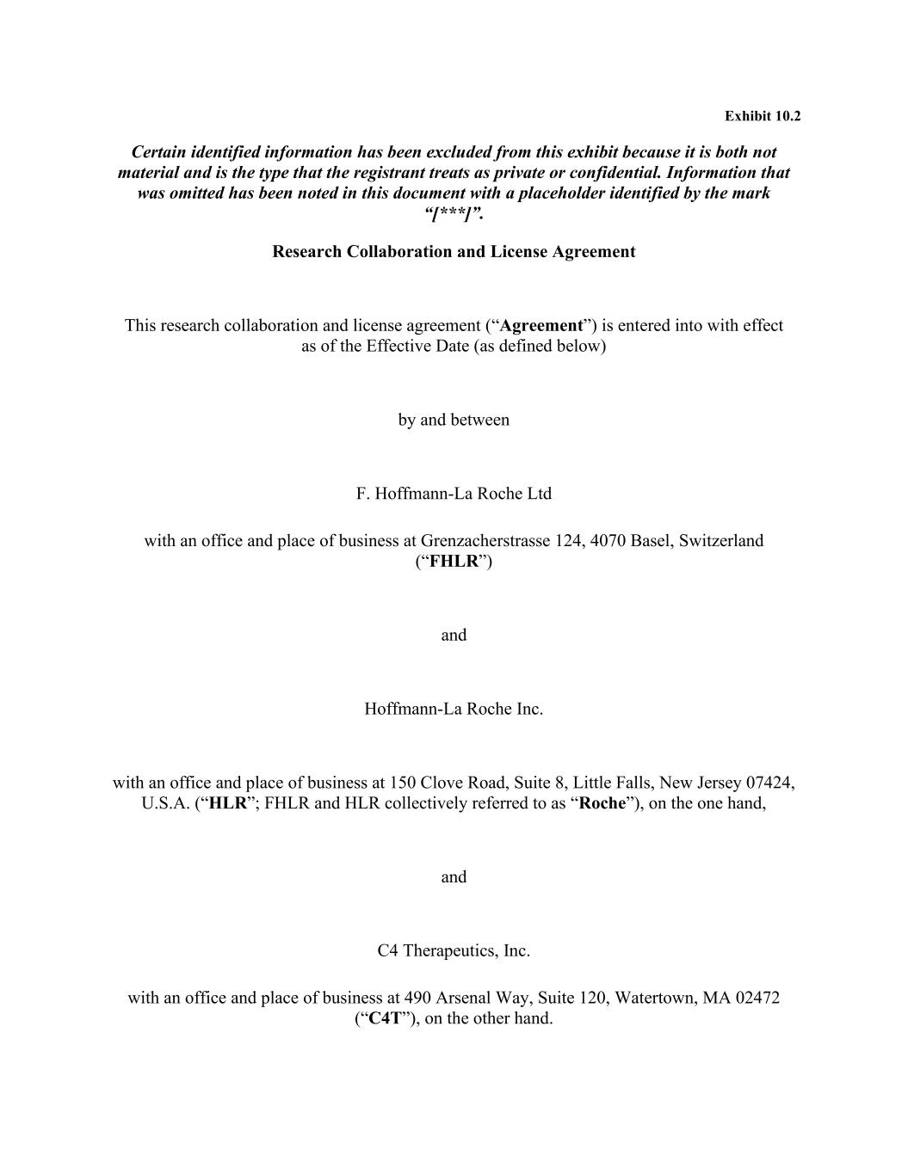
74
Exhibit 10.2 Certain identified information has been excluded from this exhibit because it is both not material and is the type that the registrant treats as private or confidential. Information that was omitted has been noted in this document with a placeholder identified by the mark “[***]”. Research Collaboration and License Agreement This research collaboration and license agreement (“Agreement”) is entered into with effect as of the Effective Date (as defined below) by and between F. Hoffmann-La Roche Ltd with an office and place of business at Grenzacherstrasse 124, 4070 Basel, Switzerland (“FHLR”) and Hoffmann-La Roche Inc. with an office and place of business at 150 Clove Road, Suite 8, Little Falls, New Jersey 07424, U.S.A. (“HLR”; FHLR and HLR collectively referred to as “Roche”), on the one hand, and C4 Therapeutics, Inc. with an office and place of business at 490 Arsenal Way, Suite 120, Watertown, MA 02472 (“C4T”), on the other hand.



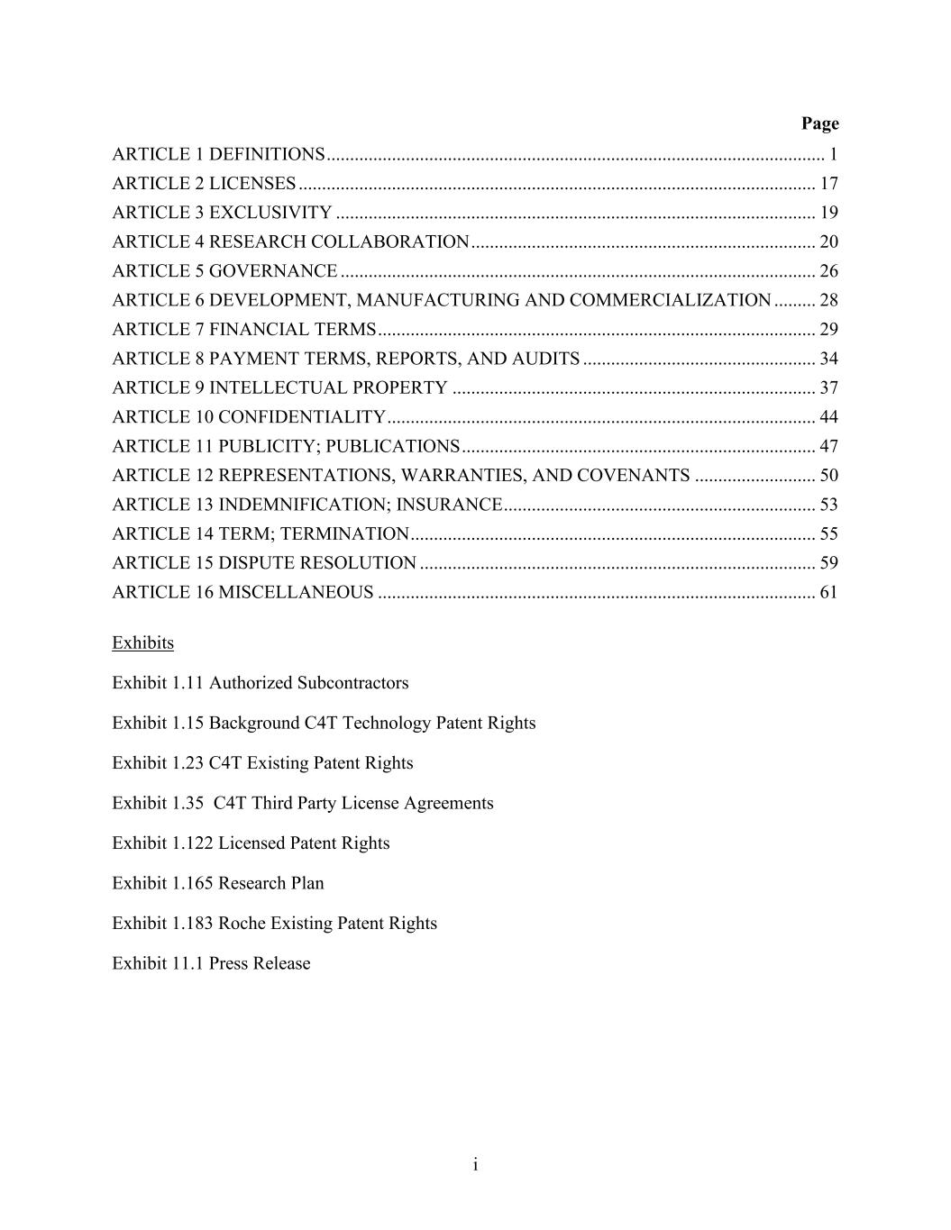
i Page ARTICLE 1 DEFINITIONS ........................................................................................................... 1 ARTICLE 2 LICENSES ............................................................................................................... 17 ARTICLE 3 EXCLUSIVITY ....................................................................................................... 19 ARTICLE 4 RESEARCH COLLABORATION .......................................................................... 20 ARTICLE 5 GOVERNANCE ...................................................................................................... 26 ARTICLE 6 DEVELOPMENT, MANUFACTURING AND COMMERCIALIZATION ......... 28 ARTICLE 7 FINANCIAL TERMS .............................................................................................. 29 ARTICLE 8 PAYMENT TERMS, REPORTS, AND AUDITS .................................................. 34 ARTICLE 9 INTELLECTUAL PROPERTY .............................................................................. 37 ARTICLE 10 CONFIDENTIALITY ............................................................................................ 44 ARTICLE 11 PUBLICITY; PUBLICATIONS ............................................................................ 47 ARTICLE 12 REPRESENTATIONS, WARRANTIES, AND COVENANTS .......................... 50 ARTICLE 13 INDEMNIFICATION; INSURANCE ................................................................... 53 ARTICLE 14 TERM; TERMINATION ....................................................................................... 55 ARTICLE 15 DISPUTE RESOLUTION ..................................................................................... 59 ARTICLE 16 MISCELLANEOUS .............................................................................................. 61 Exhibits Exhibit 1.11 Authorized Subcontractors Exhibit 1.15 Background C4T Technology Patent Rights Exhibit 1.23 C4T Existing Patent Rights Exhibit 1.35 C4T Third Party License Agreements Exhibit 1.122 Licensed Patent Rights Exhibit 1.165 Research Plan Exhibit 1.183 Roche Existing Patent Rights Exhibit 11.1 Press Release

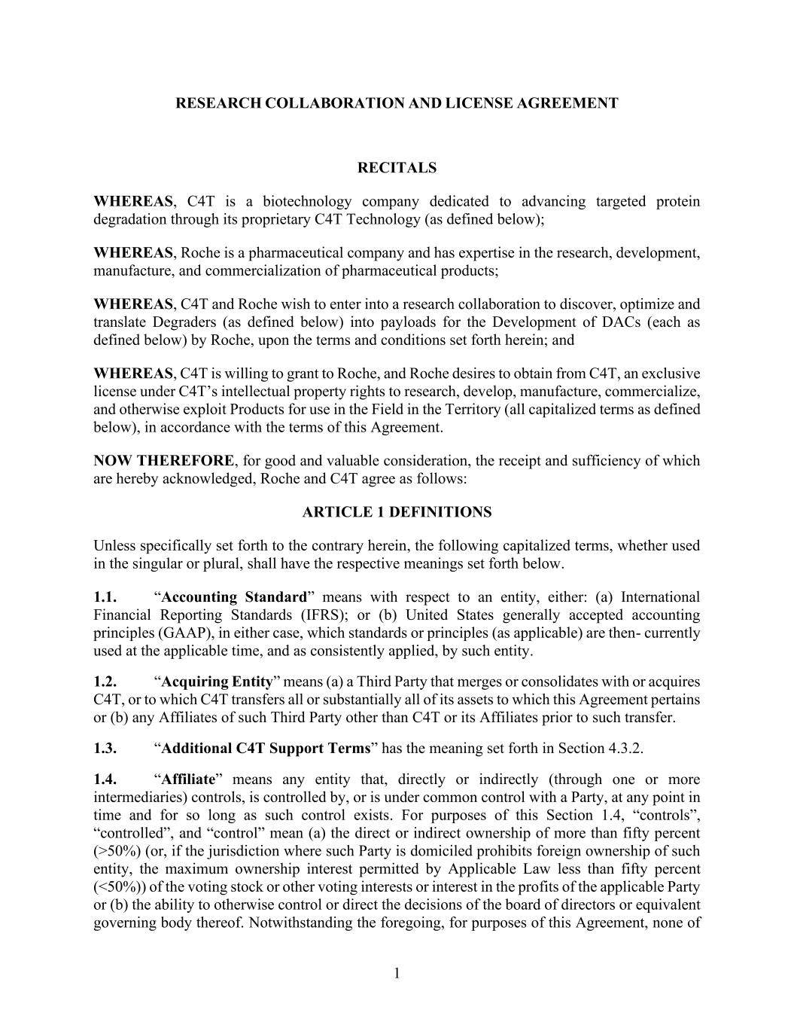
1 RESEARCH COLLABORATION AND LICENSE AGREEMENT RECITALS WHEREAS, C4T is a biotechnology company dedicated to advancing targeted protein degradation through its proprietary C4T Technology (as defined below); WHEREAS, Roche is a pharmaceutical company and has expertise in the research, development, manufacture, and commercialization of pharmaceutical products; WHEREAS, C4T and Roche wish to enter into a research collaboration to discover, optimize and translate Degraders (as defined below) into payloads for the Development of DACs (each as defined below) by Roche, upon the terms and conditions set forth herein; and WHEREAS, C4T is willing to grant to Roche, and Roche desires to obtain from C4T, an exclusive license under C4T’s intellectual property rights to research, develop, manufacture, commercialize, and otherwise exploit Products for use in the Field in the Territory (all capitalized terms as defined below), in accordance with the terms of this Agreement. NOW THEREFORE, for good and valuable consideration, the receipt and sufficiency of which are hereby acknowledged, Roche and C4T agree as follows: ARTICLE 1 DEFINITIONS Unless specifically set forth to the contrary herein, the following capitalized terms, whether used in the singular or plural, shall have the respective meanings set forth below. 1.1. “Accounting Standard” means with respect to an entity, either: (a) International Financial Reporting Standards (IFRS); or (b) United States generally accepted accounting principles (GAAP), in either case, which standards or principles (as applicable) are then- currently used at the applicable time, and as consistently applied, by such entity. 1.2. “Acquiring Entity” means (a) a Third Party that merges or consolidates with or acquires C4T, or to which C4T transfers all or substantially all of its assets to which this Agreement pertains or (b) any Affiliates of such Third Party other than C4T or its Affiliates prior to such transfer. 1.3. “Additional C4T Support Terms” has the meaning set forth in Section 4.3.2. 1.4. “Affiliate” means any entity that, directly or indirectly (through one or more intermediaries) controls, is controlled by, or is under common control with a Party, at any point in time and for so long as such control exists. For purposes of this Section 1.4, “controls”, “controlled”, and “control” mean (a) the direct or indirect ownership of more than fifty percent (>50%) (or, if the jurisdiction where such Party is domiciled prohibits foreign ownership of such entity, the maximum ownership interest permitted by Applicable Law less than fifty percent (<50%)) of the voting stock or other voting interests or interest in the profits of the applicable Party or (b) the ability to otherwise control or direct the decisions of the board of directors or equivalent governing body thereof. Notwithstanding the foregoing, for purposes of this Agreement, none of

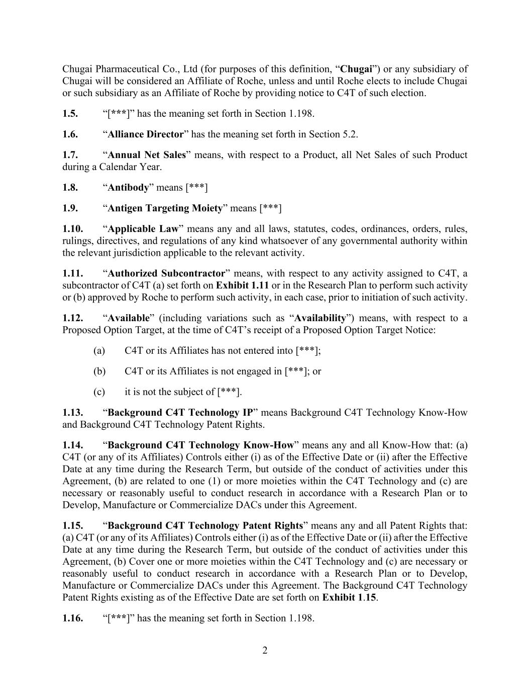
2 Chugai Pharmaceutical Co., Ltd (for purposes of this definition, “Chugai”) or any subsidiary of Chugai will be considered an Affiliate of Roche, unless and until Roche elects to include Chugai or such subsidiary as an Affiliate of Roche by providing notice to C4T of such election. 1.5. “[***]” has the meaning set forth in Section 1.198. 1.6. “Alliance Director” has the meaning set forth in Section 5.2. 1.7. “Annual Net Sales” means, with respect to a Product, all Net Sales of such Product during a Calendar Year. 1.8. “Antibody” means [***] 1.9. “Antigen Targeting Moiety” means [***] 1.10. “Applicable Law” means any and all laws, statutes, codes, ordinances, orders, rules, rulings, directives, and regulations of any kind whatsoever of any governmental authority within the relevant jurisdiction applicable to the relevant activity. 1.11. “Authorized Subcontractor” means, with respect to any activity assigned to C4T, a subcontractor of C4T (a) set forth on Exhibit 1.11 or in the Research Plan to perform such activity or (b) approved by Roche to perform such activity, in each case, prior to initiation of such activity. 1.12. “Available” (including variations such as “Availability”) means, with respect to a Proposed Option Target, at the time of C4T’s receipt of a Proposed Option Target Notice: (a) C4T or its Affiliates has not entered into [***]; (b) C4T or its Affiliates is not engaged in [***]; or (c) it is not the subject of [***]. 1.13. “Background C4T Technology IP” means Background C4T Technology Know-How and Background C4T Technology Patent Rights. 1.14. “Background C4T Technology Know-How” means any and all Know-How that: (a) C4T (or any of its Affiliates) Controls either (i) as of the Effective Date or (ii) after the Effective Date at any time during the Research Term, but outside of the conduct of activities under this Agreement, (b) are related to one (1) or more moieties within the C4T Technology and (c) are necessary or reasonably useful to conduct research in accordance with a Research Plan or to Develop, Manufacture or Commercialize DACs under this Agreement. 1.15. “Background C4T Technology Patent Rights” means any and all Patent Rights that: (a) C4T (or any of its Affiliates) Controls either (i) as of the Effective Date or (ii) after the Effective Date at any time during the Research Term, but outside of the conduct of activities under this Agreement, (b) Cover one or more moieties within the C4T Technology and (c) are necessary or reasonably useful to conduct research in accordance with a Research Plan or to Develop, Manufacture or Commercialize DACs under this Agreement. The Background C4T Technology Patent Rights existing as of the Effective Date are set forth on Exhibit 1.15. 1.16. “[***]” has the meaning set forth in Section 1.198.

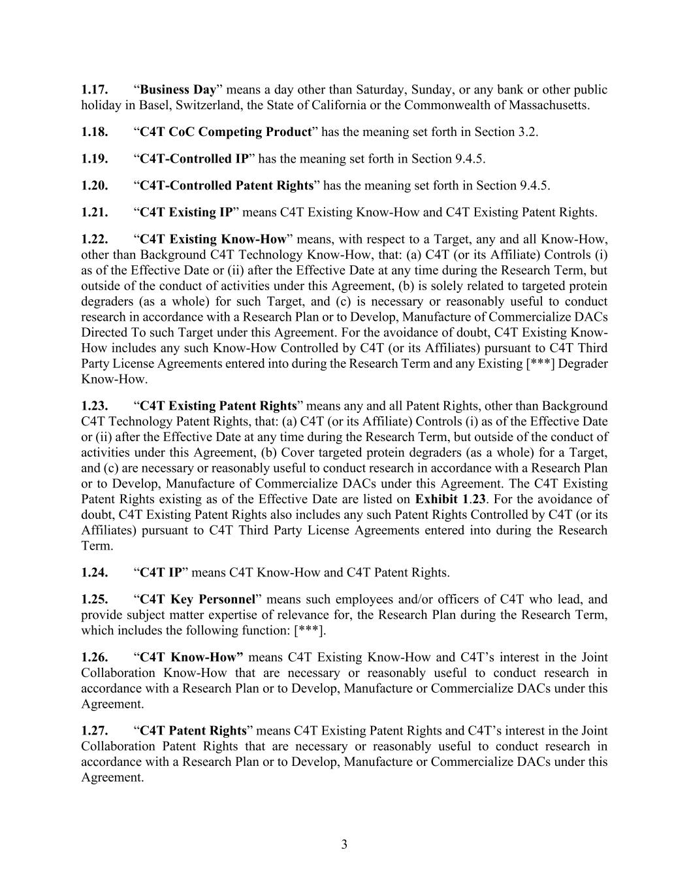
3 1.17. “Business Day” means a day other than Saturday, Sunday, or any bank or other public holiday in Basel, Switzerland, the State of California or the Commonwealth of Massachusetts. 1.18. “C4T CoC Competing Product” has the meaning set forth in Section 3.2. 1.19. “C4T-Controlled IP” has the meaning set forth in Section 9.4.5. 1.20. “C4T-Controlled Patent Rights” has the meaning set forth in Section 9.4.5. 1.21. “C4T Existing IP” means C4T Existing Know-How and C4T Existing Patent Rights. 1.22. “C4T Existing Know-How” means, with respect to a Target, any and all Know-How, other than Background C4T Technology Know-How, that: (a) C4T (or its Affiliate) Controls (i) as of the Effective Date or (ii) after the Effective Date at any time during the Research Term, but outside of the conduct of activities under this Agreement, (b) is solely related to targeted protein degraders (as a whole) for such Target, and (c) is necessary or reasonably useful to conduct research in accordance with a Research Plan or to Develop, Manufacture of Commercialize DACs Directed To such Target under this Agreement. For the avoidance of doubt, C4T Existing Know- How includes any such Know-How Controlled by C4T (or its Affiliates) pursuant to C4T Third Party License Agreements entered into during the Research Term and any Existing [***] Degrader Know-How. 1.23. “C4T Existing Patent Rights” means any and all Patent Rights, other than Background C4T Technology Patent Rights, that: (a) C4T (or its Affiliate) Controls (i) as of the Effective Date or (ii) after the Effective Date at any time during the Research Term, but outside of the conduct of activities under this Agreement, (b) Cover targeted protein degraders (as a whole) for a Target, and (c) are necessary or reasonably useful to conduct research in accordance with a Research Plan or to Develop, Manufacture of Commercialize DACs under this Agreement. The C4T Existing Patent Rights existing as of the Effective Date are listed on Exhibit 1.23. For the avoidance of doubt, C4T Existing Patent Rights also includes any such Patent Rights Controlled by C4T (or its Affiliates) pursuant to C4T Third Party License Agreements entered into during the Research Term. 1.24. “C4T IP” means C4T Know-How and C4T Patent Rights. 1.25. “C4T Key Personnel” means such employees and/or officers of C4T who lead, and provide subject matter expertise of relevance for, the Research Plan during the Research Term, which includes the following function: [***]. 1.26. “C4T Know-How” means C4T Existing Know-How and C4T’s interest in the Joint Collaboration Know-How that are necessary or reasonably useful to conduct research in accordance with a Research Plan or to Develop, Manufacture or Commercialize DACs under this Agreement. 1.27. “C4T Patent Rights” means C4T Existing Patent Rights and C4T’s interest in the Joint Collaboration Patent Rights that are necessary or reasonably useful to conduct research in accordance with a Research Plan or to Develop, Manufacture or Commercialize DACs under this Agreement.

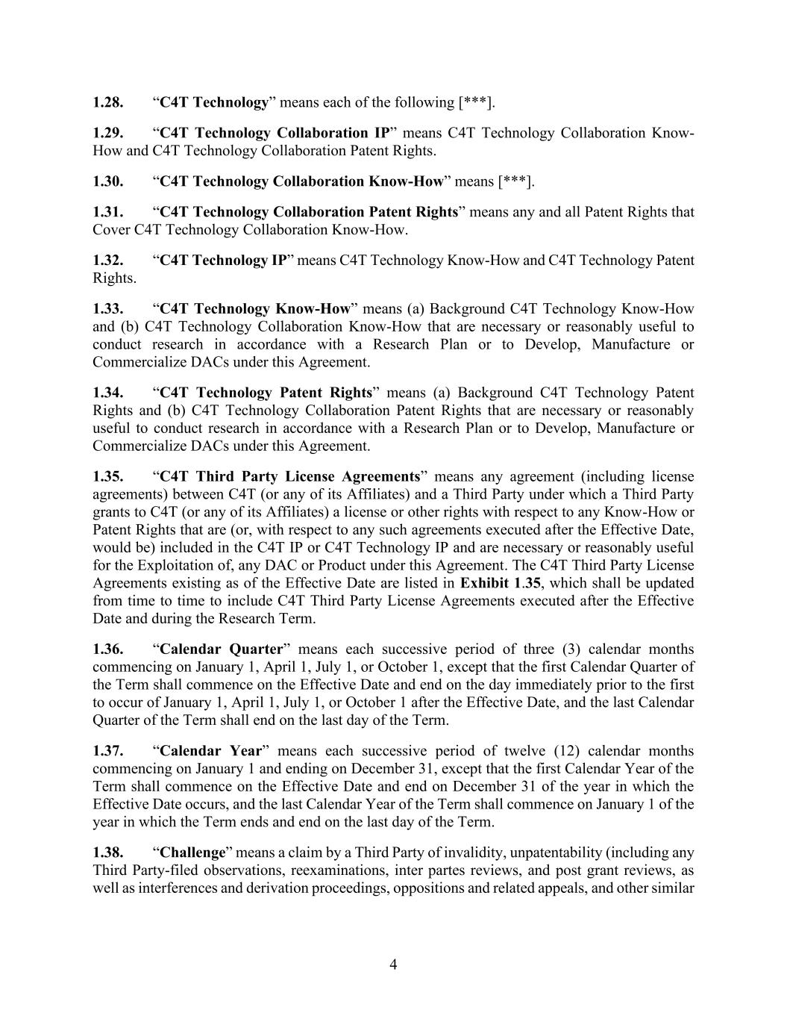
4 1.28. “C4T Technology” means each of the following [***]. 1.29. “C4T Technology Collaboration IP” means C4T Technology Collaboration Know- How and C4T Technology Collaboration Patent Rights. 1.30. “C4T Technology Collaboration Know-How” means [***]. 1.31. “C4T Technology Collaboration Patent Rights” means any and all Patent Rights that Cover C4T Technology Collaboration Know-How. 1.32. “C4T Technology IP” means C4T Technology Know-How and C4T Technology Patent Rights. 1.33. “C4T Technology Know-How” means (a) Background C4T Technology Know-How and (b) C4T Technology Collaboration Know-How that are necessary or reasonably useful to conduct research in accordance with a Research Plan or to Develop, Manufacture or Commercialize DACs under this Agreement. 1.34. “C4T Technology Patent Rights” means (a) Background C4T Technology Patent Rights and (b) C4T Technology Collaboration Patent Rights that are necessary or reasonably useful to conduct research in accordance with a Research Plan or to Develop, Manufacture or Commercialize DACs under this Agreement. 1.35. “C4T Third Party License Agreements” means any agreement (including license agreements) between C4T (or any of its Affiliates) and a Third Party under which a Third Party grants to C4T (or any of its Affiliates) a license or other rights with respect to any Know-How or Patent Rights that are (or, with respect to any such agreements executed after the Effective Date, would be) included in the C4T IP or C4T Technology IP and are necessary or reasonably useful for the Exploitation of, any DAC or Product under this Agreement. The C4T Third Party License Agreements existing as of the Effective Date are listed in Exhibit 1.35, which shall be updated from time to time to include C4T Third Party License Agreements executed after the Effective Date and during the Research Term. 1.36. “Calendar Quarter” means each successive period of three (3) calendar months commencing on January 1, April 1, July 1, or October 1, except that the first Calendar Quarter of the Term shall commence on the Effective Date and end on the day immediately prior to the first to occur of January 1, April 1, July 1, or October 1 after the Effective Date, and the last Calendar Quarter of the Term shall end on the last day of the Term. 1.37. “Calendar Year” means each successive period of twelve (12) calendar months commencing on January 1 and ending on December 31, except that the first Calendar Year of the Term shall commence on the Effective Date and end on December 31 of the year in which the Effective Date occurs, and the last Calendar Year of the Term shall commence on January 1 of the year in which the Term ends and end on the last day of the Term. 1.38. “Challenge” means a claim by a Third Party of invalidity, unpatentability (including any Third Party-filed observations, reexaminations, inter partes reviews, and post grant reviews, as well as interferences and derivation proceedings, oppositions and related appeals, and other similar

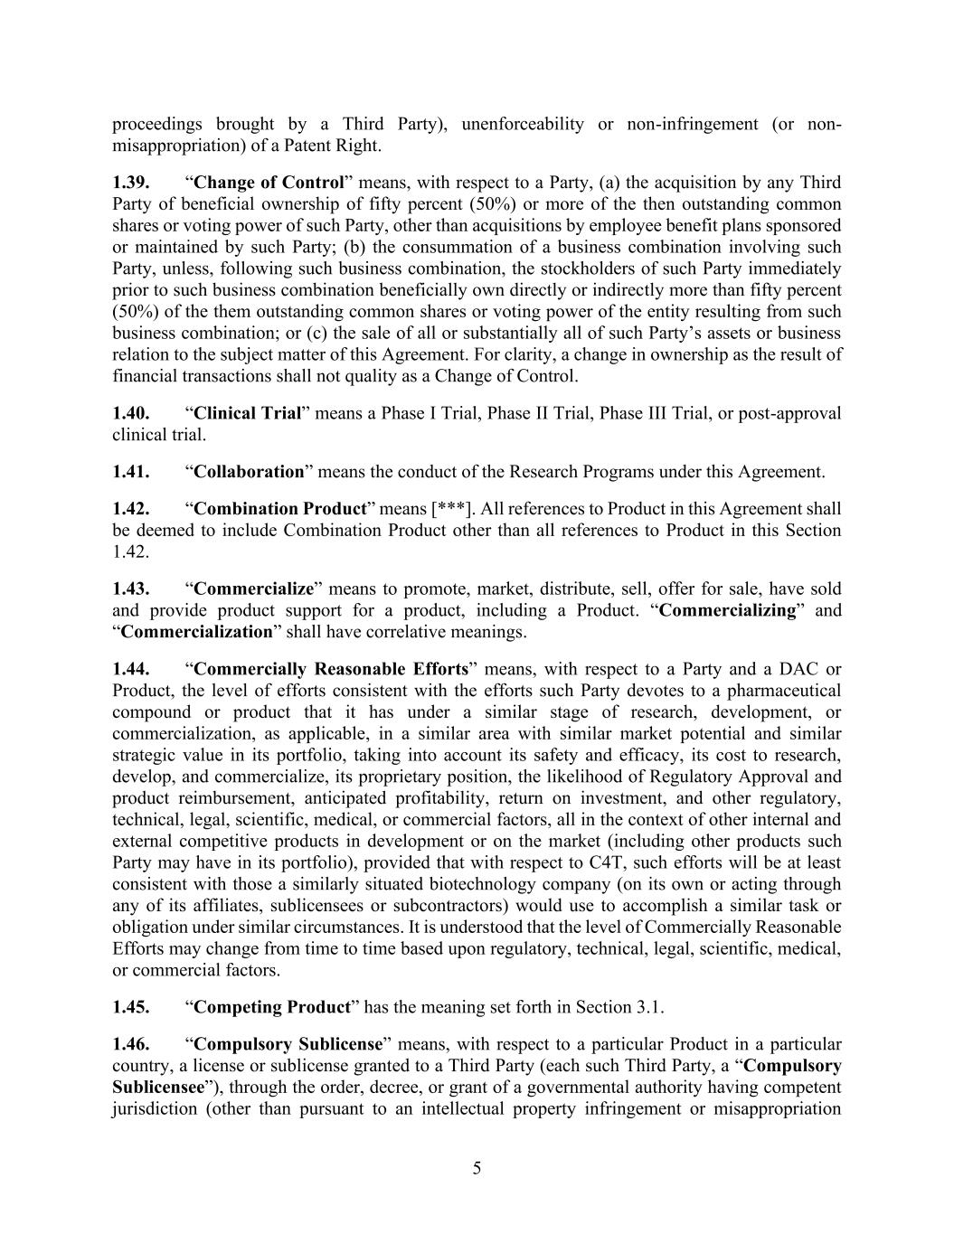
5 proceedings brought by a Third Party), unenforceability or non-infringement (or non- misappropriation) of a Patent Right. 1.39. “Change of Control” means, with respect to a Party, (a) the acquisition by any Third Party of beneficial ownership of fifty percent (50%) or more of the then outstanding common shares or voting power of such Party, other than acquisitions by employee benefit plans sponsored or maintained by such Party; (b) the consummation of a business combination involving such Party, unless, following such business combination, the stockholders of such Party immediately prior to such business combination beneficially own directly or indirectly more than fifty percent (50%) of the them outstanding common shares or voting power of the entity resulting from such business combination; or (c) the sale of all or substantially all of such Party’s assets or business relation to the subject matter of this Agreement. For clarity, a change in ownership as the result of financial transactions shall not quality as a Change of Control. 1.40. “Clinical Trial” means a Phase I Trial, Phase II Trial, Phase III Trial, or post-approval clinical trial. 1.41. “Collaboration” means the conduct of the Research Programs under this Agreement. 1.42. “Combination Product” means [***]. All references to Product in this Agreement shall be deemed to include Combination Product other than all references to Product in this Section 1.42. 1.43. “Commercialize” means to promote, market, distribute, sell, offer for sale, have sold and provide product support for a product, including a Product. “Commercializing” and “Commercialization” shall have correlative meanings. 1.44. “Commercially Reasonable Efforts” means, with respect to a Party and a DAC or Product, the level of efforts consistent with the efforts such Party devotes to a pharmaceutical compound or product that it has under a similar stage of research, development, or commercialization, as applicable, in a similar area with similar market potential and similar strategic value in its portfolio, taking into account its safety and efficacy, its cost to research, develop, and commercialize, its proprietary position, the likelihood of Regulatory Approval and product reimbursement, anticipated profitability, return on investment, and other regulatory, technical, legal, scientific, medical, or commercial factors, all in the context of other internal and external competitive products in development or on the market (including other products such Party may have in its portfolio), provided that with respect to C4T, such efforts will be at least consistent with those a similarly situated biotechnology company (on its own or acting through any of its affiliates, sublicensees or subcontractors) would use to accomplish a similar task or obligation under similar circumstances. It is understood that the level of Commercially Reasonable Efforts may change from time to time based upon regulatory, technical, legal, scientific, medical, or commercial factors. 1.45. “Competing Product” has the meaning set forth in Section 3.1. 1.46. “Compulsory Sublicense” means, with respect to a particular Product in a particular country, a license or sublicense granted to a Third Party (each such Third Party, a “Compulsory Sublicensee”), through the order, decree, or grant of a governmental authority having competent jurisdiction (other than pursuant to an intellectual property infringement or misappropriation

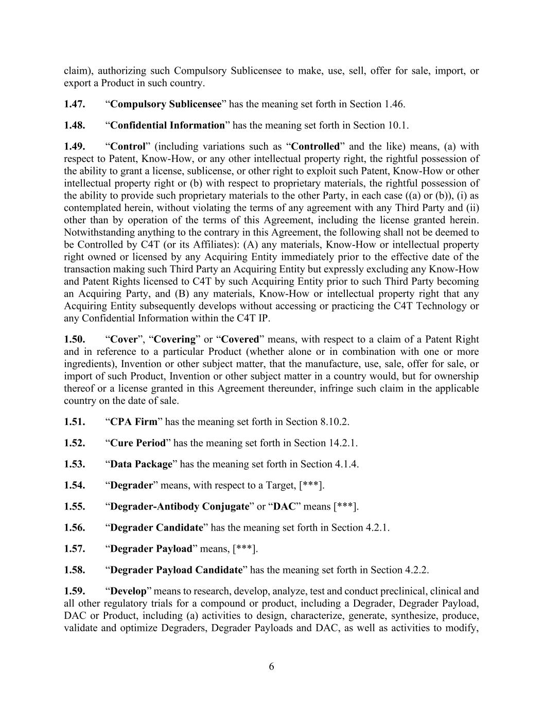
6 claim), authorizing such Compulsory Sublicensee to make, use, sell, offer for sale, import, or export a Product in such country. 1.47. “Compulsory Sublicensee” has the meaning set forth in Section 1.46. 1.48. “Confidential Information” has the meaning set forth in Section 10.1. 1.49. “Control” (including variations such as “Controlled” and the like) means, (a) with respect to Patent, Know-How, or any other intellectual property right, the rightful possession of the ability to grant a license, sublicense, or other right to exploit such Patent, Know-How or other intellectual property right or (b) with respect to proprietary materials, the rightful possession of the ability to provide such proprietary materials to the other Party, in each case ((a) or (b)), (i) as contemplated herein, without violating the terms of any agreement with any Third Party and (ii) other than by operation of the terms of this Agreement, including the license granted herein. Notwithstanding anything to the contrary in this Agreement, the following shall not be deemed to be Controlled by C4T (or its Affiliates): (A) any materials, Know-How or intellectual property right owned or licensed by any Acquiring Entity immediately prior to the effective date of the transaction making such Third Party an Acquiring Entity but expressly excluding any Know-How and Patent Rights licensed to C4T by such Acquiring Entity prior to such Third Party becoming an Acquiring Party, and (B) any materials, Know-How or intellectual property right that any Acquiring Entity subsequently develops without accessing or practicing the C4T Technology or any Confidential Information within the C4T IP. 1.50. “Cover”, “Covering” or “Covered” means, with respect to a claim of a Patent Right and in reference to a particular Product (whether alone or in combination with one or more ingredients), Invention or other subject matter, that the manufacture, use, sale, offer for sale, or import of such Product, Invention or other subject matter in a country would, but for ownership thereof or a license granted in this Agreement thereunder, infringe such claim in the applicable country on the date of sale. 1.51. “CPA Firm” has the meaning set forth in Section 8.10.2. 1.52. “Cure Period” has the meaning set forth in Section 14.2.1. 1.53. “Data Package” has the meaning set forth in Section 4.1.4. 1.54. “Degrader” means, with respect to a Target, [***]. 1.55. “Degrader-Antibody Conjugate” or “DAC” means [***]. 1.56. “Degrader Candidate” has the meaning set forth in Section 4.2.1. 1.57. “Degrader Payload” means, [***]. 1.58. “Degrader Payload Candidate” has the meaning set forth in Section 4.2.2. 1.59. “Develop” means to research, develop, analyze, test and conduct preclinical, clinical and all other regulatory trials for a compound or product, including a Degrader, Degrader Payload, DAC or Product, including (a) activities to design, characterize, generate, synthesize, produce, validate and optimize Degraders, Degrader Payloads and DAC, as well as activities to modify,

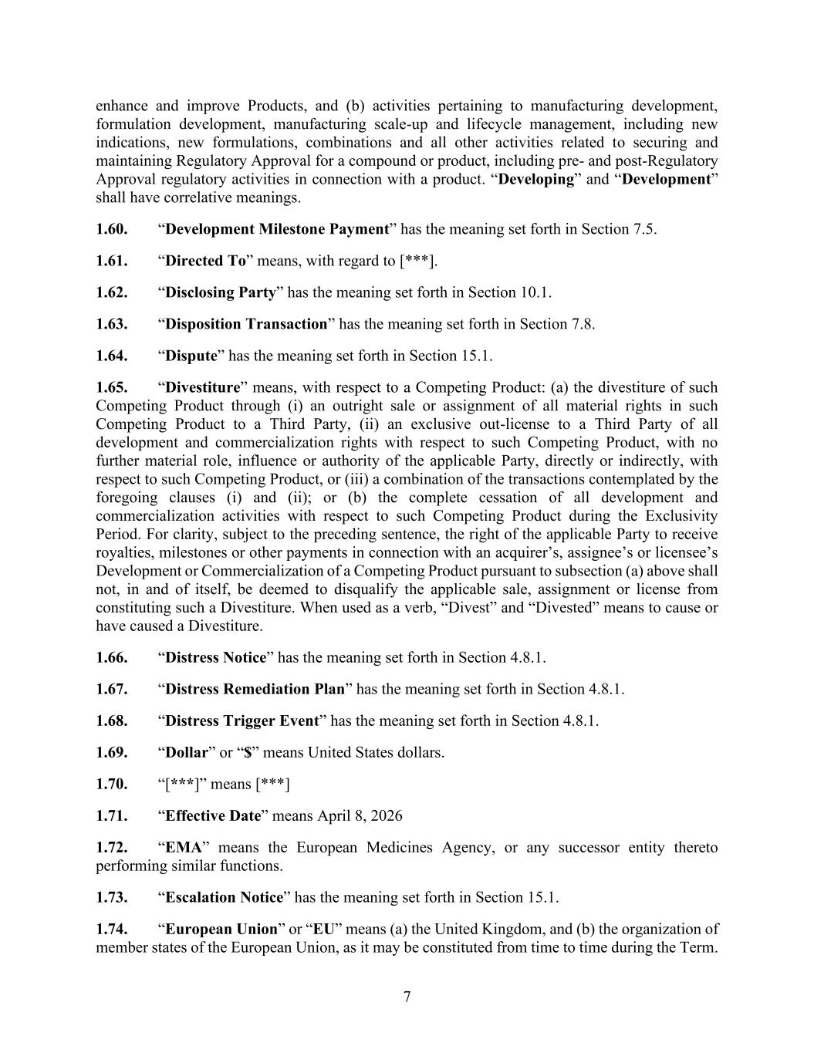
7 enhance and improve Products, and (b) activities pertaining to manufacturing development, formulation development, manufacturing scale-up and lifecycle management, including new indications, new formulations, combinations and all other activities related to securing and maintaining Regulatory Approval for a compound or product, including pre- and post-Regulatory Approval regulatory activities in connection with a product. “Developing” and “Development” shall have correlative meanings. 1.60. “Development Milestone Payment” has the meaning set forth in Section 7.5. 1.61. “Directed To” means, with regard to [***]. 1.62. “Disclosing Party” has the meaning set forth in Section 10.1. 1.63. “Disposition Transaction” has the meaning set forth in Section 7.8. 1.64. “Dispute” has the meaning set forth in Section 15.1. 1.65. “Divestiture” means, with respect to a Competing Product: (a) the divestiture of such Competing Product through (i) an outright sale or assignment of all material rights in such Competing Product to a Third Party, (ii) an exclusive out-license to a Third Party of all development and commercialization rights with respect to such Competing Product, with no further material role, influence or authority of the applicable Party, directly or indirectly, with respect to such Competing Product, or (iii) a combination of the transactions contemplated by the foregoing clauses (i) and (ii); or (b) the complete cessation of all development and commercialization activities with respect to such Competing Product during the Exclusivity Period. For clarity, subject to the preceding sentence, the right of the applicable Party to receive royalties, milestones or other payments in connection with an acquirer’s, assignee’s or licensee’s Development or Commercialization of a Competing Product pursuant to subsection (a) above shall not, in and of itself, be deemed to disqualify the applicable sale, assignment or license from constituting such a Divestiture. When used as a verb, “Divest” and “Divested” means to cause or have caused a Divestiture. 1.66. “Distress Notice” has the meaning set forth in Section 4.8.1. 1.67. “Distress Remediation Plan” has the meaning set forth in Section 4.8.1. 1.68. “Distress Trigger Event” has the meaning set forth in Section 4.8.1. 1.69. “Dollar” or “$” means United States dollars. 1.70. “[***]” means [***] 1.71. “Effective Date” means April 8, 2026 1.72. “EMA” means the European Medicines Agency, or any successor entity thereto performing similar functions. 1.73. “Escalation Notice” has the meaning set forth in Section 15.1. 1.74. “European Union” or “EU” means (a) the United Kingdom, and (b) the organization of member states of the European Union, as it may be constituted from time to time during the Term.

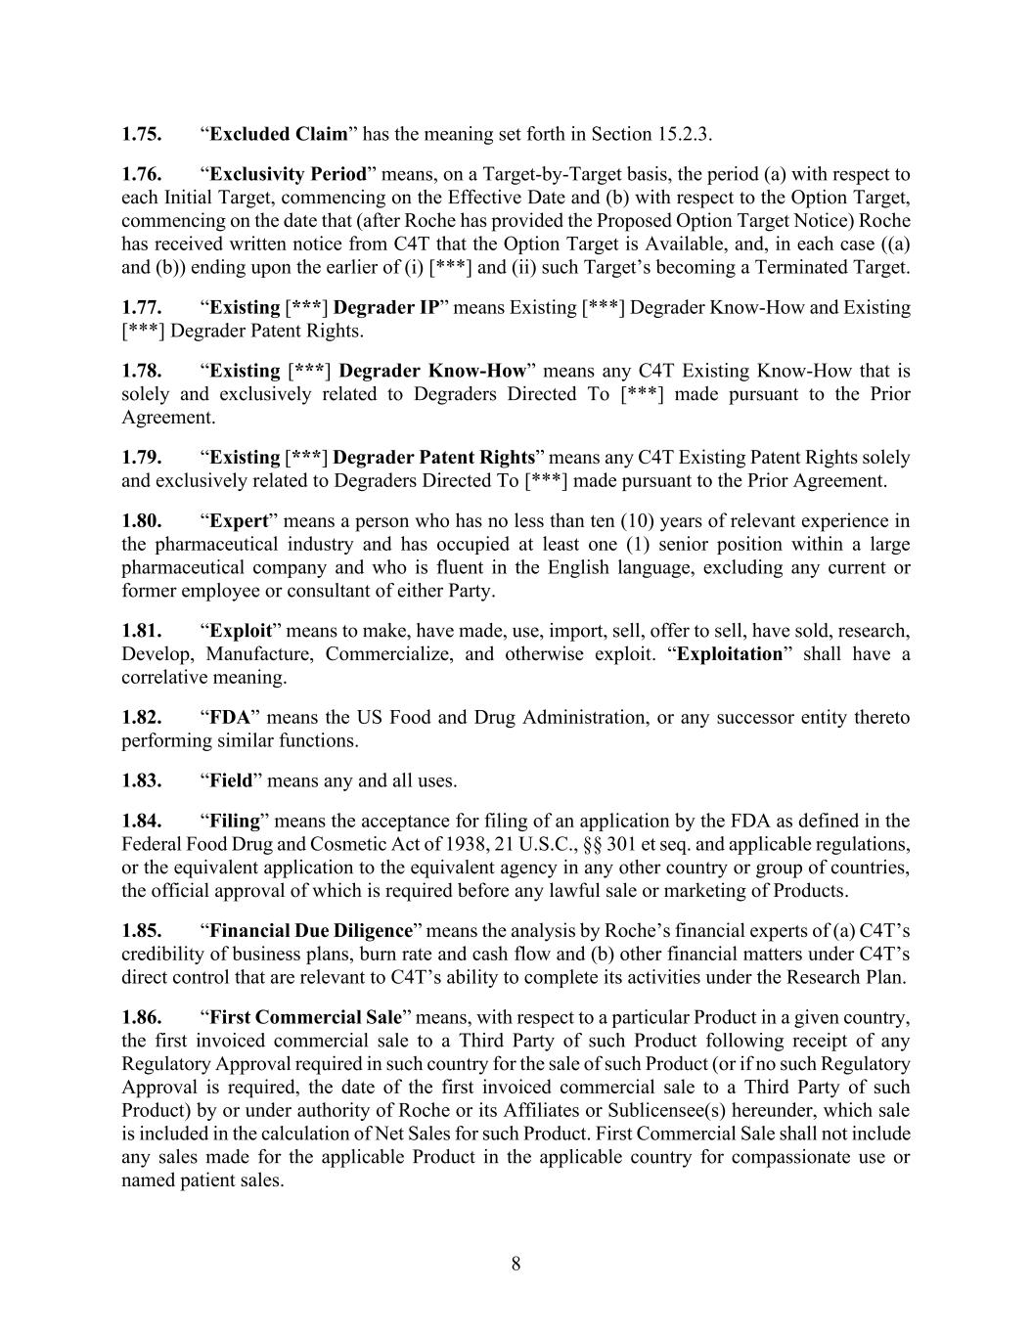
8 1.75. “Excluded Claim” has the meaning set forth in Section 15.2.3. 1.76. “Exclusivity Period” means, on a Target-by-Target basis, the period (a) with respect to each Initial Target, commencing on the Effective Date and (b) with respect to the Option Target, commencing on the date that (after Roche has provided the Proposed Option Target Notice) Roche has received written notice from C4T that the Option Target is Available, and, in each case ((a) and (b)) ending upon the earlier of (i) [***] and (ii) such Target’s becoming a Terminated Target. 1.77. “Existing [***] Degrader IP” means Existing [***] Degrader Know-How and Existing [***] Degrader Patent Rights. 1.78. “Existing [***] Degrader Know-How” means any C4T Existing Know-How that is solely and exclusively related to Degraders Directed To [***] made pursuant to the Prior Agreement. 1.79. “Existing [***] Degrader Patent Rights” means any C4T Existing Patent Rights solely and exclusively related to Degraders Directed To [***] made pursuant to the Prior Agreement. 1.80. “Expert” means a person who has no less than ten (10) years of relevant experience in the pharmaceutical industry and has occupied at least one (1) senior position within a large pharmaceutical company and who is fluent in the English language, excluding any current or former employee or consultant of either Party. 1.81. “Exploit” means to make, have made, use, import, sell, offer to sell, have sold, research, Develop, Manufacture, Commercialize, and otherwise exploit. “Exploitation” shall have a correlative meaning. 1.82. “FDA” means the US Food and Drug Administration, or any successor entity thereto performing similar functions. 1.83. “Field” means any and all uses. 1.84. “Filing” means the acceptance for filing of an application by the FDA as defined in the Federal Food Drug and Cosmetic Act of 1938, 21 U.S.C., §§ 301 et seq. and applicable regulations, or the equivalent application to the equivalent agency in any other country or group of countries, the official approval of which is required before any lawful sale or marketing of Products. 1.85. “Financial Due Diligence” means the analysis by Roche’s financial experts of (a) C4T’s credibility of business plans, burn rate and cash flow and (b) other financial matters under C4T’s direct control that are relevant to C4T’s ability to complete its activities under the Research Plan. 1.86. “First Commercial Sale” means, with respect to a particular Product in a given country, the first invoiced commercial sale to a Third Party of such Product following receipt of any Regulatory Approval required in such country for the sale of such Product (or if no such Regulatory Approval is required, the date of the first invoiced commercial sale to a Third Party of such Product) by or under authority of Roche or its Affiliates or Sublicensee(s) hereunder, which sale is included in the calculation of Net Sales for such Product. First Commercial Sale shall not include any sales made for the applicable Product in the applicable country for compassionate use or named patient sales.

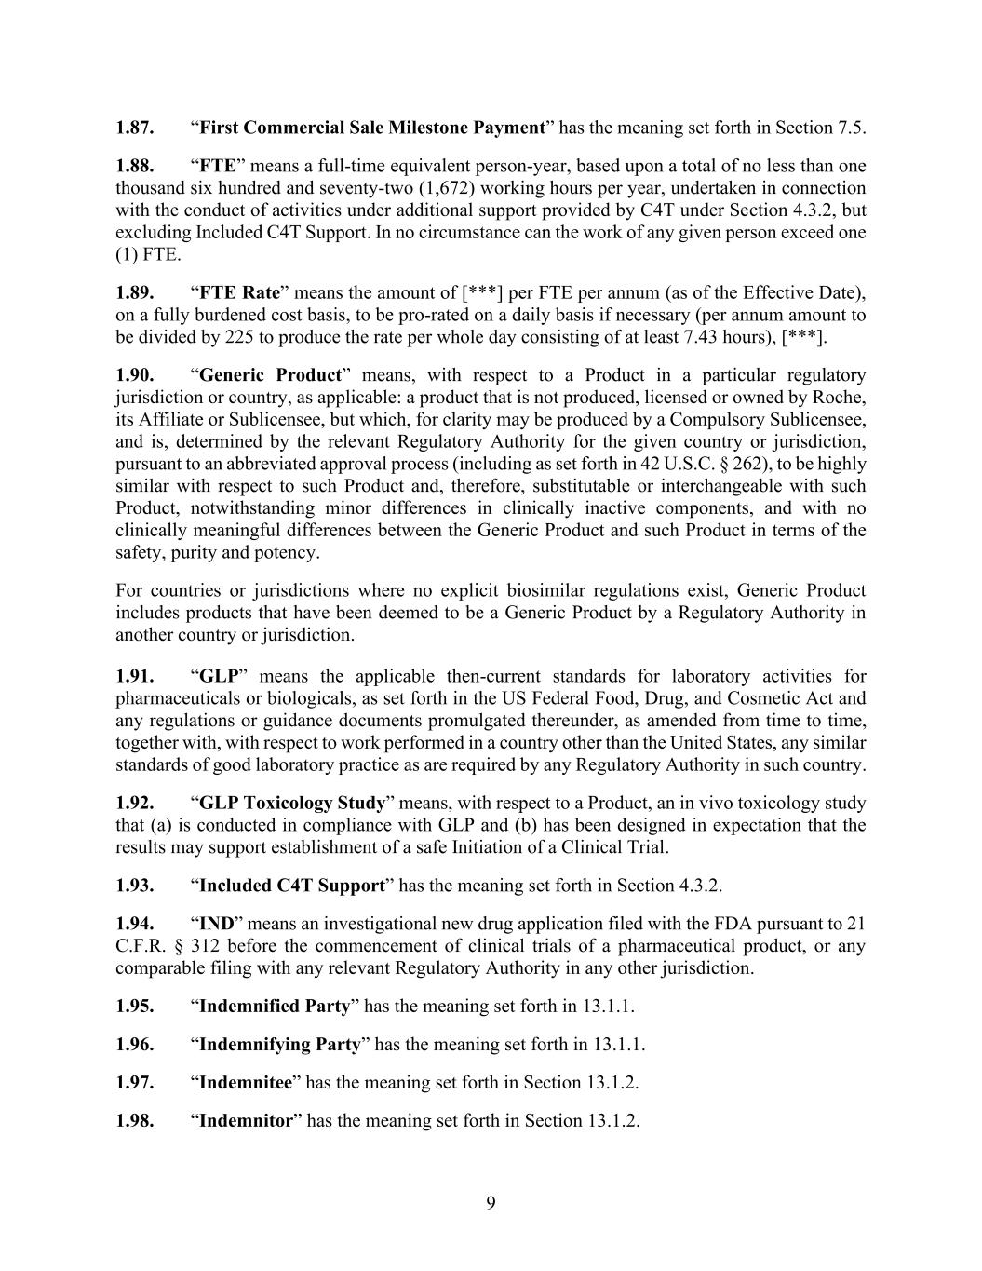
9 1.87. “First Commercial Sale Milestone Payment” has the meaning set forth in Section 7.5. 1.88. “FTE” means a full-time equivalent person-year, based upon a total of no less than one thousand six hundred and seventy-two (1,672) working hours per year, undertaken in connection with the conduct of activities under additional support provided by C4T under Section 4.3.2, but excluding Included C4T Support. In no circumstance can the work of any given person exceed one (1) FTE. 1.89. “FTE Rate” means the amount of [***] per FTE per annum (as of the Effective Date), on a fully burdened cost basis, to be pro-rated on a daily basis if necessary (per annum amount to be divided by 225 to produce the rate per whole day consisting of at least 7.43 hours), [***]. 1.90. “Generic Product” means, with respect to a Product in a particular regulatory jurisdiction or country, as applicable: a product that is not produced, licensed or owned by Roche, its Affiliate or Sublicensee, but which, for clarity may be produced by a Compulsory Sublicensee, and is, determined by the relevant Regulatory Authority for the given country or jurisdiction, pursuant to an abbreviated approval process (including as set forth in 42 U.S.C. § 262), to be highly similar with respect to such Product and, therefore, substitutable or interchangeable with such Product, notwithstanding minor differences in clinically inactive components, and with no clinically meaningful differences between the Generic Product and such Product in terms of the safety, purity and potency. For countries or jurisdictions where no explicit biosimilar regulations exist, Generic Product includes products that have been deemed to be a Generic Product by a Regulatory Authority in another country or jurisdiction. 1.91. “GLP” means the applicable then-current standards for laboratory activities for pharmaceuticals or biologicals, as set forth in the US Federal Food, Drug, and Cosmetic Act and any regulations or guidance documents promulgated thereunder, as amended from time to time, together with, with respect to work performed in a country other than the United States, any similar standards of good laboratory practice as are required by any Regulatory Authority in such country. 1.92. “GLP Toxicology Study” means, with respect to a Product, an in vivo toxicology study that (a) is conducted in compliance with GLP and (b) has been designed in expectation that the results may support establishment of a safe Initiation of a Clinical Trial. 1.93. “Included C4T Support” has the meaning set forth in Section 4.3.2. 1.94. “IND” means an investigational new drug application filed with the FDA pursuant to 21 C.F.R. § 312 before the commencement of clinical trials of a pharmaceutical product, or any comparable filing with any relevant Regulatory Authority in any other jurisdiction. 1.95. “Indemnified Party” has the meaning set forth in 13.1.1. 1.96. “Indemnifying Party” has the meaning set forth in 13.1.1. 1.97. “Indemnitee” has the meaning set forth in Section 13.1.2. 1.98. “Indemnitor” has the meaning set forth in Section 13.1.2.

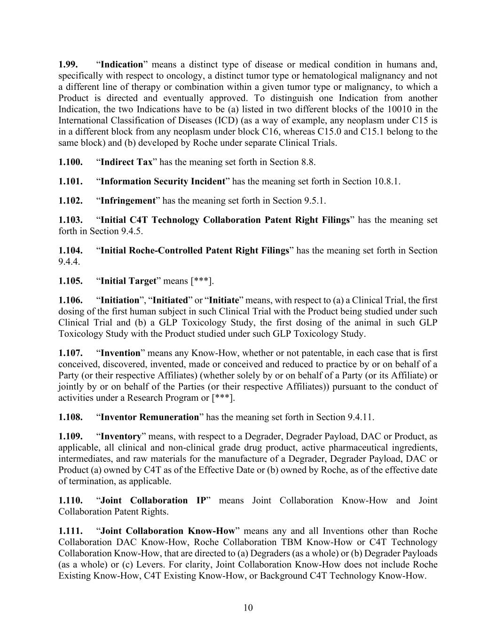
10 1.99. “Indication” means a distinct type of disease or medical condition in humans and, specifically with respect to oncology, a distinct tumor type or hematological malignancy and not a different line of therapy or combination within a given tumor type or malignancy, to which a Product is directed and eventually approved. To distinguish one Indication from another Indication, the two Indications have to be (a) listed in two different blocks of the 10010 in the International Classification of Diseases (ICD) (as a way of example, any neoplasm under C15 is in a different block from any neoplasm under block C16, whereas C15.0 and C15.1 belong to the same block) and (b) developed by Roche under separate Clinical Trials. 1.100. “Indirect Tax” has the meaning set forth in Section 8.8. 1.101. “Information Security Incident” has the meaning set forth in Section 10.8.1. 1.102. “Infringement” has the meaning set forth in Section 9.5.1. 1.103. “Initial C4T Technology Collaboration Patent Right Filings” has the meaning set forth in Section 9.4.5. 1.104. “Initial Roche-Controlled Patent Right Filings” has the meaning set forth in Section 9.4.4. 1.105. “Initial Target” means [***]. 1.106. “Initiation”, “Initiated” or “Initiate” means, with respect to (a) a Clinical Trial, the first dosing of the first human subject in such Clinical Trial with the Product being studied under such Clinical Trial and (b) a GLP Toxicology Study, the first dosing of the animal in such GLP Toxicology Study with the Product studied under such GLP Toxicology Study. 1.107. “Invention” means any Know-How, whether or not patentable, in each case that is first conceived, discovered, invented, made or conceived and reduced to practice by or on behalf of a Party (or their respective Affiliates) (whether solely by or on behalf of a Party (or its Affiliate) or jointly by or on behalf of the Parties (or their respective Affiliates)) pursuant to the conduct of activities under a Research Program or [***]. 1.108. “Inventor Remuneration” has the meaning set forth in Section 9.4.11. 1.109. “Inventory” means, with respect to a Degrader, Degrader Payload, DAC or Product, as applicable, all clinical and non-clinical grade drug product, active pharmaceutical ingredients, intermediates, and raw materials for the manufacture of a Degrader, Degrader Payload, DAC or Product (a) owned by C4T as of the Effective Date or (b) owned by Roche, as of the effective date of termination, as applicable. 1.110. “Joint Collaboration IP” means Joint Collaboration Know-How and Joint Collaboration Patent Rights. 1.111. “Joint Collaboration Know-How” means any and all Inventions other than Roche Collaboration DAC Know-How, Roche Collaboration TBM Know-How or C4T Technology Collaboration Know-How, that are directed to (a) Degraders (as a whole) or (b) Degrader Payloads (as a whole) or (c) Levers. For clarity, Joint Collaboration Know-How does not include Roche Existing Know-How, C4T Existing Know-How, or Background C4T Technology Know-How.

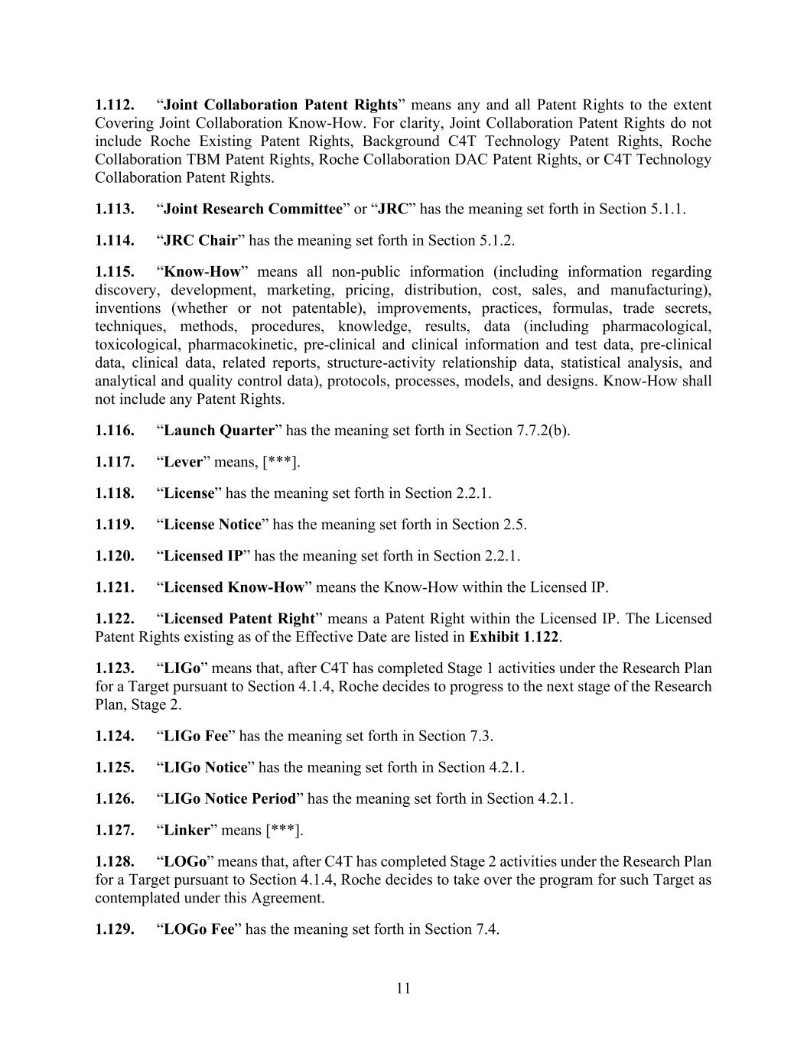
11 1.112. “Joint Collaboration Patent Rights” means any and all Patent Rights to the extent Covering Joint Collaboration Know-How. For clarity, Joint Collaboration Patent Rights do not include Roche Existing Patent Rights, Background C4T Technology Patent Rights, Roche Collaboration TBM Patent Rights, Roche Collaboration DAC Patent Rights, or C4T Technology Collaboration Patent Rights. 1.113. “Joint Research Committee” or “JRC” has the meaning set forth in Section 5.1.1. 1.114. “JRC Chair” has the meaning set forth in Section 5.1.2. 1.115. “Know-How” means all non-public information (including information regarding discovery, development, marketing, pricing, distribution, cost, sales, and manufacturing), inventions (whether or not patentable), improvements, practices, formulas, trade secrets, techniques, methods, procedures, knowledge, results, data (including pharmacological, toxicological, pharmacokinetic, pre-clinical and clinical information and test data, pre-clinical data, clinical data, related reports, structure-activity relationship data, statistical analysis, and analytical and quality control data), protocols, processes, models, and designs. Know-How shall not include any Patent Rights. 1.116. “Launch Quarter” has the meaning set forth in Section 7.7.2(b). 1.117. “Lever” means, [***]. 1.118. “License” has the meaning set forth in Section 2.2.1. 1.119. “License Notice” has the meaning set forth in Section 2.5. 1.120. “Licensed IP” has the meaning set forth in Section 2.2.1. 1.121. “Licensed Know-How” means the Know-How within the Licensed IP. 1.122. “Licensed Patent Right” means a Patent Right within the Licensed IP. The Licensed Patent Rights existing as of the Effective Date are listed in Exhibit 1.122. 1.123. “LIGo” means that, after C4T has completed Stage 1 activities under the Research Plan for a Target pursuant to Section 4.1.4, Roche decides to progress to the next stage of the Research Plan, Stage 2. 1.124. “LIGo Fee” has the meaning set forth in Section 7.3. 1.125. “LIGo Notice” has the meaning set forth in Section 4.2.1. 1.126. “LIGo Notice Period” has the meaning set forth in Section 4.2.1. 1.127. “Linker” means [***]. 1.128. “LOGo” means that, after C4T has completed Stage 2 activities under the Research Plan for a Target pursuant to Section 4.1.4, Roche decides to take over the program for such Target as contemplated under this Agreement. 1.129. “LOGo Fee” has the meaning set forth in Section 7.4.

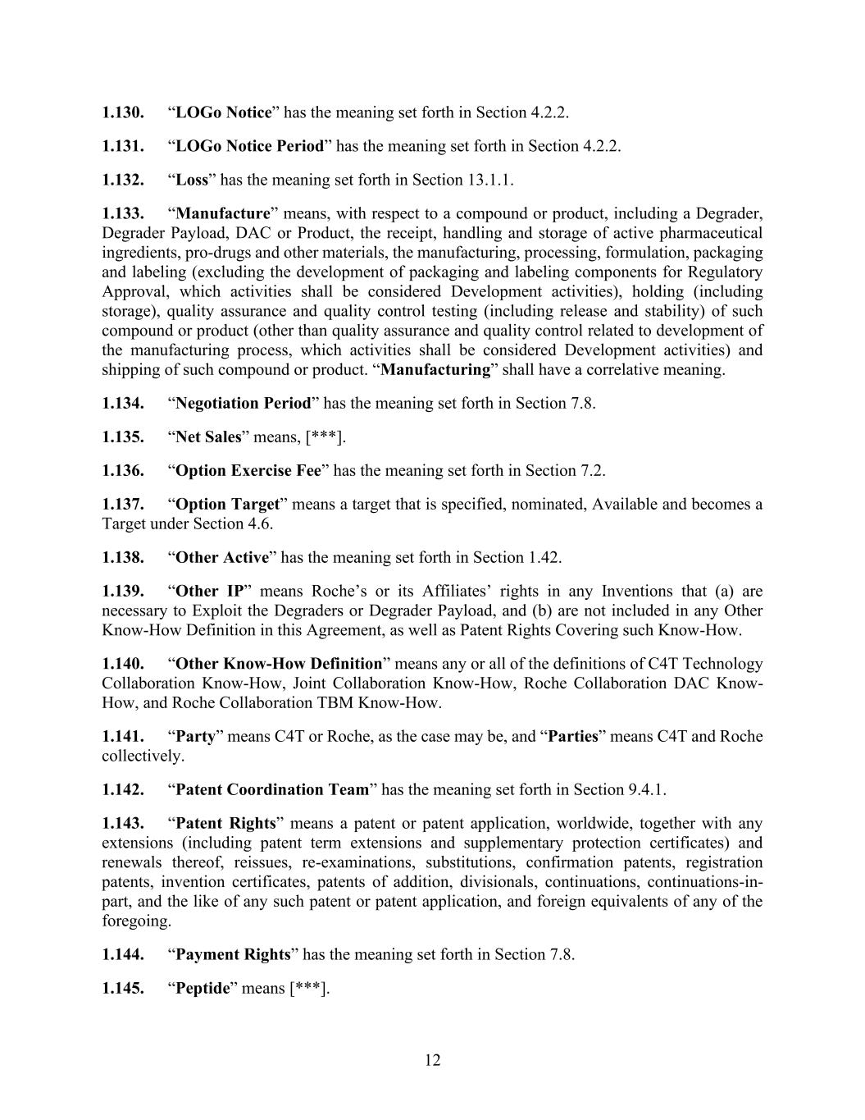
12 1.130. “LOGo Notice” has the meaning set forth in Section 4.2.2. 1.131. “LOGo Notice Period” has the meaning set forth in Section 4.2.2. 1.132. “Loss” has the meaning set forth in Section 13.1.1. 1.133. “Manufacture” means, with respect to a compound or product, including a Degrader, Degrader Payload, DAC or Product, the receipt, handling and storage of active pharmaceutical ingredients, pro-drugs and other materials, the manufacturing, processing, formulation, packaging and labeling (excluding the development of packaging and labeling components for Regulatory Approval, which activities shall be considered Development activities), holding (including storage), quality assurance and quality control testing (including release and stability) of such compound or product (other than quality assurance and quality control related to development of the manufacturing process, which activities shall be considered Development activities) and shipping of such compound or product. “Manufacturing” shall have a correlative meaning. 1.134. “Negotiation Period” has the meaning set forth in Section 7.8. 1.135. “Net Sales” means, [***]. 1.136. “Option Exercise Fee” has the meaning set forth in Section 7.2. 1.137. “Option Target” means a target that is specified, nominated, Available and becomes a Target under Section 4.6. 1.138. “Other Active” has the meaning set forth in Section 1.42. 1.139. “Other IP” means Roche’s or its Affiliates’ rights in any Inventions that (a) are necessary to Exploit the Degraders or Degrader Payload, and (b) are not included in any Other Know-How Definition in this Agreement, as well as Patent Rights Covering such Know-How. 1.140. “Other Know-How Definition” means any or all of the definitions of C4T Technology Collaboration Know-How, Joint Collaboration Know-How, Roche Collaboration DAC Know- How, and Roche Collaboration TBM Know-How. 1.141. “Party” means C4T or Roche, as the case may be, and “Parties” means C4T and Roche collectively. 1.142. “Patent Coordination Team” has the meaning set forth in Section 9.4.1. 1.143. “Patent Rights” means a patent or patent application, worldwide, together with any extensions (including patent term extensions and supplementary protection certificates) and renewals thereof, reissues, re-examinations, substitutions, confirmation patents, registration patents, invention certificates, patents of addition, divisionals, continuations, continuations-in- part, and the like of any such patent or patent application, and foreign equivalents of any of the foregoing. 1.144. “Payment Rights” has the meaning set forth in Section 7.8. 1.145. “Peptide” means [***].

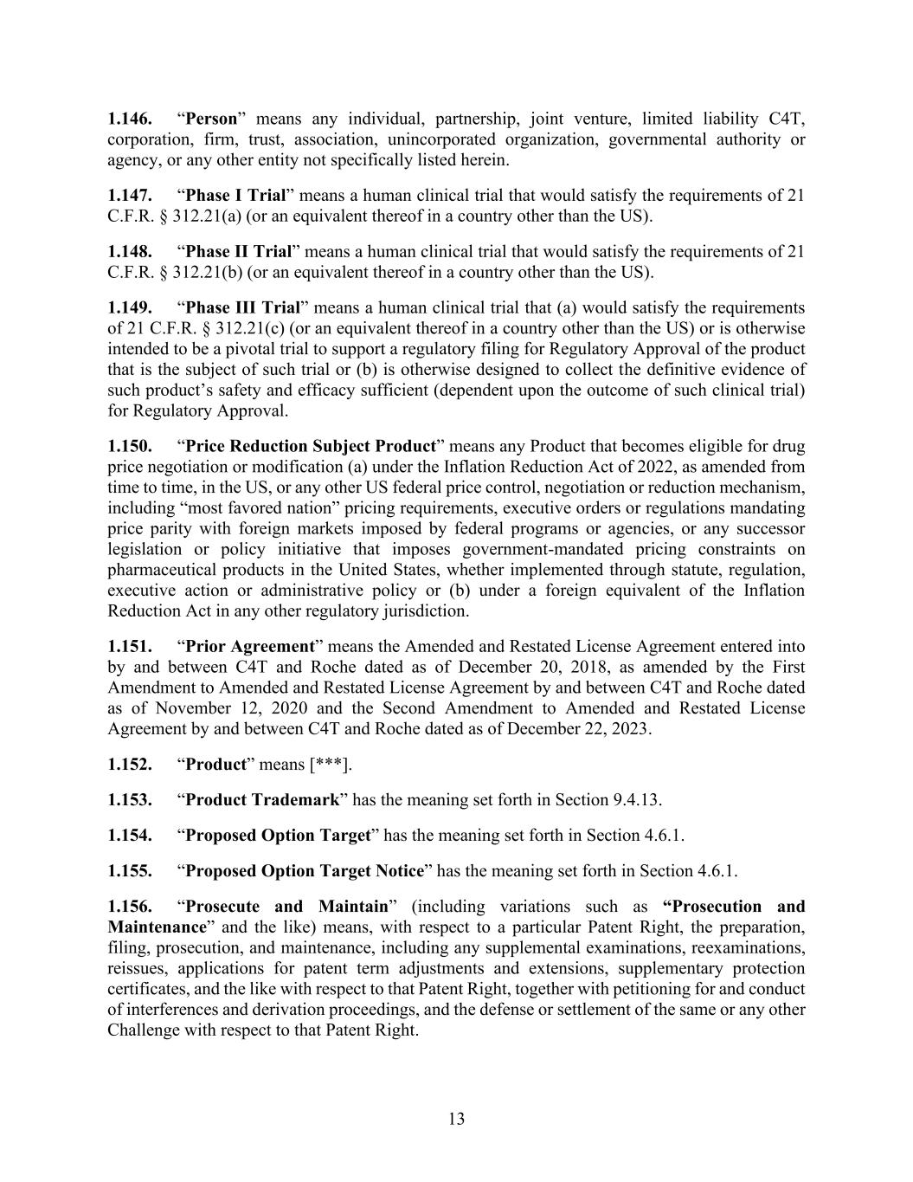
13 1.146. “Person” means any individual, partnership, joint venture, limited liability C4T, corporation, firm, trust, association, unincorporated organization, governmental authority or agency, or any other entity not specifically listed herein. 1.147. “Phase I Trial” means a human clinical trial that would satisfy the requirements of 21 C.F.R. § 312.21(a) (or an equivalent thereof in a country other than the US). 1.148. “Phase II Trial” means a human clinical trial that would satisfy the requirements of 21 C.F.R. § 312.21(b) (or an equivalent thereof in a country other than the US). 1.149. “Phase III Trial” means a human clinical trial that (a) would satisfy the requirements of 21 C.F.R. § 312.21(c) (or an equivalent thereof in a country other than the US) or is otherwise intended to be a pivotal trial to support a regulatory filing for Regulatory Approval of the product that is the subject of such trial or (b) is otherwise designed to collect the definitive evidence of such product’s safety and efficacy sufficient (dependent upon the outcome of such clinical trial) for Regulatory Approval. 1.150. “Price Reduction Subject Product” means any Product that becomes eligible for drug price negotiation or modification (a) under the Inflation Reduction Act of 2022, as amended from time to time, in the US, or any other US federal price control, negotiation or reduction mechanism, including “most favored nation” pricing requirements, executive orders or regulations mandating price parity with foreign markets imposed by federal programs or agencies, or any successor legislation or policy initiative that imposes government-mandated pricing constraints on pharmaceutical products in the United States, whether implemented through statute, regulation, executive action or administrative policy or (b) under a foreign equivalent of the Inflation Reduction Act in any other regulatory jurisdiction. 1.151. “Prior Agreement” means the Amended and Restated License Agreement entered into by and between C4T and Roche dated as of December 20, 2018, as amended by the First Amendment to Amended and Restated License Agreement by and between C4T and Roche dated as of November 12, 2020 and the Second Amendment to Amended and Restated License Agreement by and between C4T and Roche dated as of December 22, 2023. 1.152. “Product” means [***]. 1.153. “Product Trademark” has the meaning set forth in Section 9.4.13. 1.154. “Proposed Option Target” has the meaning set forth in Section 4.6.1. 1.155. “Proposed Option Target Notice” has the meaning set forth in Section 4.6.1. 1.156. “Prosecute and Maintain” (including variations such as “Prosecution and Maintenance” and the like) means, with respect to a particular Patent Right, the preparation, filing, prosecution, and maintenance, including any supplemental examinations, reexaminations, reissues, applications for patent term adjustments and extensions, supplementary protection certificates, and the like with respect to that Patent Right, together with petitioning for and conduct of interferences and derivation proceedings, and the defense or settlement of the same or any other Challenge with respect to that Patent Right.

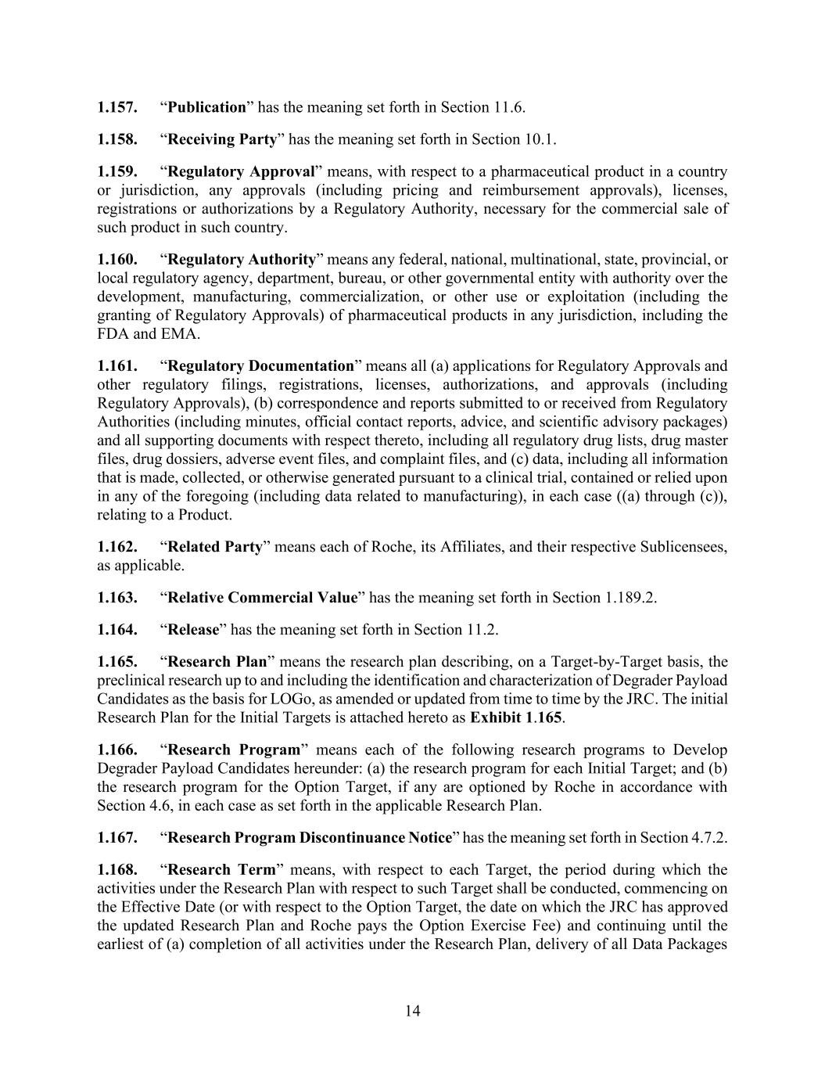
14 1.157. “Publication” has the meaning set forth in Section 11.6. 1.158. “Receiving Party” has the meaning set forth in Section 10.1. 1.159. “Regulatory Approval” means, with respect to a pharmaceutical product in a country or jurisdiction, any approvals (including pricing and reimbursement approvals), licenses, registrations or authorizations by a Regulatory Authority, necessary for the commercial sale of such product in such country. 1.160. “Regulatory Authority” means any federal, national, multinational, state, provincial, or local regulatory agency, department, bureau, or other governmental entity with authority over the development, manufacturing, commercialization, or other use or exploitation (including the granting of Regulatory Approvals) of pharmaceutical products in any jurisdiction, including the FDA and EMA. 1.161. “Regulatory Documentation” means all (a) applications for Regulatory Approvals and other regulatory filings, registrations, licenses, authorizations, and approvals (including Regulatory Approvals), (b) correspondence and reports submitted to or received from Regulatory Authorities (including minutes, official contact reports, advice, and scientific advisory packages) and all supporting documents with respect thereto, including all regulatory drug lists, drug master files, drug dossiers, adverse event files, and complaint files, and (c) data, including all information that is made, collected, or otherwise generated pursuant to a clinical trial, contained or relied upon in any of the foregoing (including data related to manufacturing), in each case ((a) through (c)), relating to a Product. 1.162. “Related Party” means each of Roche, its Affiliates, and their respective Sublicensees, as applicable. 1.163. “Relative Commercial Value” has the meaning set forth in Section 1.189.2. 1.164. “Release” has the meaning set forth in Section 11.2. 1.165. “Research Plan” means the research plan describing, on a Target-by-Target basis, the preclinical research up to and including the identification and characterization of Degrader Payload Candidates as the basis for LOGo, as amended or updated from time to time by the JRC. The initial Research Plan for the Initial Targets is attached hereto as Exhibit 1.165. 1.166. “Research Program” means each of the following research programs to Develop Degrader Payload Candidates hereunder: (a) the research program for each Initial Target; and (b) the research program for the Option Target, if any are optioned by Roche in accordance with Section 4.6, in each case as set forth in the applicable Research Plan. 1.167. “Research Program Discontinuance Notice” has the meaning set forth in Section 4.7.2. 1.168. “Research Term” means, with respect to each Target, the period during which the activities under the Research Plan with respect to such Target shall be conducted, commencing on the Effective Date (or with respect to the Option Target, the date on which the JRC has approved the updated Research Plan and Roche pays the Option Exercise Fee) and continuing until the earliest of (a) completion of all activities under the Research Plan, delivery of all Data Packages

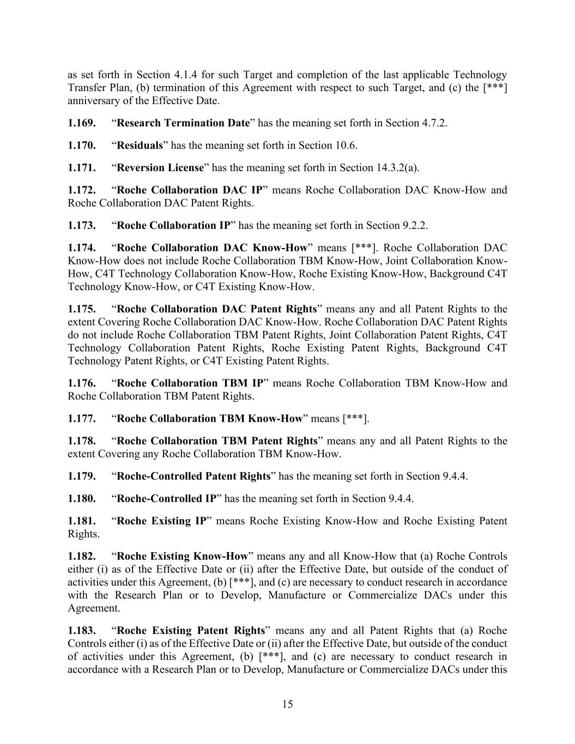
15 as set forth in Section 4.1.4 for such Target and completion of the last applicable Technology Transfer Plan, (b) termination of this Agreement with respect to such Target, and (c) the [***] anniversary of the Effective Date. 1.169. “Research Termination Date” has the meaning set forth in Section 4.7.2. 1.170. “Residuals” has the meaning set forth in Section 10.6. 1.171. “Reversion License” has the meaning set forth in Section 14.3.2(a). 1.172. “Roche Collaboration DAC IP” means Roche Collaboration DAC Know-How and Roche Collaboration DAC Patent Rights. 1.173. “Roche Collaboration IP” has the meaning set forth in Section 9.2.2. 1.174. “Roche Collaboration DAC Know-How” means [***]. Roche Collaboration DAC Know-How does not include Roche Collaboration TBM Know-How, Joint Collaboration Know- How, C4T Technology Collaboration Know-How, Roche Existing Know-How, Background C4T Technology Know-How, or C4T Existing Know-How. 1.175. “Roche Collaboration DAC Patent Rights” means any and all Patent Rights to the extent Covering Roche Collaboration DAC Know-How. Roche Collaboration DAC Patent Rights do not include Roche Collaboration TBM Patent Rights, Joint Collaboration Patent Rights, C4T Technology Collaboration Patent Rights, Roche Existing Patent Rights, Background C4T Technology Patent Rights, or C4T Existing Patent Rights. 1.176. “Roche Collaboration TBM IP” means Roche Collaboration TBM Know-How and Roche Collaboration TBM Patent Rights. 1.177. “Roche Collaboration TBM Know-How” means [***]. 1.178. “Roche Collaboration TBM Patent Rights” means any and all Patent Rights to the extent Covering any Roche Collaboration TBM Know-How. 1.179. “Roche-Controlled Patent Rights” has the meaning set forth in Section 9.4.4. 1.180. “Roche-Controlled IP” has the meaning set forth in Section 9.4.4. 1.181. “Roche Existing IP” means Roche Existing Know-How and Roche Existing Patent Rights. 1.182. “Roche Existing Know-How” means any and all Know-How that (a) Roche Controls either (i) as of the Effective Date or (ii) after the Effective Date, but outside of the conduct of activities under this Agreement, (b) [***], and (c) are necessary to conduct research in accordance with the Research Plan or to Develop, Manufacture or Commercialize DACs under this Agreement. 1.183. “Roche Existing Patent Rights” means any and all Patent Rights that (a) Roche Controls either (i) as of the Effective Date or (ii) after the Effective Date, but outside of the conduct of activities under this Agreement, (b) [***], and (c) are necessary to conduct research in accordance with a Research Plan or to Develop, Manufacture or Commercialize DACs under this

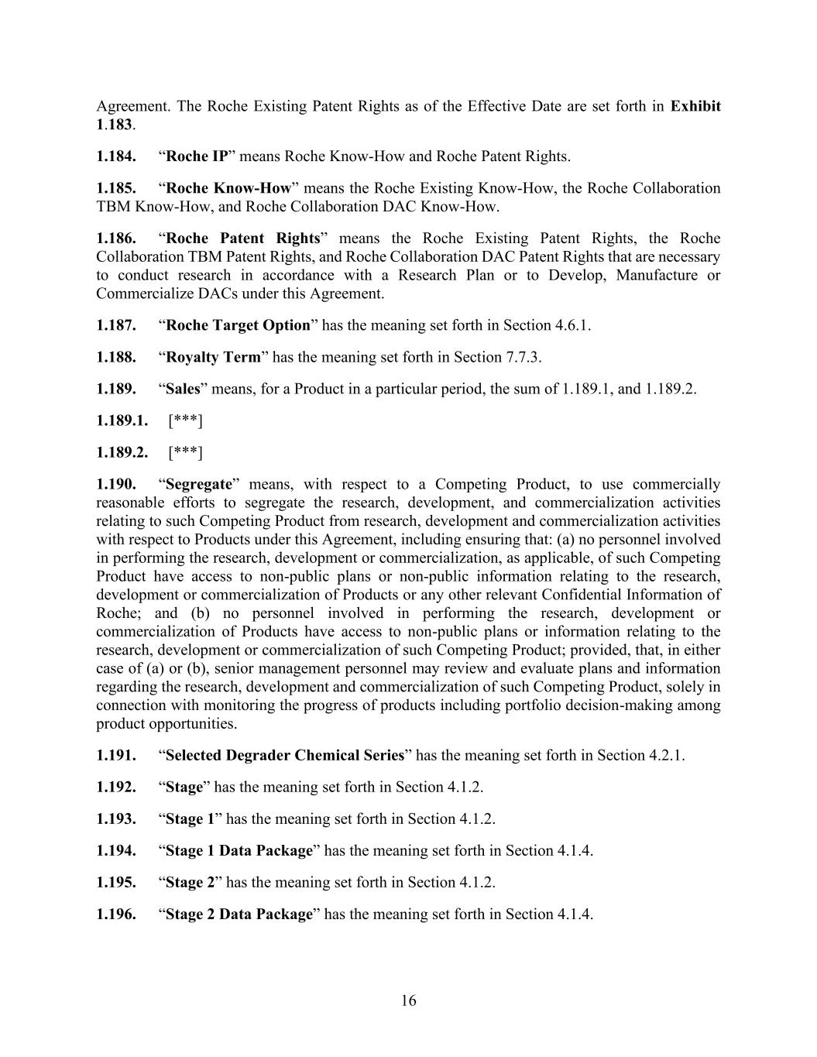
16 Agreement. The Roche Existing Patent Rights as of the Effective Date are set forth in Exhibit 1.183. 1.184. “Roche IP” means Roche Know-How and Roche Patent Rights. 1.185. “Roche Know-How” means the Roche Existing Know-How, the Roche Collaboration TBM Know-How, and Roche Collaboration DAC Know-How. 1.186. “Roche Patent Rights” means the Roche Existing Patent Rights, the Roche Collaboration TBM Patent Rights, and Roche Collaboration DAC Patent Rights that are necessary to conduct research in accordance with a Research Plan or to Develop, Manufacture or Commercialize DACs under this Agreement. 1.187. “Roche Target Option” has the meaning set forth in Section 4.6.1. 1.188. “Royalty Term” has the meaning set forth in Section 7.7.3. 1.189. “Sales” means, for a Product in a particular period, the sum of 1.189.1, and 1.189.2. 1.189.1. [***] 1.189.2. [***] 1.190. “Segregate” means, with respect to a Competing Product, to use commercially reasonable efforts to segregate the research, development, and commercialization activities relating to such Competing Product from research, development and commercialization activities with respect to Products under this Agreement, including ensuring that: (a) no personnel involved in performing the research, development or commercialization, as applicable, of such Competing Product have access to non-public plans or non-public information relating to the research, development or commercialization of Products or any other relevant Confidential Information of Roche; and (b) no personnel involved in performing the research, development or commercialization of Products have access to non-public plans or information relating to the research, development or commercialization of such Competing Product; provided, that, in either case of (a) or (b), senior management personnel may review and evaluate plans and information regarding the research, development and commercialization of such Competing Product, solely in connection with monitoring the progress of products including portfolio decision-making among product opportunities. 1.191. “Selected Degrader Chemical Series” has the meaning set forth in Section 4.2.1. 1.192. “Stage” has the meaning set forth in Section 4.1.2. 1.193. “Stage 1” has the meaning set forth in Section 4.1.2. 1.194. “Stage 1 Data Package” has the meaning set forth in Section 4.1.4. 1.195. “Stage 2” has the meaning set forth in Section 4.1.2. 1.196. “Stage 2 Data Package” has the meaning set forth in Section 4.1.4.

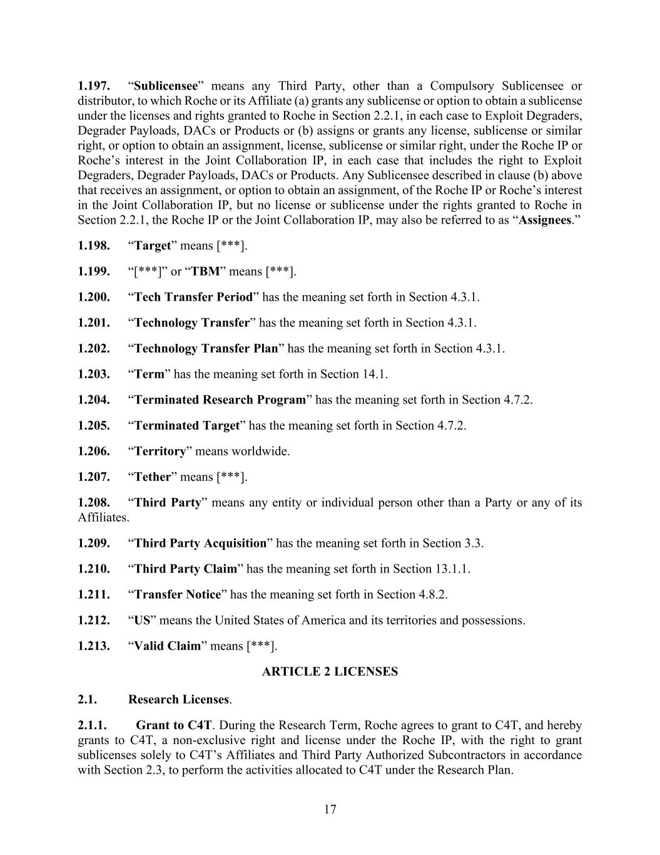
17 1.197. “Sublicensee” means any Third Party, other than a Compulsory Sublicensee or distributor, to which Roche or its Affiliate (a) grants any sublicense or option to obtain a sublicense under the licenses and rights granted to Roche in Section 2.2.1, in each case to Exploit Degraders, Degrader Payloads, DACs or Products or (b) assigns or grants any license, sublicense or similar right, or option to obtain an assignment, license, sublicense or similar right, under the Roche IP or Roche’s interest in the Joint Collaboration IP, in each case that includes the right to Exploit Degraders, Degrader Payloads, DACs or Products. Any Sublicensee described in clause (b) above that receives an assignment, or option to obtain an assignment, of the Roche IP or Roche’s interest in the Joint Collaboration IP, but no license or sublicense under the rights granted to Roche in Section 2.2.1, the Roche IP or the Joint Collaboration IP, may also be referred to as “Assignees.” 1.198. “Target” means [***]. 1.199. “[***]” or “TBM” means [***]. 1.200. “Tech Transfer Period” has the meaning set forth in Section 4.3.1. 1.201. “Technology Transfer” has the meaning set forth in Section 4.3.1. 1.202. “Technology Transfer Plan” has the meaning set forth in Section 4.3.1. 1.203. “Term” has the meaning set forth in Section 14.1. 1.204. “Terminated Research Program” has the meaning set forth in Section 4.7.2. 1.205. “Terminated Target” has the meaning set forth in Section 4.7.2. 1.206. “Territory” means worldwide. 1.207. “Tether” means [***]. 1.208. “Third Party” means any entity or individual person other than a Party or any of its Affiliates. 1.209. “Third Party Acquisition” has the meaning set forth in Section 3.3. 1.210. “Third Party Claim” has the meaning set forth in Section 13.1.1. 1.211. “Transfer Notice” has the meaning set forth in Section 4.8.2. 1.212. “US” means the United States of America and its territories and possessions. 1.213. “Valid Claim” means [***]. ARTICLE 2 LICENSES 2.1. Research Licenses. 2.1.1. Grant to C4T. During the Research Term, Roche agrees to grant to C4T, and hereby grants to C4T, a non-exclusive right and license under the Roche IP, with the right to grant sublicenses solely to C4T’s Affiliates and Third Party Authorized Subcontractors in accordance with Section 2.3, to perform the activities allocated to C4T under the Research Plan.

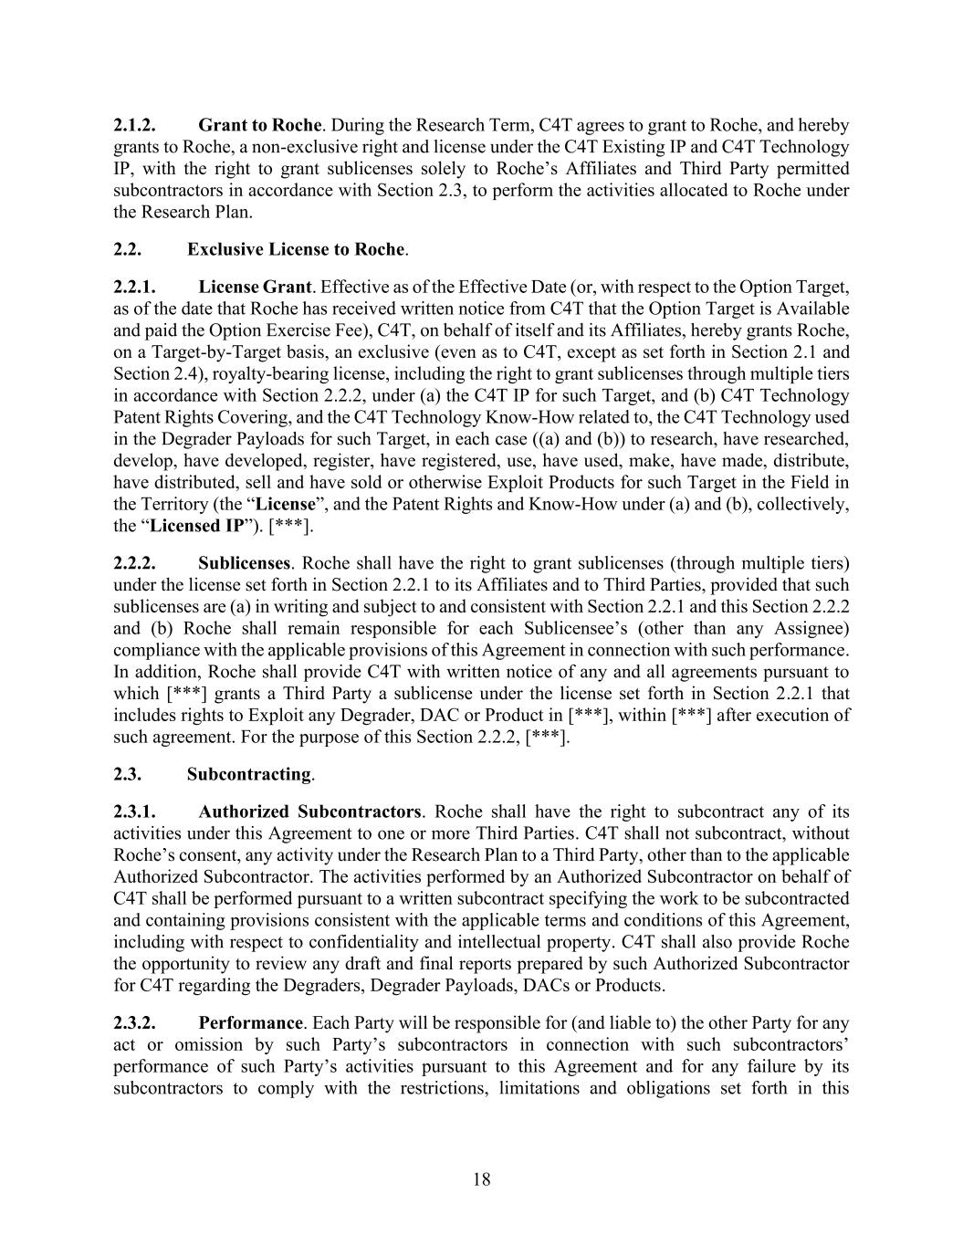
18 2.1.2. Grant to Roche. During the Research Term, C4T agrees to grant to Roche, and hereby grants to Roche, a non-exclusive right and license under the C4T Existing IP and C4T Technology IP, with the right to grant sublicenses solely to Roche’s Affiliates and Third Party permitted subcontractors in accordance with Section 2.3, to perform the activities allocated to Roche under the Research Plan. 2.2. Exclusive License to Roche. 2.2.1. License Grant. Effective as of the Effective Date (or, with respect to the Option Target, as of the date that Roche has received written notice from C4T that the Option Target is Available and paid the Option Exercise Fee), C4T, on behalf of itself and its Affiliates, hereby grants Roche, on a Target-by-Target basis, an exclusive (even as to C4T, except as set forth in Section 2.1 and Section 2.4), royalty-bearing license, including the right to grant sublicenses through multiple tiers in accordance with Section 2.2.2, under (a) the C4T IP for such Target, and (b) C4T Technology Patent Rights Covering, and the C4T Technology Know-How related to, the C4T Technology used in the Degrader Payloads for such Target, in each case ((a) and (b)) to research, have researched, develop, have developed, register, have registered, use, have used, make, have made, distribute, have distributed, sell and have sold or otherwise Exploit Products for such Target in the Field in the Territory (the “License”, and the Patent Rights and Know-How under (a) and (b), collectively, the “Licensed IP”). [***]. 2.2.2. Sublicenses. Roche shall have the right to grant sublicenses (through multiple tiers) under the license set forth in Section 2.2.1 to its Affiliates and to Third Parties, provided that such sublicenses are (a) in writing and subject to and consistent with Section 2.2.1 and this Section 2.2.2 and (b) Roche shall remain responsible for each Sublicensee’s (other than any Assignee) compliance with the applicable provisions of this Agreement in connection with such performance. In addition, Roche shall provide C4T with written notice of any and all agreements pursuant to which [***] grants a Third Party a sublicense under the license set forth in Section 2.2.1 that includes rights to Exploit any Degrader, DAC or Product in [***], within [***] after execution of such agreement. For the purpose of this Section 2.2.2, [***]. 2.3. Subcontracting. 2.3.1. Authorized Subcontractors. Roche shall have the right to subcontract any of its activities under this Agreement to one or more Third Parties. C4T shall not subcontract, without Roche’s consent, any activity under the Research Plan to a Third Party, other than to the applicable Authorized Subcontractor. The activities performed by an Authorized Subcontractor on behalf of C4T shall be performed pursuant to a written subcontract specifying the work to be subcontracted and containing provisions consistent with the applicable terms and conditions of this Agreement, including with respect to confidentiality and intellectual property. C4T shall also provide Roche the opportunity to review any draft and final reports prepared by such Authorized Subcontractor for C4T regarding the Degraders, Degrader Payloads, DACs or Products. 2.3.2. Performance. Each Party will be responsible for (and liable to) the other Party for any act or omission by such Party’s subcontractors in connection with such subcontractors’ performance of such Party’s activities pursuant to this Agreement and for any failure by its subcontractors to comply with the restrictions, limitations and obligations set forth in this

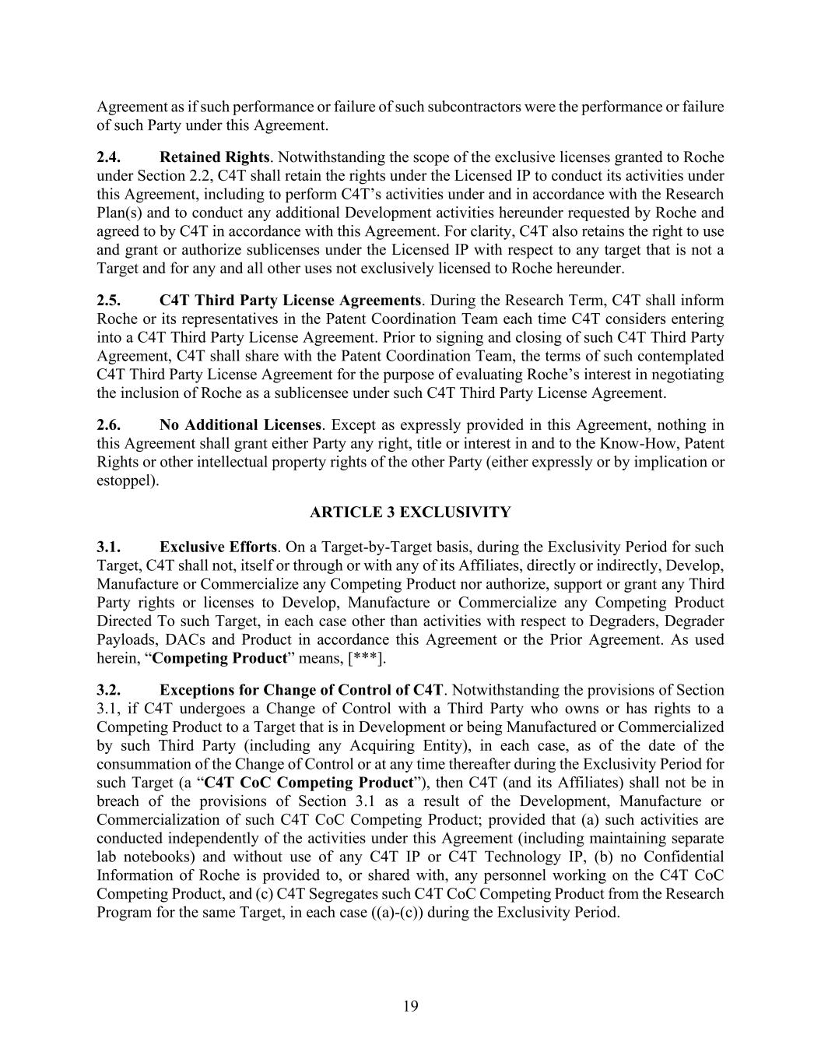
19 Agreement as if such performance or failure of such subcontractors were the performance or failure of such Party under this Agreement. 2.4. Retained Rights. Notwithstanding the scope of the exclusive licenses granted to Roche under Section 2.2, C4T shall retain the rights under the Licensed IP to conduct its activities under this Agreement, including to perform C4T’s activities under and in accordance with the Research Plan(s) and to conduct any additional Development activities hereunder requested by Roche and agreed to by C4T in accordance with this Agreement. For clarity, C4T also retains the right to use and grant or authorize sublicenses under the Licensed IP with respect to any target that is not a Target and for any and all other uses not exclusively licensed to Roche hereunder. 2.5. C4T Third Party License Agreements. During the Research Term, C4T shall inform Roche or its representatives in the Patent Coordination Team each time C4T considers entering into a C4T Third Party License Agreement. Prior to signing and closing of such C4T Third Party Agreement, C4T shall share with the Patent Coordination Team, the terms of such contemplated C4T Third Party License Agreement for the purpose of evaluating Roche’s interest in negotiating the inclusion of Roche as a sublicensee under such C4T Third Party License Agreement. 2.6. No Additional Licenses. Except as expressly provided in this Agreement, nothing in this Agreement shall grant either Party any right, title or interest in and to the Know-How, Patent Rights or other intellectual property rights of the other Party (either expressly or by implication or estoppel). ARTICLE 3 EXCLUSIVITY 3.1. Exclusive Efforts. On a Target-by-Target basis, during the Exclusivity Period for such Target, C4T shall not, itself or through or with any of its Affiliates, directly or indirectly, Develop, Manufacture or Commercialize any Competing Product nor authorize, support or grant any Third Party rights or licenses to Develop, Manufacture or Commercialize any Competing Product Directed To such Target, in each case other than activities with respect to Degraders, Degrader Payloads, DACs and Product in accordance this Agreement or the Prior Agreement. As used herein, “Competing Product” means, [***]. 3.2. Exceptions for Change of Control of C4T. Notwithstanding the provisions of Section 3.1, if C4T undergoes a Change of Control with a Third Party who owns or has rights to a Competing Product to a Target that is in Development or being Manufactured or Commercialized by such Third Party (including any Acquiring Entity), in each case, as of the date of the consummation of the Change of Control or at any time thereafter during the Exclusivity Period for such Target (a “C4T CoC Competing Product”), then C4T (and its Affiliates) shall not be in breach of the provisions of Section 3.1 as a result of the Development, Manufacture or Commercialization of such C4T CoC Competing Product; provided that (a) such activities are conducted independently of the activities under this Agreement (including maintaining separate lab notebooks) and without use of any C4T IP or C4T Technology IP, (b) no Confidential Information of Roche is provided to, or shared with, any personnel working on the C4T CoC Competing Product, and (c) C4T Segregates such C4T CoC Competing Product from the Research Program for the same Target, in each case ((a)-(c)) during the Exclusivity Period.

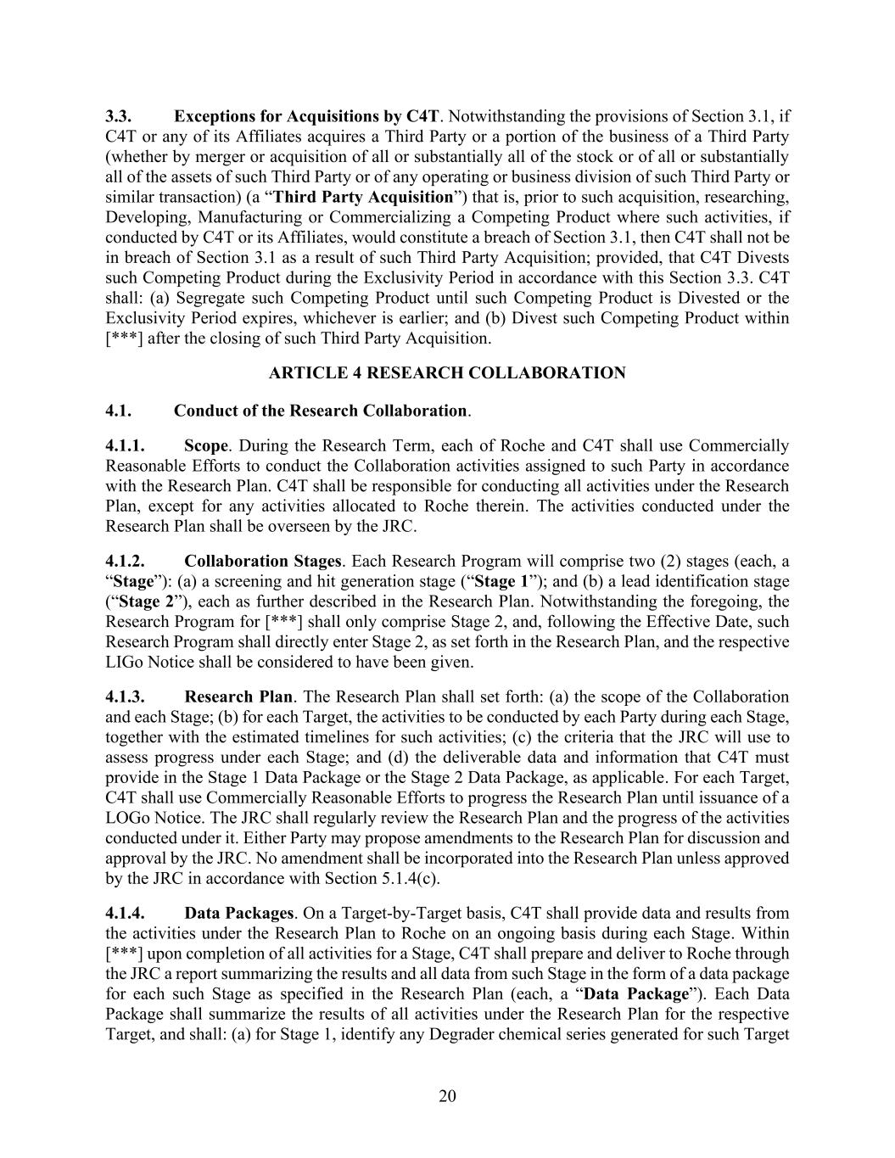
20 3.3. Exceptions for Acquisitions by C4T. Notwithstanding the provisions of Section 3.1, if C4T or any of its Affiliates acquires a Third Party or a portion of the business of a Third Party (whether by merger or acquisition of all or substantially all of the stock or of all or substantially all of the assets of such Third Party or of any operating or business division of such Third Party or similar transaction) (a “Third Party Acquisition”) that is, prior to such acquisition, researching, Developing, Manufacturing or Commercializing a Competing Product where such activities, if conducted by C4T or its Affiliates, would constitute a breach of Section 3.1, then C4T shall not be in breach of Section 3.1 as a result of such Third Party Acquisition; provided, that C4T Divests such Competing Product during the Exclusivity Period in accordance with this Section 3.3. C4T shall: (a) Segregate such Competing Product until such Competing Product is Divested or the Exclusivity Period expires, whichever is earlier; and (b) Divest such Competing Product within [***] after the closing of such Third Party Acquisition. ARTICLE 4 RESEARCH COLLABORATION 4.1. Conduct of the Research Collaboration. 4.1.1. Scope. During the Research Term, each of Roche and C4T shall use Commercially Reasonable Efforts to conduct the Collaboration activities assigned to such Party in accordance with the Research Plan. C4T shall be responsible for conducting all activities under the Research Plan, except for any activities allocated to Roche therein. The activities conducted under the Research Plan shall be overseen by the JRC. 4.1.2. Collaboration Stages. Each Research Program will comprise two (2) stages (each, a “Stage”): (a) a screening and hit generation stage (“Stage 1”); and (b) a lead identification stage (“Stage 2”), each as further described in the Research Plan. Notwithstanding the foregoing, the Research Program for [***] shall only comprise Stage 2, and, following the Effective Date, such Research Program shall directly enter Stage 2, as set forth in the Research Plan, and the respective LIGo Notice shall be considered to have been given. 4.1.3. Research Plan. The Research Plan shall set forth: (a) the scope of the Collaboration and each Stage; (b) for each Target, the activities to be conducted by each Party during each Stage, together with the estimated timelines for such activities; (c) the criteria that the JRC will use to assess progress under each Stage; and (d) the deliverable data and information that C4T must provide in the Stage 1 Data Package or the Stage 2 Data Package, as applicable. For each Target, C4T shall use Commercially Reasonable Efforts to progress the Research Plan until issuance of a LOGo Notice. The JRC shall regularly review the Research Plan and the progress of the activities conducted under it. Either Party may propose amendments to the Research Plan for discussion and approval by the JRC. No amendment shall be incorporated into the Research Plan unless approved by the JRC in accordance with Section 5.1.4(c). 4.1.4. Data Packages. On a Target-by-Target basis, C4T shall provide data and results from the activities under the Research Plan to Roche on an ongoing basis during each Stage. Within [***] upon completion of all activities for a Stage, C4T shall prepare and deliver to Roche through the JRC a report summarizing the results and all data from such Stage in the form of a data package for each such Stage as specified in the Research Plan (each, a “Data Package”). Each Data Package shall summarize the results of all activities under the Research Plan for the respective Target, and shall: (a) for Stage 1, identify any Degrader chemical series generated for such Target

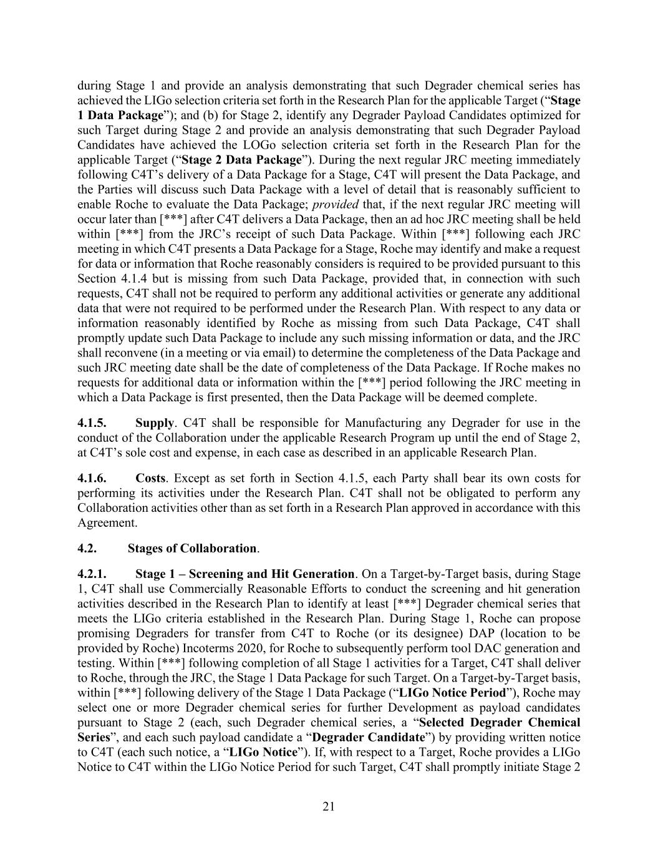
21 during Stage 1 and provide an analysis demonstrating that such Degrader chemical series has achieved the LIGo selection criteria set forth in the Research Plan for the applicable Target (“Stage 1 Data Package”); and (b) for Stage 2, identify any Degrader Payload Candidates optimized for such Target during Stage 2 and provide an analysis demonstrating that such Degrader Payload Candidates have achieved the LOGo selection criteria set forth in the Research Plan for the applicable Target (“Stage 2 Data Package”). During the next regular JRC meeting immediately following C4T’s delivery of a Data Package for a Stage, C4T will present the Data Package, and the Parties will discuss such Data Package with a level of detail that is reasonably sufficient to enable Roche to evaluate the Data Package; provided that, if the next regular JRC meeting will occur later than [***] after C4T delivers a Data Package, then an ad hoc JRC meeting shall be held within [***] from the JRC’s receipt of such Data Package. Within [***] following each JRC meeting in which C4T presents a Data Package for a Stage, Roche may identify and make a request for data or information that Roche reasonably considers is required to be provided pursuant to this Section 4.1.4 but is missing from such Data Package, provided that, in connection with such requests, C4T shall not be required to perform any additional activities or generate any additional data that were not required to be performed under the Research Plan. With respect to any data or information reasonably identified by Roche as missing from such Data Package, C4T shall promptly update such Data Package to include any such missing information or data, and the JRC shall reconvene (in a meeting or via email) to determine the completeness of the Data Package and such JRC meeting date shall be the date of completeness of the Data Package. If Roche makes no requests for additional data or information within the [***] period following the JRC meeting in which a Data Package is first presented, then the Data Package will be deemed complete. 4.1.5. Supply. C4T shall be responsible for Manufacturing any Degrader for use in the conduct of the Collaboration under the applicable Research Program up until the end of Stage 2, at C4T’s sole cost and expense, in each case as described in an applicable Research Plan. 4.1.6. Costs. Except as set forth in Section 4.1.5, each Party shall bear its own costs for performing its activities under the Research Plan. C4T shall not be obligated to perform any Collaboration activities other than as set forth in a Research Plan approved in accordance with this Agreement. 4.2. Stages of Collaboration. 4.2.1. Stage 1 – Screening and Hit Generation. On a Target-by-Target basis, during Stage 1, C4T shall use Commercially Reasonable Efforts to conduct the screening and hit generation activities described in the Research Plan to identify at least [***] Degrader chemical series that meets the LIGo criteria established in the Research Plan. During Stage 1, Roche can propose promising Degraders for transfer from C4T to Roche (or its designee) DAP (location to be provided by Roche) Incoterms 2020, for Roche to subsequently perform tool DAC generation and testing. Within [***] following completion of all Stage 1 activities for a Target, C4T shall deliver to Roche, through the JRC, the Stage 1 Data Package for such Target. On a Target-by-Target basis, within [***] following delivery of the Stage 1 Data Package (“LIGo Notice Period”), Roche may select one or more Degrader chemical series for further Development as payload candidates pursuant to Stage 2 (each, such Degrader chemical series, a “Selected Degrader Chemical Series”, and each such payload candidate a “Degrader Candidate”) by providing written notice to C4T (each such notice, a “LIGo Notice”). If, with respect to a Target, Roche provides a LIGo Notice to C4T within the LIGo Notice Period for such Target, C4T shall promptly initiate Stage 2

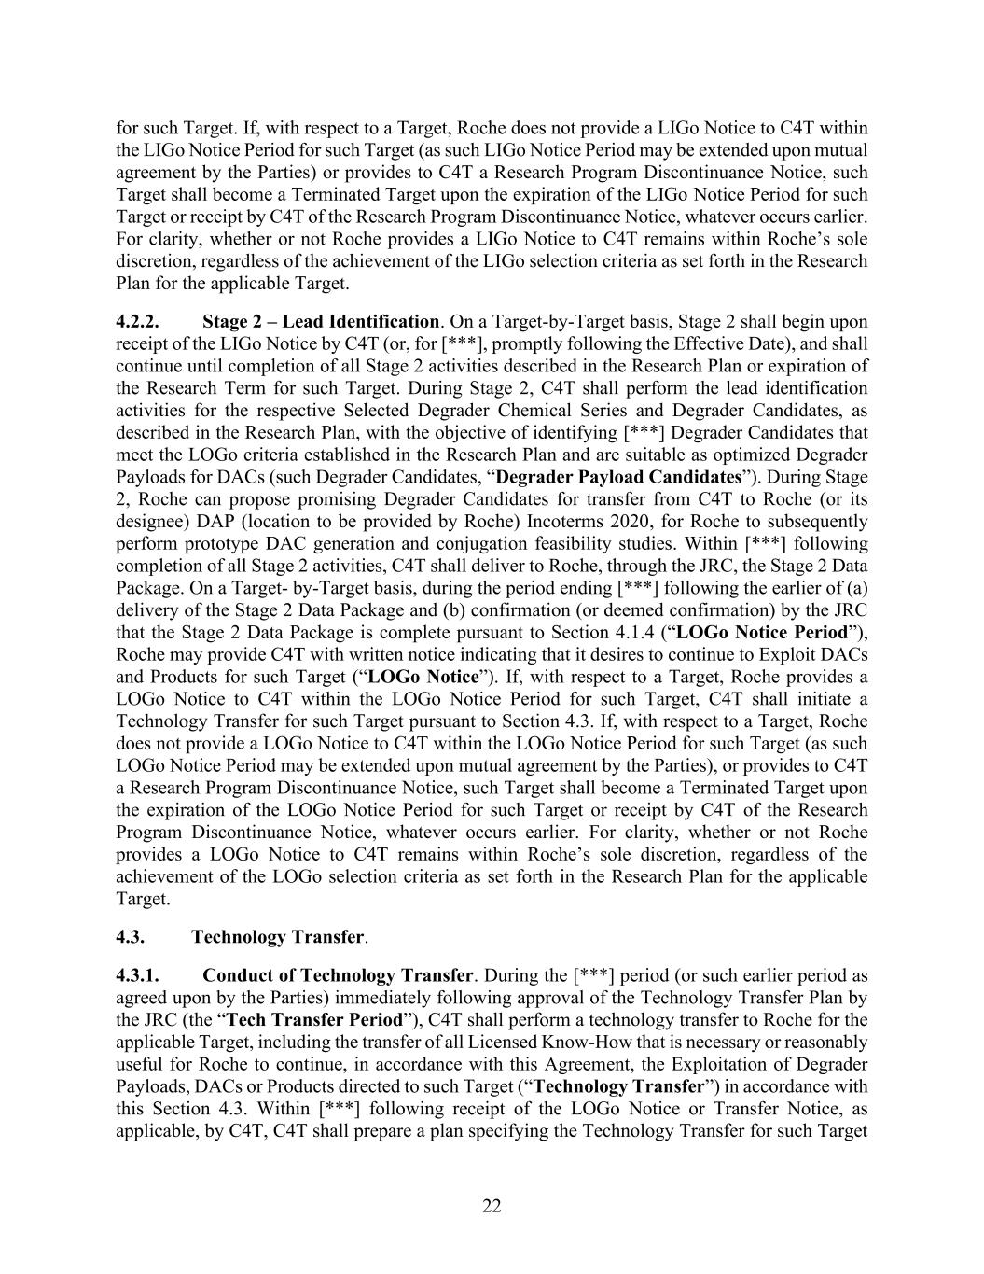
22 for such Target. If, with respect to a Target, Roche does not provide a LIGo Notice to C4T within the LIGo Notice Period for such Target (as such LIGo Notice Period may be extended upon mutual agreement by the Parties) or provides to C4T a Research Program Discontinuance Notice, such Target shall become a Terminated Target upon the expiration of the LIGo Notice Period for such Target or receipt by C4T of the Research Program Discontinuance Notice, whatever occurs earlier. For clarity, whether or not Roche provides a LIGo Notice to C4T remains within Roche’s sole discretion, regardless of the achievement of the LIGo selection criteria as set forth in the Research Plan for the applicable Target. 4.2.2. Stage 2 – Lead Identification. On a Target-by-Target basis, Stage 2 shall begin upon receipt of the LIGo Notice by C4T (or, for [***], promptly following the Effective Date), and shall continue until completion of all Stage 2 activities described in the Research Plan or expiration of the Research Term for such Target. During Stage 2, C4T shall perform the lead identification activities for the respective Selected Degrader Chemical Series and Degrader Candidates, as described in the Research Plan, with the objective of identifying [***] Degrader Candidates that meet the LOGo criteria established in the Research Plan and are suitable as optimized Degrader Payloads for DACs (such Degrader Candidates, “Degrader Payload Candidates”). During Stage 2, Roche can propose promising Degrader Candidates for transfer from C4T to Roche (or its designee) DAP (location to be provided by Roche) Incoterms 2020, for Roche to subsequently perform prototype DAC generation and conjugation feasibility studies. Within [***] following completion of all Stage 2 activities, C4T shall deliver to Roche, through the JRC, the Stage 2 Data Package. On a Target- by-Target basis, during the period ending [***] following the earlier of (a) delivery of the Stage 2 Data Package and (b) confirmation (or deemed confirmation) by the JRC that the Stage 2 Data Package is complete pursuant to Section 4.1.4 (“LOGo Notice Period”), Roche may provide C4T with written notice indicating that it desires to continue to Exploit DACs and Products for such Target (“LOGo Notice”). If, with respect to a Target, Roche provides a LOGo Notice to C4T within the LOGo Notice Period for such Target, C4T shall initiate a Technology Transfer for such Target pursuant to Section 4.3. If, with respect to a Target, Roche does not provide a LOGo Notice to C4T within the LOGo Notice Period for such Target (as such LOGo Notice Period may be extended upon mutual agreement by the Parties), or provides to C4T a Research Program Discontinuance Notice, such Target shall become a Terminated Target upon the expiration of the LOGo Notice Period for such Target or receipt by C4T of the Research Program Discontinuance Notice, whatever occurs earlier. For clarity, whether or not Roche provides a LOGo Notice to C4T remains within Roche’s sole discretion, regardless of the achievement of the LOGo selection criteria as set forth in the Research Plan for the applicable Target. 4.3. Technology Transfer. 4.3.1. Conduct of Technology Transfer. During the [***] period (or such earlier period as agreed upon by the Parties) immediately following approval of the Technology Transfer Plan by the JRC (the “Tech Transfer Period”), C4T shall perform a technology transfer to Roche for the applicable Target, including the transfer of all Licensed Know-How that is necessary or reasonably useful for Roche to continue, in accordance with this Agreement, the Exploitation of Degrader Payloads, DACs or Products directed to such Target (“Technology Transfer”) in accordance with this Section 4.3. Within [***] following receipt of the LOGo Notice or Transfer Notice, as applicable, by C4T, C4T shall prepare a plan specifying the Technology Transfer for such Target

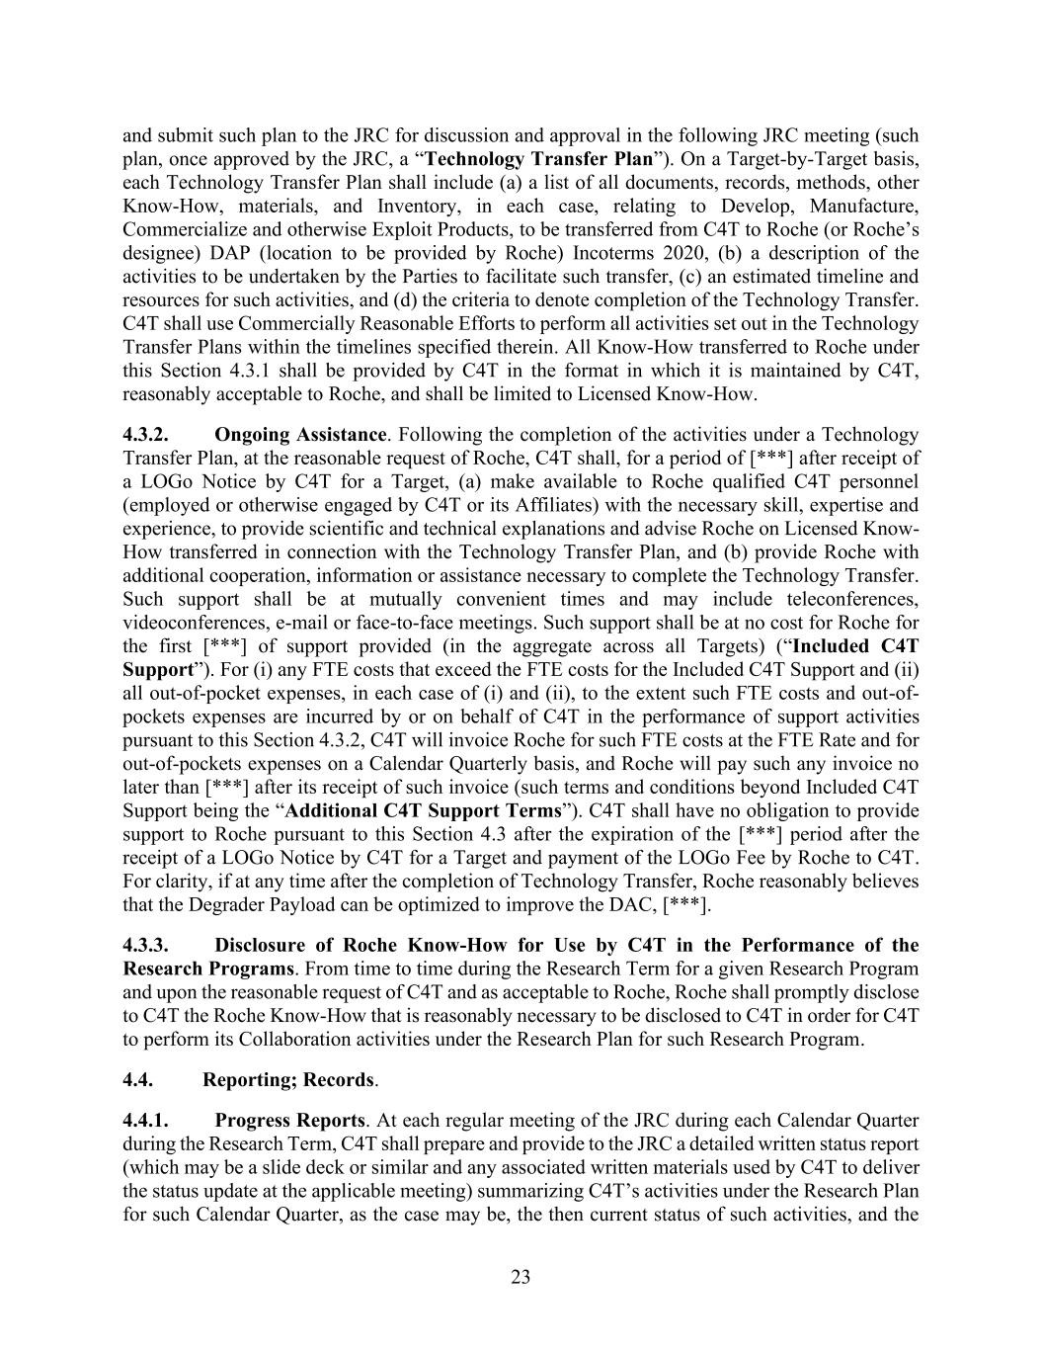
23 and submit such plan to the JRC for discussion and approval in the following JRC meeting (such plan, once approved by the JRC, a “Technology Transfer Plan”). On a Target-by-Target basis, each Technology Transfer Plan shall include (a) a list of all documents, records, methods, other Know-How, materials, and Inventory, in each case, relating to Develop, Manufacture, Commercialize and otherwise Exploit Products, to be transferred from C4T to Roche (or Roche’s designee) DAP (location to be provided by Roche) Incoterms 2020, (b) a description of the activities to be undertaken by the Parties to facilitate such transfer, (c) an estimated timeline and resources for such activities, and (d) the criteria to denote completion of the Technology Transfer. C4T shall use Commercially Reasonable Efforts to perform all activities set out in the Technology Transfer Plans within the timelines specified therein. All Know-How transferred to Roche under this Section 4.3.1 shall be provided by C4T in the format in which it is maintained by C4T, reasonably acceptable to Roche, and shall be limited to Licensed Know-How. 4.3.2. Ongoing Assistance. Following the completion of the activities under a Technology Transfer Plan, at the reasonable request of Roche, C4T shall, for a period of [***] after receipt of a LOGo Notice by C4T for a Target, (a) make available to Roche qualified C4T personnel (employed or otherwise engaged by C4T or its Affiliates) with the necessary skill, expertise and experience, to provide scientific and technical explanations and advise Roche on Licensed Know- How transferred in connection with the Technology Transfer Plan, and (b) provide Roche with additional cooperation, information or assistance necessary to complete the Technology Transfer. Such support shall be at mutually convenient times and may include teleconferences, videoconferences, e-mail or face-to-face meetings. Such support shall be at no cost for Roche for the first [***] of support provided (in the aggregate across all Targets) (“Included C4T Support”). For (i) any FTE costs that exceed the FTE costs for the Included C4T Support and (ii) all out-of-pocket expenses, in each case of (i) and (ii), to the extent such FTE costs and out-of- pockets expenses are incurred by or on behalf of C4T in the performance of support activities pursuant to this Section 4.3.2, C4T will invoice Roche for such FTE costs at the FTE Rate and for out-of-pockets expenses on a Calendar Quarterly basis, and Roche will pay such any invoice no later than [***] after its receipt of such invoice (such terms and conditions beyond Included C4T Support being the “Additional C4T Support Terms”). C4T shall have no obligation to provide support to Roche pursuant to this Section 4.3 after the expiration of the [***] period after the receipt of a LOGo Notice by C4T for a Target and payment of the LOGo Fee by Roche to C4T. For clarity, if at any time after the completion of Technology Transfer, Roche reasonably believes that the Degrader Payload can be optimized to improve the DAC, [***]. 4.3.3. Disclosure of Roche Know-How for Use by C4T in the Performance of the Research Programs. From time to time during the Research Term for a given Research Program and upon the reasonable request of C4T and as acceptable to Roche, Roche shall promptly disclose to C4T the Roche Know-How that is reasonably necessary to be disclosed to C4T in order for C4T to perform its Collaboration activities under the Research Plan for such Research Program. 4.4. Reporting; Records. 4.4.1. Progress Reports. At each regular meeting of the JRC during each Calendar Quarter during the Research Term, C4T shall prepare and provide to the JRC a detailed written status report (which may be a slide deck or similar and any associated written materials used by C4T to deliver the status update at the applicable meeting) summarizing C4T’s activities under the Research Plan for such Calendar Quarter, as the case may be, the then current status of such activities, and the

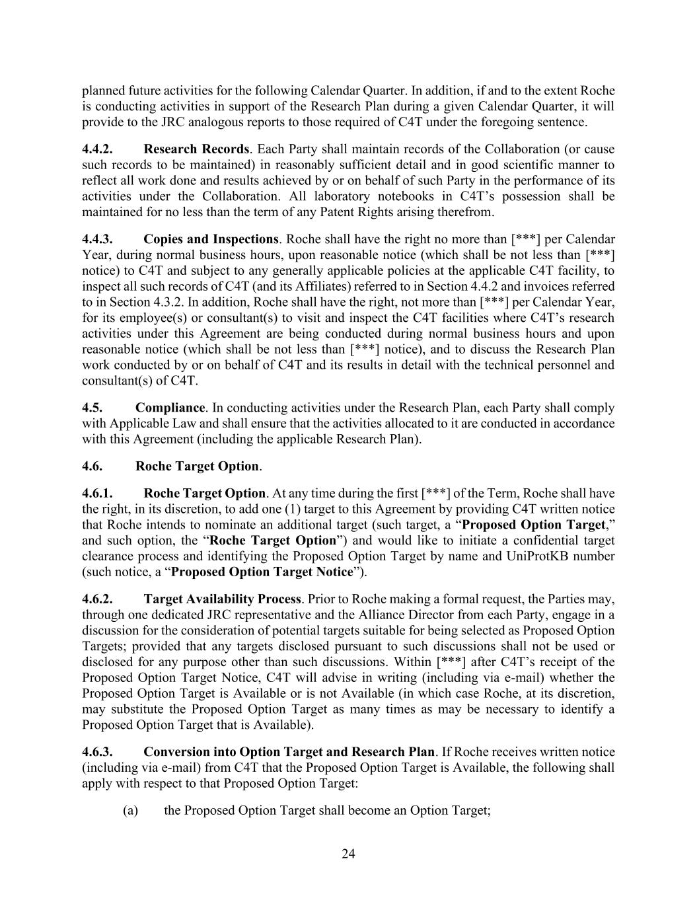
24 planned future activities for the following Calendar Quarter. In addition, if and to the extent Roche is conducting activities in support of the Research Plan during a given Calendar Quarter, it will provide to the JRC analogous reports to those required of C4T under the foregoing sentence. 4.4.2. Research Records. Each Party shall maintain records of the Collaboration (or cause such records to be maintained) in reasonably sufficient detail and in good scientific manner to reflect all work done and results achieved by or on behalf of such Party in the performance of its activities under the Collaboration. All laboratory notebooks in C4T’s possession shall be maintained for no less than the term of any Patent Rights arising therefrom. 4.4.3. Copies and Inspections. Roche shall have the right no more than [***] per Calendar Year, during normal business hours, upon reasonable notice (which shall be not less than [***] notice) to C4T and subject to any generally applicable policies at the applicable C4T facility, to inspect all such records of C4T (and its Affiliates) referred to in Section 4.4.2 and invoices referred to in Section 4.3.2. In addition, Roche shall have the right, not more than [***] per Calendar Year, for its employee(s) or consultant(s) to visit and inspect the C4T facilities where C4T’s research activities under this Agreement are being conducted during normal business hours and upon reasonable notice (which shall be not less than [***] notice), and to discuss the Research Plan work conducted by or on behalf of C4T and its results in detail with the technical personnel and consultant(s) of C4T. 4.5. Compliance. In conducting activities under the Research Plan, each Party shall comply with Applicable Law and shall ensure that the activities allocated to it are conducted in accordance with this Agreement (including the applicable Research Plan). 4.6. Roche Target Option. 4.6.1. Roche Target Option. At any time during the first [***] of the Term, Roche shall have the right, in its discretion, to add one (1) target to this Agreement by providing C4T written notice that Roche intends to nominate an additional target (such target, a “Proposed Option Target,” and such option, the “Roche Target Option”) and would like to initiate a confidential target clearance process and identifying the Proposed Option Target by name and UniProtKB number (such notice, a “Proposed Option Target Notice”). 4.6.2. Target Availability Process. Prior to Roche making a formal request, the Parties may, through one dedicated JRC representative and the Alliance Director from each Party, engage in a discussion for the consideration of potential targets suitable for being selected as Proposed Option Targets; provided that any targets disclosed pursuant to such discussions shall not be used or disclosed for any purpose other than such discussions. Within [***] after C4T’s receipt of the Proposed Option Target Notice, C4T will advise in writing (including via e-mail) whether the Proposed Option Target is Available or is not Available (in which case Roche, at its discretion, may substitute the Proposed Option Target as many times as may be necessary to identify a Proposed Option Target that is Available). 4.6.3. Conversion into Option Target and Research Plan. If Roche receives written notice (including via e-mail) from C4T that the Proposed Option Target is Available, the following shall apply with respect to that Proposed Option Target: (a) the Proposed Option Target shall become an Option Target;

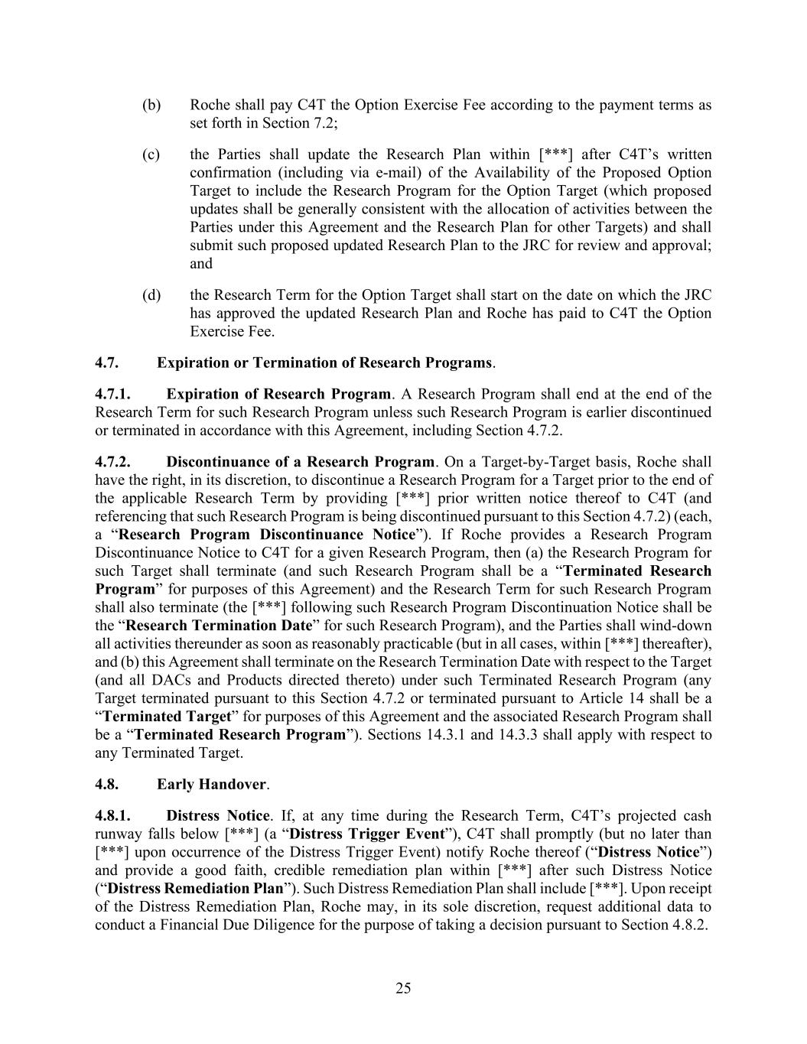
25 (b) Roche shall pay C4T the Option Exercise Fee according to the payment terms as set forth in Section 7.2; (c) the Parties shall update the Research Plan within [***] after C4T’s written confirmation (including via e-mail) of the Availability of the Proposed Option Target to include the Research Program for the Option Target (which proposed updates shall be generally consistent with the allocation of activities between the Parties under this Agreement and the Research Plan for other Targets) and shall submit such proposed updated Research Plan to the JRC for review and approval; and (d) the Research Term for the Option Target shall start on the date on which the JRC has approved the updated Research Plan and Roche has paid to C4T the Option Exercise Fee. 4.7. Expiration or Termination of Research Programs. 4.7.1. Expiration of Research Program. A Research Program shall end at the end of the Research Term for such Research Program unless such Research Program is earlier discontinued or terminated in accordance with this Agreement, including Section 4.7.2. 4.7.2. Discontinuance of a Research Program. On a Target-by-Target basis, Roche shall have the right, in its discretion, to discontinue a Research Program for a Target prior to the end of the applicable Research Term by providing [***] prior written notice thereof to C4T (and referencing that such Research Program is being discontinued pursuant to this Section 4.7.2) (each, a “Research Program Discontinuance Notice”). If Roche provides a Research Program Discontinuance Notice to C4T for a given Research Program, then (a) the Research Program for such Target shall terminate (and such Research Program shall be a “Terminated Research Program” for purposes of this Agreement) and the Research Term for such Research Program shall also terminate (the [***] following such Research Program Discontinuation Notice shall be the “Research Termination Date” for such Research Program), and the Parties shall wind-down all activities thereunder as soon as reasonably practicable (but in all cases, within [***] thereafter), and (b) this Agreement shall terminate on the Research Termination Date with respect to the Target (and all DACs and Products directed thereto) under such Terminated Research Program (any Target terminated pursuant to this Section 4.7.2 or terminated pursuant to Article 14 shall be a “Terminated Target” for purposes of this Agreement and the associated Research Program shall be a “Terminated Research Program”). Sections 14.3.1 and 14.3.3 shall apply with respect to any Terminated Target. 4.8. Early Handover. 4.8.1. Distress Notice. If, at any time during the Research Term, C4T’s projected cash runway falls below [***] (a “Distress Trigger Event”), C4T shall promptly (but no later than [***] upon occurrence of the Distress Trigger Event) notify Roche thereof (“Distress Notice”) and provide a good faith, credible remediation plan within [***] after such Distress Notice (“Distress Remediation Plan”). Such Distress Remediation Plan shall include [***]. Upon receipt of the Distress Remediation Plan, Roche may, in its sole discretion, request additional data to conduct a Financial Due Diligence for the purpose of taking a decision pursuant to Section 4.8.2.

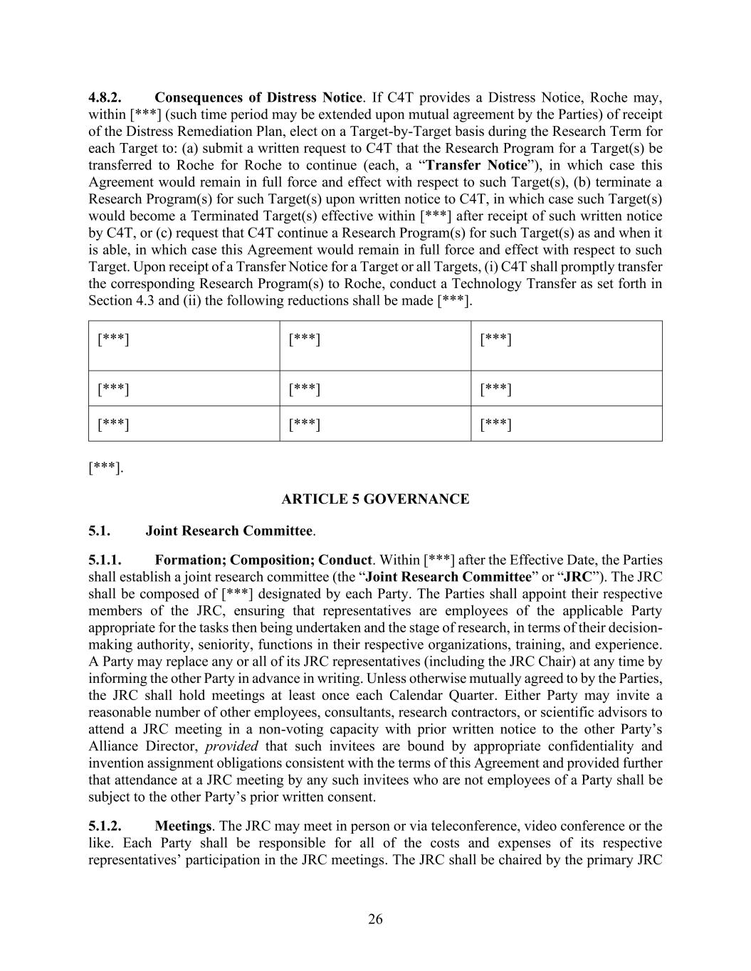
26 4.8.2. Consequences of Distress Notice. If C4T provides a Distress Notice, Roche may, within [***] (such time period may be extended upon mutual agreement by the Parties) of receipt of the Distress Remediation Plan, elect on a Target-by-Target basis during the Research Term for each Target to: (a) submit a written request to C4T that the Research Program for a Target(s) be transferred to Roche for Roche to continue (each, a “Transfer Notice”), in which case this Agreement would remain in full force and effect with respect to such Target(s), (b) terminate a Research Program(s) for such Target(s) upon written notice to C4T, in which case such Target(s) would become a Terminated Target(s) effective within [***] after receipt of such written notice by C4T, or (c) request that C4T continue a Research Program(s) for such Target(s) as and when it is able, in which case this Agreement would remain in full force and effect with respect to such Target. Upon receipt of a Transfer Notice for a Target or all Targets, (i) C4T shall promptly transfer the corresponding Research Program(s) to Roche, conduct a Technology Transfer as set forth in Section 4.3 and (ii) the following reductions shall be made [***]. [***] [***] [***] [***] [***] [***] [***] [***] [***] [***]. ARTICLE 5 GOVERNANCE 5.1. Joint Research Committee. 5.1.1. Formation; Composition; Conduct. Within [***] after the Effective Date, the Parties shall establish a joint research committee (the “Joint Research Committee” or “JRC”). The JRC shall be composed of [***] designated by each Party. The Parties shall appoint their respective members of the JRC, ensuring that representatives are employees of the applicable Party appropriate for the tasks then being undertaken and the stage of research, in terms of their decision- making authority, seniority, functions in their respective organizations, training, and experience. A Party may replace any or all of its JRC representatives (including the JRC Chair) at any time by informing the other Party in advance in writing. Unless otherwise mutually agreed to by the Parties, the JRC shall hold meetings at least once each Calendar Quarter. Either Party may invite a reasonable number of other employees, consultants, research contractors, or scientific advisors to attend a JRC meeting in a non-voting capacity with prior written notice to the other Party’s Alliance Director, provided that such invitees are bound by appropriate confidentiality and invention assignment obligations consistent with the terms of this Agreement and provided further that attendance at a JRC meeting by any such invitees who are not employees of a Party shall be subject to the other Party’s prior written consent. 5.1.2. Meetings. The JRC may meet in person or via teleconference, video conference or the like. Each Party shall be responsible for all of the costs and expenses of its respective representatives’ participation in the JRC meetings. The JRC shall be chaired by the primary JRC

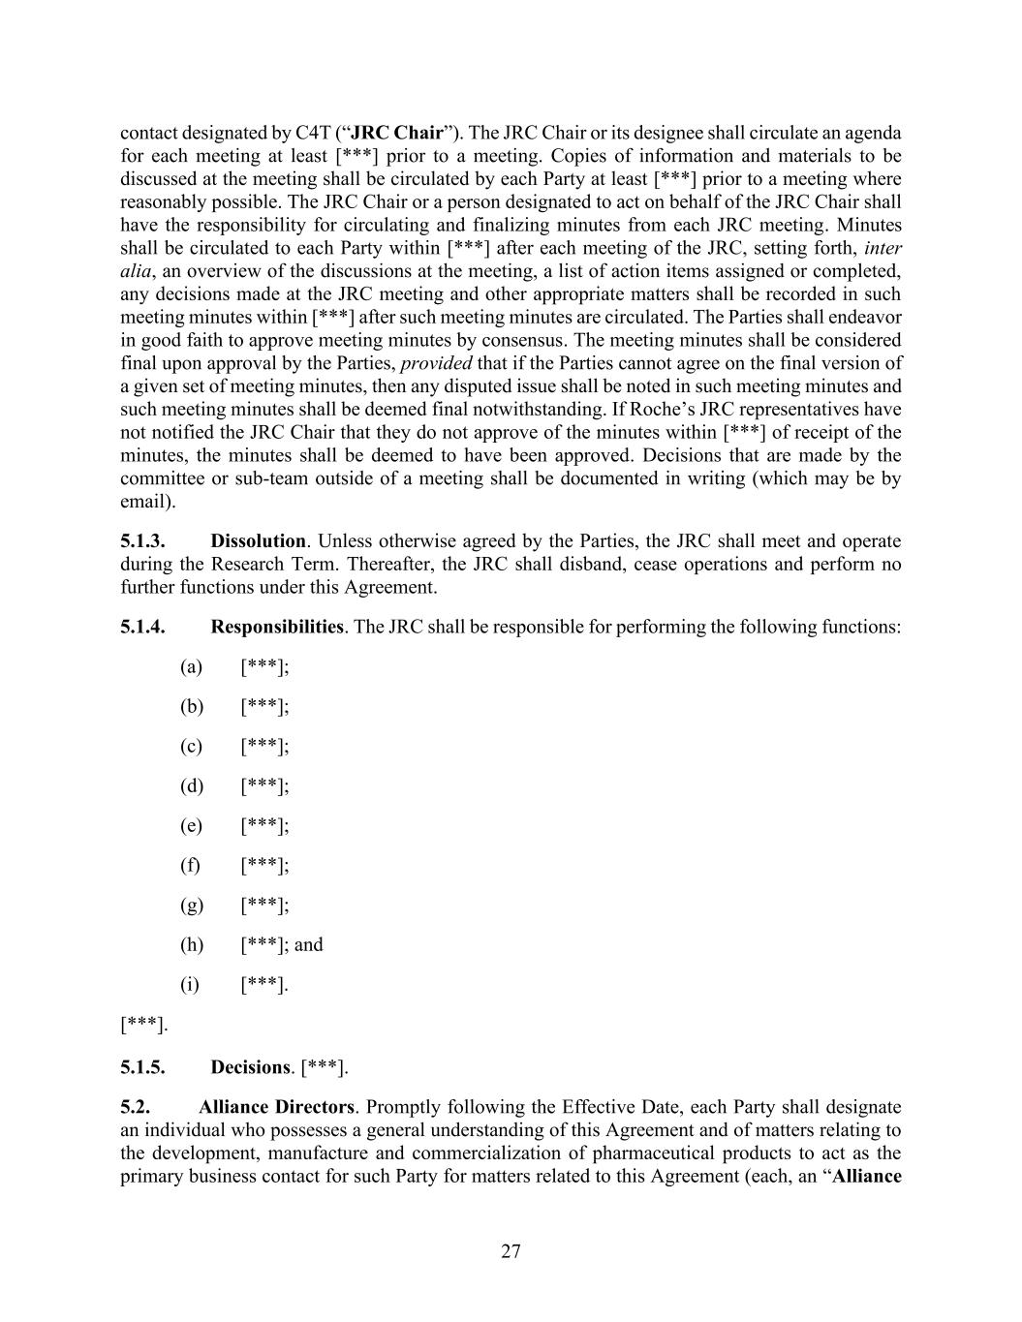
27 contact designated by C4T (“JRC Chair”). The JRC Chair or its designee shall circulate an agenda for each meeting at least [***] prior to a meeting. Copies of information and materials to be discussed at the meeting shall be circulated by each Party at least [***] prior to a meeting where reasonably possible. The JRC Chair or a person designated to act on behalf of the JRC Chair shall have the responsibility for circulating and finalizing minutes from each JRC meeting. Minutes shall be circulated to each Party within [***] after each meeting of the JRC, setting forth, inter alia, an overview of the discussions at the meeting, a list of action items assigned or completed, any decisions made at the JRC meeting and other appropriate matters shall be recorded in such meeting minutes within [***] after such meeting minutes are circulated. The Parties shall endeavor in good faith to approve meeting minutes by consensus. The meeting minutes shall be considered final upon approval by the Parties, provided that if the Parties cannot agree on the final version of a given set of meeting minutes, then any disputed issue shall be noted in such meeting minutes and such meeting minutes shall be deemed final notwithstanding. If Roche’s JRC representatives have not notified the JRC Chair that they do not approve of the minutes within [***] of receipt of the minutes, the minutes shall be deemed to have been approved. Decisions that are made by the committee or sub-team outside of a meeting shall be documented in writing (which may be by email). 5.1.3. Dissolution. Unless otherwise agreed by the Parties, the JRC shall meet and operate during the Research Term. Thereafter, the JRC shall disband, cease operations and perform no further functions under this Agreement. 5.1.4. Responsibilities. The JRC shall be responsible for performing the following functions: (a) [***]; (b) [***]; (c) [***]; (d) [***]; (e) [***]; (f) [***]; (g) [***]; (h) [***]; and (i) [***]. [***]. 5.1.5. Decisions. [***]. 5.2. Alliance Directors. Promptly following the Effective Date, each Party shall designate an individual who possesses a general understanding of this Agreement and of matters relating to the development, manufacture and commercialization of pharmaceutical products to act as the primary business contact for such Party for matters related to this Agreement (each, an “Alliance

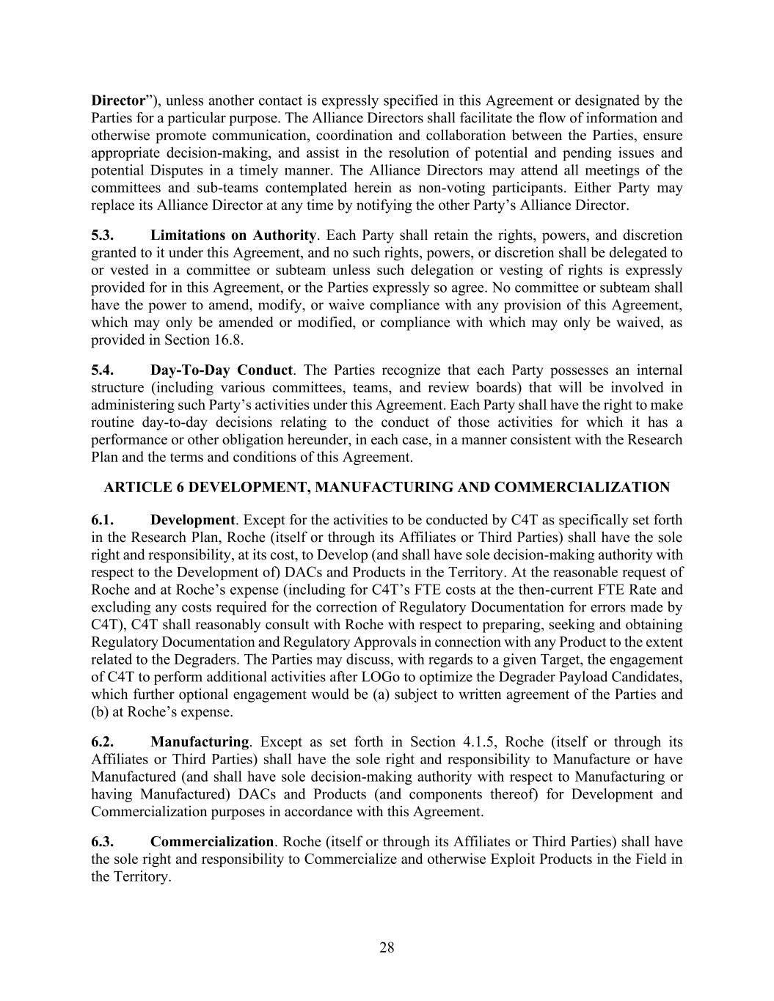
28 Director”), unless another contact is expressly specified in this Agreement or designated by the Parties for a particular purpose. The Alliance Directors shall facilitate the flow of information and otherwise promote communication, coordination and collaboration between the Parties, ensure appropriate decision-making, and assist in the resolution of potential and pending issues and potential Disputes in a timely manner. The Alliance Directors may attend all meetings of the committees and sub-teams contemplated herein as non-voting participants. Either Party may replace its Alliance Director at any time by notifying the other Party’s Alliance Director. 5.3. Limitations on Authority. Each Party shall retain the rights, powers, and discretion granted to it under this Agreement, and no such rights, powers, or discretion shall be delegated to or vested in a committee or subteam unless such delegation or vesting of rights is expressly provided for in this Agreement, or the Parties expressly so agree. No committee or subteam shall have the power to amend, modify, or waive compliance with any provision of this Agreement, which may only be amended or modified, or compliance with which may only be waived, as provided in Section 16.8. 5.4. Day-To-Day Conduct. The Parties recognize that each Party possesses an internal structure (including various committees, teams, and review boards) that will be involved in administering such Party’s activities under this Agreement. Each Party shall have the right to make routine day-to-day decisions relating to the conduct of those activities for which it has a performance or other obligation hereunder, in each case, in a manner consistent with the Research Plan and the terms and conditions of this Agreement. ARTICLE 6 DEVELOPMENT, MANUFACTURING AND COMMERCIALIZATION 6.1. Development. Except for the activities to be conducted by C4T as specifically set forth in the Research Plan, Roche (itself or through its Affiliates or Third Parties) shall have the sole right and responsibility, at its cost, to Develop (and shall have sole decision-making authority with respect to the Development of) DACs and Products in the Territory. At the reasonable request of Roche and at Roche’s expense (including for C4T’s FTE costs at the then-current FTE Rate and excluding any costs required for the correction of Regulatory Documentation for errors made by C4T), C4T shall reasonably consult with Roche with respect to preparing, seeking and obtaining Regulatory Documentation and Regulatory Approvals in connection with any Product to the extent related to the Degraders. The Parties may discuss, with regards to a given Target, the engagement of C4T to perform additional activities after LOGo to optimize the Degrader Payload Candidates, which further optional engagement would be (a) subject to written agreement of the Parties and (b) at Roche’s expense. 6.2. Manufacturing. Except as set forth in Section 4.1.5, Roche (itself or through its Affiliates or Third Parties) shall have the sole right and responsibility to Manufacture or have Manufactured (and shall have sole decision-making authority with respect to Manufacturing or having Manufactured) DACs and Products (and components thereof) for Development and Commercialization purposes in accordance with this Agreement. 6.3. Commercialization. Roche (itself or through its Affiliates or Third Parties) shall have the sole right and responsibility to Commercialize and otherwise Exploit Products in the Field in the Territory.

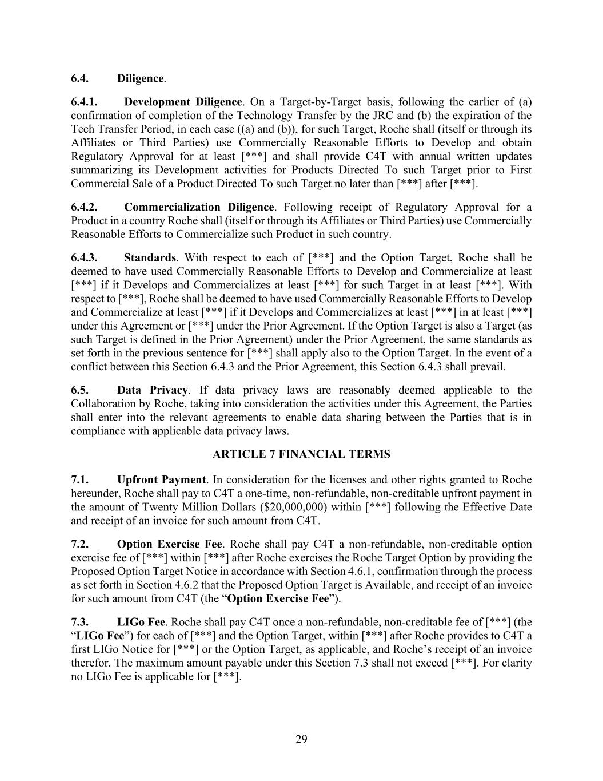
29 6.4. Diligence. 6.4.1. Development Diligence. On a Target-by-Target basis, following the earlier of (a) confirmation of completion of the Technology Transfer by the JRC and (b) the expiration of the Tech Transfer Period, in each case ((a) and (b)), for such Target, Roche shall (itself or through its Affiliates or Third Parties) use Commercially Reasonable Efforts to Develop and obtain Regulatory Approval for at least [***] and shall provide C4T with annual written updates summarizing its Development activities for Products Directed To such Target prior to First Commercial Sale of a Product Directed To such Target no later than [***] after [***]. 6.4.2. Commercialization Diligence. Following receipt of Regulatory Approval for a Product in a country Roche shall (itself or through its Affiliates or Third Parties) use Commercially Reasonable Efforts to Commercialize such Product in such country. 6.4.3. Standards. With respect to each of [***] and the Option Target, Roche shall be deemed to have used Commercially Reasonable Efforts to Develop and Commercialize at least [***] if it Develops and Commercializes at least [***] for such Target in at least [***]. With respect to [***], Roche shall be deemed to have used Commercially Reasonable Efforts to Develop and Commercialize at least [***] if it Develops and Commercializes at least [***] in at least [***] under this Agreement or [***] under the Prior Agreement. If the Option Target is also a Target (as such Target is defined in the Prior Agreement) under the Prior Agreement, the same standards as set forth in the previous sentence for [***] shall apply also to the Option Target. In the event of a conflict between this Section 6.4.3 and the Prior Agreement, this Section 6.4.3 shall prevail. 6.5. Data Privacy. If data privacy laws are reasonably deemed applicable to the Collaboration by Roche, taking into consideration the activities under this Agreement, the Parties shall enter into the relevant agreements to enable data sharing between the Parties that is in compliance with applicable data privacy laws. ARTICLE 7 FINANCIAL TERMS 7.1. Upfront Payment. In consideration for the licenses and other rights granted to Roche hereunder, Roche shall pay to C4T a one-time, non-refundable, non-creditable upfront payment in the amount of Twenty Million Dollars ($20,000,000) within [***] following the Effective Date and receipt of an invoice for such amount from C4T. 7.2. Option Exercise Fee. Roche shall pay C4T a non-refundable, non-creditable option exercise fee of [***] within [***] after Roche exercises the Roche Target Option by providing the Proposed Option Target Notice in accordance with Section 4.6.1, confirmation through the process as set forth in Section 4.6.2 that the Proposed Option Target is Available, and receipt of an invoice for such amount from C4T (the “Option Exercise Fee”). 7.3. LIGo Fee. Roche shall pay C4T once a non-refundable, non-creditable fee of [***] (the “LIGo Fee”) for each of [***] and the Option Target, within [***] after Roche provides to C4T a first LIGo Notice for [***] or the Option Target, as applicable, and Roche’s receipt of an invoice therefor. The maximum amount payable under this Section 7.3 shall not exceed [***]. For clarity no LIGo Fee is applicable for [***].

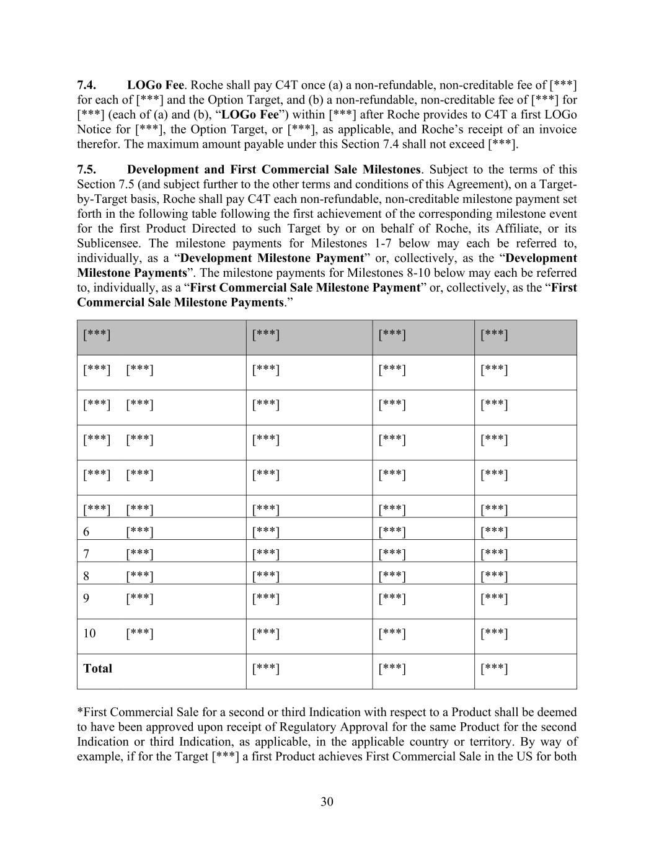
30 7.4. LOGo Fee. Roche shall pay C4T once (a) a non-refundable, non-creditable fee of [***] for each of [***] and the Option Target, and (b) a non-refundable, non-creditable fee of [***] for [***] (each of (a) and (b), “LOGo Fee”) within [***] after Roche provides to C4T a first LOGo Notice for [***], the Option Target, or [***], as applicable, and Roche’s receipt of an invoice therefor. The maximum amount payable under this Section 7.4 shall not exceed [***]. 7.5. Development and First Commercial Sale Milestones. Subject to the terms of this Section 7.5 (and subject further to the other terms and conditions of this Agreement), on a Target- by-Target basis, Roche shall pay C4T each non-refundable, non-creditable milestone payment set forth in the following table following the first achievement of the corresponding milestone event for the first Product Directed to such Target by or on behalf of Roche, its Affiliate, or its Sublicensee. The milestone payments for Milestones 1-7 below may each be referred to, individually, as a “Development Milestone Payment” or, collectively, as the “Development Milestone Payments”. The milestone payments for Milestones 8-10 below may each be referred to, individually, as a “First Commercial Sale Milestone Payment” or, collectively, as the “First Commercial Sale Milestone Payments.” [***] [***] [***] [***] [***] [***] [***] [***] [***] [***] [***] [***] [***] [***] [***] [***] [***] [***] [***] [***] [***] [***] [***] [***] [***] [***] [***] [***] [***] 6 [***] [***] [***] [***] 7 [***] [***] [***] [***] 8 [***] [***] [***] [***] 9 [***] [***] [***] [***] 10 [***] [***] [***] [***] Total [***] [***] [***] *First Commercial Sale for a second or third Indication with respect to a Product shall be deemed to have been approved upon receipt of Regulatory Approval for the same Product for the second Indication or third Indication, as applicable, in the applicable country or territory. By way of example, if for the Target [***] a first Product achieves First Commercial Sale in the US for both

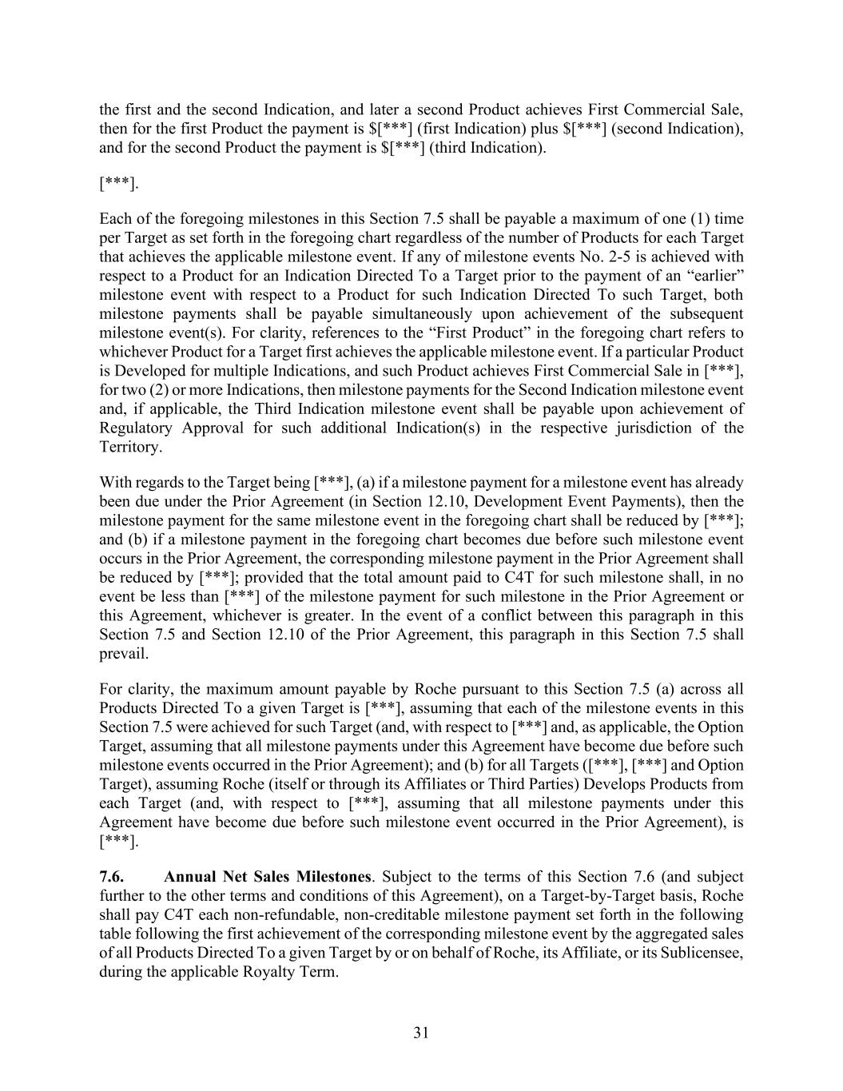
31 the first and the second Indication, and later a second Product achieves First Commercial Sale, then for the first Product the payment is $[***] (first Indication) plus $[***] (second Indication), and for the second Product the payment is $[***] (third Indication). [***]. Each of the foregoing milestones in this Section 7.5 shall be payable a maximum of one (1) time per Target as set forth in the foregoing chart regardless of the number of Products for each Target that achieves the applicable milestone event. If any of milestone events No. 2-5 is achieved with respect to a Product for an Indication Directed To a Target prior to the payment of an “earlier” milestone event with respect to a Product for such Indication Directed To such Target, both milestone payments shall be payable simultaneously upon achievement of the subsequent milestone event(s). For clarity, references to the “First Product” in the foregoing chart refers to whichever Product for a Target first achieves the applicable milestone event. If a particular Product is Developed for multiple Indications, and such Product achieves First Commercial Sale in [***], for two (2) or more Indications, then milestone payments for the Second Indication milestone event and, if applicable, the Third Indication milestone event shall be payable upon achievement of Regulatory Approval for such additional Indication(s) in the respective jurisdiction of the Territory. With regards to the Target being [***], (a) if a milestone payment for a milestone event has already been due under the Prior Agreement (in Section 12.10, Development Event Payments), then the milestone payment for the same milestone event in the foregoing chart shall be reduced by [***]; and (b) if a milestone payment in the foregoing chart becomes due before such milestone event occurs in the Prior Agreement, the corresponding milestone payment in the Prior Agreement shall be reduced by [***]; provided that the total amount paid to C4T for such milestone shall, in no event be less than [***] of the milestone payment for such milestone in the Prior Agreement or this Agreement, whichever is greater. In the event of a conflict between this paragraph in this Section 7.5 and Section 12.10 of the Prior Agreement, this paragraph in this Section 7.5 shall prevail. For clarity, the maximum amount payable by Roche pursuant to this Section 7.5 (a) across all Products Directed To a given Target is [***], assuming that each of the milestone events in this Section 7.5 were achieved for such Target (and, with respect to [***] and, as applicable, the Option Target, assuming that all milestone payments under this Agreement have become due before such milestone events occurred in the Prior Agreement); and (b) for all Targets ([***], [***] and Option Target), assuming Roche (itself or through its Affiliates or Third Parties) Develops Products from each Target (and, with respect to [***], assuming that all milestone payments under this Agreement have become due before such milestone event occurred in the Prior Agreement), is [***]. 7.6. Annual Net Sales Milestones. Subject to the terms of this Section 7.6 (and subject further to the other terms and conditions of this Agreement), on a Target-by-Target basis, Roche shall pay C4T each non-refundable, non-creditable milestone payment set forth in the following table following the first achievement of the corresponding milestone event by the aggregated sales of all Products Directed To a given Target by or on behalf of Roche, its Affiliate, or its Sublicensee, during the applicable Royalty Term.

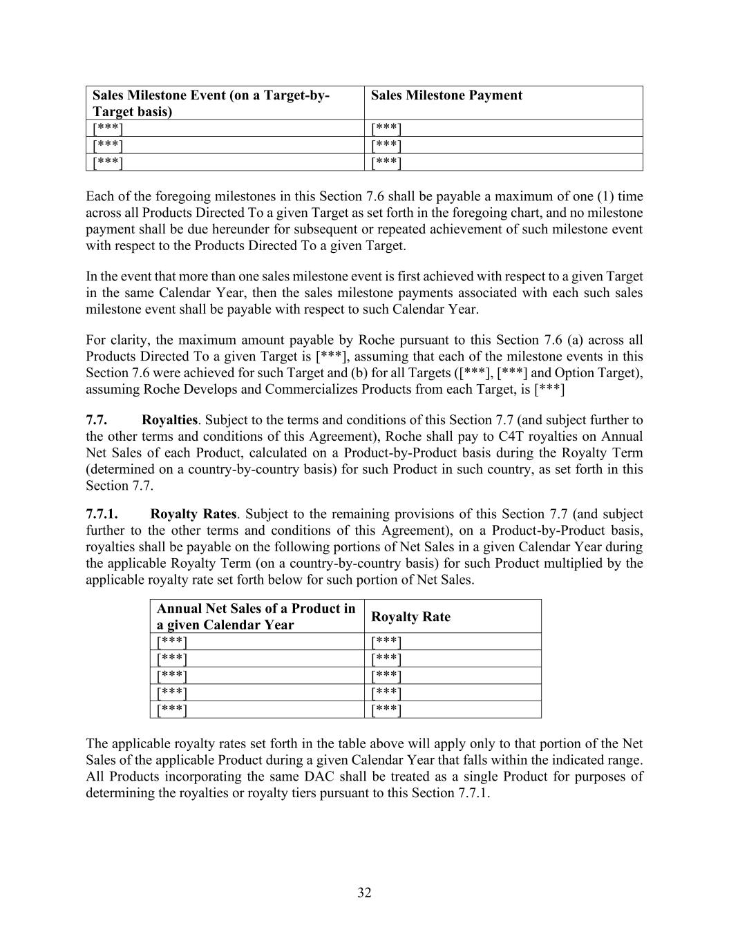
32 Sales Milestone Event (on a Target-by- Target basis) Sales Milestone Payment [***] [***] [***] [***] [***] [***] Each of the foregoing milestones in this Section 7.6 shall be payable a maximum of one (1) time across all Products Directed To a given Target as set forth in the foregoing chart, and no milestone payment shall be due hereunder for subsequent or repeated achievement of such milestone event with respect to the Products Directed To a given Target. In the event that more than one sales milestone event is first achieved with respect to a given Target in the same Calendar Year, then the sales milestone payments associated with each such sales milestone event shall be payable with respect to such Calendar Year. For clarity, the maximum amount payable by Roche pursuant to this Section 7.6 (a) across all Products Directed To a given Target is [***], assuming that each of the milestone events in this Section 7.6 were achieved for such Target and (b) for all Targets ([***], [***] and Option Target), assuming Roche Develops and Commercializes Products from each Target, is [***] 7.7. Royalties. Subject to the terms and conditions of this Section 7.7 (and subject further to the other terms and conditions of this Agreement), Roche shall pay to C4T royalties on Annual Net Sales of each Product, calculated on a Product-by-Product basis during the Royalty Term (determined on a country-by-country basis) for such Product in such country, as set forth in this Section 7.7. 7.7.1. Royalty Rates. Subject to the remaining provisions of this Section 7.7 (and subject further to the other terms and conditions of this Agreement), on a Product-by-Product basis, royalties shall be payable on the following portions of Net Sales in a given Calendar Year during the applicable Royalty Term (on a country-by-country basis) for such Product multiplied by the applicable royalty rate set forth below for such portion of Net Sales. Annual Net Sales of a Product in a given Calendar Year Royalty Rate [***] [***] [***] [***] [***] [***] [***] [***] [***] [***] The applicable royalty rates set forth in the table above will apply only to that portion of the Net Sales of the applicable Product during a given Calendar Year that falls within the indicated range. All Products incorporating the same DAC shall be treated as a single Product for purposes of determining the royalties or royalty tiers pursuant to this Section 7.7.1.

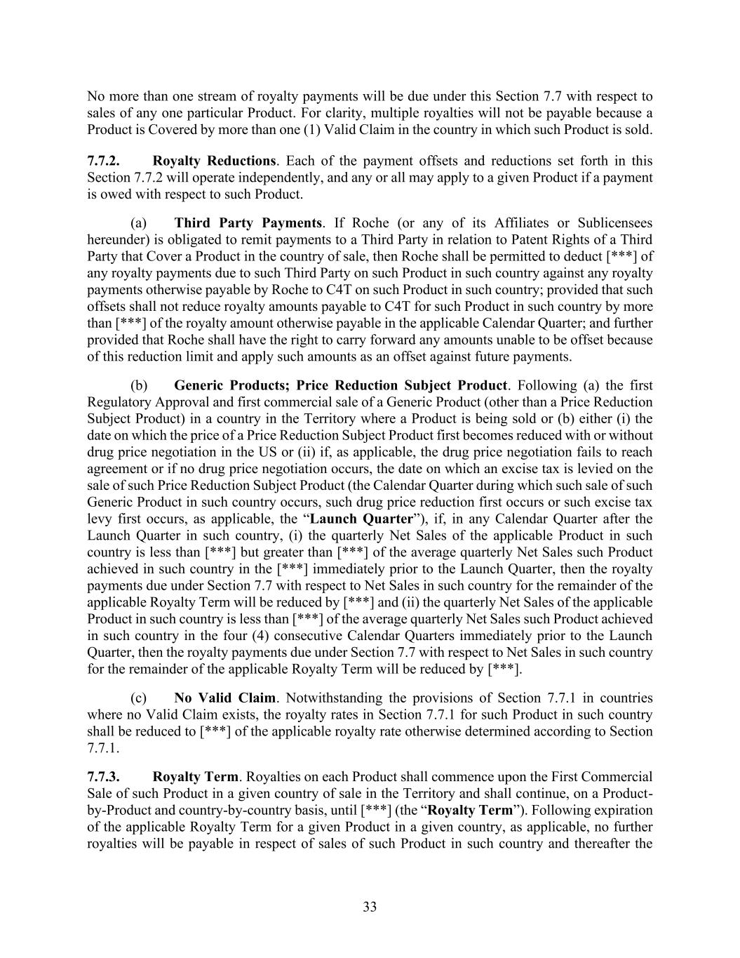
33 No more than one stream of royalty payments will be due under this Section 7.7 with respect to sales of any one particular Product. For clarity, multiple royalties will not be payable because a Product is Covered by more than one (1) Valid Claim in the country in which such Product is sold. 7.7.2. Royalty Reductions. Each of the payment offsets and reductions set forth in this Section 7.7.2 will operate independently, and any or all may apply to a given Product if a payment is owed with respect to such Product. (a) Third Party Payments. If Roche (or any of its Affiliates or Sublicensees hereunder) is obligated to remit payments to a Third Party in relation to Patent Rights of a Third Party that Cover a Product in the country of sale, then Roche shall be permitted to deduct [***] of any royalty payments due to such Third Party on such Product in such country against any royalty payments otherwise payable by Roche to C4T on such Product in such country; provided that such offsets shall not reduce royalty amounts payable to C4T for such Product in such country by more than [***] of the royalty amount otherwise payable in the applicable Calendar Quarter; and further provided that Roche shall have the right to carry forward any amounts unable to be offset because of this reduction limit and apply such amounts as an offset against future payments. (b) Generic Products; Price Reduction Subject Product. Following (a) the first Regulatory Approval and first commercial sale of a Generic Product (other than a Price Reduction Subject Product) in a country in the Territory where a Product is being sold or (b) either (i) the date on which the price of a Price Reduction Subject Product first becomes reduced with or without drug price negotiation in the US or (ii) if, as applicable, the drug price negotiation fails to reach agreement or if no drug price negotiation occurs, the date on which an excise tax is levied on the sale of such Price Reduction Subject Product (the Calendar Quarter during which such sale of such Generic Product in such country occurs, such drug price reduction first occurs or such excise tax levy first occurs, as applicable, the “Launch Quarter”), if, in any Calendar Quarter after the Launch Quarter in such country, (i) the quarterly Net Sales of the applicable Product in such country is less than [***] but greater than [***] of the average quarterly Net Sales such Product achieved in such country in the [***] immediately prior to the Launch Quarter, then the royalty payments due under Section 7.7 with respect to Net Sales in such country for the remainder of the applicable Royalty Term will be reduced by [***] and (ii) the quarterly Net Sales of the applicable Product in such country is less than [***] of the average quarterly Net Sales such Product achieved in such country in the four (4) consecutive Calendar Quarters immediately prior to the Launch Quarter, then the royalty payments due under Section 7.7 with respect to Net Sales in such country for the remainder of the applicable Royalty Term will be reduced by [***]. (c) No Valid Claim. Notwithstanding the provisions of Section 7.7.1 in countries where no Valid Claim exists, the royalty rates in Section 7.7.1 for such Product in such country shall be reduced to [***] of the applicable royalty rate otherwise determined according to Section 7.7.1. 7.7.3. Royalty Term. Royalties on each Product shall commence upon the First Commercial Sale of such Product in a given country of sale in the Territory and shall continue, on a Product- by-Product and country-by-country basis, until [***] (the “Royalty Term”). Following expiration of the applicable Royalty Term for a given Product in a given country, as applicable, no further royalties will be payable in respect of sales of such Product in such country and thereafter the

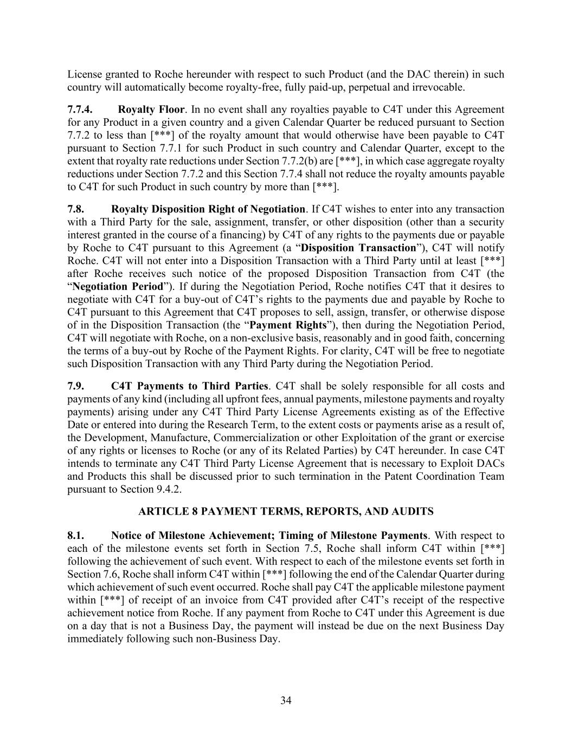
34 License granted to Roche hereunder with respect to such Product (and the DAC therein) in such country will automatically become royalty-free, fully paid-up, perpetual and irrevocable. 7.7.4. Royalty Floor. In no event shall any royalties payable to C4T under this Agreement for any Product in a given country and a given Calendar Quarter be reduced pursuant to Section 7.7.2 to less than [***] of the royalty amount that would otherwise have been payable to C4T pursuant to Section 7.7.1 for such Product in such country and Calendar Quarter, except to the extent that royalty rate reductions under Section 7.7.2(b) are [***], in which case aggregate royalty reductions under Section 7.7.2 and this Section 7.7.4 shall not reduce the royalty amounts payable to C4T for such Product in such country by more than [***]. 7.8. Royalty Disposition Right of Negotiation. If C4T wishes to enter into any transaction with a Third Party for the sale, assignment, transfer, or other disposition (other than a security interest granted in the course of a financing) by C4T of any rights to the payments due or payable by Roche to C4T pursuant to this Agreement (a “Disposition Transaction”), C4T will notify Roche. C4T will not enter into a Disposition Transaction with a Third Party until at least [***] after Roche receives such notice of the proposed Disposition Transaction from C4T (the “Negotiation Period”). If during the Negotiation Period, Roche notifies C4T that it desires to negotiate with C4T for a buy-out of C4T’s rights to the payments due and payable by Roche to C4T pursuant to this Agreement that C4T proposes to sell, assign, transfer, or otherwise dispose of in the Disposition Transaction (the “Payment Rights”), then during the Negotiation Period, C4T will negotiate with Roche, on a non-exclusive basis, reasonably and in good faith, concerning the terms of a buy-out by Roche of the Payment Rights. For clarity, C4T will be free to negotiate such Disposition Transaction with any Third Party during the Negotiation Period. 7.9. C4T Payments to Third Parties. C4T shall be solely responsible for all costs and payments of any kind (including all upfront fees, annual payments, milestone payments and royalty payments) arising under any C4T Third Party License Agreements existing as of the Effective Date or entered into during the Research Term, to the extent costs or payments arise as a result of, the Development, Manufacture, Commercialization or other Exploitation of the grant or exercise of any rights or licenses to Roche (or any of its Related Parties) by C4T hereunder. In case C4T intends to terminate any C4T Third Party License Agreement that is necessary to Exploit DACs and Products this shall be discussed prior to such termination in the Patent Coordination Team pursuant to Section 9.4.2. ARTICLE 8 PAYMENT TERMS, REPORTS, AND AUDITS 8.1. Notice of Milestone Achievement; Timing of Milestone Payments. With respect to each of the milestone events set forth in Section 7.5, Roche shall inform C4T within [***] following the achievement of such event. With respect to each of the milestone events set forth in Section 7.6, Roche shall inform C4T within [***] following the end of the Calendar Quarter during which achievement of such event occurred. Roche shall pay C4T the applicable milestone payment within [***] of receipt of an invoice from C4T provided after C4T’s receipt of the respective achievement notice from Roche. If any payment from Roche to C4T under this Agreement is due on a day that is not a Business Day, the payment will instead be due on the next Business Day immediately following such non-Business Day.

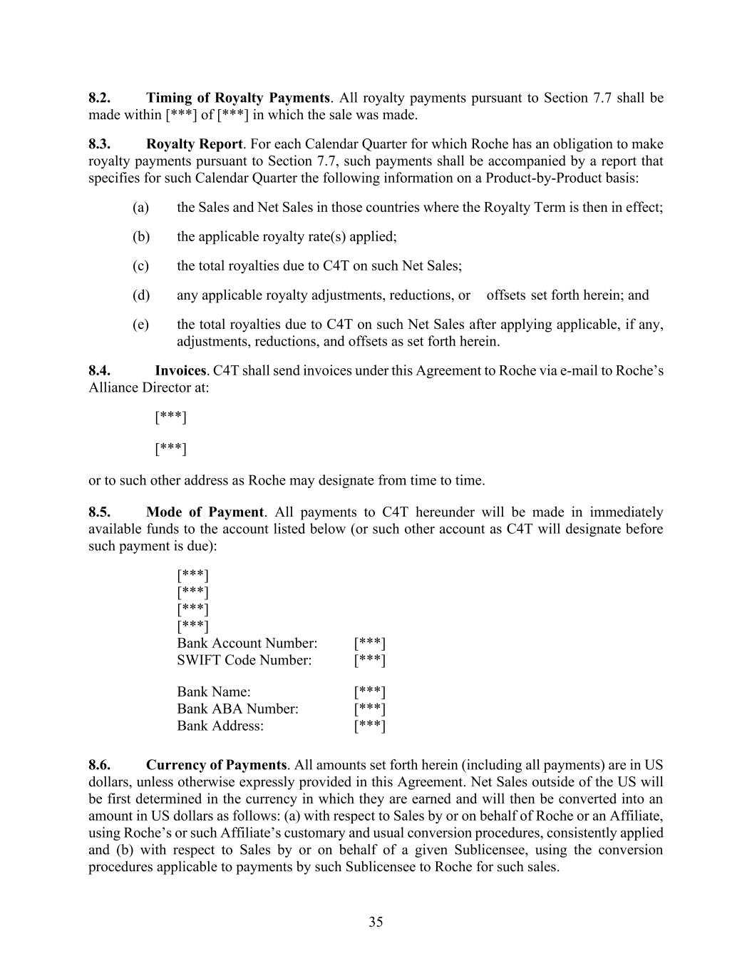
35 8.2. Timing of Royalty Payments. All royalty payments pursuant to Section 7.7 shall be made within [***] of [***] in which the sale was made. 8.3. Royalty Report. For each Calendar Quarter for which Roche has an obligation to make royalty payments pursuant to Section 7.7, such payments shall be accompanied by a report that specifies for such Calendar Quarter the following information on a Product-by-Product basis: (a) the Sales and Net Sales in those countries where the Royalty Term is then in effect; (b) the applicable royalty rate(s) applied; (c) the total royalties due to C4T on such Net Sales; (d) any applicable royalty adjustments, reductions, or offsets set forth herein; and (e) the total royalties due to C4T on such Net Sales after applying applicable, if any, adjustments, reductions, and offsets as set forth herein. 8.4. Invoices. C4T shall send invoices under this Agreement to Roche via e-mail to Roche’s Alliance Director at: [***] [***] or to such other address as Roche may designate from time to time. 8.5. Mode of Payment. All payments to C4T hereunder will be made in immediately available funds to the account listed below (or such other account as C4T will designate before such payment is due): [***] [***] [***] [***] Bank Account Number: [***] SWIFT Code Number: [***] Bank Name: [***] Bank ABA Number: [***] Bank Address: [***] 8.6. Currency of Payments. All amounts set forth herein (including all payments) are in US dollars, unless otherwise expressly provided in this Agreement. Net Sales outside of the US will be first determined in the currency in which they are earned and will then be converted into an amount in US dollars as follows: (a) with respect to Sales by or on behalf of Roche or an Affiliate, using Roche’s or such Affiliate’s customary and usual conversion procedures, consistently applied and (b) with respect to Sales by or on behalf of a given Sublicensee, using the conversion procedures applicable to payments by such Sublicensee to Roche for such sales.

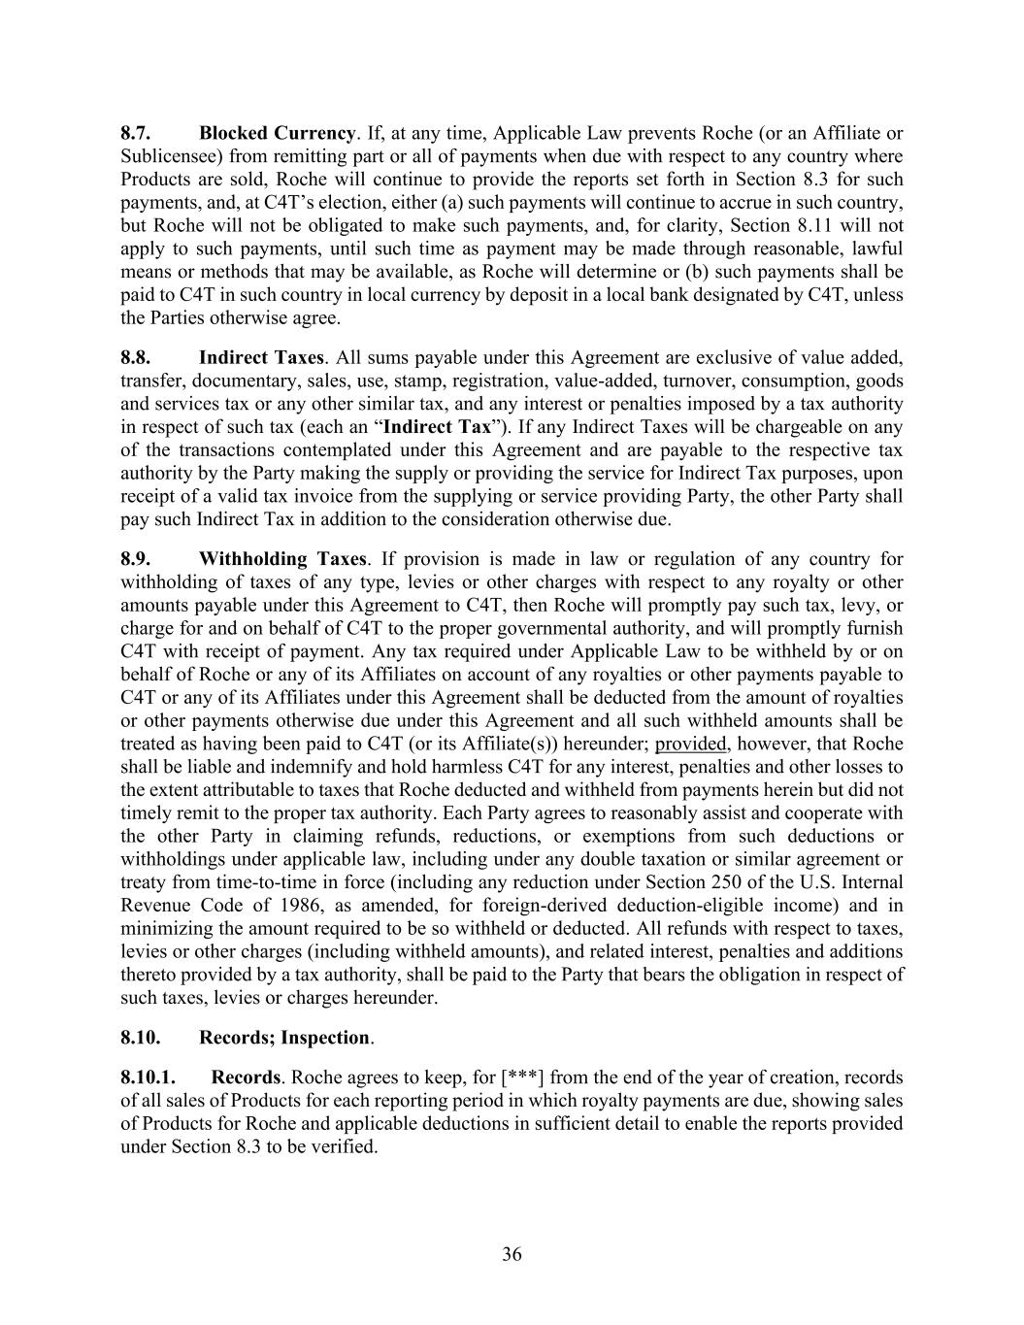
36 8.7. Blocked Currency. If, at any time, Applicable Law prevents Roche (or an Affiliate or Sublicensee) from remitting part or all of payments when due with respect to any country where Products are sold, Roche will continue to provide the reports set forth in Section 8.3 for such payments, and, at C4T’s election, either (a) such payments will continue to accrue in such country, but Roche will not be obligated to make such payments, and, for clarity, Section 8.11 will not apply to such payments, until such time as payment may be made through reasonable, lawful means or methods that may be available, as Roche will determine or (b) such payments shall be paid to C4T in such country in local currency by deposit in a local bank designated by C4T, unless the Parties otherwise agree. 8.8. Indirect Taxes. All sums payable under this Agreement are exclusive of value added, transfer, documentary, sales, use, stamp, registration, value-added, turnover, consumption, goods and services tax or any other similar tax, and any interest or penalties imposed by a tax authority in respect of such tax (each an “Indirect Tax”). If any Indirect Taxes will be chargeable on any of the transactions contemplated under this Agreement and are payable to the respective tax authority by the Party making the supply or providing the service for Indirect Tax purposes, upon receipt of a valid tax invoice from the supplying or service providing Party, the other Party shall pay such Indirect Tax in addition to the consideration otherwise due. 8.9. Withholding Taxes. If provision is made in law or regulation of any country for withholding of taxes of any type, levies or other charges with respect to any royalty or other amounts payable under this Agreement to C4T, then Roche will promptly pay such tax, levy, or charge for and on behalf of C4T to the proper governmental authority, and will promptly furnish C4T with receipt of payment. Any tax required under Applicable Law to be withheld by or on behalf of Roche or any of its Affiliates on account of any royalties or other payments payable to C4T or any of its Affiliates under this Agreement shall be deducted from the amount of royalties or other payments otherwise due under this Agreement and all such withheld amounts shall be treated as having been paid to C4T (or its Affiliate(s)) hereunder; provided, however, that Roche shall be liable and indemnify and hold harmless C4T for any interest, penalties and other losses to the extent attributable to taxes that Roche deducted and withheld from payments herein but did not timely remit to the proper tax authority. Each Party agrees to reasonably assist and cooperate with the other Party in claiming refunds, reductions, or exemptions from such deductions or withholdings under applicable law, including under any double taxation or similar agreement or treaty from time-to-time in force (including any reduction under Section 250 of the U.S. Internal Revenue Code of 1986, as amended, for foreign-derived deduction-eligible income) and in minimizing the amount required to be so withheld or deducted. All refunds with respect to taxes, levies or other charges (including withheld amounts), and related interest, penalties and additions thereto provided by a tax authority, shall be paid to the Party that bears the obligation in respect of such taxes, levies or charges hereunder. 8.10. Records; Inspection. 8.10.1. Records. Roche agrees to keep, for [***] from the end of the year of creation, records of all sales of Products for each reporting period in which royalty payments are due, showing sales of Products for Roche and applicable deductions in sufficient detail to enable the reports provided under Section 8.3 to be verified.

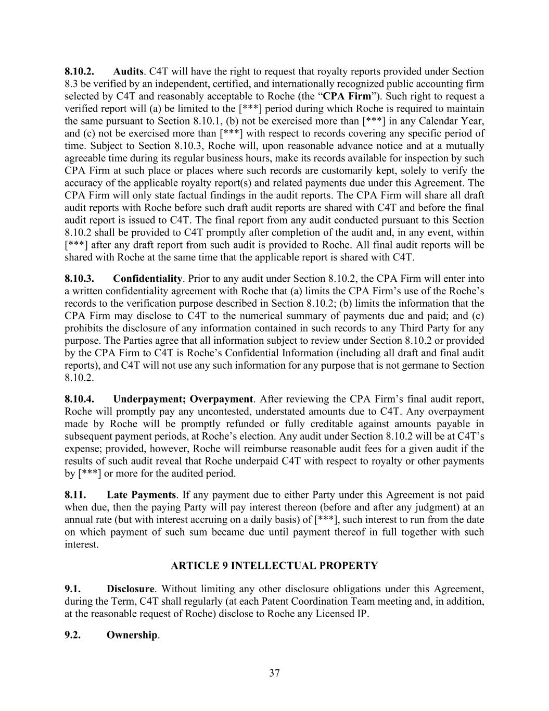
37 8.10.2. Audits. C4T will have the right to request that royalty reports provided under Section 8.3 be verified by an independent, certified, and internationally recognized public accounting firm selected by C4T and reasonably acceptable to Roche (the “CPA Firm”). Such right to request a verified report will (a) be limited to the [***] period during which Roche is required to maintain the same pursuant to Section 8.10.1, (b) not be exercised more than [***] in any Calendar Year, and (c) not be exercised more than [***] with respect to records covering any specific period of time. Subject to Section 8.10.3, Roche will, upon reasonable advance notice and at a mutually agreeable time during its regular business hours, make its records available for inspection by such CPA Firm at such place or places where such records are customarily kept, solely to verify the accuracy of the applicable royalty report(s) and related payments due under this Agreement. The CPA Firm will only state factual findings in the audit reports. The CPA Firm will share all draft audit reports with Roche before such draft audit reports are shared with C4T and before the final audit report is issued to C4T. The final report from any audit conducted pursuant to this Section 8.10.2 shall be provided to C4T promptly after completion of the audit and, in any event, within [***] after any draft report from such audit is provided to Roche. All final audit reports will be shared with Roche at the same time that the applicable report is shared with C4T. 8.10.3. Confidentiality. Prior to any audit under Section 8.10.2, the CPA Firm will enter into a written confidentiality agreement with Roche that (a) limits the CPA Firm’s use of the Roche’s records to the verification purpose described in Section 8.10.2; (b) limits the information that the CPA Firm may disclose to C4T to the numerical summary of payments due and paid; and (c) prohibits the disclosure of any information contained in such records to any Third Party for any purpose. The Parties agree that all information subject to review under Section 8.10.2 or provided by the CPA Firm to C4T is Roche’s Confidential Information (including all draft and final audit reports), and C4T will not use any such information for any purpose that is not germane to Section 8.10.2. 8.10.4. Underpayment; Overpayment. After reviewing the CPA Firm’s final audit report, Roche will promptly pay any uncontested, understated amounts due to C4T. Any overpayment made by Roche will be promptly refunded or fully creditable against amounts payable in subsequent payment periods, at Roche’s election. Any audit under Section 8.10.2 will be at C4T’s expense; provided, however, Roche will reimburse reasonable audit fees for a given audit if the results of such audit reveal that Roche underpaid C4T with respect to royalty or other payments by [***] or more for the audited period. 8.11. Late Payments. If any payment due to either Party under this Agreement is not paid when due, then the paying Party will pay interest thereon (before and after any judgment) at an annual rate (but with interest accruing on a daily basis) of [***], such interest to run from the date on which payment of such sum became due until payment thereof in full together with such interest. ARTICLE 9 INTELLECTUAL PROPERTY 9.1. Disclosure. Without limiting any other disclosure obligations under this Agreement, during the Term, C4T shall regularly (at each Patent Coordination Team meeting and, in addition, at the reasonable request of Roche) disclose to Roche any Licensed IP. 9.2. Ownership.

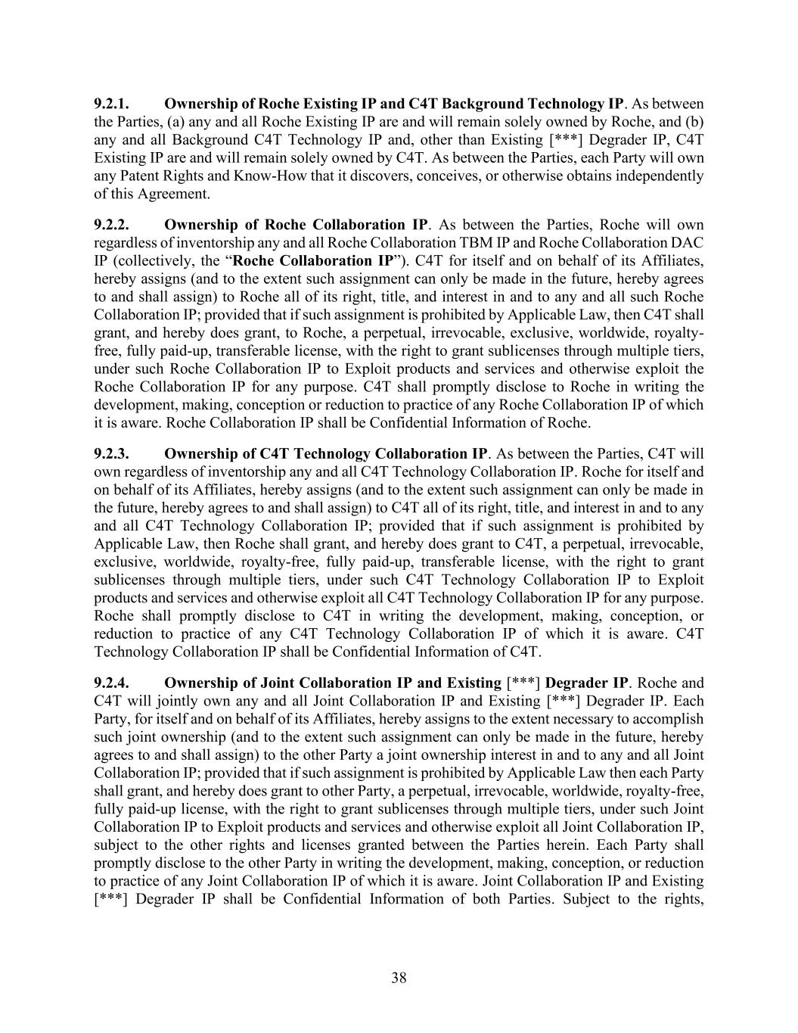
38 9.2.1. Ownership of Roche Existing IP and C4T Background Technology IP. As between the Parties, (a) any and all Roche Existing IP are and will remain solely owned by Roche, and (b) any and all Background C4T Technology IP and, other than Existing [***] Degrader IP, C4T Existing IP are and will remain solely owned by C4T. As between the Parties, each Party will own any Patent Rights and Know-How that it discovers, conceives, or otherwise obtains independently of this Agreement. 9.2.2. Ownership of Roche Collaboration IP. As between the Parties, Roche will own regardless of inventorship any and all Roche Collaboration TBM IP and Roche Collaboration DAC IP (collectively, the “Roche Collaboration IP”). C4T for itself and on behalf of its Affiliates, hereby assigns (and to the extent such assignment can only be made in the future, hereby agrees to and shall assign) to Roche all of its right, title, and interest in and to any and all such Roche Collaboration IP; provided that if such assignment is prohibited by Applicable Law, then C4T shall grant, and hereby does grant, to Roche, a perpetual, irrevocable, exclusive, worldwide, royalty- free, fully paid-up, transferable license, with the right to grant sublicenses through multiple tiers, under such Roche Collaboration IP to Exploit products and services and otherwise exploit the Roche Collaboration IP for any purpose. C4T shall promptly disclose to Roche in writing the development, making, conception or reduction to practice of any Roche Collaboration IP of which it is aware. Roche Collaboration IP shall be Confidential Information of Roche. 9.2.3. Ownership of C4T Technology Collaboration IP. As between the Parties, C4T will own regardless of inventorship any and all C4T Technology Collaboration IP. Roche for itself and on behalf of its Affiliates, hereby assigns (and to the extent such assignment can only be made in the future, hereby agrees to and shall assign) to C4T all of its right, title, and interest in and to any and all C4T Technology Collaboration IP; provided that if such assignment is prohibited by Applicable Law, then Roche shall grant, and hereby does grant to C4T, a perpetual, irrevocable, exclusive, worldwide, royalty-free, fully paid-up, transferable license, with the right to grant sublicenses through multiple tiers, under such C4T Technology Collaboration IP to Exploit products and services and otherwise exploit all C4T Technology Collaboration IP for any purpose. Roche shall promptly disclose to C4T in writing the development, making, conception, or reduction to practice of any C4T Technology Collaboration IP of which it is aware. C4T Technology Collaboration IP shall be Confidential Information of C4T. 9.2.4. Ownership of Joint Collaboration IP and Existing [***] Degrader IP. Roche and C4T will jointly own any and all Joint Collaboration IP and Existing [***] Degrader IP. Each Party, for itself and on behalf of its Affiliates, hereby assigns to the extent necessary to accomplish such joint ownership (and to the extent such assignment can only be made in the future, hereby agrees to and shall assign) to the other Party a joint ownership interest in and to any and all Joint Collaboration IP; provided that if such assignment is prohibited by Applicable Law then each Party shall grant, and hereby does grant to other Party, a perpetual, irrevocable, worldwide, royalty-free, fully paid-up license, with the right to grant sublicenses through multiple tiers, under such Joint Collaboration IP to Exploit products and services and otherwise exploit all Joint Collaboration IP, subject to the other rights and licenses granted between the Parties herein. Each Party shall promptly disclose to the other Party in writing the development, making, conception, or reduction to practice of any Joint Collaboration IP of which it is aware. Joint Collaboration IP and Existing [***] Degrader IP shall be Confidential Information of both Parties. Subject to the rights,

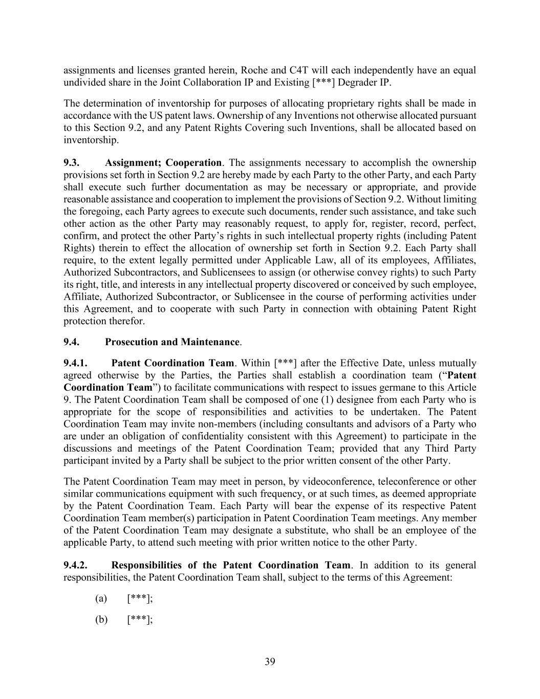
39 assignments and licenses granted herein, Roche and C4T will each independently have an equal undivided share in the Joint Collaboration IP and Existing [***] Degrader IP. The determination of inventorship for purposes of allocating proprietary rights shall be made in accordance with the US patent laws. Ownership of any Inventions not otherwise allocated pursuant to this Section 9.2, and any Patent Rights Covering such Inventions, shall be allocated based on inventorship. 9.3. Assignment; Cooperation. The assignments necessary to accomplish the ownership provisions set forth in Section 9.2 are hereby made by each Party to the other Party, and each Party shall execute such further documentation as may be necessary or appropriate, and provide reasonable assistance and cooperation to implement the provisions of Section 9.2. Without limiting the foregoing, each Party agrees to execute such documents, render such assistance, and take such other action as the other Party may reasonably request, to apply for, register, record, perfect, confirm, and protect the other Party’s rights in such intellectual property rights (including Patent Rights) therein to effect the allocation of ownership set forth in Section 9.2. Each Party shall require, to the extent legally permitted under Applicable Law, all of its employees, Affiliates, Authorized Subcontractors, and Sublicensees to assign (or otherwise convey rights) to such Party its right, title, and interests in any intellectual property discovered or conceived by such employee, Affiliate, Authorized Subcontractor, or Sublicensee in the course of performing activities under this Agreement, and to cooperate with such Party in connection with obtaining Patent Right protection therefor. 9.4. Prosecution and Maintenance. 9.4.1. Patent Coordination Team. Within [***] after the Effective Date, unless mutually agreed otherwise by the Parties, the Parties shall establish a coordination team (“Patent Coordination Team”) to facilitate communications with respect to issues germane to this Article 9. The Patent Coordination Team shall be composed of one (1) designee from each Party who is appropriate for the scope of responsibilities and activities to be undertaken. The Patent Coordination Team may invite non-members (including consultants and advisors of a Party who are under an obligation of confidentiality consistent with this Agreement) to participate in the discussions and meetings of the Patent Coordination Team; provided that any Third Party participant invited by a Party shall be subject to the prior written consent of the other Party. The Patent Coordination Team may meet in person, by videoconference, teleconference or other similar communications equipment with such frequency, or at such times, as deemed appropriate by the Patent Coordination Team. Each Party will bear the expense of its respective Patent Coordination Team member(s) participation in Patent Coordination Team meetings. Any member of the Patent Coordination Team may designate a substitute, who shall be an employee of the applicable Party, to attend such meeting with prior written notice to the other Party. 9.4.2. Responsibilities of the Patent Coordination Team. In addition to its general responsibilities, the Patent Coordination Team shall, subject to the terms of this Agreement: (a) [***]; (b) [***];

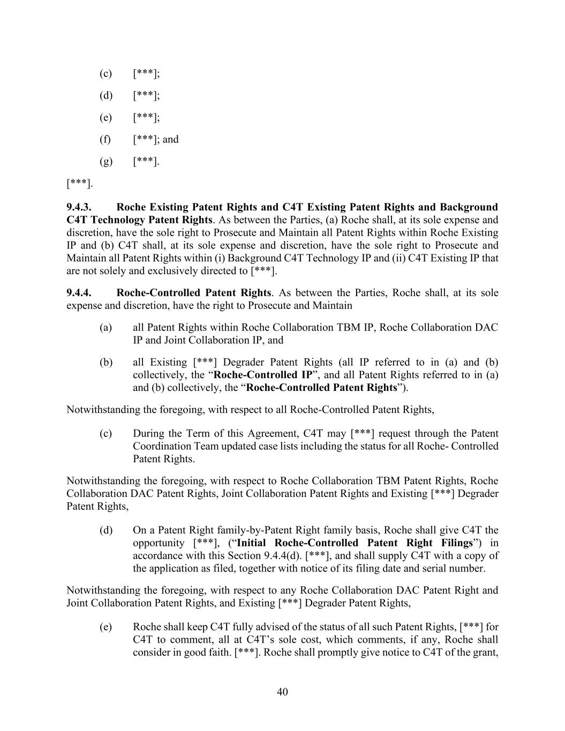
40 (c) [***]; (d) [***]; (e) [***]; (f) [***]; and (g) [***]. [***]. 9.4.3. Roche Existing Patent Rights and C4T Existing Patent Rights and Background C4T Technology Patent Rights. As between the Parties, (a) Roche shall, at its sole expense and discretion, have the sole right to Prosecute and Maintain all Patent Rights within Roche Existing IP and (b) C4T shall, at its sole expense and discretion, have the sole right to Prosecute and Maintain all Patent Rights within (i) Background C4T Technology IP and (ii) C4T Existing IP that are not solely and exclusively directed to [***]. 9.4.4. Roche-Controlled Patent Rights. As between the Parties, Roche shall, at its sole expense and discretion, have the right to Prosecute and Maintain (a) all Patent Rights within Roche Collaboration TBM IP, Roche Collaboration DAC IP and Joint Collaboration IP, and (b) all Existing [***] Degrader Patent Rights (all IP referred to in (a) and (b) collectively, the “Roche-Controlled IP”, and all Patent Rights referred to in (a) and (b) collectively, the “Roche-Controlled Patent Rights”). Notwithstanding the foregoing, with respect to all Roche-Controlled Patent Rights, (c) During the Term of this Agreement, C4T may [***] request through the Patent Coordination Team updated case lists including the status for all Roche- Controlled Patent Rights. Notwithstanding the foregoing, with respect to Roche Collaboration TBM Patent Rights, Roche Collaboration DAC Patent Rights, Joint Collaboration Patent Rights and Existing [***] Degrader Patent Rights, (d) On a Patent Right family-by-Patent Right family basis, Roche shall give C4T the opportunity [***], (“Initial Roche-Controlled Patent Right Filings”) in accordance with this Section 9.4.4(d). [***], and shall supply C4T with a copy of the application as filed, together with notice of its filing date and serial number. Notwithstanding the foregoing, with respect to any Roche Collaboration DAC Patent Right and Joint Collaboration Patent Rights, and Existing [***] Degrader Patent Rights, (e) Roche shall keep C4T fully advised of the status of all such Patent Rights, [***] for C4T to comment, all at C4T’s sole cost, which comments, if any, Roche shall consider in good faith. [***]. Roche shall promptly give notice to C4T of the grant,

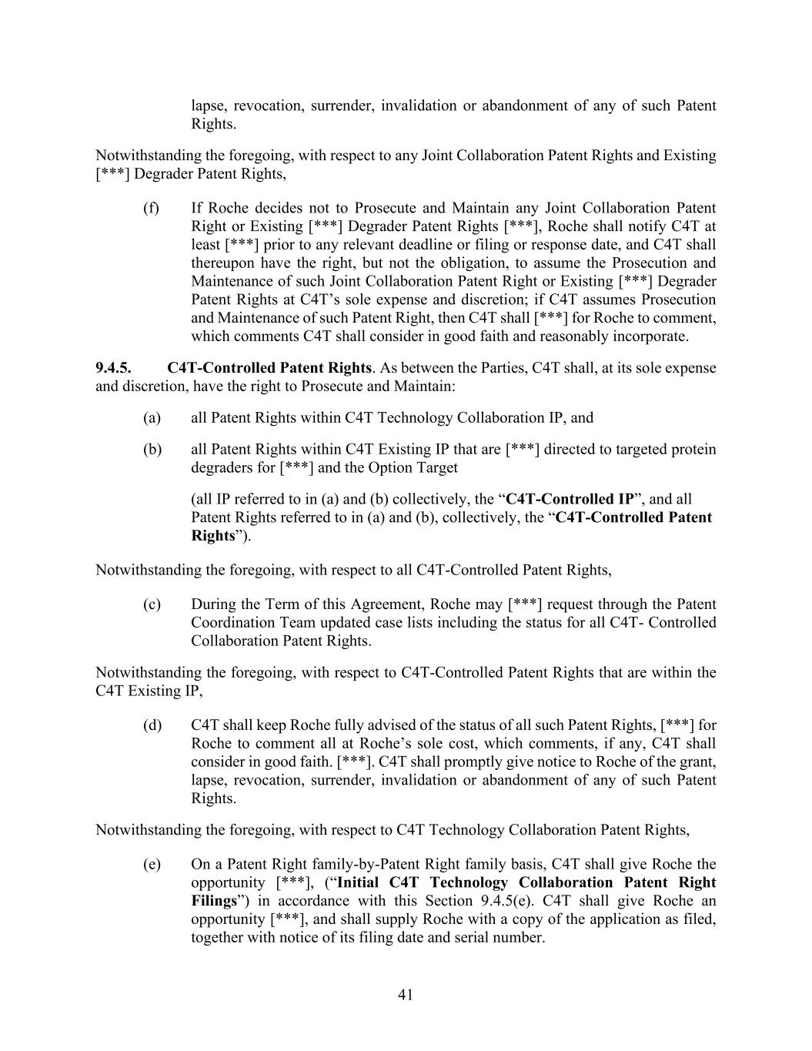
41 lapse, revocation, surrender, invalidation or abandonment of any of such Patent Rights. Notwithstanding the foregoing, with respect to any Joint Collaboration Patent Rights and Existing [***] Degrader Patent Rights, (f) If Roche decides not to Prosecute and Maintain any Joint Collaboration Patent Right or Existing [***] Degrader Patent Rights [***], Roche shall notify C4T at least [***] prior to any relevant deadline or filing or response date, and C4T shall thereupon have the right, but not the obligation, to assume the Prosecution and Maintenance of such Joint Collaboration Patent Right or Existing [***] Degrader Patent Rights at C4T’s sole expense and discretion; if C4T assumes Prosecution and Maintenance of such Patent Right, then C4T shall [***] for Roche to comment, which comments C4T shall consider in good faith and reasonably incorporate. 9.4.5. C4T-Controlled Patent Rights. As between the Parties, C4T shall, at its sole expense and discretion, have the right to Prosecute and Maintain: (a) all Patent Rights within C4T Technology Collaboration IP, and (b) all Patent Rights within C4T Existing IP that are [***] directed to targeted protein degraders for [***] and the Option Target (all IP referred to in (a) and (b) collectively, the “C4T-Controlled IP”, and all Patent Rights referred to in (a) and (b), collectively, the “C4T-Controlled Patent Rights”). Notwithstanding the foregoing, with respect to all C4T-Controlled Patent Rights, (c) During the Term of this Agreement, Roche may [***] request through the Patent Coordination Team updated case lists including the status for all C4T- Controlled Collaboration Patent Rights. Notwithstanding the foregoing, with respect to C4T-Controlled Patent Rights that are within the C4T Existing IP, (d) C4T shall keep Roche fully advised of the status of all such Patent Rights, [***] for Roche to comment all at Roche’s sole cost, which comments, if any, C4T shall consider in good faith. [***]. C4T shall promptly give notice to Roche of the grant, lapse, revocation, surrender, invalidation or abandonment of any of such Patent Rights. Notwithstanding the foregoing, with respect to C4T Technology Collaboration Patent Rights, (e) On a Patent Right family-by-Patent Right family basis, C4T shall give Roche the opportunity [***], (“Initial C4T Technology Collaboration Patent Right Filings”) in accordance with this Section 9.4.5(e). C4T shall give Roche an opportunity [***], and shall supply Roche with a copy of the application as filed, together with notice of its filing date and serial number.

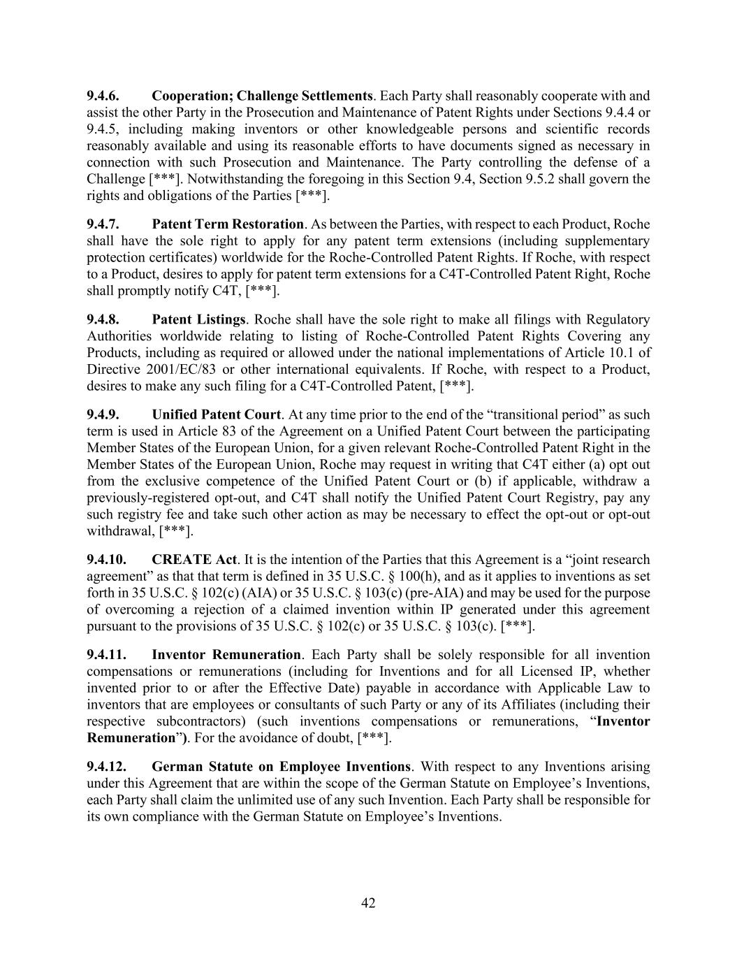
42 9.4.6. Cooperation; Challenge Settlements. Each Party shall reasonably cooperate with and assist the other Party in the Prosecution and Maintenance of Patent Rights under Sections 9.4.4 or 9.4.5, including making inventors or other knowledgeable persons and scientific records reasonably available and using its reasonable efforts to have documents signed as necessary in connection with such Prosecution and Maintenance. The Party controlling the defense of a Challenge [***]. Notwithstanding the foregoing in this Section 9.4, Section 9.5.2 shall govern the rights and obligations of the Parties [***]. 9.4.7. Patent Term Restoration. As between the Parties, with respect to each Product, Roche shall have the sole right to apply for any patent term extensions (including supplementary protection certificates) worldwide for the Roche-Controlled Patent Rights. If Roche, with respect to a Product, desires to apply for patent term extensions for a C4T-Controlled Patent Right, Roche shall promptly notify C4T, [***]. 9.4.8. Patent Listings. Roche shall have the sole right to make all filings with Regulatory Authorities worldwide relating to listing of Roche-Controlled Patent Rights Covering any Products, including as required or allowed under the national implementations of Article 10.1 of Directive 2001/EC/83 or other international equivalents. If Roche, with respect to a Product, desires to make any such filing for a C4T-Controlled Patent, [***]. 9.4.9. Unified Patent Court. At any time prior to the end of the “transitional period” as such term is used in Article 83 of the Agreement on a Unified Patent Court between the participating Member States of the European Union, for a given relevant Roche-Controlled Patent Right in the Member States of the European Union, Roche may request in writing that C4T either (a) opt out from the exclusive competence of the Unified Patent Court or (b) if applicable, withdraw a previously-registered opt-out, and C4T shall notify the Unified Patent Court Registry, pay any such registry fee and take such other action as may be necessary to effect the opt-out or opt-out withdrawal, [***]. 9.4.10. CREATE Act. It is the intention of the Parties that this Agreement is a “joint research agreement” as that that term is defined in 35 U.S.C. § 100(h), and as it applies to inventions as set forth in 35 U.S.C. § 102(c) (AIA) or 35 U.S.C. § 103(c) (pre-AIA) and may be used for the purpose of overcoming a rejection of a claimed invention within IP generated under this agreement pursuant to the provisions of 35 U.S.C. § 102(c) or 35 U.S.C. § 103(c). [***]. 9.4.11. Inventor Remuneration. Each Party shall be solely responsible for all invention compensations or remunerations (including for Inventions and for all Licensed IP, whether invented prior to or after the Effective Date) payable in accordance with Applicable Law to inventors that are employees or consultants of such Party or any of its Affiliates (including their respective subcontractors) (such inventions compensations or remunerations, “Inventor Remuneration”). For the avoidance of doubt, [***]. 9.4.12. German Statute on Employee Inventions. With respect to any Inventions arising under this Agreement that are within the scope of the German Statute on Employee’s Inventions, each Party shall claim the unlimited use of any such Invention. Each Party shall be responsible for its own compliance with the German Statute on Employee’s Inventions.

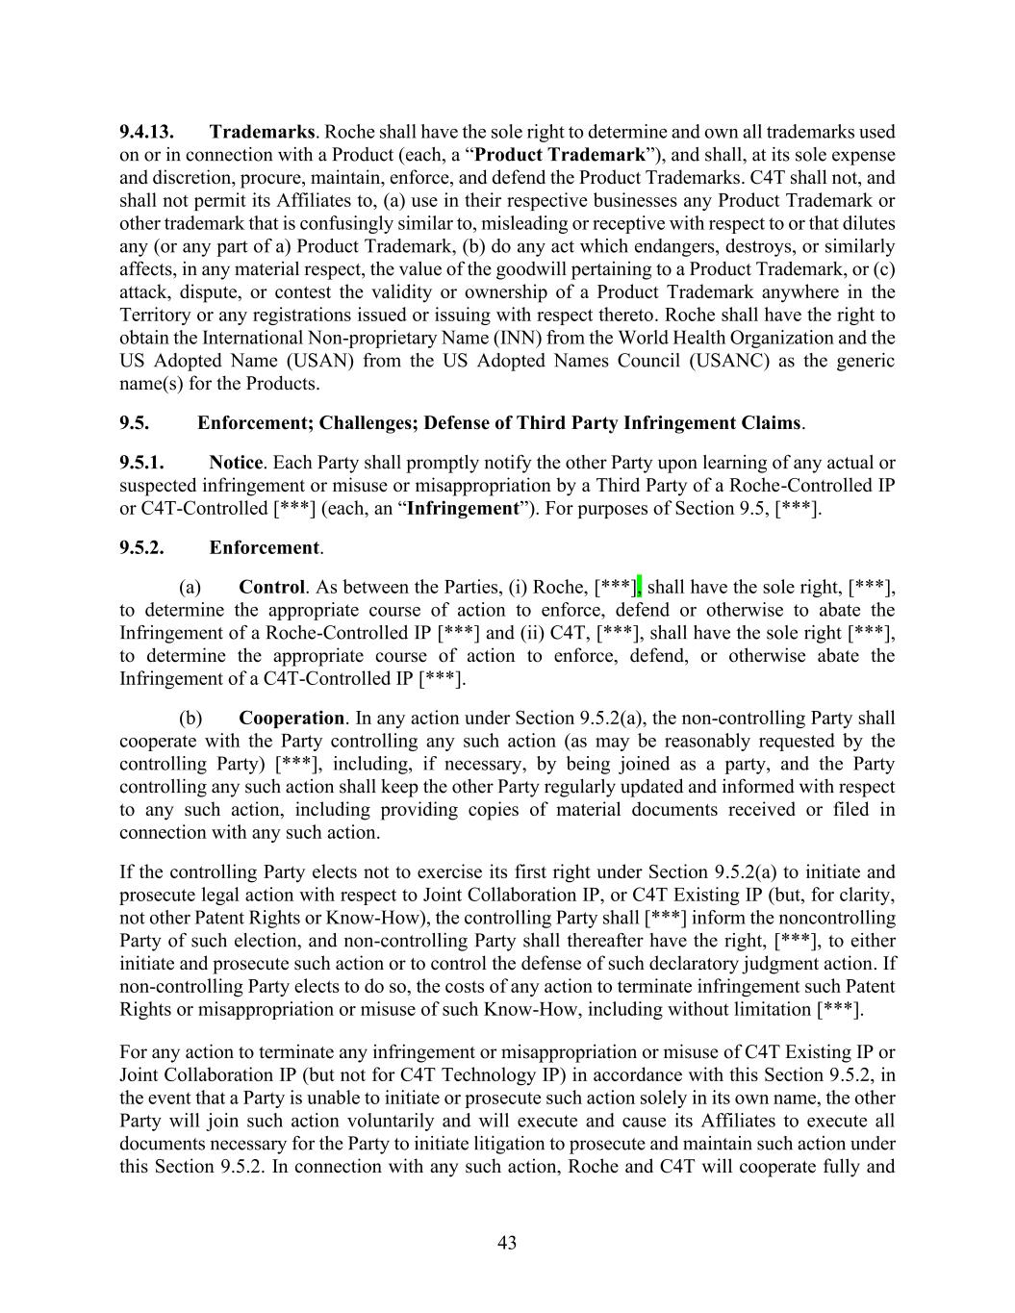
43 9.4.13. Trademarks. Roche shall have the sole right to determine and own all trademarks used on or in connection with a Product (each, a “Product Trademark”), and shall, at its sole expense and discretion, procure, maintain, enforce, and defend the Product Trademarks. C4T shall not, and shall not permit its Affiliates to, (a) use in their respective businesses any Product Trademark or other trademark that is confusingly similar to, misleading or receptive with respect to or that dilutes any (or any part of a) Product Trademark, (b) do any act which endangers, destroys, or similarly affects, in any material respect, the value of the goodwill pertaining to a Product Trademark, or (c) attack, dispute, or contest the validity or ownership of a Product Trademark anywhere in the Territory or any registrations issued or issuing with respect thereto. Roche shall have the right to obtain the International Non-proprietary Name (INN) from the World Health Organization and the US Adopted Name (USAN) from the US Adopted Names Council (USANC) as the generic name(s) for the Products. 9.5. Enforcement; Challenges; Defense of Third Party Infringement Claims. 9.5.1. Notice. Each Party shall promptly notify the other Party upon learning of any actual or suspected infringement or misuse or misappropriation by a Third Party of a Roche-Controlled IP or C4T-Controlled [***] (each, an “Infringement”). For purposes of Section 9.5, [***]. 9.5.2. Enforcement. (a) Control. As between the Parties, (i) Roche, [***], shall have the sole right, [***], to determine the appropriate course of action to enforce, defend or otherwise to abate the Infringement of a Roche-Controlled IP [***] and (ii) C4T, [***], shall have the sole right [***], to determine the appropriate course of action to enforce, defend, or otherwise abate the Infringement of a C4T-Controlled IP [***]. (b) Cooperation. In any action under Section 9.5.2(a), the non-controlling Party shall cooperate with the Party controlling any such action (as may be reasonably requested by the controlling Party) [***], including, if necessary, by being joined as a party, and the Party controlling any such action shall keep the other Party regularly updated and informed with respect to any such action, including providing copies of material documents received or filed in connection with any such action. If the controlling Party elects not to exercise its first right under Section 9.5.2(a) to initiate and prosecute legal action with respect to Joint Collaboration IP, or C4T Existing IP (but, for clarity, not other Patent Rights or Know-How), the controlling Party shall [***] inform the noncontrolling Party of such election, and non-controlling Party shall thereafter have the right, [***], to either initiate and prosecute such action or to control the defense of such declaratory judgment action. If non-controlling Party elects to do so, the costs of any action to terminate infringement such Patent Rights or misappropriation or misuse of such Know-How, including without limitation [***]. For any action to terminate any infringement or misappropriation or misuse of C4T Existing IP or Joint Collaboration IP (but not for C4T Technology IP) in accordance with this Section 9.5.2, in the event that a Party is unable to initiate or prosecute such action solely in its own name, the other Party will join such action voluntarily and will execute and cause its Affiliates to execute all documents necessary for the Party to initiate litigation to prosecute and maintain such action under this Section 9.5.2. In connection with any such action, Roche and C4T will cooperate fully and

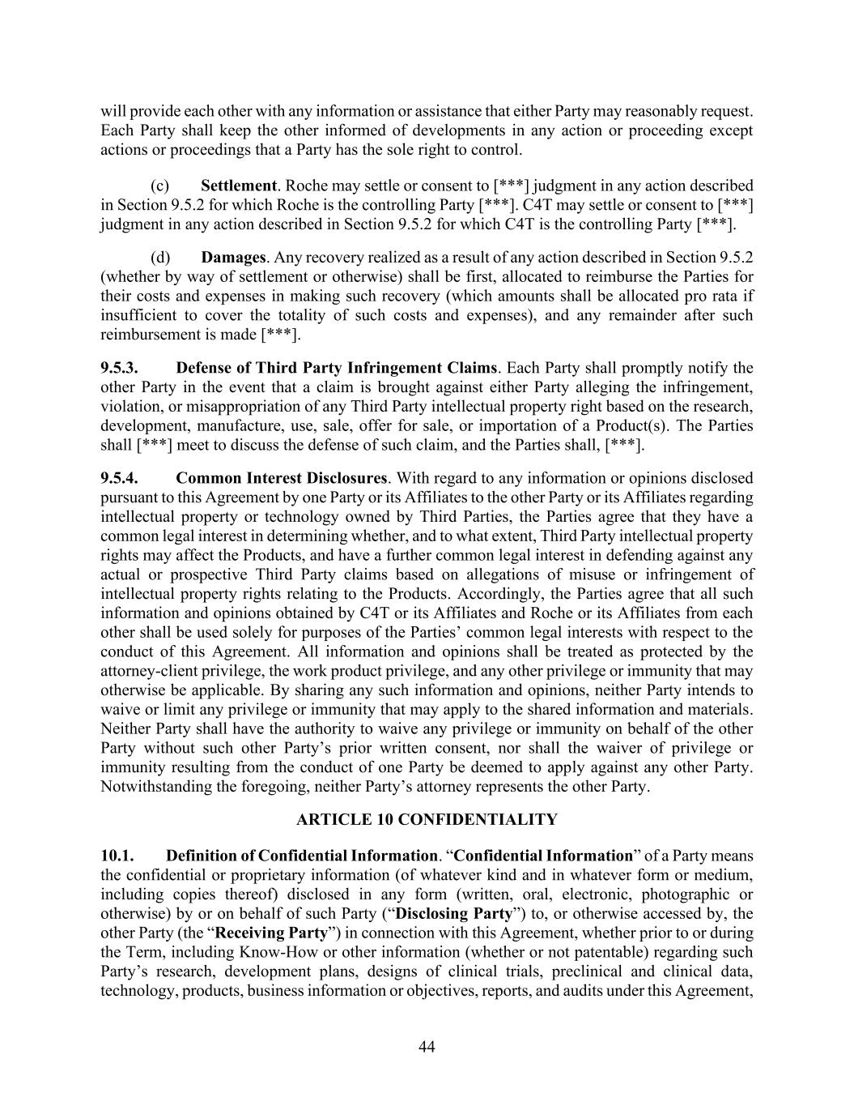
44 will provide each other with any information or assistance that either Party may reasonably request. Each Party shall keep the other informed of developments in any action or proceeding except actions or proceedings that a Party has the sole right to control. (c) Settlement. Roche may settle or consent to [***] judgment in any action described in Section 9.5.2 for which Roche is the controlling Party [***]. C4T may settle or consent to [***] judgment in any action described in Section 9.5.2 for which C4T is the controlling Party [***]. (d) Damages. Any recovery realized as a result of any action described in Section 9.5.2 (whether by way of settlement or otherwise) shall be first, allocated to reimburse the Parties for their costs and expenses in making such recovery (which amounts shall be allocated pro rata if insufficient to cover the totality of such costs and expenses), and any remainder after such reimbursement is made [***]. 9.5.3. Defense of Third Party Infringement Claims. Each Party shall promptly notify the other Party in the event that a claim is brought against either Party alleging the infringement, violation, or misappropriation of any Third Party intellectual property right based on the research, development, manufacture, use, sale, offer for sale, or importation of a Product(s). The Parties shall [***] meet to discuss the defense of such claim, and the Parties shall, [***]. 9.5.4. Common Interest Disclosures. With regard to any information or opinions disclosed pursuant to this Agreement by one Party or its Affiliates to the other Party or its Affiliates regarding intellectual property or technology owned by Third Parties, the Parties agree that they have a common legal interest in determining whether, and to what extent, Third Party intellectual property rights may affect the Products, and have a further common legal interest in defending against any actual or prospective Third Party claims based on allegations of misuse or infringement of intellectual property rights relating to the Products. Accordingly, the Parties agree that all such information and opinions obtained by C4T or its Affiliates and Roche or its Affiliates from each other shall be used solely for purposes of the Parties’ common legal interests with respect to the conduct of this Agreement. All information and opinions shall be treated as protected by the attorney-client privilege, the work product privilege, and any other privilege or immunity that may otherwise be applicable. By sharing any such information and opinions, neither Party intends to waive or limit any privilege or immunity that may apply to the shared information and materials. Neither Party shall have the authority to waive any privilege or immunity on behalf of the other Party without such other Party’s prior written consent, nor shall the waiver of privilege or immunity resulting from the conduct of one Party be deemed to apply against any other Party. Notwithstanding the foregoing, neither Party’s attorney represents the other Party. ARTICLE 10 CONFIDENTIALITY 10.1. Definition of Confidential Information. “Confidential Information” of a Party means the confidential or proprietary information (of whatever kind and in whatever form or medium, including copies thereof) disclosed in any form (written, oral, electronic, photographic or otherwise) by or on behalf of such Party (“Disclosing Party”) to, or otherwise accessed by, the other Party (the “Receiving Party”) in connection with this Agreement, whether prior to or during the Term, including Know-How or other information (whether or not patentable) regarding such Party’s research, development plans, designs of clinical trials, preclinical and clinical data, technology, products, business information or objectives, reports, and audits under this Agreement,

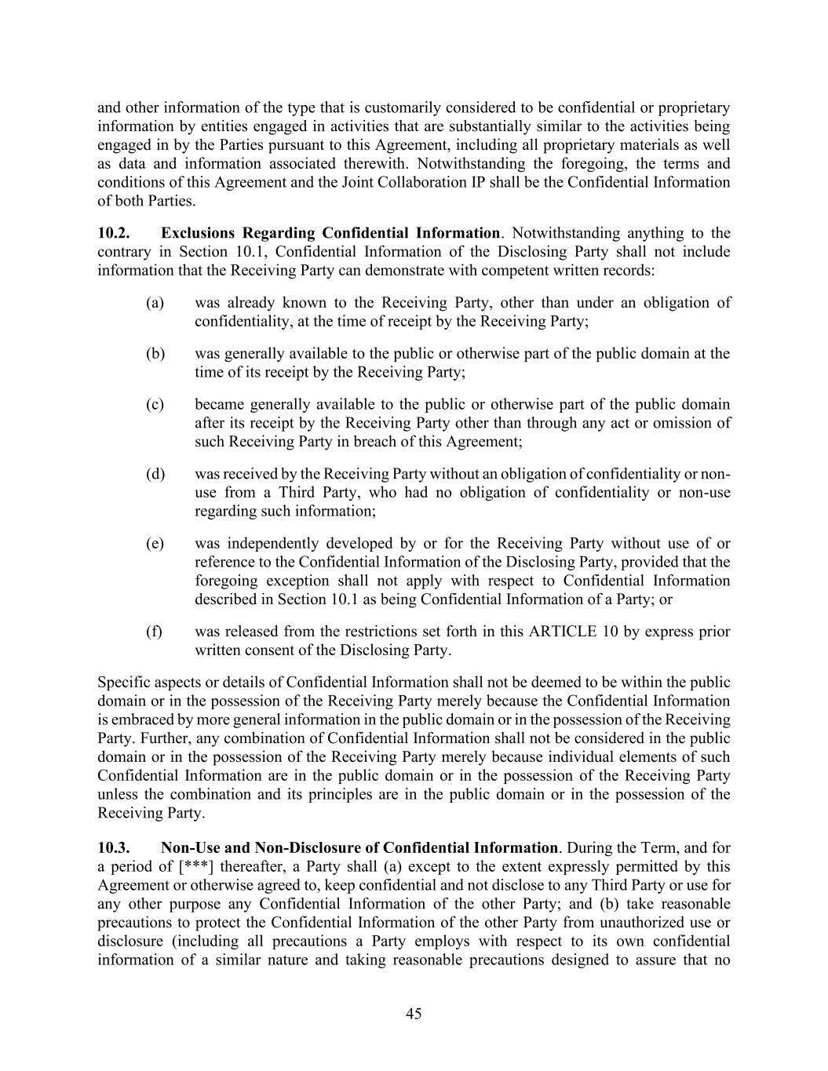
45 and other information of the type that is customarily considered to be confidential or proprietary information by entities engaged in activities that are substantially similar to the activities being engaged in by the Parties pursuant to this Agreement, including all proprietary materials as well as data and information associated therewith. Notwithstanding the foregoing, the terms and conditions of this Agreement and the Joint Collaboration IP shall be the Confidential Information of both Parties. 10.2. Exclusions Regarding Confidential Information. Notwithstanding anything to the contrary in Section 10.1, Confidential Information of the Disclosing Party shall not include information that the Receiving Party can demonstrate with competent written records: (a) was already known to the Receiving Party, other than under an obligation of confidentiality, at the time of receipt by the Receiving Party; (b) was generally available to the public or otherwise part of the public domain at the time of its receipt by the Receiving Party; (c) became generally available to the public or otherwise part of the public domain after its receipt by the Receiving Party other than through any act or omission of such Receiving Party in breach of this Agreement; (d) was received by the Receiving Party without an obligation of confidentiality or non- use from a Third Party, who had no obligation of confidentiality or non-use regarding such information; (e) was independently developed by or for the Receiving Party without use of or reference to the Confidential Information of the Disclosing Party, provided that the foregoing exception shall not apply with respect to Confidential Information described in Section 10.1 as being Confidential Information of a Party; or (f) was released from the restrictions set forth in this ARTICLE 10 by express prior written consent of the Disclosing Party. Specific aspects or details of Confidential Information shall not be deemed to be within the public domain or in the possession of the Receiving Party merely because the Confidential Information is embraced by more general information in the public domain or in the possession of the Receiving Party. Further, any combination of Confidential Information shall not be considered in the public domain or in the possession of the Receiving Party merely because individual elements of such Confidential Information are in the public domain or in the possession of the Receiving Party unless the combination and its principles are in the public domain or in the possession of the Receiving Party. 10.3. Non-Use and Non-Disclosure of Confidential Information. During the Term, and for a period of [***] thereafter, a Party shall (a) except to the extent expressly permitted by this Agreement or otherwise agreed to, keep confidential and not disclose to any Third Party or use for any other purpose any Confidential Information of the other Party; and (b) take reasonable precautions to protect the Confidential Information of the other Party from unauthorized use or disclosure (including all precautions a Party employs with respect to its own confidential information of a similar nature and taking reasonable precautions designed to assure that no

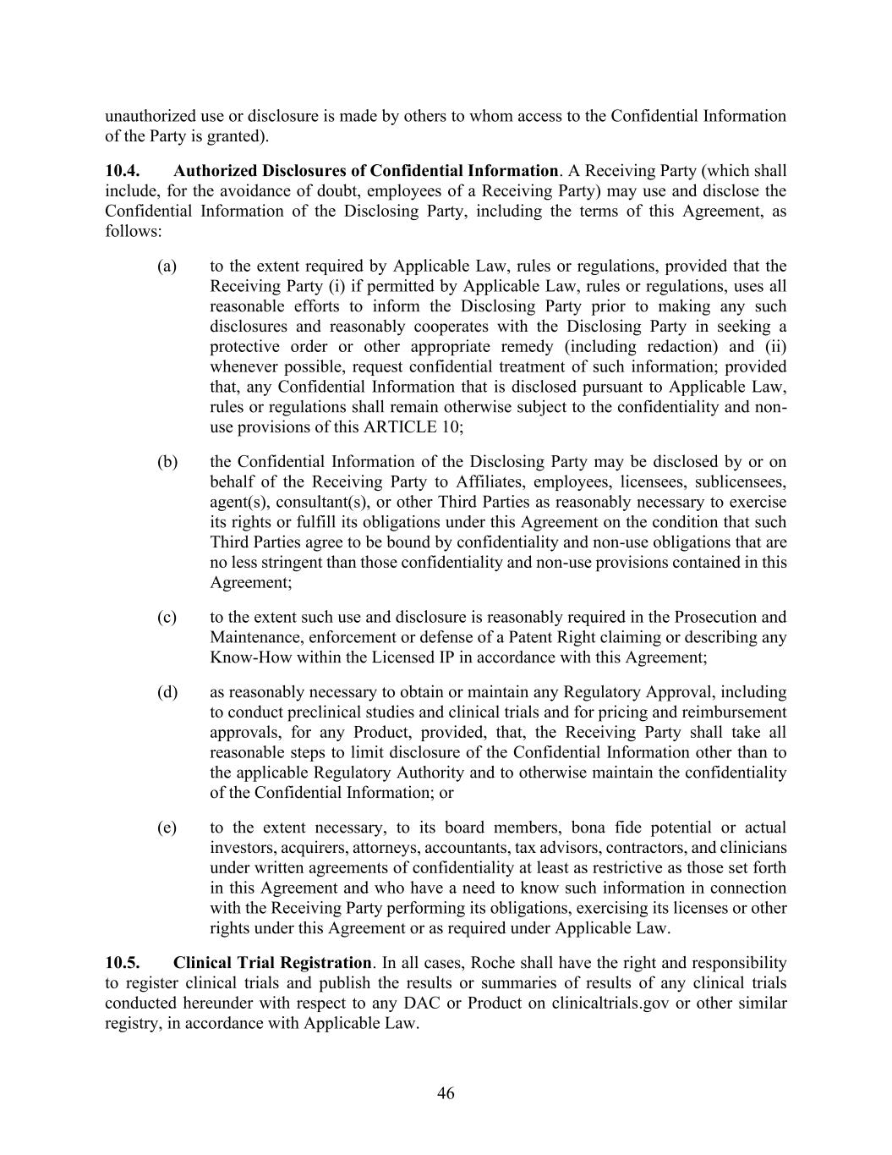
46 unauthorized use or disclosure is made by others to whom access to the Confidential Information of the Party is granted). 10.4. Authorized Disclosures of Confidential Information. A Receiving Party (which shall include, for the avoidance of doubt, employees of a Receiving Party) may use and disclose the Confidential Information of the Disclosing Party, including the terms of this Agreement, as follows: (a) to the extent required by Applicable Law, rules or regulations, provided that the Receiving Party (i) if permitted by Applicable Law, rules or regulations, uses all reasonable efforts to inform the Disclosing Party prior to making any such disclosures and reasonably cooperates with the Disclosing Party in seeking a protective order or other appropriate remedy (including redaction) and (ii) whenever possible, request confidential treatment of such information; provided that, any Confidential Information that is disclosed pursuant to Applicable Law, rules or regulations shall remain otherwise subject to the confidentiality and non- use provisions of this ARTICLE 10; (b) the Confidential Information of the Disclosing Party may be disclosed by or on behalf of the Receiving Party to Affiliates, employees, licensees, sublicensees, agent(s), consultant(s), or other Third Parties as reasonably necessary to exercise its rights or fulfill its obligations under this Agreement on the condition that such Third Parties agree to be bound by confidentiality and non-use obligations that are no less stringent than those confidentiality and non-use provisions contained in this Agreement; (c) to the extent such use and disclosure is reasonably required in the Prosecution and Maintenance, enforcement or defense of a Patent Right claiming or describing any Know-How within the Licensed IP in accordance with this Agreement; (d) as reasonably necessary to obtain or maintain any Regulatory Approval, including to conduct preclinical studies and clinical trials and for pricing and reimbursement approvals, for any Product, provided, that, the Receiving Party shall take all reasonable steps to limit disclosure of the Confidential Information other than to the applicable Regulatory Authority and to otherwise maintain the confidentiality of the Confidential Information; or (e) to the extent necessary, to its board members, bona fide potential or actual investors, acquirers, attorneys, accountants, tax advisors, contractors, and clinicians under written agreements of confidentiality at least as restrictive as those set forth in this Agreement and who have a need to know such information in connection with the Receiving Party performing its obligations, exercising its licenses or other rights under this Agreement or as required under Applicable Law. 10.5. Clinical Trial Registration. In all cases, Roche shall have the right and responsibility to register clinical trials and publish the results or summaries of results of any clinical trials conducted hereunder with respect to any DAC or Product on clinicaltrials.gov or other similar registry, in accordance with Applicable Law.

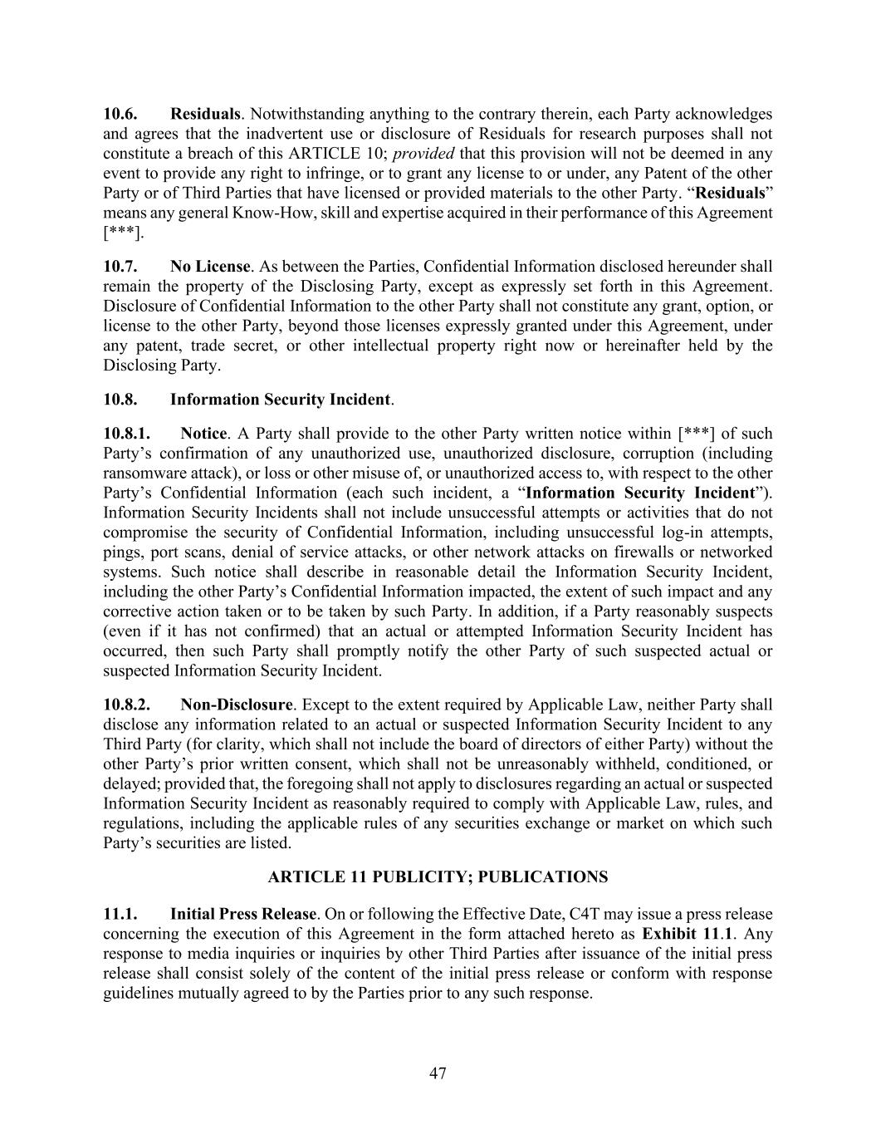
47 10.6. Residuals. Notwithstanding anything to the contrary therein, each Party acknowledges and agrees that the inadvertent use or disclosure of Residuals for research purposes shall not constitute a breach of this ARTICLE 10; provided that this provision will not be deemed in any event to provide any right to infringe, or to grant any license to or under, any Patent of the other Party or of Third Parties that have licensed or provided materials to the other Party. “Residuals” means any general Know-How, skill and expertise acquired in their performance of this Agreement [***]. 10.7. No License. As between the Parties, Confidential Information disclosed hereunder shall remain the property of the Disclosing Party, except as expressly set forth in this Agreement. Disclosure of Confidential Information to the other Party shall not constitute any grant, option, or license to the other Party, beyond those licenses expressly granted under this Agreement, under any patent, trade secret, or other intellectual property right now or hereinafter held by the Disclosing Party. 10.8. Information Security Incident. 10.8.1. Notice. A Party shall provide to the other Party written notice within [***] of such Party’s confirmation of any unauthorized use, unauthorized disclosure, corruption (including ransomware attack), or loss or other misuse of, or unauthorized access to, with respect to the other Party’s Confidential Information (each such incident, a “Information Security Incident”). Information Security Incidents shall not include unsuccessful attempts or activities that do not compromise the security of Confidential Information, including unsuccessful log-in attempts, pings, port scans, denial of service attacks, or other network attacks on firewalls or networked systems. Such notice shall describe in reasonable detail the Information Security Incident, including the other Party’s Confidential Information impacted, the extent of such impact and any corrective action taken or to be taken by such Party. In addition, if a Party reasonably suspects (even if it has not confirmed) that an actual or attempted Information Security Incident has occurred, then such Party shall promptly notify the other Party of such suspected actual or suspected Information Security Incident. 10.8.2. Non-Disclosure. Except to the extent required by Applicable Law, neither Party shall disclose any information related to an actual or suspected Information Security Incident to any Third Party (for clarity, which shall not include the board of directors of either Party) without the other Party’s prior written consent, which shall not be unreasonably withheld, conditioned, or delayed; provided that, the foregoing shall not apply to disclosures regarding an actual or suspected Information Security Incident as reasonably required to comply with Applicable Law, rules, and regulations, including the applicable rules of any securities exchange or market on which such Party’s securities are listed. ARTICLE 11 PUBLICITY; PUBLICATIONS 11.1. Initial Press Release. On or following the Effective Date, C4T may issue a press release concerning the execution of this Agreement in the form attached hereto as Exhibit 11.1. Any response to media inquiries or inquiries by other Third Parties after issuance of the initial press release shall consist solely of the content of the initial press release or conform with response guidelines mutually agreed to by the Parties prior to any such response.

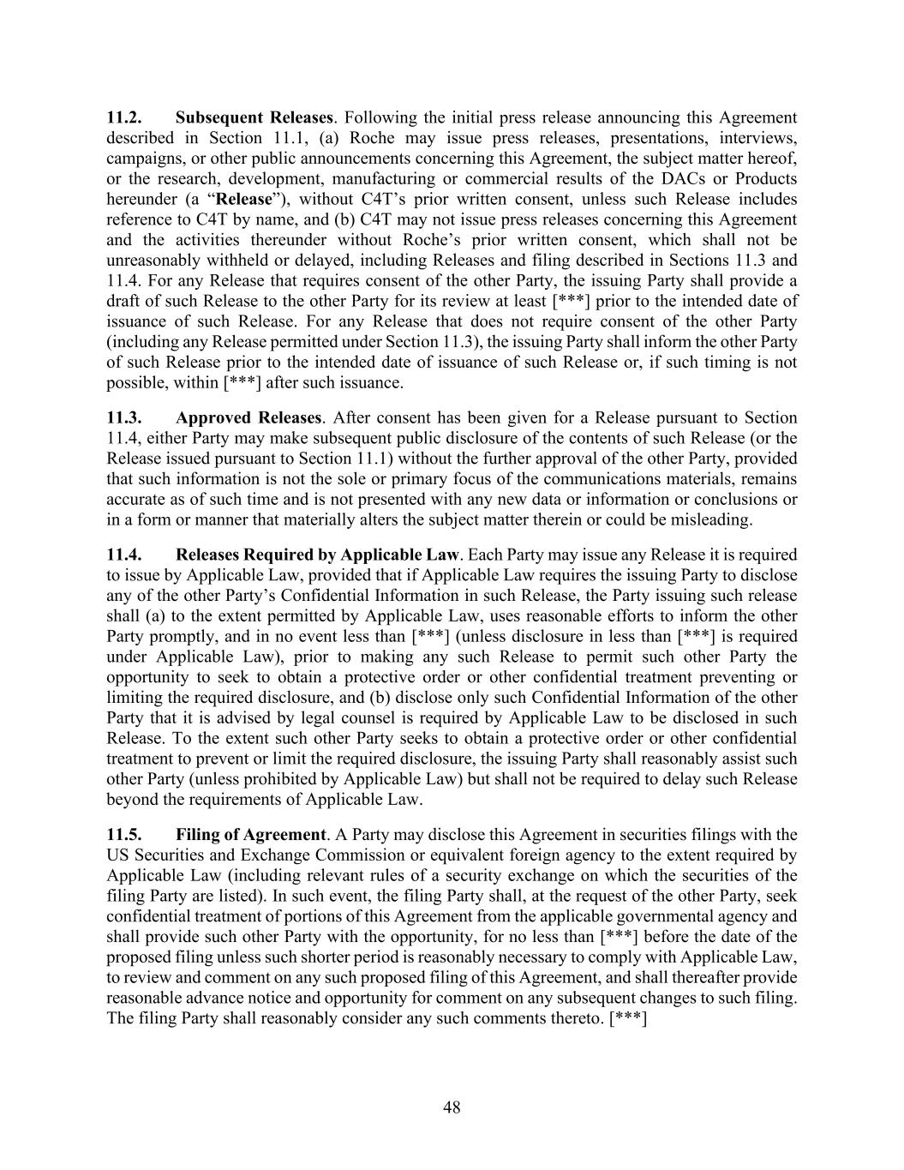
48 11.2. Subsequent Releases. Following the initial press release announcing this Agreement described in Section 11.1, (a) Roche may issue press releases, presentations, interviews, campaigns, or other public announcements concerning this Agreement, the subject matter hereof, or the research, development, manufacturing or commercial results of the DACs or Products hereunder (a “Release”), without C4T’s prior written consent, unless such Release includes reference to C4T by name, and (b) C4T may not issue press releases concerning this Agreement and the activities thereunder without Roche’s prior written consent, which shall not be unreasonably withheld or delayed, including Releases and filing described in Sections 11.3 and 11.4. For any Release that requires consent of the other Party, the issuing Party shall provide a draft of such Release to the other Party for its review at least [***] prior to the intended date of issuance of such Release. For any Release that does not require consent of the other Party (including any Release permitted under Section 11.3), the issuing Party shall inform the other Party of such Release prior to the intended date of issuance of such Release or, if such timing is not possible, within [***] after such issuance. 11.3. Approved Releases. After consent has been given for a Release pursuant to Section 11.4, either Party may make subsequent public disclosure of the contents of such Release (or the Release issued pursuant to Section 11.1) without the further approval of the other Party, provided that such information is not the sole or primary focus of the communications materials, remains accurate as of such time and is not presented with any new data or information or conclusions or in a form or manner that materially alters the subject matter therein or could be misleading. 11.4. Releases Required by Applicable Law. Each Party may issue any Release it is required to issue by Applicable Law, provided that if Applicable Law requires the issuing Party to disclose any of the other Party’s Confidential Information in such Release, the Party issuing such release shall (a) to the extent permitted by Applicable Law, uses reasonable efforts to inform the other Party promptly, and in no event less than [***] (unless disclosure in less than [***] is required under Applicable Law), prior to making any such Release to permit such other Party the opportunity to seek to obtain a protective order or other confidential treatment preventing or limiting the required disclosure, and (b) disclose only such Confidential Information of the other Party that it is advised by legal counsel is required by Applicable Law to be disclosed in such Release. To the extent such other Party seeks to obtain a protective order or other confidential treatment to prevent or limit the required disclosure, the issuing Party shall reasonably assist such other Party (unless prohibited by Applicable Law) but shall not be required to delay such Release beyond the requirements of Applicable Law. 11.5. Filing of Agreement. A Party may disclose this Agreement in securities filings with the US Securities and Exchange Commission or equivalent foreign agency to the extent required by Applicable Law (including relevant rules of a security exchange on which the securities of the filing Party are listed). In such event, the filing Party shall, at the request of the other Party, seek confidential treatment of portions of this Agreement from the applicable governmental agency and shall provide such other Party with the opportunity, for no less than [***] before the date of the proposed filing unless such shorter period is reasonably necessary to comply with Applicable Law, to review and comment on any such proposed filing of this Agreement, and shall thereafter provide reasonable advance notice and opportunity for comment on any subsequent changes to such filing. The filing Party shall reasonably consider any such comments thereto. [***]

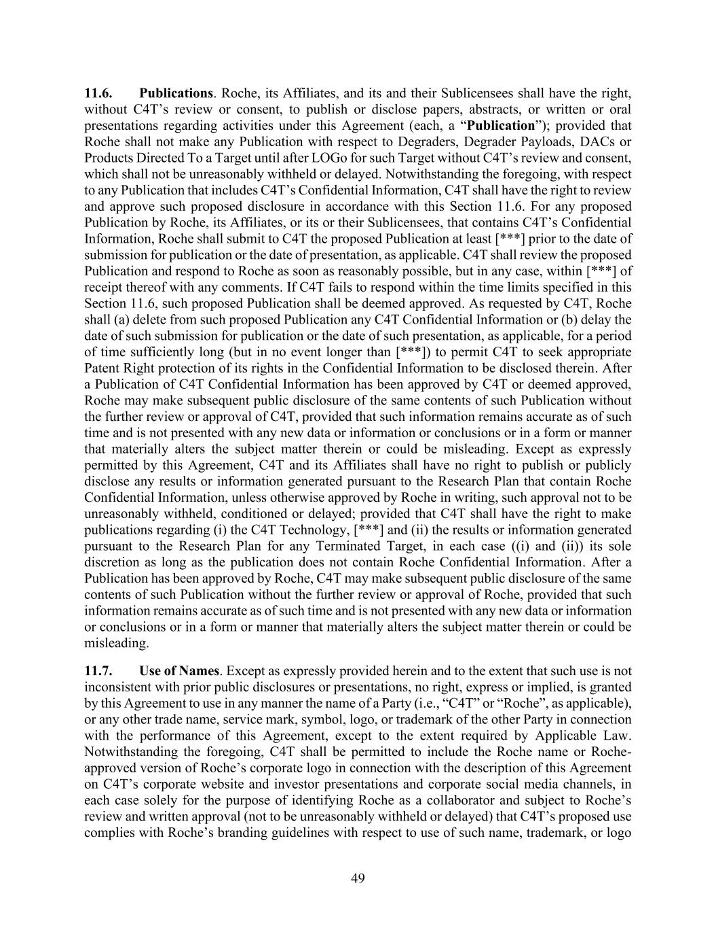
49 11.6. Publications. Roche, its Affiliates, and its and their Sublicensees shall have the right, without C4T’s review or consent, to publish or disclose papers, abstracts, or written or oral presentations regarding activities under this Agreement (each, a “Publication”); provided that Roche shall not make any Publication with respect to Degraders, Degrader Payloads, DACs or Products Directed To a Target until after LOGo for such Target without C4T’s review and consent, which shall not be unreasonably withheld or delayed. Notwithstanding the foregoing, with respect to any Publication that includes C4T’s Confidential Information, C4T shall have the right to review and approve such proposed disclosure in accordance with this Section 11.6. For any proposed Publication by Roche, its Affiliates, or its or their Sublicensees, that contains C4T’s Confidential Information, Roche shall submit to C4T the proposed Publication at least [***] prior to the date of submission for publication or the date of presentation, as applicable. C4T shall review the proposed Publication and respond to Roche as soon as reasonably possible, but in any case, within [***] of receipt thereof with any comments. If C4T fails to respond within the time limits specified in this Section 11.6, such proposed Publication shall be deemed approved. As requested by C4T, Roche shall (a) delete from such proposed Publication any C4T Confidential Information or (b) delay the date of such submission for publication or the date of such presentation, as applicable, for a period of time sufficiently long (but in no event longer than [***]) to permit C4T to seek appropriate Patent Right protection of its rights in the Confidential Information to be disclosed therein. After a Publication of C4T Confidential Information has been approved by C4T or deemed approved, Roche may make subsequent public disclosure of the same contents of such Publication without the further review or approval of C4T, provided that such information remains accurate as of such time and is not presented with any new data or information or conclusions or in a form or manner that materially alters the subject matter therein or could be misleading. Except as expressly permitted by this Agreement, C4T and its Affiliates shall have no right to publish or publicly disclose any results or information generated pursuant to the Research Plan that contain Roche Confidential Information, unless otherwise approved by Roche in writing, such approval not to be unreasonably withheld, conditioned or delayed; provided that C4T shall have the right to make publications regarding (i) the C4T Technology, [***] and (ii) the results or information generated pursuant to the Research Plan for any Terminated Target, in each case ((i) and (ii)) its sole discretion as long as the publication does not contain Roche Confidential Information. After a Publication has been approved by Roche, C4T may make subsequent public disclosure of the same contents of such Publication without the further review or approval of Roche, provided that such information remains accurate as of such time and is not presented with any new data or information or conclusions or in a form or manner that materially alters the subject matter therein or could be misleading. 11.7. Use of Names. Except as expressly provided herein and to the extent that such use is not inconsistent with prior public disclosures or presentations, no right, express or implied, is granted by this Agreement to use in any manner the name of a Party (i.e., “C4T” or “Roche”, as applicable), or any other trade name, service mark, symbol, logo, or trademark of the other Party in connection with the performance of this Agreement, except to the extent required by Applicable Law. Notwithstanding the foregoing, C4T shall be permitted to include the Roche name or Roche- approved version of Roche’s corporate logo in connection with the description of this Agreement on C4T’s corporate website and investor presentations and corporate social media channels, in each case solely for the purpose of identifying Roche as a collaborator and subject to Roche’s review and written approval (not to be unreasonably withheld or delayed) that C4T’s proposed use complies with Roche’s branding guidelines with respect to use of such name, trademark, or logo

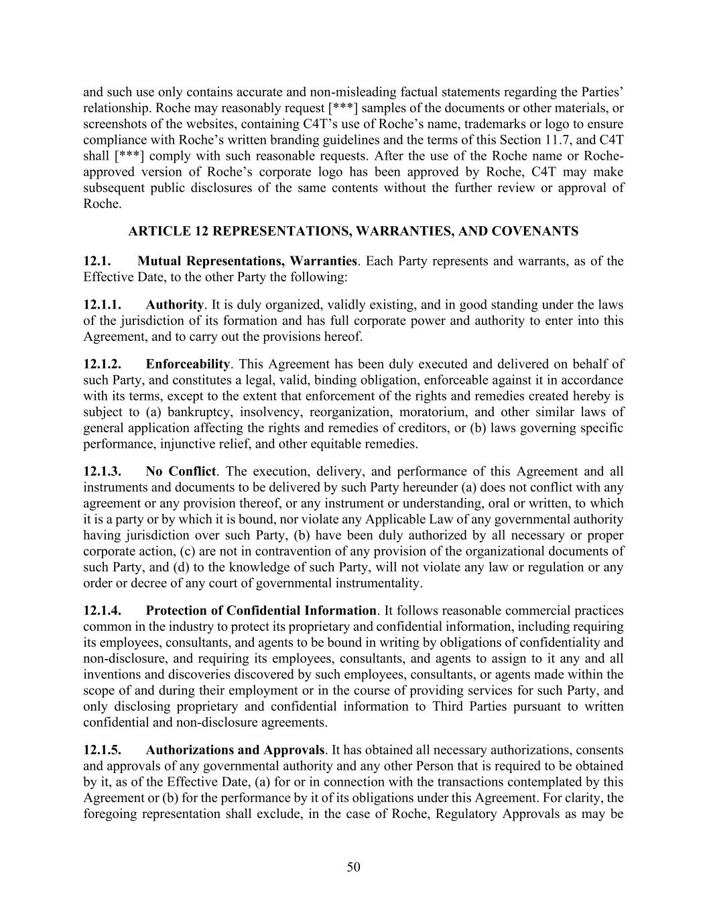
50 and such use only contains accurate and non-misleading factual statements regarding the Parties’ relationship. Roche may reasonably request [***] samples of the documents or other materials, or screenshots of the websites, containing C4T’s use of Roche’s name, trademarks or logo to ensure compliance with Roche’s written branding guidelines and the terms of this Section 11.7, and C4T shall [***] comply with such reasonable requests. After the use of the Roche name or Roche- approved version of Roche’s corporate logo has been approved by Roche, C4T may make subsequent public disclosures of the same contents without the further review or approval of Roche. ARTICLE 12 REPRESENTATIONS, WARRANTIES, AND COVENANTS 12.1. Mutual Representations, Warranties. Each Party represents and warrants, as of the Effective Date, to the other Party the following: 12.1.1. Authority. It is duly organized, validly existing, and in good standing under the laws of the jurisdiction of its formation and has full corporate power and authority to enter into this Agreement, and to carry out the provisions hereof. 12.1.2. Enforceability. This Agreement has been duly executed and delivered on behalf of such Party, and constitutes a legal, valid, binding obligation, enforceable against it in accordance with its terms, except to the extent that enforcement of the rights and remedies created hereby is subject to (a) bankruptcy, insolvency, reorganization, moratorium, and other similar laws of general application affecting the rights and remedies of creditors, or (b) laws governing specific performance, injunctive relief, and other equitable remedies. 12.1.3. No Conflict. The execution, delivery, and performance of this Agreement and all instruments and documents to be delivered by such Party hereunder (a) does not conflict with any agreement or any provision thereof, or any instrument or understanding, oral or written, to which it is a party or by which it is bound, nor violate any Applicable Law of any governmental authority having jurisdiction over such Party, (b) have been duly authorized by all necessary or proper corporate action, (c) are not in contravention of any provision of the organizational documents of such Party, and (d) to the knowledge of such Party, will not violate any law or regulation or any order or decree of any court of governmental instrumentality. 12.1.4. Protection of Confidential Information. It follows reasonable commercial practices common in the industry to protect its proprietary and confidential information, including requiring its employees, consultants, and agents to be bound in writing by obligations of confidentiality and non-disclosure, and requiring its employees, consultants, and agents to assign to it any and all inventions and discoveries discovered by such employees, consultants, or agents made within the scope of and during their employment or in the course of providing services for such Party, and only disclosing proprietary and confidential information to Third Parties pursuant to written confidential and non-disclosure agreements. 12.1.5. Authorizations and Approvals. It has obtained all necessary authorizations, consents and approvals of any governmental authority and any other Person that is required to be obtained by it, as of the Effective Date, (a) for or in connection with the transactions contemplated by this Agreement or (b) for the performance by it of its obligations under this Agreement. For clarity, the foregoing representation shall exclude, in the case of Roche, Regulatory Approvals as may be

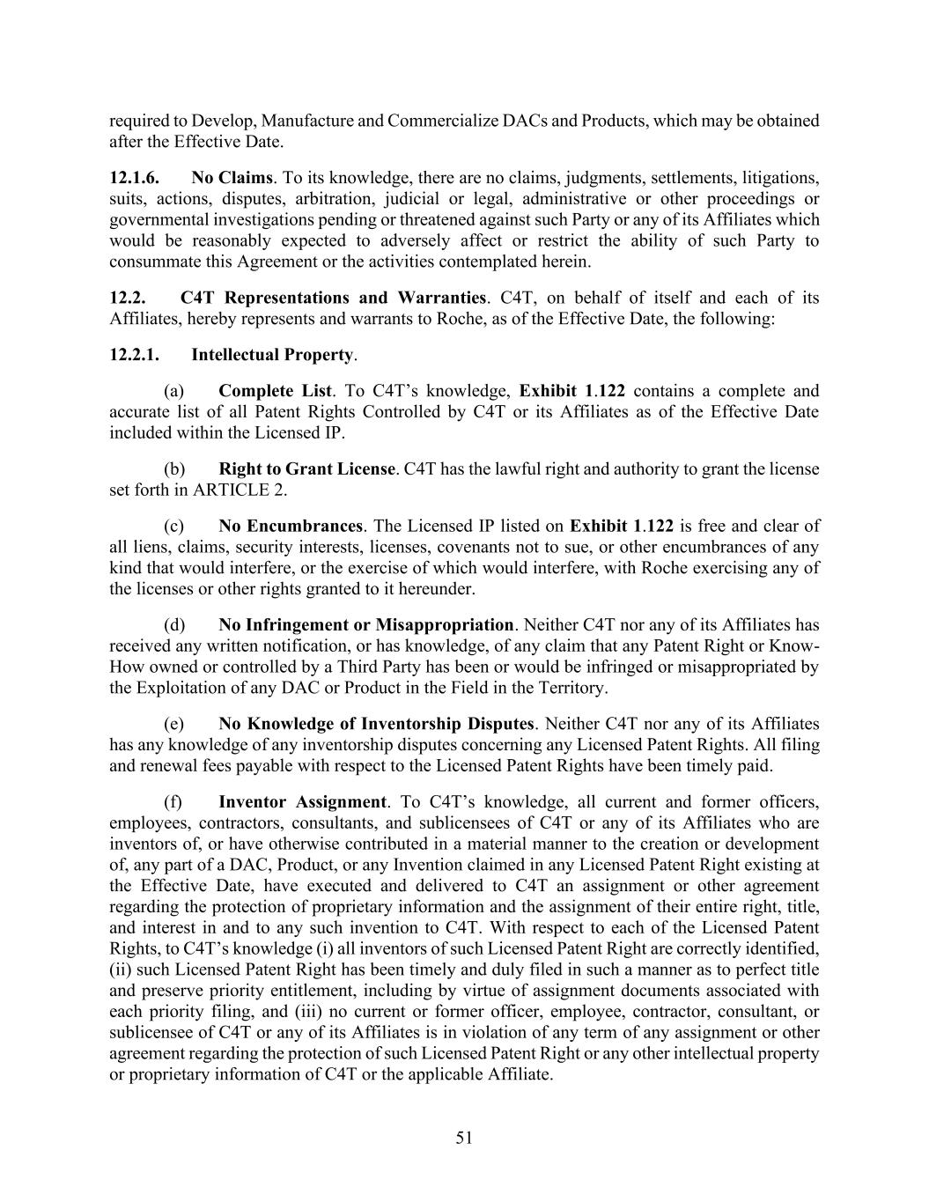
51 required to Develop, Manufacture and Commercialize DACs and Products, which may be obtained after the Effective Date. 12.1.6. No Claims. To its knowledge, there are no claims, judgments, settlements, litigations, suits, actions, disputes, arbitration, judicial or legal, administrative or other proceedings or governmental investigations pending or threatened against such Party or any of its Affiliates which would be reasonably expected to adversely affect or restrict the ability of such Party to consummate this Agreement or the activities contemplated herein. 12.2. C4T Representations and Warranties. C4T, on behalf of itself and each of its Affiliates, hereby represents and warrants to Roche, as of the Effective Date, the following: 12.2.1. Intellectual Property. (a) Complete List. To C4T’s knowledge, Exhibit 1.122 contains a complete and accurate list of all Patent Rights Controlled by C4T or its Affiliates as of the Effective Date included within the Licensed IP. (b) Right to Grant License. C4T has the lawful right and authority to grant the license set forth in ARTICLE 2. (c) No Encumbrances. The Licensed IP listed on Exhibit 1.122 is free and clear of all liens, claims, security interests, licenses, covenants not to sue, or other encumbrances of any kind that would interfere, or the exercise of which would interfere, with Roche exercising any of the licenses or other rights granted to it hereunder. (d) No Infringement or Misappropriation. Neither C4T nor any of its Affiliates has received any written notification, or has knowledge, of any claim that any Patent Right or Know- How owned or controlled by a Third Party has been or would be infringed or misappropriated by the Exploitation of any DAC or Product in the Field in the Territory. (e) No Knowledge of Inventorship Disputes. Neither C4T nor any of its Affiliates has any knowledge of any inventorship disputes concerning any Licensed Patent Rights. All filing and renewal fees payable with respect to the Licensed Patent Rights have been timely paid. (f) Inventor Assignment. To C4T’s knowledge, all current and former officers, employees, contractors, consultants, and sublicensees of C4T or any of its Affiliates who are inventors of, or have otherwise contributed in a material manner to the creation or development of, any part of a DAC, Product, or any Invention claimed in any Licensed Patent Right existing at the Effective Date, have executed and delivered to C4T an assignment or other agreement regarding the protection of proprietary information and the assignment of their entire right, title, and interest in and to any such invention to C4T. With respect to each of the Licensed Patent Rights, to C4T’s knowledge (i) all inventors of such Licensed Patent Right are correctly identified, (ii) such Licensed Patent Right has been timely and duly filed in such a manner as to perfect title and preserve priority entitlement, including by virtue of assignment documents associated with each priority filing, and (iii) no current or former officer, employee, contractor, consultant, or sublicensee of C4T or any of its Affiliates is in violation of any term of any assignment or other agreement regarding the protection of such Licensed Patent Right or any other intellectual property or proprietary information of C4T or the applicable Affiliate.

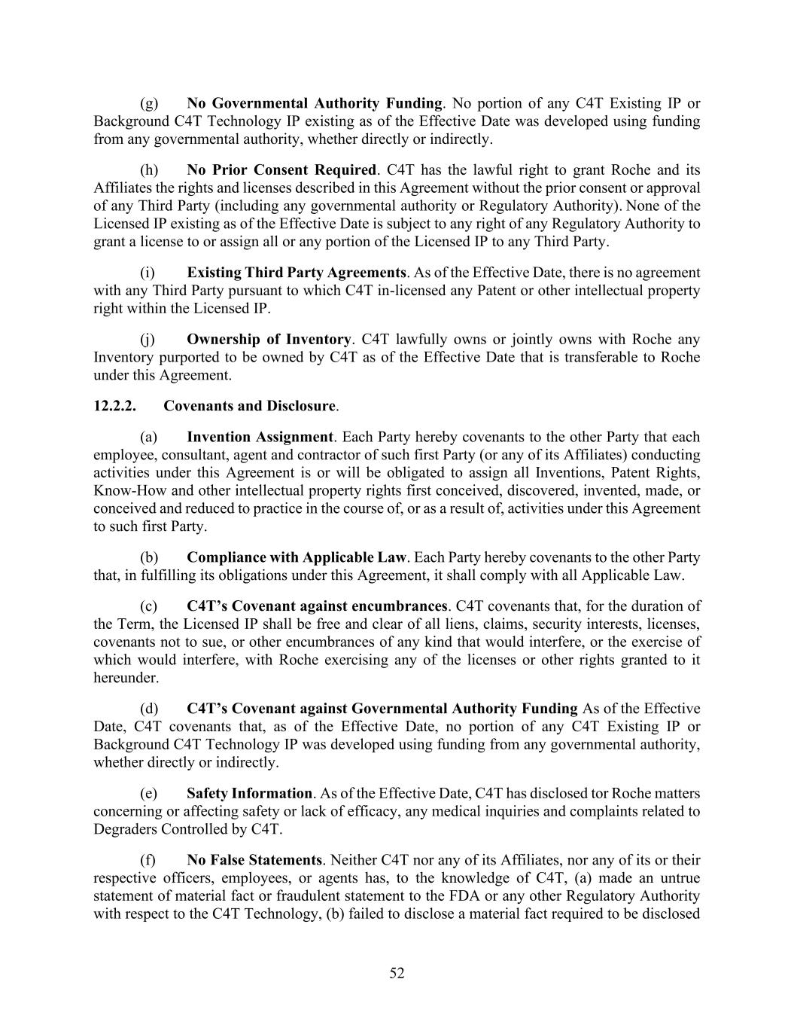
52 (g) No Governmental Authority Funding. No portion of any C4T Existing IP or Background C4T Technology IP existing as of the Effective Date was developed using funding from any governmental authority, whether directly or indirectly. (h) No Prior Consent Required. C4T has the lawful right to grant Roche and its Affiliates the rights and licenses described in this Agreement without the prior consent or approval of any Third Party (including any governmental authority or Regulatory Authority). None of the Licensed IP existing as of the Effective Date is subject to any right of any Regulatory Authority to grant a license to or assign all or any portion of the Licensed IP to any Third Party. (i) Existing Third Party Agreements. As of the Effective Date, there is no agreement with any Third Party pursuant to which C4T in-licensed any Patent or other intellectual property right within the Licensed IP. (j) Ownership of Inventory. C4T lawfully owns or jointly owns with Roche any Inventory purported to be owned by C4T as of the Effective Date that is transferable to Roche under this Agreement. 12.2.2. Covenants and Disclosure. (a) Invention Assignment. Each Party hereby covenants to the other Party that each employee, consultant, agent and contractor of such first Party (or any of its Affiliates) conducting activities under this Agreement is or will be obligated to assign all Inventions, Patent Rights, Know-How and other intellectual property rights first conceived, discovered, invented, made, or conceived and reduced to practice in the course of, or as a result of, activities under this Agreement to such first Party. (b) Compliance with Applicable Law. Each Party hereby covenants to the other Party that, in fulfilling its obligations under this Agreement, it shall comply with all Applicable Law. (c) C4T’s Covenant against encumbrances. C4T covenants that, for the duration of the Term, the Licensed IP shall be free and clear of all liens, claims, security interests, licenses, covenants not to sue, or other encumbrances of any kind that would interfere, or the exercise of which would interfere, with Roche exercising any of the licenses or other rights granted to it hereunder. (d) C4T’s Covenant against Governmental Authority Funding As of the Effective Date, C4T covenants that, as of the Effective Date, no portion of any C4T Existing IP or Background C4T Technology IP was developed using funding from any governmental authority, whether directly or indirectly. (e) Safety Information. As of the Effective Date, C4T has disclosed tor Roche matters concerning or affecting safety or lack of efficacy, any medical inquiries and complaints related to Degraders Controlled by C4T. (f) No False Statements. Neither C4T nor any of its Affiliates, nor any of its or their respective officers, employees, or agents has, to the knowledge of C4T, (a) made an untrue statement of material fact or fraudulent statement to the FDA or any other Regulatory Authority with respect to the C4T Technology, (b) failed to disclose a material fact required to be disclosed

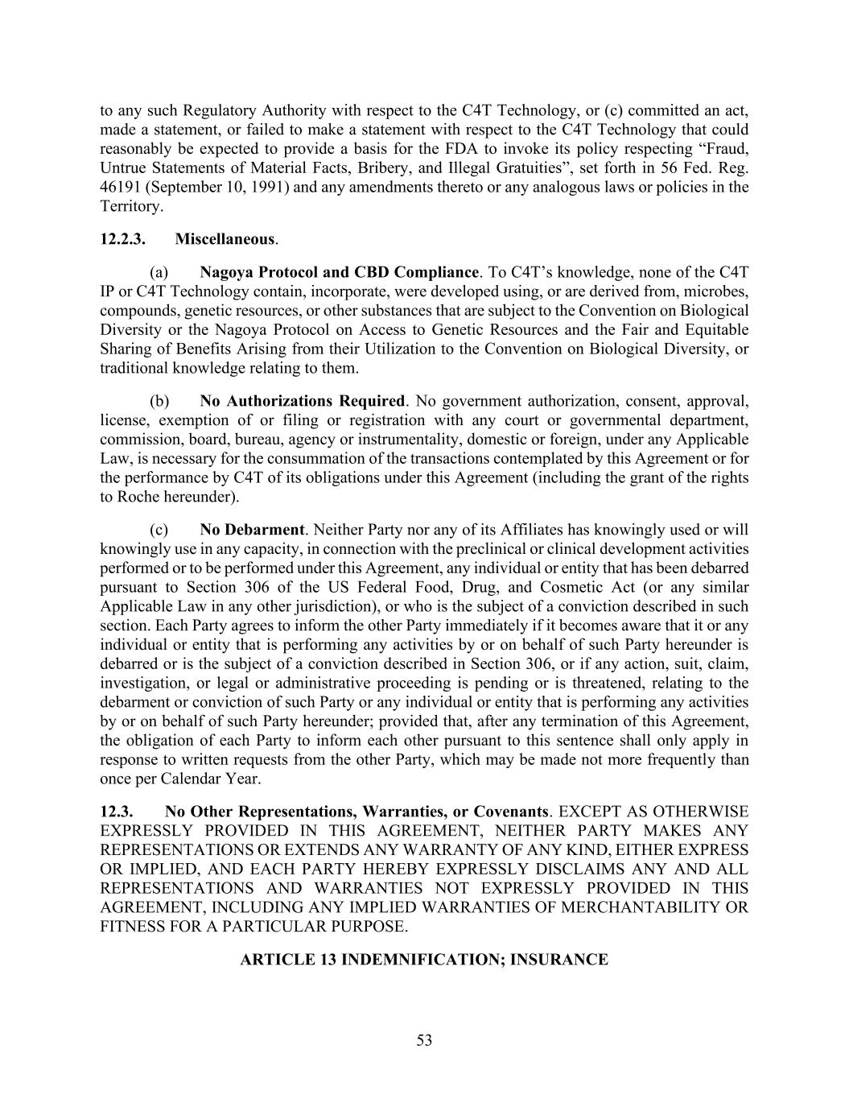
53 to any such Regulatory Authority with respect to the C4T Technology, or (c) committed an act, made a statement, or failed to make a statement with respect to the C4T Technology that could reasonably be expected to provide a basis for the FDA to invoke its policy respecting “Fraud, Untrue Statements of Material Facts, Bribery, and Illegal Gratuities”, set forth in 56 Fed. Reg. 46191 (September 10, 1991) and any amendments thereto or any analogous laws or policies in the Territory. 12.2.3. Miscellaneous. (a) Nagoya Protocol and CBD Compliance. To C4T’s knowledge, none of the C4T IP or C4T Technology contain, incorporate, were developed using, or are derived from, microbes, compounds, genetic resources, or other substances that are subject to the Convention on Biological Diversity or the Nagoya Protocol on Access to Genetic Resources and the Fair and Equitable Sharing of Benefits Arising from their Utilization to the Convention on Biological Diversity, or traditional knowledge relating to them. (b) No Authorizations Required. No government authorization, consent, approval, license, exemption of or filing or registration with any court or governmental department, commission, board, bureau, agency or instrumentality, domestic or foreign, under any Applicable Law, is necessary for the consummation of the transactions contemplated by this Agreement or for the performance by C4T of its obligations under this Agreement (including the grant of the rights to Roche hereunder). (c) No Debarment. Neither Party nor any of its Affiliates has knowingly used or will knowingly use in any capacity, in connection with the preclinical or clinical development activities performed or to be performed under this Agreement, any individual or entity that has been debarred pursuant to Section 306 of the US Federal Food, Drug, and Cosmetic Act (or any similar Applicable Law in any other jurisdiction), or who is the subject of a conviction described in such section. Each Party agrees to inform the other Party immediately if it becomes aware that it or any individual or entity that is performing any activities by or on behalf of such Party hereunder is debarred or is the subject of a conviction described in Section 306, or if any action, suit, claim, investigation, or legal or administrative proceeding is pending or is threatened, relating to the debarment or conviction of such Party or any individual or entity that is performing any activities by or on behalf of such Party hereunder; provided that, after any termination of this Agreement, the obligation of each Party to inform each other pursuant to this sentence shall only apply in response to written requests from the other Party, which may be made not more frequently than once per Calendar Year. 12.3. No Other Representations, Warranties, or Covenants. EXCEPT AS OTHERWISE EXPRESSLY PROVIDED IN THIS AGREEMENT, NEITHER PARTY MAKES ANY REPRESENTATIONS OR EXTENDS ANY WARRANTY OF ANY KIND, EITHER EXPRESS OR IMPLIED, AND EACH PARTY HEREBY EXPRESSLY DISCLAIMS ANY AND ALL REPRESENTATIONS AND WARRANTIES NOT EXPRESSLY PROVIDED IN THIS AGREEMENT, INCLUDING ANY IMPLIED WARRANTIES OF MERCHANTABILITY OR FITNESS FOR A PARTICULAR PURPOSE. ARTICLE 13 INDEMNIFICATION; INSURANCE

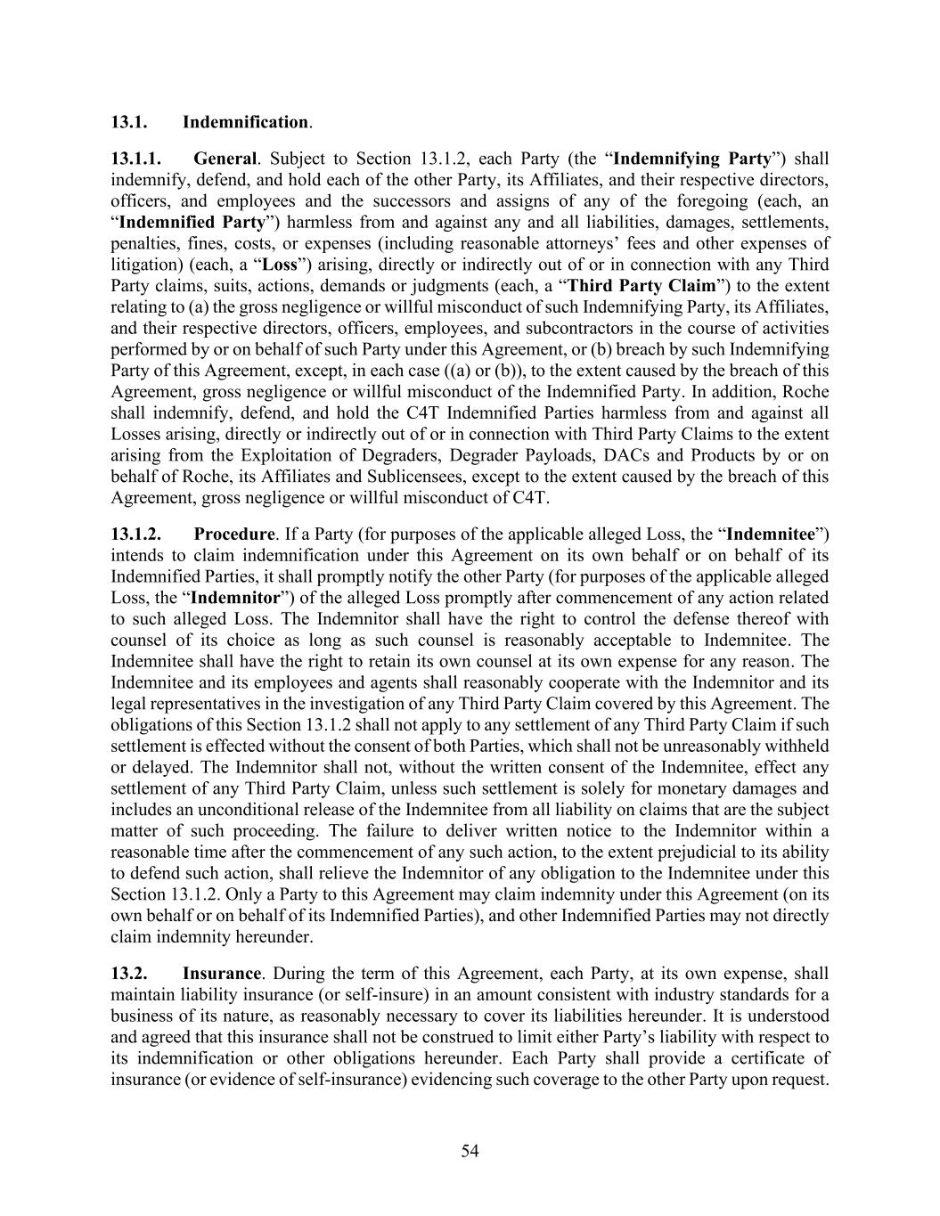
54 13.1. Indemnification. 13.1.1. General. Subject to Section 13.1.2, each Party (the “Indemnifying Party”) shall indemnify, defend, and hold each of the other Party, its Affiliates, and their respective directors, officers, and employees and the successors and assigns of any of the foregoing (each, an “Indemnified Party”) harmless from and against any and all liabilities, damages, settlements, penalties, fines, costs, or expenses (including reasonable attorneys’ fees and other expenses of litigation) (each, a “Loss”) arising, directly or indirectly out of or in connection with any Third Party claims, suits, actions, demands or judgments (each, a “Third Party Claim”) to the extent relating to (a) the gross negligence or willful misconduct of such Indemnifying Party, its Affiliates, and their respective directors, officers, employees, and subcontractors in the course of activities performed by or on behalf of such Party under this Agreement, or (b) breach by such Indemnifying Party of this Agreement, except, in each case ((a) or (b)), to the extent caused by the breach of this Agreement, gross negligence or willful misconduct of the Indemnified Party. In addition, Roche shall indemnify, defend, and hold the C4T Indemnified Parties harmless from and against all Losses arising, directly or indirectly out of or in connection with Third Party Claims to the extent arising from the Exploitation of Degraders, Degrader Payloads, DACs and Products by or on behalf of Roche, its Affiliates and Sublicensees, except to the extent caused by the breach of this Agreement, gross negligence or willful misconduct of C4T. 13.1.2. Procedure. If a Party (for purposes of the applicable alleged Loss, the “Indemnitee”) intends to claim indemnification under this Agreement on its own behalf or on behalf of its Indemnified Parties, it shall promptly notify the other Party (for purposes of the applicable alleged Loss, the “Indemnitor”) of the alleged Loss promptly after commencement of any action related to such alleged Loss. The Indemnitor shall have the right to control the defense thereof with counsel of its choice as long as such counsel is reasonably acceptable to Indemnitee. The Indemnitee shall have the right to retain its own counsel at its own expense for any reason. The Indemnitee and its employees and agents shall reasonably cooperate with the Indemnitor and its legal representatives in the investigation of any Third Party Claim covered by this Agreement. The obligations of this Section 13.1.2 shall not apply to any settlement of any Third Party Claim if such settlement is effected without the consent of both Parties, which shall not be unreasonably withheld or delayed. The Indemnitor shall not, without the written consent of the Indemnitee, effect any settlement of any Third Party Claim, unless such settlement is solely for monetary damages and includes an unconditional release of the Indemnitee from all liability on claims that are the subject matter of such proceeding. The failure to deliver written notice to the Indemnitor within a reasonable time after the commencement of any such action, to the extent prejudicial to its ability to defend such action, shall relieve the Indemnitor of any obligation to the Indemnitee under this Section 13.1.2. Only a Party to this Agreement may claim indemnity under this Agreement (on its own behalf or on behalf of its Indemnified Parties), and other Indemnified Parties may not directly claim indemnity hereunder. 13.2. Insurance. During the term of this Agreement, each Party, at its own expense, shall maintain liability insurance (or self-insure) in an amount consistent with industry standards for a business of its nature, as reasonably necessary to cover its liabilities hereunder. It is understood and agreed that this insurance shall not be construed to limit either Party’s liability with respect to its indemnification or other obligations hereunder. Each Party shall provide a certificate of insurance (or evidence of self-insurance) evidencing such coverage to the other Party upon request.

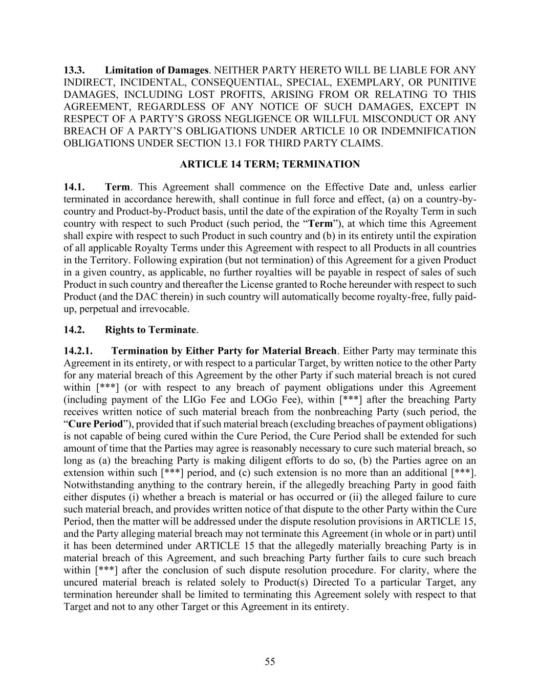
55 13.3. Limitation of Damages. NEITHER PARTY HERETO WILL BE LIABLE FOR ANY INDIRECT, INCIDENTAL, CONSEQUENTIAL, SPECIAL, EXEMPLARY, OR PUNITIVE DAMAGES, INCLUDING LOST PROFITS, ARISING FROM OR RELATING TO THIS AGREEMENT, REGARDLESS OF ANY NOTICE OF SUCH DAMAGES, EXCEPT IN RESPECT OF A PARTY’S GROSS NEGLIGENCE OR WILLFUL MISCONDUCT OR ANY BREACH OF A PARTY’S OBLIGATIONS UNDER ARTICLE 10 OR INDEMNIFICATION OBLIGATIONS UNDER SECTION 13.1 FOR THIRD PARTY CLAIMS. ARTICLE 14 TERM; TERMINATION 14.1. Term. This Agreement shall commence on the Effective Date and, unless earlier terminated in accordance herewith, shall continue in full force and effect, (a) on a country-by- country and Product-by-Product basis, until the date of the expiration of the Royalty Term in such country with respect to such Product (such period, the “Term”), at which time this Agreement shall expire with respect to such Product in such country and (b) in its entirety until the expiration of all applicable Royalty Terms under this Agreement with respect to all Products in all countries in the Territory. Following expiration (but not termination) of this Agreement for a given Product in a given country, as applicable, no further royalties will be payable in respect of sales of such Product in such country and thereafter the License granted to Roche hereunder with respect to such Product (and the DAC therein) in such country will automatically become royalty-free, fully paid- up, perpetual and irrevocable. 14.2. Rights to Terminate. 14.2.1. Termination by Either Party for Material Breach. Either Party may terminate this Agreement in its entirety, or with respect to a particular Target, by written notice to the other Party for any material breach of this Agreement by the other Party if such material breach is not cured within [***] (or with respect to any breach of payment obligations under this Agreement (including payment of the LIGo Fee and LOGo Fee), within [***] after the breaching Party receives written notice of such material breach from the nonbreaching Party (such period, the “Cure Period”), provided that if such material breach (excluding breaches of payment obligations) is not capable of being cured within the Cure Period, the Cure Period shall be extended for such amount of time that the Parties may agree is reasonably necessary to cure such material breach, so long as (a) the breaching Party is making diligent efforts to do so, (b) the Parties agree on an extension within such [***] period, and (c) such extension is no more than an additional [***]. Notwithstanding anything to the contrary herein, if the allegedly breaching Party in good faith either disputes (i) whether a breach is material or has occurred or (ii) the alleged failure to cure such material breach, and provides written notice of that dispute to the other Party within the Cure Period, then the matter will be addressed under the dispute resolution provisions in ARTICLE 15, and the Party alleging material breach may not terminate this Agreement (in whole or in part) until it has been determined under ARTICLE 15 that the allegedly materially breaching Party is in material breach of this Agreement, and such breaching Party further fails to cure such breach within [***] after the conclusion of such dispute resolution procedure. For clarity, where the uncured material breach is related solely to Product(s) Directed To a particular Target, any termination hereunder shall be limited to terminating this Agreement solely with respect to that Target and not to any other Target or this Agreement in its entirety.

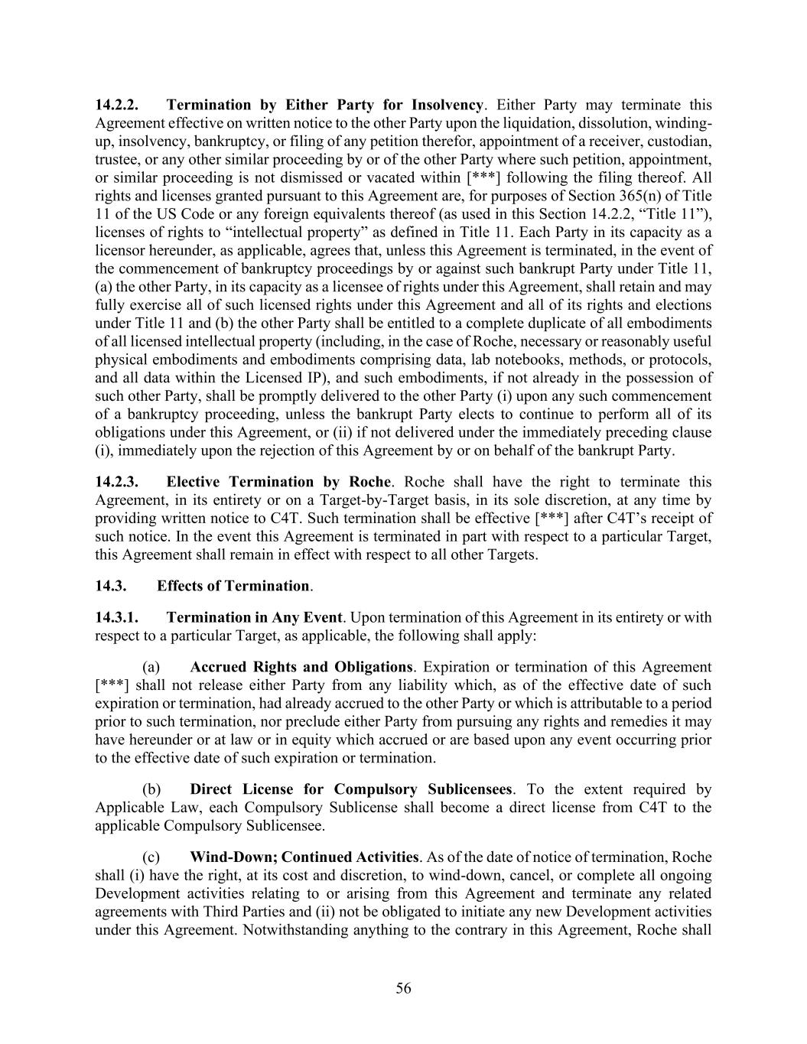
56 14.2.2. Termination by Either Party for Insolvency. Either Party may terminate this Agreement effective on written notice to the other Party upon the liquidation, dissolution, winding- up, insolvency, bankruptcy, or filing of any petition therefor, appointment of a receiver, custodian, trustee, or any other similar proceeding by or of the other Party where such petition, appointment, or similar proceeding is not dismissed or vacated within [***] following the filing thereof. All rights and licenses granted pursuant to this Agreement are, for purposes of Section 365(n) of Title 11 of the US Code or any foreign equivalents thereof (as used in this Section 14.2.2, “Title 11”), licenses of rights to “intellectual property” as defined in Title 11. Each Party in its capacity as a licensor hereunder, as applicable, agrees that, unless this Agreement is terminated, in the event of the commencement of bankruptcy proceedings by or against such bankrupt Party under Title 11, (a) the other Party, in its capacity as a licensee of rights under this Agreement, shall retain and may fully exercise all of such licensed rights under this Agreement and all of its rights and elections under Title 11 and (b) the other Party shall be entitled to a complete duplicate of all embodiments of all licensed intellectual property (including, in the case of Roche, necessary or reasonably useful physical embodiments and embodiments comprising data, lab notebooks, methods, or protocols, and all data within the Licensed IP), and such embodiments, if not already in the possession of such other Party, shall be promptly delivered to the other Party (i) upon any such commencement of a bankruptcy proceeding, unless the bankrupt Party elects to continue to perform all of its obligations under this Agreement, or (ii) if not delivered under the immediately preceding clause (i), immediately upon the rejection of this Agreement by or on behalf of the bankrupt Party. 14.2.3. Elective Termination by Roche. Roche shall have the right to terminate this Agreement, in its entirety or on a Target-by-Target basis, in its sole discretion, at any time by providing written notice to C4T. Such termination shall be effective [***] after C4T’s receipt of such notice. In the event this Agreement is terminated in part with respect to a particular Target, this Agreement shall remain in effect with respect to all other Targets. 14.3. Effects of Termination. 14.3.1. Termination in Any Event. Upon termination of this Agreement in its entirety or with respect to a particular Target, as applicable, the following shall apply: (a) Accrued Rights and Obligations. Expiration or termination of this Agreement [***] shall not release either Party from any liability which, as of the effective date of such expiration or termination, had already accrued to the other Party or which is attributable to a period prior to such termination, nor preclude either Party from pursuing any rights and remedies it may have hereunder or at law or in equity which accrued or are based upon any event occurring prior to the effective date of such expiration or termination. (b) Direct License for Compulsory Sublicensees. To the extent required by Applicable Law, each Compulsory Sublicense shall become a direct license from C4T to the applicable Compulsory Sublicensee. (c) Wind-Down; Continued Activities. As of the date of notice of termination, Roche shall (i) have the right, at its cost and discretion, to wind-down, cancel, or complete all ongoing Development activities relating to or arising from this Agreement and terminate any related agreements with Third Parties and (ii) not be obligated to initiate any new Development activities under this Agreement. Notwithstanding anything to the contrary in this Agreement, Roche shall

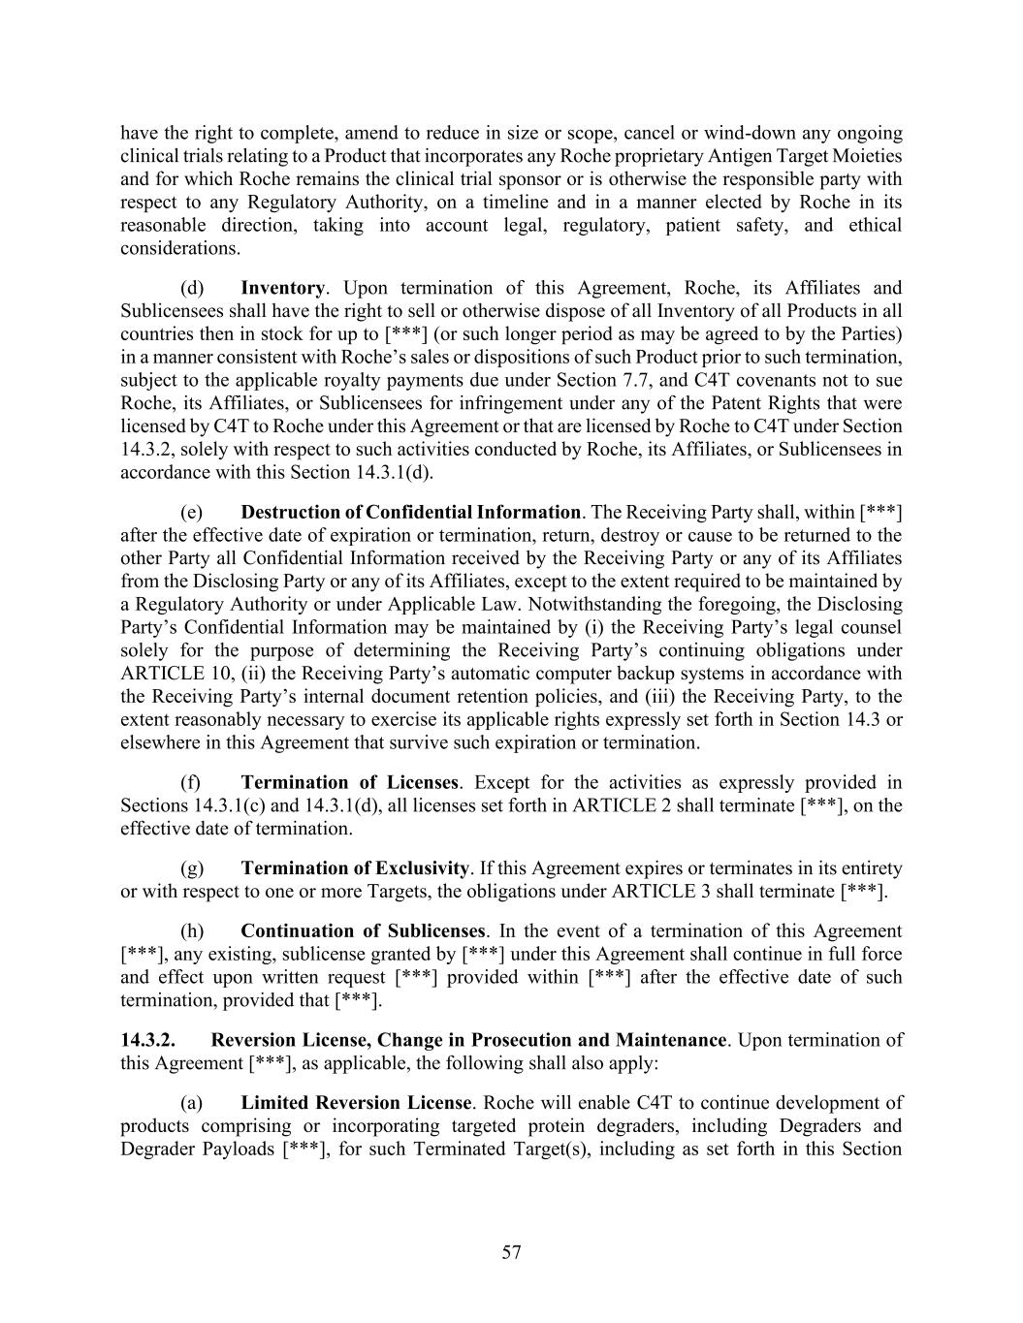
57 have the right to complete, amend to reduce in size or scope, cancel or wind-down any ongoing clinical trials relating to a Product that incorporates any Roche proprietary Antigen Target Moieties and for which Roche remains the clinical trial sponsor or is otherwise the responsible party with respect to any Regulatory Authority, on a timeline and in a manner elected by Roche in its reasonable direction, taking into account legal, regulatory, patient safety, and ethical considerations. (d) Inventory. Upon termination of this Agreement, Roche, its Affiliates and Sublicensees shall have the right to sell or otherwise dispose of all Inventory of all Products in all countries then in stock for up to [***] (or such longer period as may be agreed to by the Parties) in a manner consistent with Roche’s sales or dispositions of such Product prior to such termination, subject to the applicable royalty payments due under Section 7.7, and C4T covenants not to sue Roche, its Affiliates, or Sublicensees for infringement under any of the Patent Rights that were licensed by C4T to Roche under this Agreement or that are licensed by Roche to C4T under Section 14.3.2, solely with respect to such activities conducted by Roche, its Affiliates, or Sublicensees in accordance with this Section 14.3.1(d). (e) Destruction of Confidential Information. The Receiving Party shall, within [***] after the effective date of expiration or termination, return, destroy or cause to be returned to the other Party all Confidential Information received by the Receiving Party or any of its Affiliates from the Disclosing Party or any of its Affiliates, except to the extent required to be maintained by a Regulatory Authority or under Applicable Law. Notwithstanding the foregoing, the Disclosing Party’s Confidential Information may be maintained by (i) the Receiving Party’s legal counsel solely for the purpose of determining the Receiving Party’s continuing obligations under ARTICLE 10, (ii) the Receiving Party’s automatic computer backup systems in accordance with the Receiving Party’s internal document retention policies, and (iii) the Receiving Party, to the extent reasonably necessary to exercise its applicable rights expressly set forth in Section 14.3 or elsewhere in this Agreement that survive such expiration or termination. (f) Termination of Licenses. Except for the activities as expressly provided in Sections 14.3.1(c) and 14.3.1(d), all licenses set forth in ARTICLE 2 shall terminate [***], on the effective date of termination. (g) Termination of Exclusivity. If this Agreement expires or terminates in its entirety or with respect to one or more Targets, the obligations under ARTICLE 3 shall terminate [***]. (h) Continuation of Sublicenses. In the event of a termination of this Agreement [***], any existing, sublicense granted by [***] under this Agreement shall continue in full force and effect upon written request [***] provided within [***] after the effective date of such termination, provided that [***]. 14.3.2. Reversion License, Change in Prosecution and Maintenance. Upon termination of this Agreement [***], as applicable, the following shall also apply: (a) Limited Reversion License. Roche will enable C4T to continue development of products comprising or incorporating targeted protein degraders, including Degraders and Degrader Payloads [***], for such Terminated Target(s), including as set forth in this Section

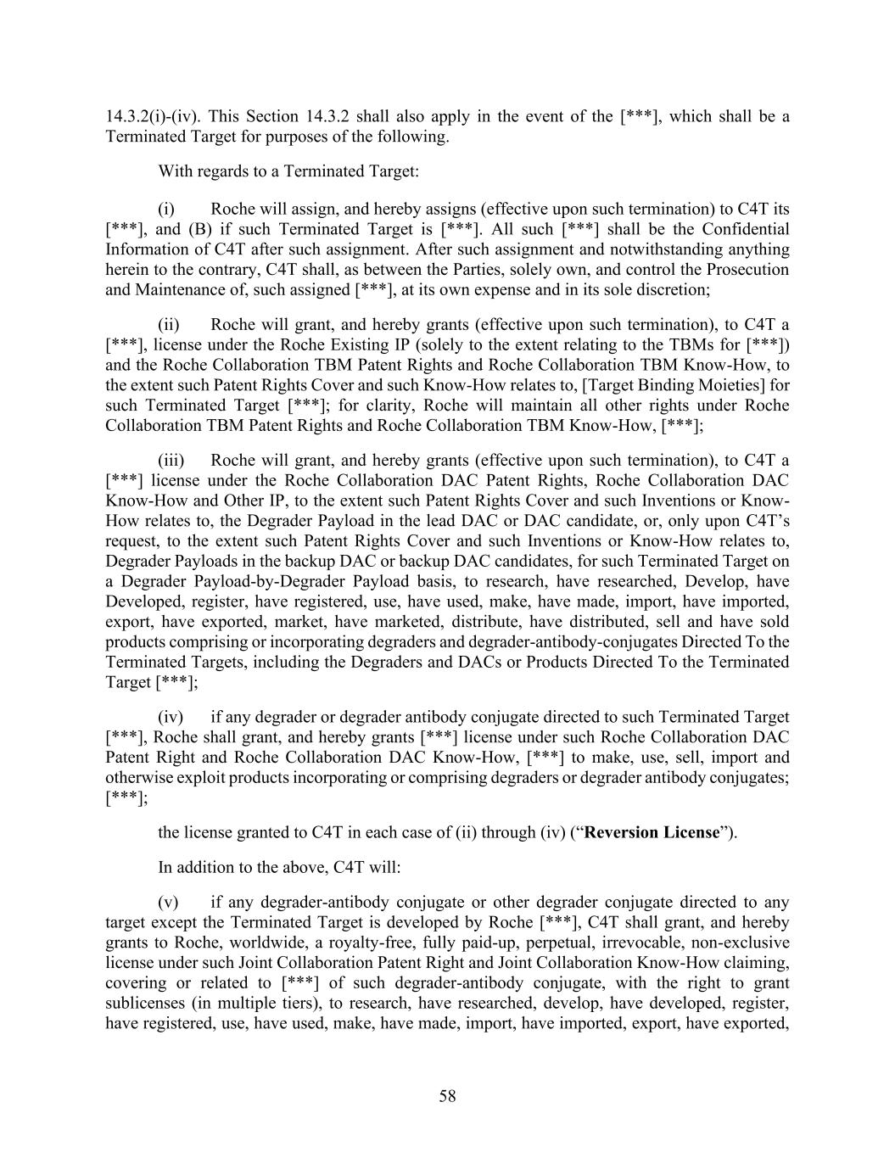
58 14.3.2(i)-(iv). This Section 14.3.2 shall also apply in the event of the [***], which shall be a Terminated Target for purposes of the following. With regards to a Terminated Target: (i) Roche will assign, and hereby assigns (effective upon such termination) to C4T its [***], and (B) if such Terminated Target is [***]. All such [***] shall be the Confidential Information of C4T after such assignment. After such assignment and notwithstanding anything herein to the contrary, C4T shall, as between the Parties, solely own, and control the Prosecution and Maintenance of, such assigned [***], at its own expense and in its sole discretion; (ii) Roche will grant, and hereby grants (effective upon such termination), to C4T a [***], license under the Roche Existing IP (solely to the extent relating to the TBMs for [***]) and the Roche Collaboration TBM Patent Rights and Roche Collaboration TBM Know-How, to the extent such Patent Rights Cover and such Know-How relates to, [Target Binding Moieties] for such Terminated Target [***]; for clarity, Roche will maintain all other rights under Roche Collaboration TBM Patent Rights and Roche Collaboration TBM Know-How, [***]; (iii) Roche will grant, and hereby grants (effective upon such termination), to C4T a [***] license under the Roche Collaboration DAC Patent Rights, Roche Collaboration DAC Know-How and Other IP, to the extent such Patent Rights Cover and such Inventions or Know- How relates to, the Degrader Payload in the lead DAC or DAC candidate, or, only upon C4T’s request, to the extent such Patent Rights Cover and such Inventions or Know-How relates to, Degrader Payloads in the backup DAC or backup DAC candidates, for such Terminated Target on a Degrader Payload-by-Degrader Payload basis, to research, have researched, Develop, have Developed, register, have registered, use, have used, make, have made, import, have imported, export, have exported, market, have marketed, distribute, have distributed, sell and have sold products comprising or incorporating degraders and degrader-antibody-conjugates Directed To the Terminated Targets, including the Degraders and DACs or Products Directed To the Terminated Target [***]; (iv) if any degrader or degrader antibody conjugate directed to such Terminated Target [***], Roche shall grant, and hereby grants [***] license under such Roche Collaboration DAC Patent Right and Roche Collaboration DAC Know-How, [***] to make, use, sell, import and otherwise exploit products incorporating or comprising degraders or degrader antibody conjugates; [***]; the license granted to C4T in each case of (ii) through (iv) (“Reversion License”). In addition to the above, C4T will: (v) if any degrader-antibody conjugate or other degrader conjugate directed to any target except the Terminated Target is developed by Roche [***], C4T shall grant, and hereby grants to Roche, worldwide, a royalty-free, fully paid-up, perpetual, irrevocable, non-exclusive license under such Joint Collaboration Patent Right and Joint Collaboration Know-How claiming, covering or related to [***] of such degrader-antibody conjugate, with the right to grant sublicenses (in multiple tiers), to research, have researched, develop, have developed, register, have registered, use, have used, make, have made, import, have imported, export, have exported,

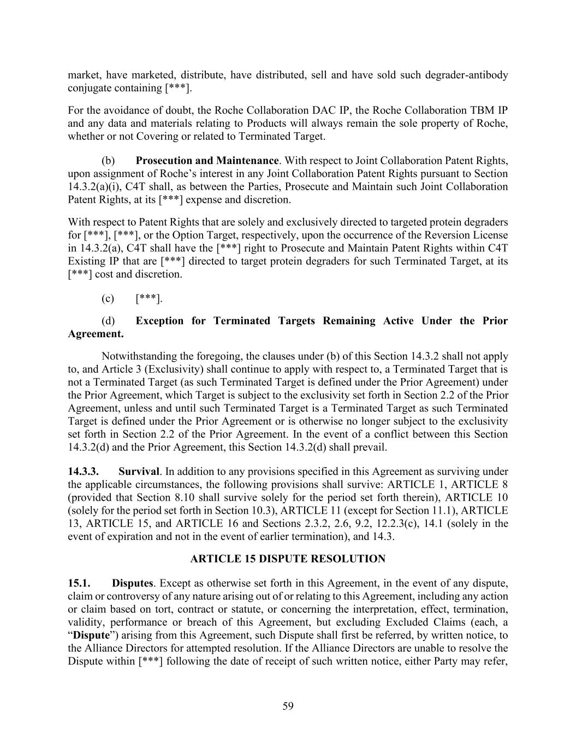
59 market, have marketed, distribute, have distributed, sell and have sold such degrader-antibody conjugate containing [***]. For the avoidance of doubt, the Roche Collaboration DAC IP, the Roche Collaboration TBM IP and any data and materials relating to Products will always remain the sole property of Roche, whether or not Covering or related to Terminated Target. (b) Prosecution and Maintenance. With respect to Joint Collaboration Patent Rights, upon assignment of Roche’s interest in any Joint Collaboration Patent Rights pursuant to Section 14.3.2(a)(i), C4T shall, as between the Parties, Prosecute and Maintain such Joint Collaboration Patent Rights, at its [***] expense and discretion. With respect to Patent Rights that are solely and exclusively directed to targeted protein degraders for [***], [***], or the Option Target, respectively, upon the occurrence of the Reversion License in 14.3.2(a), C4T shall have the [***] right to Prosecute and Maintain Patent Rights within C4T Existing IP that are [***] directed to target protein degraders for such Terminated Target, at its [***] cost and discretion. (c) [***]. (d) Exception for Terminated Targets Remaining Active Under the Prior Agreement. Notwithstanding the foregoing, the clauses under (b) of this Section 14.3.2 shall not apply to, and Article 3 (Exclusivity) shall continue to apply with respect to, a Terminated Target that is not a Terminated Target (as such Terminated Target is defined under the Prior Agreement) under the Prior Agreement, which Target is subject to the exclusivity set forth in Section 2.2 of the Prior Agreement, unless and until such Terminated Target is a Terminated Target as such Terminated Target is defined under the Prior Agreement or is otherwise no longer subject to the exclusivity set forth in Section 2.2 of the Prior Agreement. In the event of a conflict between this Section 14.3.2(d) and the Prior Agreement, this Section 14.3.2(d) shall prevail. 14.3.3. Survival. In addition to any provisions specified in this Agreement as surviving under the applicable circumstances, the following provisions shall survive: ARTICLE 1, ARTICLE 8 (provided that Section 8.10 shall survive solely for the period set forth therein), ARTICLE 10 (solely for the period set forth in Section 10.3), ARTICLE 11 (except for Section 11.1), ARTICLE 13, ARTICLE 15, and ARTICLE 16 and Sections 2.3.2, 2.6, 9.2, 12.2.3(c), 14.1 (solely in the event of expiration and not in the event of earlier termination), and 14.3. ARTICLE 15 DISPUTE RESOLUTION 15.1. Disputes. Except as otherwise set forth in this Agreement, in the event of any dispute, claim or controversy of any nature arising out of or relating to this Agreement, including any action or claim based on tort, contract or statute, or concerning the interpretation, effect, termination, validity, performance or breach of this Agreement, but excluding Excluded Claims (each, a “Dispute”) arising from this Agreement, such Dispute shall first be referred, by written notice, to the Alliance Directors for attempted resolution. If the Alliance Directors are unable to resolve the Dispute within [***] following the date of receipt of such written notice, either Party may refer,

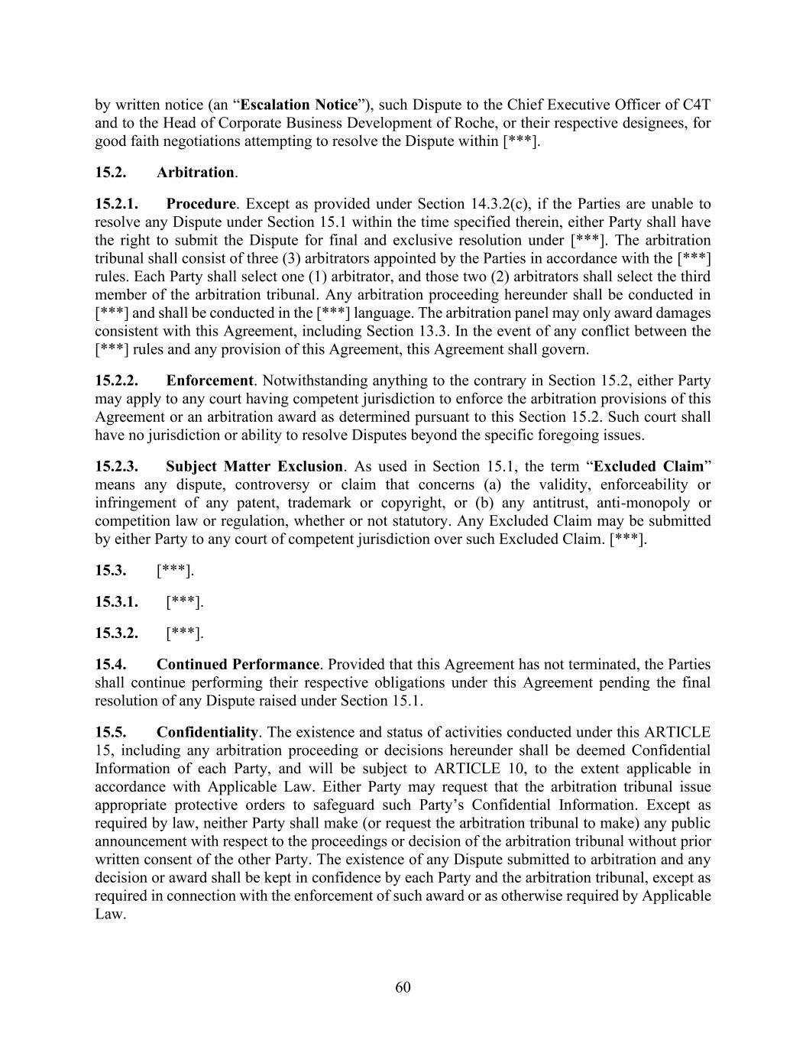
60 by written notice (an “Escalation Notice”), such Dispute to the Chief Executive Officer of C4T and to the Head of Corporate Business Development of Roche, or their respective designees, for good faith negotiations attempting to resolve the Dispute within [***]. 15.2. Arbitration. 15.2.1. Procedure. Except as provided under Section 14.3.2(c), if the Parties are unable to resolve any Dispute under Section 15.1 within the time specified therein, either Party shall have the right to submit the Dispute for final and exclusive resolution under [***]. The arbitration tribunal shall consist of three (3) arbitrators appointed by the Parties in accordance with the [***] rules. Each Party shall select one (1) arbitrator, and those two (2) arbitrators shall select the third member of the arbitration tribunal. Any arbitration proceeding hereunder shall be conducted in [***] and shall be conducted in the [***] language. The arbitration panel may only award damages consistent with this Agreement, including Section 13.3. In the event of any conflict between the [***] rules and any provision of this Agreement, this Agreement shall govern. 15.2.2. Enforcement. Notwithstanding anything to the contrary in Section 15.2, either Party may apply to any court having competent jurisdiction to enforce the arbitration provisions of this Agreement or an arbitration award as determined pursuant to this Section 15.2. Such court shall have no jurisdiction or ability to resolve Disputes beyond the specific foregoing issues. 15.2.3. Subject Matter Exclusion. As used in Section 15.1, the term “Excluded Claim” means any dispute, controversy or claim that concerns (a) the validity, enforceability or infringement of any patent, trademark or copyright, or (b) any antitrust, anti-monopoly or competition law or regulation, whether or not statutory. Any Excluded Claim may be submitted by either Party to any court of competent jurisdiction over such Excluded Claim. [***]. 15.3. [***]. 15.3.1. [***]. 15.3.2. [***]. 15.4. Continued Performance. Provided that this Agreement has not terminated, the Parties shall continue performing their respective obligations under this Agreement pending the final resolution of any Dispute raised under Section 15.1. 15.5. Confidentiality. The existence and status of activities conducted under this ARTICLE 15, including any arbitration proceeding or decisions hereunder shall be deemed Confidential Information of each Party, and will be subject to ARTICLE 10, to the extent applicable in accordance with Applicable Law. Either Party may request that the arbitration tribunal issue appropriate protective orders to safeguard such Party’s Confidential Information. Except as required by law, neither Party shall make (or request the arbitration tribunal to make) any public announcement with respect to the proceedings or decision of the arbitration tribunal without prior written consent of the other Party. The existence of any Dispute submitted to arbitration and any decision or award shall be kept in confidence by each Party and the arbitration tribunal, except as required in connection with the enforcement of such award or as otherwise required by Applicable Law.

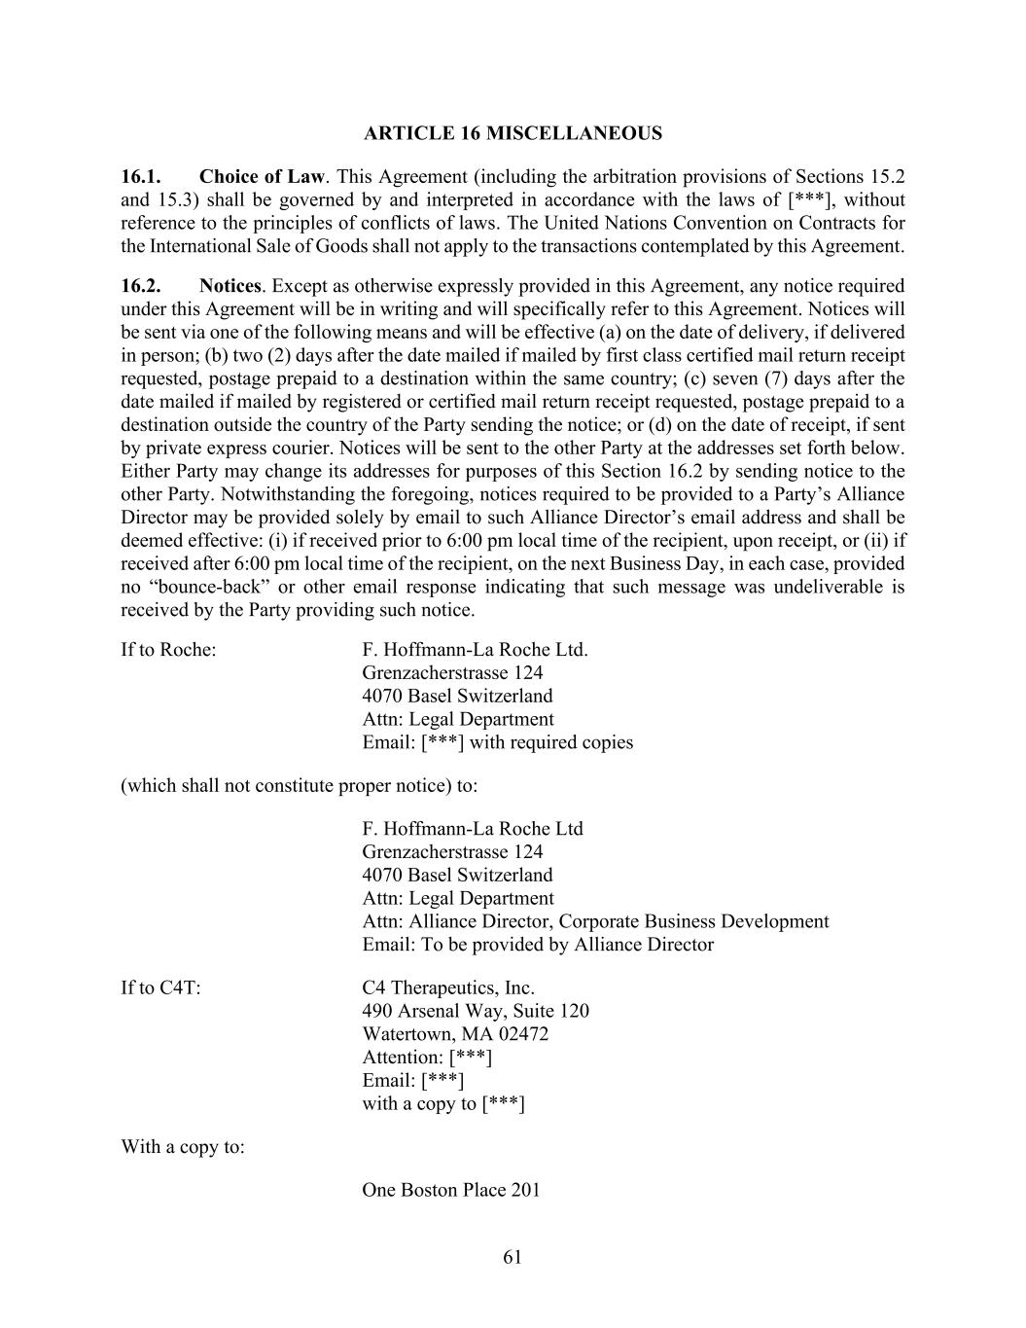
61 ARTICLE 16 MISCELLANEOUS 16.1. Choice of Law. This Agreement (including the arbitration provisions of Sections 15.2 and 15.3) shall be governed by and interpreted in accordance with the laws of [***], without reference to the principles of conflicts of laws. The United Nations Convention on Contracts for the International Sale of Goods shall not apply to the transactions contemplated by this Agreement. 16.2. Notices. Except as otherwise expressly provided in this Agreement, any notice required under this Agreement will be in writing and will specifically refer to this Agreement. Notices will be sent via one of the following means and will be effective (a) on the date of delivery, if delivered in person; (b) two (2) days after the date mailed if mailed by first class certified mail return receipt requested, postage prepaid to a destination within the same country; (c) seven (7) days after the date mailed if mailed by registered or certified mail return receipt requested, postage prepaid to a destination outside the country of the Party sending the notice; or (d) on the date of receipt, if sent by private express courier. Notices will be sent to the other Party at the addresses set forth below. Either Party may change its addresses for purposes of this Section 16.2 by sending notice to the other Party. Notwithstanding the foregoing, notices required to be provided to a Party’s Alliance Director may be provided solely by email to such Alliance Director’s email address and shall be deemed effective: (i) if received prior to 6:00 pm local time of the recipient, upon receipt, or (ii) if received after 6:00 pm local time of the recipient, on the next Business Day, in each case, provided no “bounce-back” or other email response indicating that such message was undeliverable is received by the Party providing such notice. If to Roche: F. Hoffmann-La Roche Ltd. Grenzacherstrasse 124 4070 Basel Switzerland Attn: Legal Department Email: [***] with required copies (which shall not constitute proper notice) to: F. Hoffmann-La Roche Ltd Grenzacherstrasse 124 4070 Basel Switzerland Attn: Legal Department Attn: Alliance Director, Corporate Business Development Email: To be provided by Alliance Director If to C4T: C4 Therapeutics, Inc. 490 Arsenal Way, Suite 120 Watertown, MA 02472 Attention: [***] Email: [***] with a copy to [***] With a copy to: One Boston Place 201

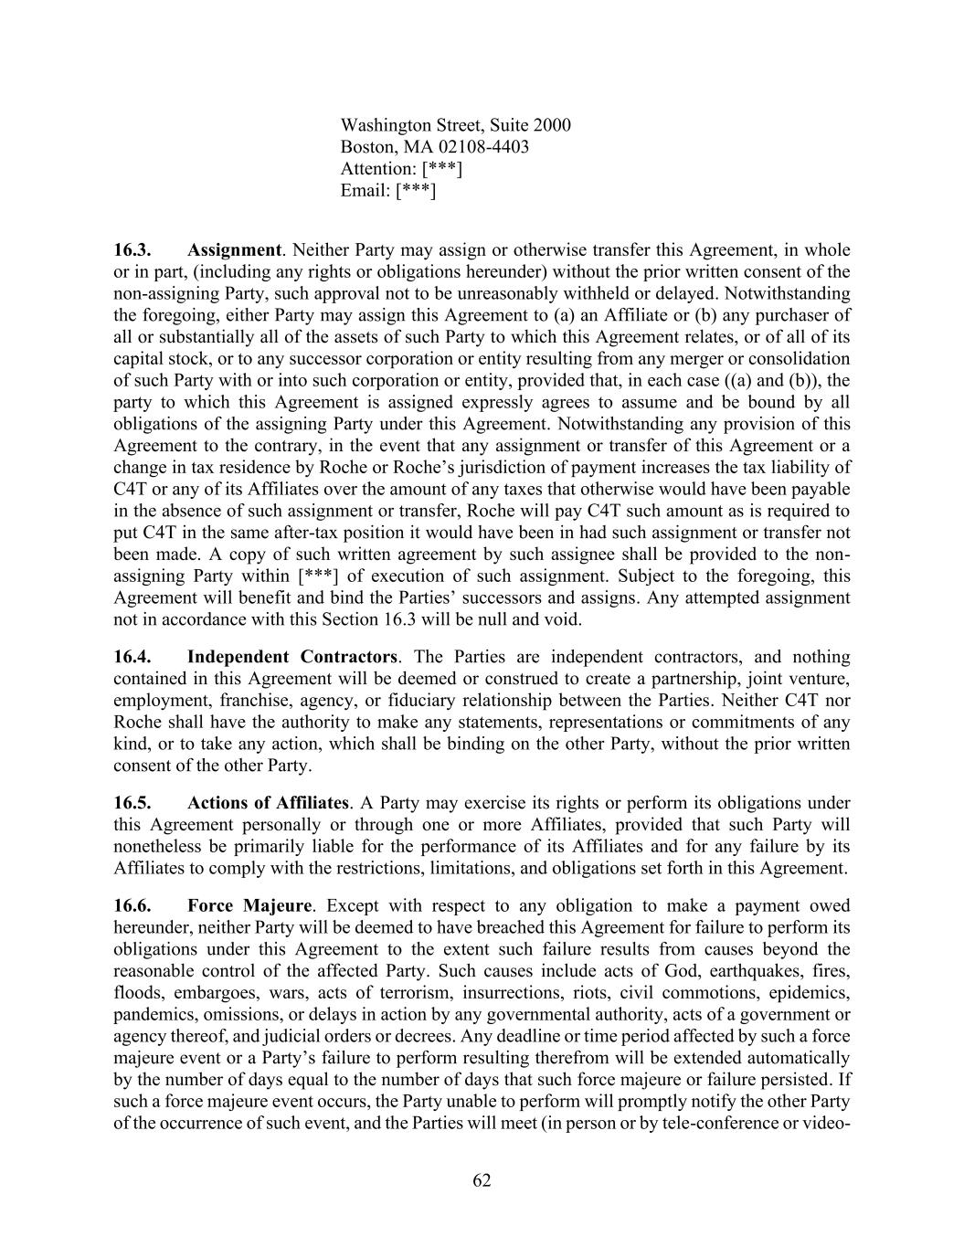
62 Washington Street, Suite 2000 Boston, MA 02108-4403 Attention: [***] Email: [***] 16.3. Assignment. Neither Party may assign or otherwise transfer this Agreement, in whole or in part, (including any rights or obligations hereunder) without the prior written consent of the non-assigning Party, such approval not to be unreasonably withheld or delayed. Notwithstanding the foregoing, either Party may assign this Agreement to (a) an Affiliate or (b) any purchaser of all or substantially all of the assets of such Party to which this Agreement relates, or of all of its capital stock, or to any successor corporation or entity resulting from any merger or consolidation of such Party with or into such corporation or entity, provided that, in each case ((a) and (b)), the party to which this Agreement is assigned expressly agrees to assume and be bound by all obligations of the assigning Party under this Agreement. Notwithstanding any provision of this Agreement to the contrary, in the event that any assignment or transfer of this Agreement or a change in tax residence by Roche or Roche’s jurisdiction of payment increases the tax liability of C4T or any of its Affiliates over the amount of any taxes that otherwise would have been payable in the absence of such assignment or transfer, Roche will pay C4T such amount as is required to put C4T in the same after-tax position it would have been in had such assignment or transfer not been made. A copy of such written agreement by such assignee shall be provided to the non- assigning Party within [***] of execution of such assignment. Subject to the foregoing, this Agreement will benefit and bind the Parties’ successors and assigns. Any attempted assignment not in accordance with this Section 16.3 will be null and void. 16.4. Independent Contractors. The Parties are independent contractors, and nothing contained in this Agreement will be deemed or construed to create a partnership, joint venture, employment, franchise, agency, or fiduciary relationship between the Parties. Neither C4T nor Roche shall have the authority to make any statements, representations or commitments of any kind, or to take any action, which shall be binding on the other Party, without the prior written consent of the other Party. 16.5. Actions of Affiliates. A Party may exercise its rights or perform its obligations under this Agreement personally or through one or more Affiliates, provided that such Party will nonetheless be primarily liable for the performance of its Affiliates and for any failure by its Affiliates to comply with the restrictions, limitations, and obligations set forth in this Agreement. 16.6. Force Majeure. Except with respect to any obligation to make a payment owed hereunder, neither Party will be deemed to have breached this Agreement for failure to perform its obligations under this Agreement to the extent such failure results from causes beyond the reasonable control of the affected Party. Such causes include acts of God, earthquakes, fires, floods, embargoes, wars, acts of terrorism, insurrections, riots, civil commotions, epidemics, pandemics, omissions, or delays in action by any governmental authority, acts of a government or agency thereof, and judicial orders or decrees. Any deadline or time period affected by such a force majeure event or a Party’s failure to perform resulting therefrom will be extended automatically by the number of days equal to the number of days that such force majeure or failure persisted. If such a force majeure event occurs, the Party unable to perform will promptly notify the other Party of the occurrence of such event, and the Parties will meet (in person or by tele-conference or video-

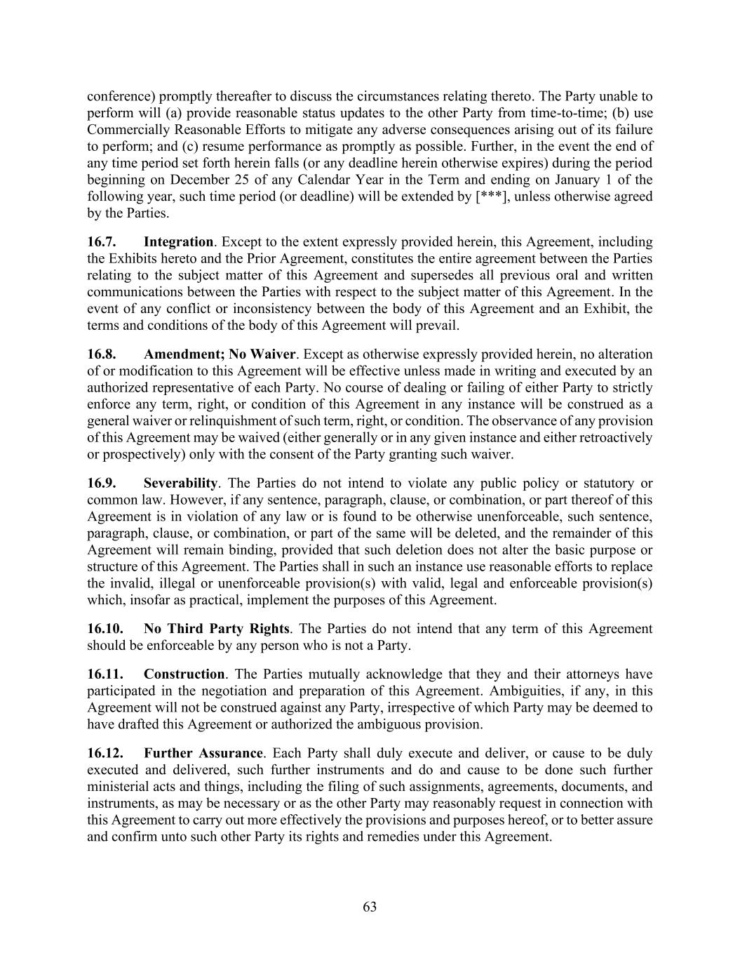
63 conference) promptly thereafter to discuss the circumstances relating thereto. The Party unable to perform will (a) provide reasonable status updates to the other Party from time-to-time; (b) use Commercially Reasonable Efforts to mitigate any adverse consequences arising out of its failure to perform; and (c) resume performance as promptly as possible. Further, in the event the end of any time period set forth herein falls (or any deadline herein otherwise expires) during the period beginning on December 25 of any Calendar Year in the Term and ending on January 1 of the following year, such time period (or deadline) will be extended by [***], unless otherwise agreed by the Parties. 16.7. Integration. Except to the extent expressly provided herein, this Agreement, including the Exhibits hereto and the Prior Agreement, constitutes the entire agreement between the Parties relating to the subject matter of this Agreement and supersedes all previous oral and written communications between the Parties with respect to the subject matter of this Agreement. In the event of any conflict or inconsistency between the body of this Agreement and an Exhibit, the terms and conditions of the body of this Agreement will prevail. 16.8. Amendment; No Waiver. Except as otherwise expressly provided herein, no alteration of or modification to this Agreement will be effective unless made in writing and executed by an authorized representative of each Party. No course of dealing or failing of either Party to strictly enforce any term, right, or condition of this Agreement in any instance will be construed as a general waiver or relinquishment of such term, right, or condition. The observance of any provision of this Agreement may be waived (either generally or in any given instance and either retroactively or prospectively) only with the consent of the Party granting such waiver. 16.9. Severability. The Parties do not intend to violate any public policy or statutory or common law. However, if any sentence, paragraph, clause, or combination, or part thereof of this Agreement is in violation of any law or is found to be otherwise unenforceable, such sentence, paragraph, clause, or combination, or part of the same will be deleted, and the remainder of this Agreement will remain binding, provided that such deletion does not alter the basic purpose or structure of this Agreement. The Parties shall in such an instance use reasonable efforts to replace the invalid, illegal or unenforceable provision(s) with valid, legal and enforceable provision(s) which, insofar as practical, implement the purposes of this Agreement. 16.10. No Third Party Rights. The Parties do not intend that any term of this Agreement should be enforceable by any person who is not a Party. 16.11. Construction. The Parties mutually acknowledge that they and their attorneys have participated in the negotiation and preparation of this Agreement. Ambiguities, if any, in this Agreement will not be construed against any Party, irrespective of which Party may be deemed to have drafted this Agreement or authorized the ambiguous provision. 16.12. Further Assurance. Each Party shall duly execute and deliver, or cause to be duly executed and delivered, such further instruments and do and cause to be done such further ministerial acts and things, including the filing of such assignments, agreements, documents, and instruments, as may be necessary or as the other Party may reasonably request in connection with this Agreement to carry out more effectively the provisions and purposes hereof, or to better assure and confirm unto such other Party its rights and remedies under this Agreement.

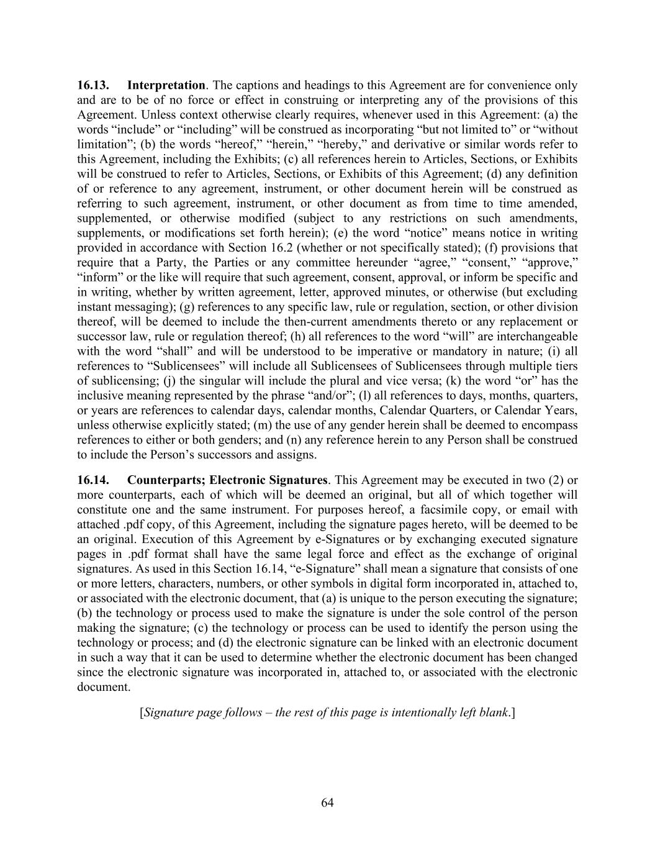
64 16.13. Interpretation. The captions and headings to this Agreement are for convenience only and are to be of no force or effect in construing or interpreting any of the provisions of this Agreement. Unless context otherwise clearly requires, whenever used in this Agreement: (a) the words “include” or “including” will be construed as incorporating “but not limited to” or “without limitation”; (b) the words “hereof,” “herein,” “hereby,” and derivative or similar words refer to this Agreement, including the Exhibits; (c) all references herein to Articles, Sections, or Exhibits will be construed to refer to Articles, Sections, or Exhibits of this Agreement; (d) any definition of or reference to any agreement, instrument, or other document herein will be construed as referring to such agreement, instrument, or other document as from time to time amended, supplemented, or otherwise modified (subject to any restrictions on such amendments, supplements, or modifications set forth herein); (e) the word “notice” means notice in writing provided in accordance with Section 16.2 (whether or not specifically stated); (f) provisions that require that a Party, the Parties or any committee hereunder “agree,” “consent,” “approve,” “inform” or the like will require that such agreement, consent, approval, or inform be specific and in writing, whether by written agreement, letter, approved minutes, or otherwise (but excluding instant messaging); (g) references to any specific law, rule or regulation, section, or other division thereof, will be deemed to include the then-current amendments thereto or any replacement or successor law, rule or regulation thereof; (h) all references to the word “will” are interchangeable with the word “shall” and will be understood to be imperative or mandatory in nature; (i) all references to “Sublicensees” will include all Sublicensees of Sublicensees through multiple tiers of sublicensing; (j) the singular will include the plural and vice versa; (k) the word “or” has the inclusive meaning represented by the phrase “and/or”; (l) all references to days, months, quarters, or years are references to calendar days, calendar months, Calendar Quarters, or Calendar Years, unless otherwise explicitly stated; (m) the use of any gender herein shall be deemed to encompass references to either or both genders; and (n) any reference herein to any Person shall be construed to include the Person’s successors and assigns. 16.14. Counterparts; Electronic Signatures. This Agreement may be executed in two (2) or more counterparts, each of which will be deemed an original, but all of which together will constitute one and the same instrument. For purposes hereof, a facsimile copy, or email with attached .pdf copy, of this Agreement, including the signature pages hereto, will be deemed to be an original. Execution of this Agreement by e-Signatures or by exchanging executed signature pages in .pdf format shall have the same legal force and effect as the exchange of original signatures. As used in this Section 16.14, “e-Signature” shall mean a signature that consists of one or more letters, characters, numbers, or other symbols in digital form incorporated in, attached to, or associated with the electronic document, that (a) is unique to the person executing the signature; (b) the technology or process used to make the signature is under the sole control of the person making the signature; (c) the technology or process can be used to identify the person using the technology or process; and (d) the electronic signature can be linked with an electronic document in such a way that it can be used to determine whether the electronic document has been changed since the electronic signature was incorporated in, attached to, or associated with the electronic document. [Signature page follows – the rest of this page is intentionally left blank.]

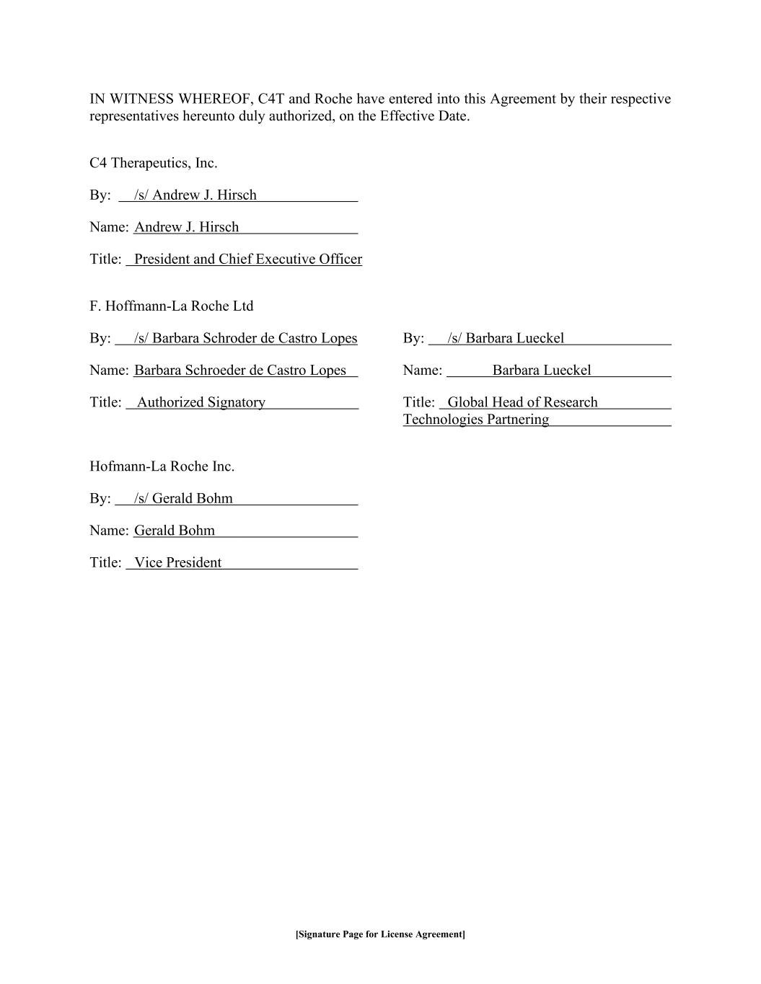
[Signature Page for License Agreement] IN WITNESS WHEREOF, C4T and Roche have entered into this Agreement by their respective representatives hereunto duly authorized, on the Effective Date. C4 Therapeutics, Inc. By: /s/ Andrew J. Hirsch Name: Andrew J. Hirsch Title: President and Chief Executive Officer F. Hoffmann-La Roche Ltd By: /s/ Barbara Schroder de Castro Lopes By: /s/ Barbara Lueckel Name: Barbara Schroeder de Castro Lopes Name: Barbara Lueckel Title: Authorized Signatory Title: Global Head of Research Technologies Partnering Hofmann-La Roche Inc. By: /s/ Gerald Bohm Name: Gerald Bohm Title: Vice President


1 Exhibit 1.11 Authorized Subcontractors [***]


1 Exhibit 1.15 Background C4T Technology Patent Rights [***]


1 Exhibit 1.23 C4T Existing Patent Rights [***]


1 Exhibit 1.35 C4T Third Party License Agreements [***]


1 Exhibit 1.122 Licensed Patent Rights [***]


1 Exhibit 1.165 Research Plan [***]


1 Exhibit 1.183 Roche Existing Patent Rights [***]


1 Exhibit 11.1 Press Release [***]

Exhibit 31.1
CERTIFICATION PURSUANT TO
RULES 13a-14(a) AND 15d-14(a) UNDER THE SECURITIES EXCHANGE ACT OF 1934,
AS ADOPTED PURSUANT TO SECTION 302 OF THE SARBANES-OXLEY ACT OF 2002
I, Andrew J. Hirsch, certify that:
1.I have reviewed this Quarterly Report on Form 10-Q of C4 Therapeutics, Inc.;
2.Based on my knowledge, this report does not contain any untrue statement of a material fact or omit to state a material fact necessary to make the statements made, in light of the circumstances under which such statements were made, not misleading with respect to the period covered by this report;
3.Based on my knowledge, the financial statements, and other financial information included in this report, fairly present in all material respects the financial condition, results of operations and cash flows of the registrant as of, and for, the periods presented in this report;
4.The registrant's other certifying officer(s) and I are responsible for establishing and maintaining disclosure controls and procedures (as defined in Exchange Act Rules 13a-15(e) and 15d-15(e)) and internal control over financial reporting (as defined in Exchange Act Rules 13a-15(f) and 15d-15(f)) for the registrant and have:
(a)Designed such disclosure controls and procedures, or caused such disclosure controls and procedures to be designed under our supervision, to ensure that material information relating to the registrant, including its consolidated subsidiaries, is made known to us by others within those entities, particularly during the period in which this report is being prepared;
(b)Designed such internal control over financial reporting, or caused such internal control over financial reporting to be designed under our supervision, to provide reasonable assurance regarding the reliability of financial reporting and the preparation of financial statements for external purposes in accordance with generally accepted accounting principles;
(c)Evaluated the effectiveness of the registrant's disclosure controls and procedures and presented in this report our conclusions about the effectiveness of the disclosure controls and procedures, as of the end of the period covered by this report based on such evaluation; and
(d)Disclosed in this report any change in the registrant's internal control over financial reporting that occurred during the registrant's most recent fiscal quarter (the registrant's fourth fiscal quarter in the case of an annual report) that has materially affected, or is reasonably likely to materially affect, the registrant's internal control over financial reporting; and
5.The registrant's other certifying officer(s) and I have disclosed, based on our most recent evaluation of internal control over financial reporting, to the registrant's auditors and the audit committee of the registrant's board of directors (or persons performing the equivalent functions):
(a)All significant deficiencies and material weaknesses in the design or operation of internal control over financial reporting which are reasonably likely to adversely affect the registrant's ability to record, process, summarize and report financial information; and
(b)Any fraud, whether or not material, that involves management or other employees who have a significant role in the registrant's internal control over financial reporting.
Date: August 11, 2026 |  |  | By: |  |  | /s/ Andrew J. Hirsch
 |  |  |  |  |  | Andrew J. Hirsch
 |  |  |  |  |  | Chief Executive Officer

Exhibit 31.2
CERTIFICATION PURSUANT TO
RULES 13a-14(a) AND 15d-14(a) UNDER THE SECURITIES EXCHANGE ACT OF 1934,
AS ADOPTED PURSUANT TO SECTION 302 OF THE SARBANES-OXLEY ACT OF 2002
I, Kendra R. Adams, certify that:
1.I have reviewed this Quarterly Report on Form 10-Q of C4 Therapeutics, Inc.;
2.Based on my knowledge, this report does not contain any untrue statement of a material fact or omit to state a material fact necessary to make the statements made, in light of the circumstances under which such statements were made, not misleading with respect to the period covered by this report;
3.Based on my knowledge, the financial statements, and other financial information included in this report, fairly present in all material respects the financial condition, results of operations and cash flows of the registrant as of, and for, the periods presented in this report;
4.The registrant's other certifying officer(s) and I are responsible for establishing and maintaining disclosure controls and procedures (as defined in Exchange Act Rules 13a-15(e) and 15d-15(e)) and internal control over financial reporting (as defined in Exchange Act Rules 13a-15(f) and 15d-15(f)) for the registrant and have:
(a)Designed such disclosure controls and procedures, or caused such disclosure controls and procedures to be designed under our supervision, to ensure that material information relating to the registrant, including its consolidated subsidiaries, is made known to us by others within those entities, particularly during the period in which this report is being prepared;
(b)Designed such internal control over financial reporting, or caused such internal control over financial reporting to be designed under our supervision, to provide reasonable assurance regarding the reliability of financial reporting and the preparation of financial statements for external purposes in accordance with generally accepted accounting principles;
(c)Evaluated the effectiveness of the registrant's disclosure controls and procedures and presented in this report our conclusions about the effectiveness of the disclosure controls and procedures, as of the end of the period covered by this report based on such evaluation; and
(d)Disclosed in this report any change in the registrant's internal control over financial reporting that occurred during the registrant's most recent fiscal quarter (the registrant's fourth fiscal quarter in the case of an annual report) that has materially affected, or is reasonably likely to materially affect, the registrant's internal control over financial reporting; and
5.The registrant's other certifying officer(s) and I have disclosed, based on our most recent evaluation of internal control over financial reporting, to the registrant's auditors and the audit committee of the registrant's board of directors (or persons performing the equivalent functions):
(a)All significant deficiencies and material weaknesses in the design or operation of internal control over financial reporting which are reasonably likely to adversely affect the registrant's ability to record, process, summarize and report financial information; and
(b)Any fraud, whether or not material, that involves management or other employees who have a significant role in the registrant's internal control over financial reporting.
Date: August 11, 2026 |  |  | By: |  |  | /s/ Kendra R. Adams
 |  |  |  |  |  | Kendra R. Adams
 |  |  |  |  |  | Chief Financial Officer, Head of Corporate Affairs, and Treasurer

Exhibit 32.1
CERTIFICATION PURSUANT TO
18 U.S.C. SECTION 1350, AS ADOPTED PURSUANT TO
SECTION 906 OF THE SARBANES-OXLEY ACT OF 2002
In connection with the Quarterly Report of C4 Therapeutics, Inc. (the “Company”) on Form 10-Q for the period ended June 30, 2026, as filed with the Securities and Exchange Commission on the date hereof (the “Report”), I certify, pursuant to 18 U.S.C. § 1350, as adopted pursuant to § 906 of the Sarbanes-Oxley Act of 2002, that:
(1)The Report fully complies with the requirements of section 13(a) or 15(d) of the Securities Exchange Act of 1934; and
(2)The information contained in the Report fairly presents, in all material respects, the financial condition and results of operations of the Company.
Date: August 11, 2026 |  |  | By: |  |  | /s/ Andrew J. Hirsch
 |  |  |  |  |  | Andrew J. Hirsch
 |  |  |  |  |  | Chief Executive Officer

Exhibit 32.2
CERTIFICATION PURSUANT TO
18 U.S.C. SECTION 1350, AS ADOPTED PURSUANT TO
SECTION 906 OF THE SARBANES-OXLEY ACT OF 2002
In connection with the Quarterly Report of C4 Therapeutics, Inc. (the “Company”) on Form 10-Q for the period ended June 30, 2026, as filed with the Securities and Exchange Commission on the date hereof (the “Report”), I certify, pursuant to 18 U.S.C. § 1350, as adopted pursuant to § 906 of the Sarbanes-Oxley Act of 2002, that:
(1)The Report fully complies with the requirements of section 13(a) or 15(d) of the Securities Exchange Act of 1934; and
(2)The information contained in the Report fairly presents, in all material respects, the financial condition and results of operations of the Company.
Date: August 11, 2026 |  |  | By: |  |  | /s/ Kendra R. Adams
 |  |  |  |  |  | Kendra R. Adams
 |  |  |  |  |  | Chief Financial Officer, Head of Corporate Affairs, and Treasurer

